FARDC-M23 Negotiations Highlight Imperialist Rivalries in Congo
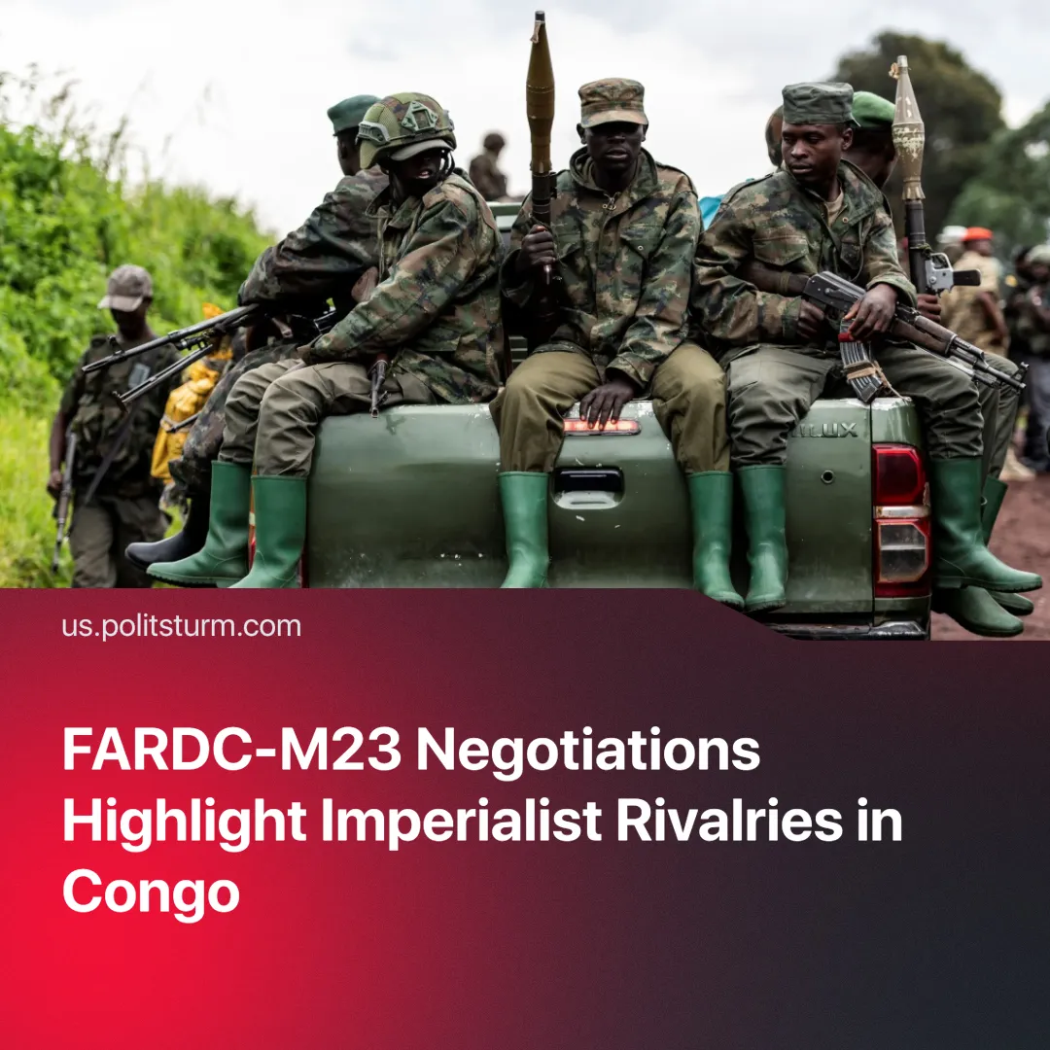

Original article
2025-04-10
2 min read

The March 23 Movement (M23) rebels will meet with Congolese officials for their first direct negotiations in months after capturing Goma and Bukavu. Though delayed as of March 9, the talks were set to take place in Doha under Qatari mediation.
Details. The primary aim of these talks is to address M23’s key demand: an end to the persecution of ethnic Tutsi groups in Kinshasa. Another key issue is the escalating conflict in Eastern Congo.
► Preliminary discussions held in late March led to M23’s strategic withdrawal from the mineral-rich town of Walikale as a gesture of goodwill to enter negotiations under certain conditions.
► International observers will monitor the talks. While M23 commanders remain cautious about engaging in talks, they continue to accuse the Congolese army of collaborating with the anti-Rwandan Hutu militia group, the FDLR, which they claim poses a threat to their community.
► The Congolese government, in turn, claims Rwanda backs M23—an allegation Rwanda denies.
Context. M23 was formed on May 6, 2012, named after the March 23, 2009, peace agreement signed by ethnic Tutsis and former rebels of the National Congress for the Defence of the People (CNDP), a Rwandan-backed militia active in eastern Congo. It rapidly gained territory and seized the city of Goma in 2012 but was eventually forced to retreat following a series of defeats by the Congolese army.
► After nearly a decade of dormancy, M23 re-emerged in late 2021, claiming to defend Congolese Tutsis. It quickly captured strategic areas and displaced around 1.7 million across the Kivu region.
► UN reports have confirmed that the Congolese army (FARDC) has collaborated with the FDLR, which was formed by individuals involved in the Rwandan genocide.
► The Congolese state has long struggled to control its eastern provinces, leaving power vacuums exploited by rebel groups and foreign actors. Today, it survives largely through international backing—especially from the United Nations and donor states, with the United States as the leading contributor—while regional powers like Rwanda and Uganda compete for influence over the mineral-rich territory.
► Past peace initiatives have failed to deliver lasting stability, such as the 2013 Kampala Agreement, the 2022 Kenya talks, and the 2024 Angola accord.
► Meanwhile, global powers like the U.S. and China have intensified their involvement in Congo, competing for access to critical minerals—especially cobalt, copper, and rare earth elements essential to electronics and green energy production.
Important to Know. Beneath the surface of diplomatic negotiations lies a deeper reality: both M23 and the Congolese state serve competing imperialist agendas—regional and global—driven by the scramble for Congo’s resources.
► M23 claims to defend Tutsis against the FDLR but uses this to justify territorial expansion and has itself committed documented abuses against civilians. Backed by Rwanda, the group only serves Kigali’s strategic interests in eastern Congo’s mining zones.
► Likewise, the Congolese government frames its military actions as “defense” against M23 aggression, but its alliances—including support for the FDLR—reveal its role in perpetuating ethnic divisions and militarised competition over territory.
► Imperialist blocs often use ceasefires and withdrawals tactically—not to end conflict but to reassert and consolidate control over vital resources and trade corridors.
Conclusion. The M23 negotiations are not a step toward peace, but likely only a tactical pause in a broader imperialist contest over Congo’s vast mineral wealth. Even relatively small states like Rwanda actively participate in these competitions—not only as victims of imperialist dependency but as junior partners seeking regional power and economic advantage within a global capitalist system.
This reveals the true nature of modern imperialism: a world hierarchy in which states of all sizes pursue monopoly profits through militarisation, proxy warfare, and political destabilisation.

Original article

