Comrade Fritz: A Wehrmacht Soldier Who Became a Hero of the Soviet Union
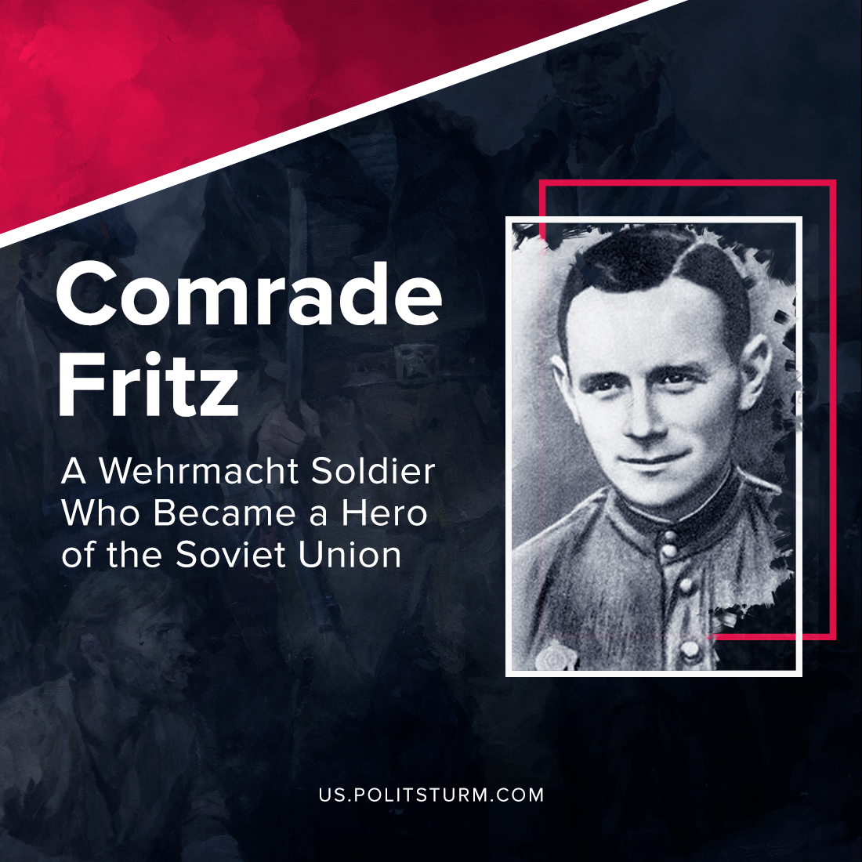

Original article
2021-12-28
8 min read

Fritz Schmenkel was a staunch Communist. His father, a supporter of the KPD, was killed during a fight with SA in 1932. Not surprisingly, Fritz, then barely 16 years old, had no warm feelings toward Hitler and his supporters. The young man had no intention to die for the Führer’s cause at all. He was drafted into the army in 1938, but did not serve long there. After two excommunication and propaganda against the government, he was sent to reformatory prison for two years.
In June 1941 Fritz was “re-educated”. He wrote to the director of the prison a request to leave his prison cell in order “to wash away the old sins” with his blood on the Eastern Front. He received the permission, and in October of that year lance-corporal Schmenkel found himself near Vyazma. He did not stay there for long. At the end of November, he took a small stock of dry rations, ripped shoulder straps off his uniform and left his unit without permission.
His way was to the east. Several weeks wandering through the surrounding woods, Fritz entered villages, knocked on huts and, waiting for the owners to open, uttered the only words he knew in Russian: “Lenin, Stalin, Telman”.
The locals were at first frightened of the strange German, but over time they grew accustomed to him. They fed him and sometimes let him stay overnight. For this, Fritz helped them in the household, thus thanking the villagers for their kindness and participation.
This went on until February 17, 1942, when he was detained by a German patrol in the village of Kurganovo. The squad officer had no time to deal with the deserter. He ordered the mayor to lock the fugitive in the barn, promising to pick him up in the morning and send him on his way.
But it turned out that in the evening, Kurganovo was occupied by a partisan detachment with the catchy name of “Death to Fascism”. Schmenkel had every reason to fear an encounter with the partisans no less than a chance encounter with his former comrades-in-arms. After all, according to rumors, the partisans did not take Germans prisoner, preferring to deal with them on the spot. And indeed, the first thing the squad members decided to do when they learned that a German deserter was hiding in the village was to shoot him without trial.
But then Fritz was unexpectedly interceded by the locals, who said he was a peaceful German who had done nothing wrong and was even helping them with household chores. The squad leader wondered: how could this be? A Wehrmacht soldier, and suddenly a good one? That could not be! Just in case, he decided to take the strange German with him. Later, we’ll see how peaceful he is.
The next day the guerrillas began examining the captured German machine gun MG-34. They were turning it this way and that, trying to understand how this thing was built and how it “worked”. Seeing this, Fritz silently approached them, quickly disassembled the machine gun and then as quickly assembled it. He showed them how to set up the sighting frame, replace the barrel and insert the magazine. After that, the question of shooting was not even considered. The German had not yet become an “insider” of the partisans, but they no longer considered him an enemy.
That same February, Fritz had to take part in the first battle against his former “comrades” from the Wehrmacht. After this, the partisans finally recognized him as “one of their own” and gave him a new nickname – “Ivan Ivanovich” or simply “Ivan”.
And he turned out to be a real gift of destiny for them. Wearing a German uniform, Fritz easily made his way into the location of German garrisons and units, obtaining invaluable information.
None of his comrades in the squad would have been able to cope with such dangerous work. Other guerrillas would have been exposed by their improper pronunciation and lack of knowledge of military regulations, whereas Schmenkel, who was born and raised in Germany, spoke German without the slightest accent and served in the Wehrmacht, had no difficulty in passing himself off as a German officer.
In August 1942, Fritz, dressed as an Oberleutnant, came to the village of Skerino and ordered the local police to follow him. A responsible operation was to be conducted and as many people as possible had to be gathered. He took the entire garrison from the village and led them directly to the partisans. None of the policemen managed to escape.
In October of the same year he repeated the same “trick”. He went out to meet a German cart laden with ammunition and food and sent it to the place where the partisans had set up an ambush.
The Germans soon realized that a deserter from their army was fighting for the partisans. The Gestapo, the SD, and the Feldgendarmerie searched for the defector, but time after time he managed to escape from under their noses. The Nazis put a large reward on the head of the traitor, but time passed and nobody came for it.
Meanwhile in March 1943 the Smolensk region was liberated from the occupiers and Fritz Schmenkel was in the Soviet Union. According to the laws of wartime he was “lighted” to be sent to a prisoner-of-war camp. But the intelligence service of the Soviet Western Front, realizing how valuable a “personnel” was in their hands, did not intend to refuse the “gift of destiny” that fell on them.
Error loading image
Yes, during the war there were many talented spies in the USSR, including recent graduates of the language school who had only recently left the walls of their native Alma Mater. But to turn a former Soviet student into a “German officer” is not an easy task. Even with perfect mastery of the German language, the agent could get caught because of a subtle accent, inconsistencies in the legend or lack of knowledge of German customs and habits of life in Germany. And here in their hands, one might say, was the perfect spy. It would have been a sin not to use him to carry out particularly important and secret operations.
Shmenkel was sent for training in an intelligence school and after its completion was included in a subversive-intelligence group “Polye”, which was to begin in the region of Orsha to carry out a special mission. Scouts were redeployed across the front line on the night of December 29-30, 1943. And though the transfer was successful, the group was never in contact with each other again.
Only in the summer of 1944, sorting out documents in the Gestapo chancellery, security officers found out what had happened to the Soviet spies. It turned out that they were caught almost immediately after crossing the front line. To the great delight of the Nazis, the very defector, whom they had been searching for so long, was also found among the group.
On February 15, 1944, the court-martial sentenced Corporal Fritz Schmenkel to death, and on February 22 this sentence was carried out. Before going to the place of execution, during his last confession, he had time to give a letter to the pastor for his wife and children, who had remained in Germany. Erna Schmenkel, upon receiving this farewell message, was afraid to keep it in her possession and burned it. But before the piece of paper went into the furnace, she managed to learn the lines written there by heart:
“Forgive me for the sorrow I have caused you. I have chosen my path and followed it to the end. I do not repent of anything, because I fought for a good cause. Take care of the children. Tell your grandmother and mother that I died shortly after my 28th birthday. Farewell. 22.02.1944”.
In 1964, after a petition from the Kalinin District Department of State Security, Fritz Schmenkel was posthumously awarded the title of Hero of the Soviet Union.

Original article

