Compensation For Top 0.1% Up 345% Between 1979-2019
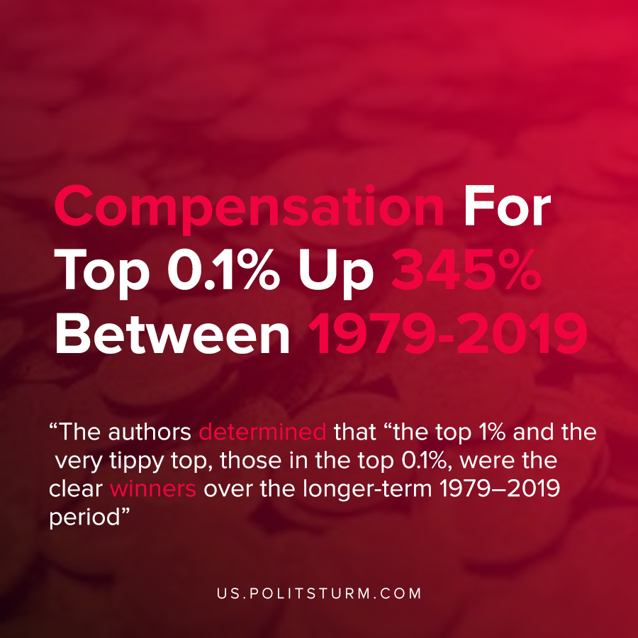

Original article
2020-12-10
1 min read

According to a recent release by the Economic Policy Institute, the wages for the bottom 90% of Americans have increased only 26% between 1979-2019. The wages of the top 0.1% increased by 345.2% over the same period because wages include the exercise of stock options and vested stock awards along with earned labor income.
The overall wage growth for the bottom 90% only took place over 11 of the 40 years that during the boom period of the capitalist economic cycle.
The authors determined that “the top 1% and the very tippy top, those in the top 0.1%, were the clear winners over the longer-term 1979–2019 period”.
The capitalist class who own the means of production are able to extract profits from production and experience exponential monetary growth off the labor of exploited workers. As such, their compensation from stock options and grants has soared while the workers incomes have grown much less over a long period of time.
The capitalist system will continue to serve the needs of the oligarchs until it is replaced by a socialist system that serves the needs of the workers and their class interests.
Source: 1

Original article

