Commemoration Day of Stalin
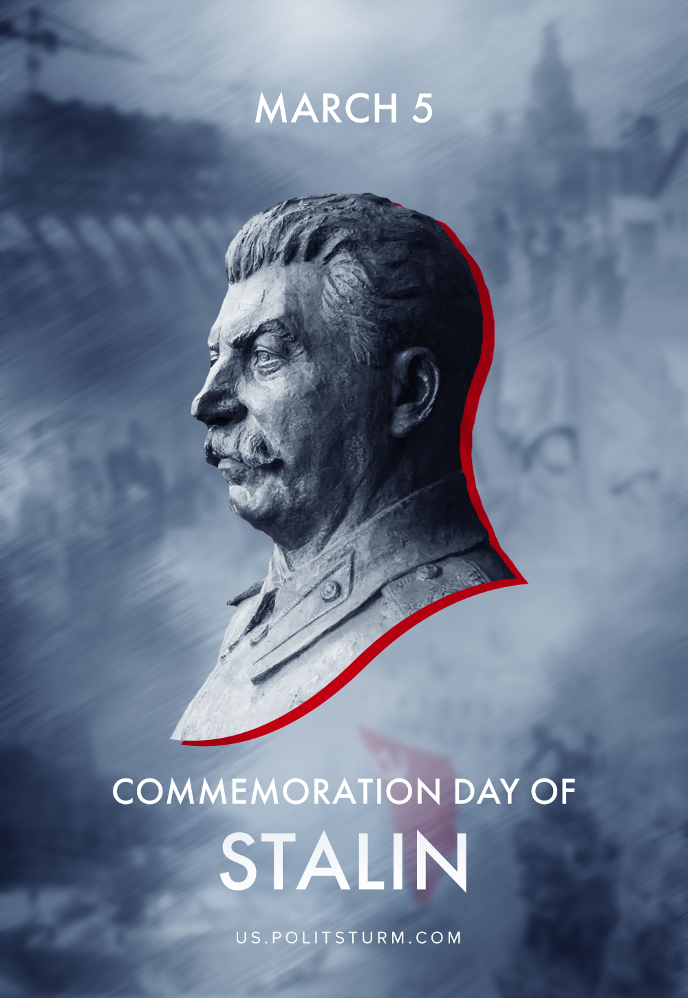

Original article
2020-03-05

On March 5, 1953, the heart of Joseph Stalin, one of the leading figures in the Communist Party and the Soviet Union, the leader of the international communist and labor movement, stopped beating.

Original article

