Colorado King Soopers Workers On Strike
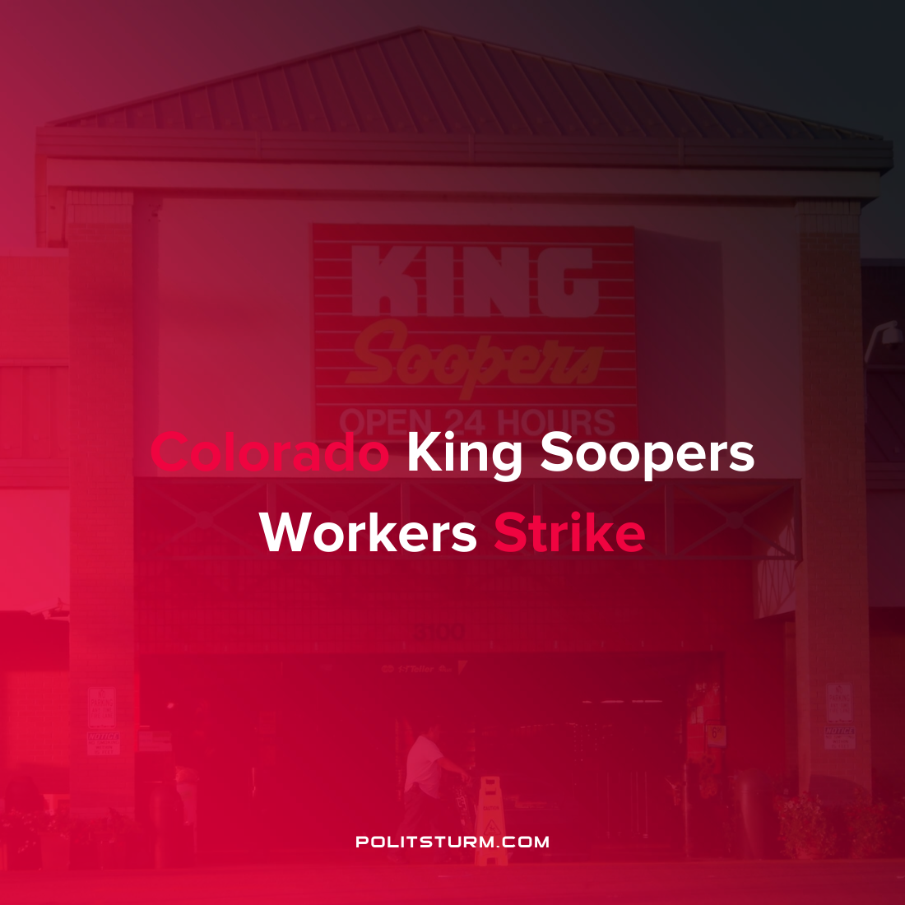

Original article
2022-01-14
1 min read

Thousands of King Soopers employees in Colorado went on strike after negotiations between the United Food and Commercial Workers Local 7 fell through. The grocery retailer gave its “last, best, and final offer” following which 95% of union workers voted to go on strike.
The union described the company proposal as “highly concessionary” with respect to the limited wage increase, a one-time sell out ratification bonus, and no improvements for worker safety. Under the terms of the proposal many workers would only see a wage increase of $1/hour with some increases as meager as 13 cents. For comparison, over the last year inflation increased by 7% which was the largest increase in prices since 1981.
The struggle between King Soopers executives and union representatives is yet another concrete example of the class struggle between the capitalists and workers. The capitalists, serving the interests of the shareholders and private owners seek to maximize profits by reducing costs including wage increases. While the capitalists rhetorically claim to be doing “what is best for [their] associates” their true interests lie in maximizing unpaid labor to pay out to investors and executives.
Source: 1 2

Original article

