Colombian Students Clash with Police During Protests
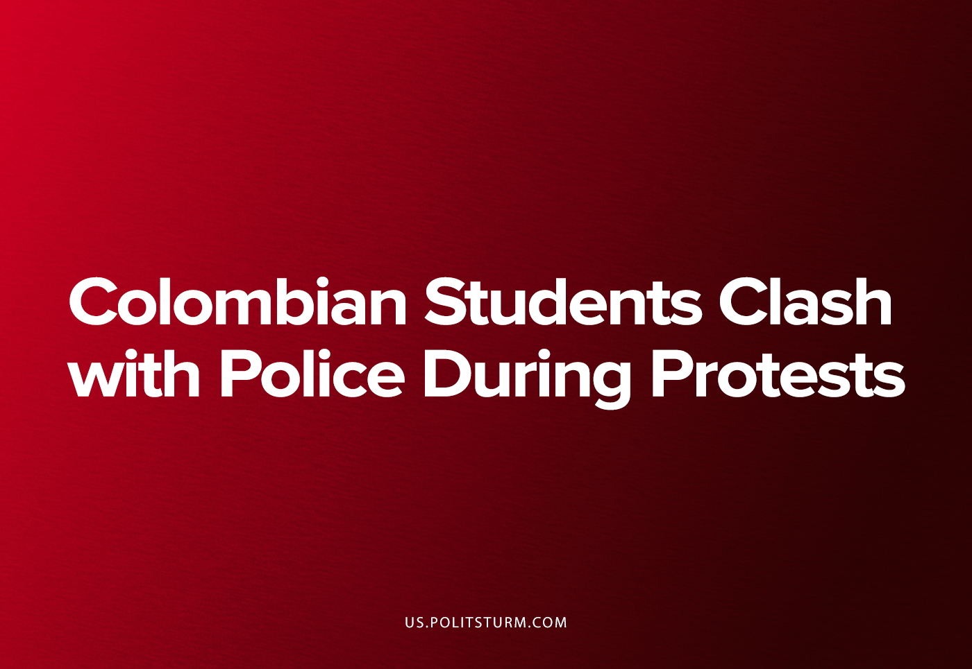

Original article
2023-04-26
5 min read

by Comrade César
In the second week of April the traffic in the Colombian capital was gridlocked around the evening rush hour by a type of event that became part of the political landscape many years ago. This was a mock-combat between the anti-riot police squad (ESMAD) and a group of masked university students [1], acting the part of those who use violence as a means of propaganda, those who believe that the political consciousness of the masses can be elevated by the public confrontation of a small group and the State forces.
Colombian state universities have some legal autonomy with regards to their own administrative and educational issues [2], and armed forces need either a judge’s permission or the presence of an exceptional threat to intervene in the campus of any university [3]. Even though this protection has not been fully respected since some university professors and students have been trialed and condemned without actual proof because of their criticism towards government policies [4], their investigations based on accusations commonly used in military propaganda and even their participation in legal protests for increases of the educational budget [6].
To show the other side, anti-riot police have a grim record of torture, brutality, and false-flag vandalism to justify their attacks. Against many indigenous protests for the recovery of productive lands, they have set fire to houses [7] and used machetes and firearms against protesters [8]. Their abuse record against peasant and civil strikers goes as far as robbing small traders [9], attacking journalists [10], and aiming their “non-lethal” weapons against the heads or the bodies of civilians [16], beating people to death [11], sexual abuse – both direct [12][13] and by ordering prisoners to rape detained protesters [14], and sending agents to infiltrate the protesters [15] in order to identify targets for future reprisals or to attack their own formations thereby obtaining an excuse disperse the demonstration. Within the context of the last national strike against the last reactionary government they shot gas canisters with mortars against homes [17] and the police used their trucks to transport civilian-clothed people with improvised weapons (possibly their own agents) between residential complexes to create the illusion of massive violent apartment assaults by the protesters [18] as a pretext for their repression. In almost all of these events, they used illegal ammunition against civilians; namely reused tear-gas cases stuffed with improvised shrapnel [19].
In a more general sense, we can see how anti-riot squads are used around the world as the spear-point of the interests of bourgeoisie against the general population when the disapproval of those interests is openly expressed. Those impositions generate a diverse means of resistance from video recording of police actions (that are being made illegal in many “democratic” countries), like the use of road blockades, diffuse or intermittent protests through the urban areas and physical protections against police projectiles. Colombia has not been unfamiliar with these resistance methods and the working masses have learnt how to use them in a coordinated and effective way. In addition, the very painful experience of police brutality and the collective defense against it, as in the case in the rest of Latin America in recent years, has elevated the organization and political consciousness of the workers to the point of the establishment of local independent assemblies and the realization into common consciousness of the dishonest alliance between the state, monopolist capitalists and the big press. Therefore we must ask, what role do these adventurist student groups play in the larger process of the workers fighting for their full interests and achieving class consciousness from that?
To answer this, we will return to the concrete situation described at the beginning of this article, the riots. Their real and immediate effect was the interruption of the traffic for around two hours, where the workers merely remained inside crowded buses with little air or space between passengers or else walk through the violent scene to pay for another bus ticket home. We can observe that neither the students nor any other social group supported the action of the radical group that engaged in that mock-combat, although that action was used as a pretext (as are many other actions of the same nature) for the Colombian reactionaries to express openly their support for the anti-riot squad and to draw a false equivalence between these groups and the critics of both police brutality and the fascistic party that supports the numerous aforementioned abuses for the sake of anti-terrorism.
It must be asked, what can these adventurist groups win through their actions? Nothing, even if they manage to loot police weapons, it will not really benefit the student movement nor the whole political advance among the masses. They are not defending any real mass activity from police aggression and if they “defeat” the squad they fought that would only encourage the State to greater and more sophisticated violence, including the Army, against the future manifestations of mass protest.
Now, what’s the origin of these groups? They come from several backgrounds: anarchism, Maoism, several left-wing eclectic movements and also from the active guerrillas which fight in the countryside. What do these seemingly disunited trends have in common? They all deny the fundamental role of both the proletariat and the Communist Party in the revolutionary process. Based on diverse reasoning: Anarchists dogmatically deny the need for centralization and discipline in both production and political activity. Maoists claim small proprietors (in place of the proletariat) should take the leading place in the revolutionary process (despite their class interest towards returning to pre-industrial economic conditions where they weren't ruined by large capitalists). Eclectics propose a pluralist abstract democracy beyond class contradictions. Guerillas suffer a historic isolation from the cities that kept their parent groups from understanding and correctly planning action within the current context (derived from Maoist deviations or a desire to imitate the 'Cuban', adventurist, state-capitalist experience). Additionally, other groups simply reflect their petty-bourgeois resistance against their imminent descent into the proletarian ranks, parallel to their disconnection with the actual workers’ struggle.
What can we learn from all this in the end? The same lesson Lenin acquired from the analysis of Russian terror in the bridge between the 19th and 20th centuries:
“[...] But the important point is that terror, at the present time, is by no means suggested as an operation for the army in the field, an operation closely connected with and integrated into the entire system of struggle, but as an independent form of occasional attack unrelated to any army. Without a central body and with the weakness of local revolutionary organisations, this, in fact, is all that terror can be. We, therefore, declare emphatically that under the present conditions such a means of struggle is inopportune and unsuitable; that it diverts the most active fighters from their real task, the task which is most important from the standpoint of the interests of the movement as a whole; and that it disorganises the forces, not of the government, but of the revolution. We need but recall the recent events. With our own eyes we saw that the mass of workers and ‘common people’ of the towns pressed forward in struggle, while the revolutionaries lacked a staff of leaders and organisers. […] In other words, the immediate task of our Party is not to summon all available forces for the attack right now, but to call for the formation of a revolutionary organisation capable of uniting all forces and guiding the movement in actual practice and not in name alone, that is, an organisation ready at any time to support every protest and every outbreak and use it to build up and consolidate the fighting forces suitable for the decisive struggle.”
V.I. Lenin, Where to begin?, 1901.
Sources: 1, 2, 3, 4, 5, 6, 7, 8, 9, 10, 11, 12, 13, 14, 15, 16, 17, 18, 19

Original article

