Coaching, Casinos, Network Marketing: How Capitalists Deceive People in Russia
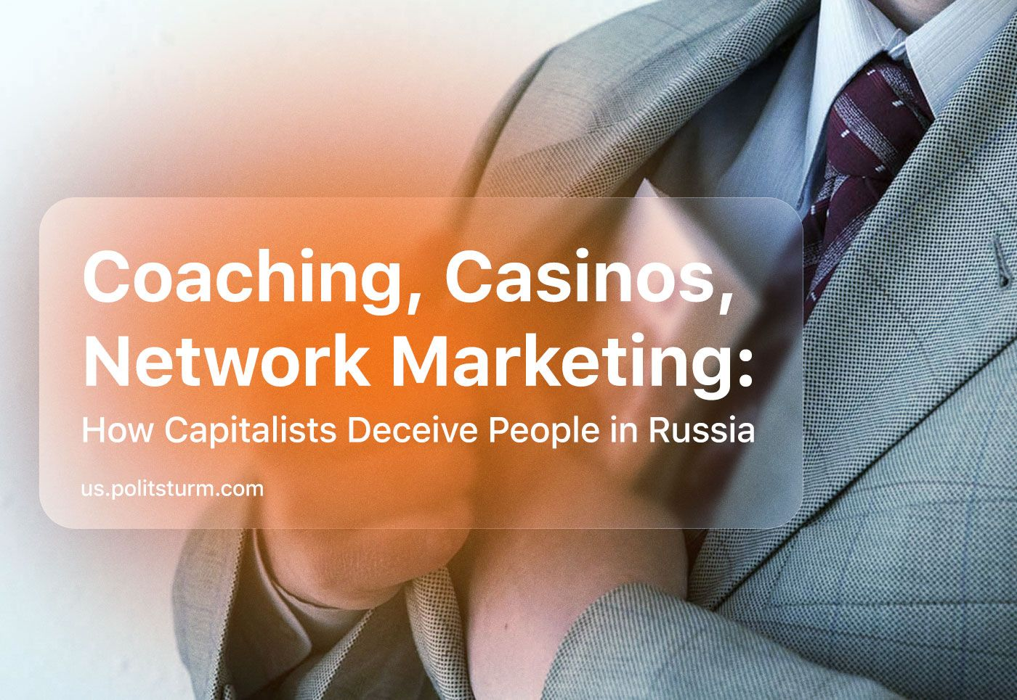

Original article
2023-09-16
18 min read

In the spring of 2023, the Investigative Committee of the Russian Federation opened several criminal cases against some “coaching” bloggers for tax evasion. The most famous of them is the case of Elena Blinovskaya, who was detained while trying to cross the border of the Russian Federation. According to the prosecutor's office, she did not pay 918 million rubles in tax to the treasury (9 476 128 $) [1]. Blinovskaya earned this money by selling business courses that had no significant practical value.
What forms of fraud are popular nowadays among Russians and why do people fall for outright swindles?

I. Modern Types of Fraud

1.1 “Infogypsy”
A common form of modern fraud is the so-called "Infogypsy". Usually, this not entirely correct term refers to people who sell training courses or other information products that supposedly help them achieve success in a particular area in a short time.
The term “infogypsy” implies the coach selling useless information and carrying out fraudulent activities. This term is associated with the ethnic stereotype of gypsies as manipulators who impose on the victim a product or service that they don't need and for which they must pay. While the term can be criticized as racist and xenophobic, it's the main name given to the Russian fake-coaches in Russia in everyday life.
The subject matter of the "Infogypsy" can be very different, varying from: business coaching, diets and fitness coaching, esotericism, psychology, etc. [2].
A well-known example of a typical "infogypsy” are the projects of the already mentioned Elena Blinovskaya. In particular, her "Marathon of Desires" or the "Expansion of Financial Consciousness" marathon.
“In fact, you need to allow yourself to earn money and lots of money, if you don’t allow this for yourself, you won’t have it ...” - with these words Blinovskaya invited people to the money marathon [3].
Valeria Chekalina and Artyom Chekalin are the authors of the “Money Marathon”. According to them, if you buy the course, your consciousness will change in a month, and you will be able to earn millions. But, according to customer reviews, apart from motivational speeches, bloggers do not give any actual practical advice. Chekalina herself (known as "Lerchek") organized fitness marathons, luring her followers to them with drawings of iPhones and expensive cars. Course buyers reported that they were being sold typical workouts and weight loss systems that are already available on the Internet. The Chekalins were also prosecuted for tax evasion. According to the Investigative Committee, they did not pay more than 300 million rubles (3 096 774 $) in tax [4].
In fact, such "training courses" are an eclectic mixture of banal motivational advice, "spiritual" practices and psychological manipulation, seasoned with esoteric illusions. Using social networks and large investments in advertising, “infogypsies” lure people who are in a difficult life situation with false promises to easily and quickly improve their lives.

Source: Sincerely Media / Unsplash
In reality, there are no special secrets of doing business, and magic rituals and self-hypnosis do not lead to concrete results. The real capitalist market is designed in such a way that people from already rich families are the ones who can easily achieve real “success”, if they have connections, through deceit, or directly through criminal means.

1.2 Online Casino, Sports Betting, Bookmakers
Another ‘industry’ of deception is online gambling. A vivid example of this industry is the “1xBet” betting company, one of the largest companies in Asia, Africa and Europe, registered on the island of Curacao in the southern Caribbean [5] [6]. 1xBet makes money by accepting bets on sports games, or cultural and social events. The site provides access to various gambling entertainments: a live casino, online games, sweepstakes, and virtual football.
In 2014, laws on licensing online bookmakers were introduced in Russia. The company did not accept the new rules and since 2015, the Federal Service for Supervision of Communication and Protection of Culture (Roskomnadzor) has blocked the “1xBet” website. However, the “1xStavka” website continues to operate in the country as a legal analogue of “1xBet”. Despite the formal ban, the fact remains that the company continues to accept bets from Russians using mirrors of its website. In 2020, the global turnover of 1xBet was estimated at $2 billion [7].
In 2019, the Sunday Times investigated 1xBet and revealed that the platform placed bets on children's sports and cockfights, as well as “pornhub casino” ads with topless female croupiers [8].
The alleged founders of 1xBet, Roman Semiokhin, Dmitry Kazorin and Sergey Karshkov, were put on an international wanted list and were hiding in Cyprus. On June 21, 2023, Karshkov died in Switzerland at the age of 42 during a medical examination. Prior to founding 1xBet, Karshkov headed the “K” department for combating cybercrime within the Internal Affairs Directorate for the Bryansk region [9].
Previously, Semiokhin and Karshkov argued that the business "does not have one owner." It is difficult to find one beneficiary because they hide behind offshore accounts issued in denominations or so-called "mass directors". Businessmen called their own brainchild a “platform”, “brand” or “product”, distributed according to the franchise principle and shifted the responsibility to the franchisees, who themselves decide how to work their franchise [10].
The gambling business acts, in fact, as a legalized form of deceit and robbery. The average person in most cases will not be able to get rich in a casino or other similar kinds of "entertainment".

The casino will always have the statistical advantage and earn on every bet, regardless of the winnings of some players. The more people play, the more the casino earns. The only ones who can afford this type of entertainment without serious consequences are the minority of the richest people in the world: for them, it is just one type of “leisure” and “entertainment”.

1.3 Financial Pyramids, Crypto-Pyramids, Network Marketing
Income in such fraudulent financial schemes is provided by constantly attracting new participants and their funds. The founders of the pyramid scheme attract investors with the promise of very high returns, but in the end, only the creators of the pyramid and a minority close to the top are the winners.
The most famous pyramid in Russia was “MMM” by Sergei Mavrodi. It was founded in 1989, and engaged in trading and financial activities. Having launched a large advertising campaign, he began to attract investors, promising more than a thousand per cent return.
By 1994, interest in buying “MMM” tickets began to decline, and so did the value of the company's papers. Millions of people went bankrupt; 50 of them ended up committing suicide. In 1997, “MMM” was declared bankrupt and abolished. However, all this did not prevent Mavrodi from continuing to create his next “financial networks”. In 2011, MMM-11, MMM-12 were created, and “MMM Global Republic of Bitcoin” was developed through the “Bitcoin” system [11].
The financial pyramid Finiko appeared in 2019 in Tatarstan. The company's founders called it "an automatic profit generation system". The service took money from depositors, converted it into bitcoin, transferred it to the company's internal crypto wallets and traded it on stock and cryptocurrency exchanges, promising depositors an income of 30% per annum or even as much as 5% per day. Finiko's user agreement stated: "The company is not responsible for any losses incurred by the client when using the system".

Source: RBC
Neither the reliability of the information nor the security of the services provided by the company was guaranteed. Soon after, the company stopped all payments to customers. In 2020, a criminal case was initiated against the organizers of the pyramid scheme. In 2021, the Central Bank blacklisted Finiko [12] [13]. The official damage caused by the scheme was estimated at 179.6 million rubles [14].
Despite the fact that numerous experiences demonstrate that bankruptcy is a natural result of the existence of any financial pyramid, many people still continue to give money to such newly emerging organizations [15]. Most victims, even though they are aware of the risks, still hope that they will be able to exit early and make a profit. One thing is obvious: Only the creator himself can get out of the financial pyramid in time.
Network marketing, or "multi-level marketing," is a system in which a company contracts individuals to sell a set of products and they themselves can recruit other people and receive commissions from the sales and "newbies" recruited. Thus, a network of "independent" sellers-couriers is created, each of whom is interested in expanding the staff and all are engaged in delivering advertising booklets and the goods themselves to potential buyers.
An example of a popular network marketing firm in Russia is NL International. It is engaged in the sale of "functional nutrition", cosmetics and household chemicals. The company lures people with promises of high earnings after a few months of work without any investment, as well as gifts from the company for the most successful sellers - for example, a supposedly free Mercedes car.
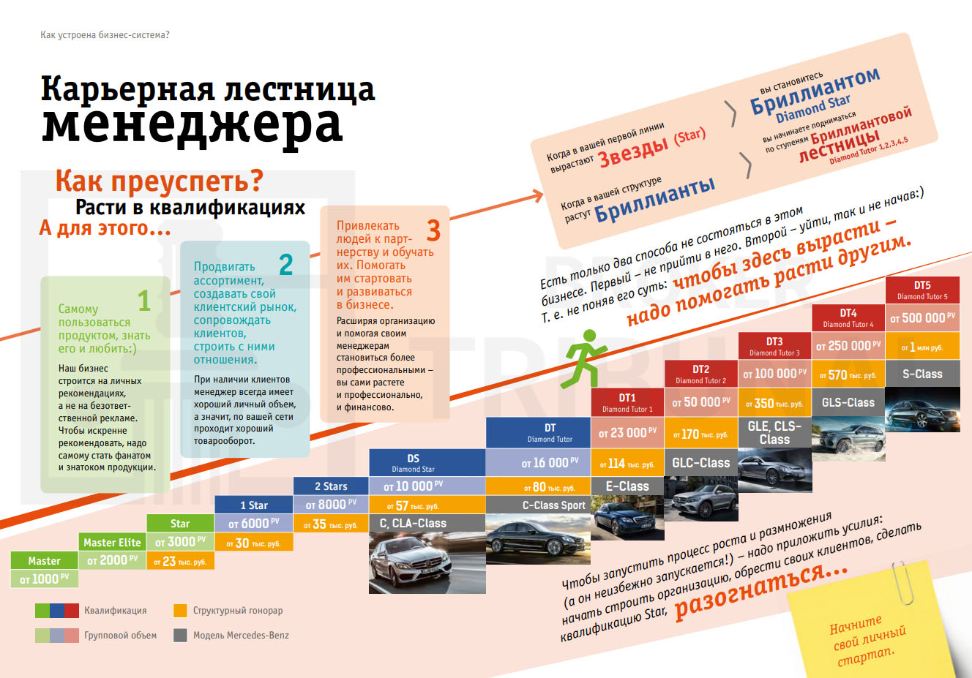
The NL manager career ladder chart promises 'great success'
In NL, one can become a consultant. For this one needs to get a "mentor" who cannot be changed, but they can be chosen by the candidate, and during the test period one must purchase 70 PV of the company's products per month. PV is NL's own unit of turnover, earned from the sale of a product. 70 PV equals approximately 8,000 rubles. It turns out that sellers are also mostly consumers themselves.
If the seller does not buy goods worth the required amount of 70 PV per month, then the company will cancel the seller's contract. As we can see, the promise of earning "without investments" was just an empty phrase. As for the “free” Mercedes car, according to employees, they do not give it as a gift but mortgage it up on credit to the employee themselves, and if it is not possible to keep up the payments for the car on the turnover made by the employee, the employee must pay the loan with their own money [16].
One of the arguments against comparing network companies with "classic" financial pyramid schemes is the assertion that they work with "real goods". Nevertheless, it was worth delving a little into the specifics of the work - and it becomes clear that, despite some differences, this new name, in fact, hides the same fraudulent essence as financial pyramid schemes.

II. Why Do People Trust Scammers?
Often the answer to this question is sought in the psyche and consciousness of the victim. It is argued that people go to scammers because of their belief in a magical way to get results without investing labor, or because of poor education or a low level of "financial literacy" [17].
There is a point of view that considers that the problem is purely in the legal field - i.e. for informational education, online casinos and “blogging”, and that competent laws and reforms have not been introduced. For example, the main claim of the state in relation to the Blinovskaya case does not come down to the essence of her activities, which is built on clearly manipulative and anti-scientific foundations, but only to the legal side of the tax issue. Moreover, she purposefully formally split the business and paid taxes according to the simplified scheme of an individual entrepreneur, which was valid for an income of no more than 150 million rubles per year, while Blinovskaya had a significantly higher income.
But if there had been a corresponding reform regulating this practice, and Blinovskaya paid taxes "according to the law", then there would have been no questions about her activities - she would have been an "honest" entrepreneur selling a "specific", "unique" product. The state makes similar claims in relation to bloggers, bookmakers, and other similar activities [18] [19].
Of course, there are psychological and legal aspects, but in reality, they are only the tip of the iceberg, a manifestation of economic processes.
Fraud, as a type of crime, is a social phenomenon that arose and was conditioned by a certain historical stage in the development of society, namely, class society. To determine the causes of fraudulent activity, it is necessary to take into account a number of social phenomena in conjunction with the material, economic and ideological conditions of life. This also includes the study of the subjective mental characteristics of a particular person, but it is important to understand that essential personality traits are formed and changed under the influence of the material conditions of a person's life and upbringing.
We are now living in the era of capitalism at its final stage – imperialism, or monopoly capitalism.
For capitalist countries, crime is a characteristic, inalienable feature of life and not an exception to the rule. This is because the basis of capitalism is private ownership of the means of production and the exploitation of the labor of the majority of workers by a minority of large private owners. These material, economic conditions inevitably give rise to inequality, the desire for gain, selfishness, neglect of others, the "cult of success", ideas about "easy money", and in general an idealistic worldview.

Source: Forbes.ru // shot from the movie "The Wolf of Wall Street"
The contradictions of capitalism are especially acute during crises. Difficult economic conditions encourage some to look for any and all tricks, to use deceit and manipulation to make a profit. While others befuddled with ideas about a "successful life" and faith in "fortune", give money into the hands of scammers who promise mountains of gold.
Some may object: there are people who actually made money on exchange rates and speculation, or those who say that the courses of "infogypsies" personally helped them. But it is worth asking questions: at whose expense this “success” is ensured and does the life of the majority of the population get better from this?
All real wealth and all products necessary for the life of society are created, first of all, by the majority of working people in the sphere of material production. Under capitalism, the part of the social product created by the unpaid wage labor of workers in excess of what is necessary for their reproduction is a surplus product, acting in the form of surplus value under capitalism, which is appropriated freely by the large owners of the means of production on the basis of private property rights. Thus, the source of capitalist profit is the unpaid labor of the majority of wage workers.
“Infogypsies”, bloggers, and online casino players are a minority of the population, participating only in the redistribution of a part of the surplus value (profit) produced. They therefore are in fact, a parasite on the body of society, living off the impoverishment of the majority.

III. A Real Way to Improve Living Standards
The complete destruction of the roots that give rise to poverty and the conditions under which swindlers are given the opportunity to deceive people will occur only after the transition to a more historically progressive stage of social development – socialism.
In a socialist society, with the establishment of public ownership of the means of production, the abolition of the exploitation of man by man, and the transfer of power into the hands of the working class, a real material basis is created for the eradication of poverty and fraud as a social phenomenon.
Socialism is only the first step in the development of communist society. In this regard, some problems are not yet completely eliminated. But the reasons for their existence are no longer in the economic basis, but in the remnants of capitalism that exist in various social areas, in everyday life, in the minds and psyches of people.
In the course of the struggle against the remnants of the old society, a new advanced worldview, ideology and culture will be formed. Socialism creates conditions for free access for the majority of the population to work and education, raises science to a higher level of development and gradually introduces its achievements into production and into all social spheres.
Only by embarking on the path of socialism, with the transfer of power into the hands of the working people, is it possible to destroy fraud, poverty, and the idealistic and parasitic world outlook all endemic to capitalism. For a correct understanding and assessment of practical actions, it is necessary to study Marxist-Leninist theory: only in this way can a real improvement in the standard of living of the majority of the population be achieved.

Sources:
[1] RBC: Blogger Blinovskaya was detained in the case of non-payment of taxes for ₽918 ml — From April, 2023
[2] Lenta: Millions of Russians become victims of infogypsies. Who are they and how can you prevent them from deceiving you? — From November 18, 2022
[3] Lenta: “Good business of infogypsies” Blogger Elena Blinovskaya earned billions of rubles. Why was the “marathon queen” detained? — From April 28, 2023
[4] RBC: The Investigative committee opened a case against blogger Lerchek Chekalina and her husband — From March 7, 2023
[5] Kommersant: Betting company 1xBet — From December 12, 2019
[6] Kommersant: 1xBet Review: How the bookmaker works — From January 18, 2019
[7] Forbes: Secrets of the Bryansk Las Vegas: who is behind the most mysterious bookmaker on the Russian market — From December 9, 2020
[8] SportBusiness: «1XBet suspended in UK after Sunday Times investigation» — From August 12, 2019
[9] Forbes: 1xBet Founder Sergey Karshkov Died — From June 21, 2023
[10] Forbes: “It would be boring here without a criminal case”: how 1xBet organizers live in Cyprus — From December 29, 2021
[11] Lenta: Three funny letters: Sergey Mavrodi announced the creation of a new MMM — From January 11, 2011
[12] Forbes: The second after MMM: how the Finiko financial pyramid worked — From August 18, 2021
[13] Kazanfirst: The Central Bank recognized Finiko as a financial pyramid, and Kirill Doronin is now officially a charlatan — From June 2, 2021
[14] RBC: Media: damage in the Finiko pyramid case decreased to 5 billion to ₽179.6 million — From December 9, 2022
[15] Forbes: The Central Bank estimated the losses of Russians from participation in financial pyramids — From July 8, 2022
[16] Smartguide: NL International - Overview
[17] RBC: The illusion of success: the cost of online courses and marathons is growing in Tyumen — From April 19, 2023
[18] RBC: The Federation Council will propose to introduce taxation for bloggers — From May 24, 2023
[19] RBC: Lawyers called the main claim of the tax authorities to bloggers — From May 4, 2023

Original article

