The Climate Crisis: How Capitalism Destroys the Earth
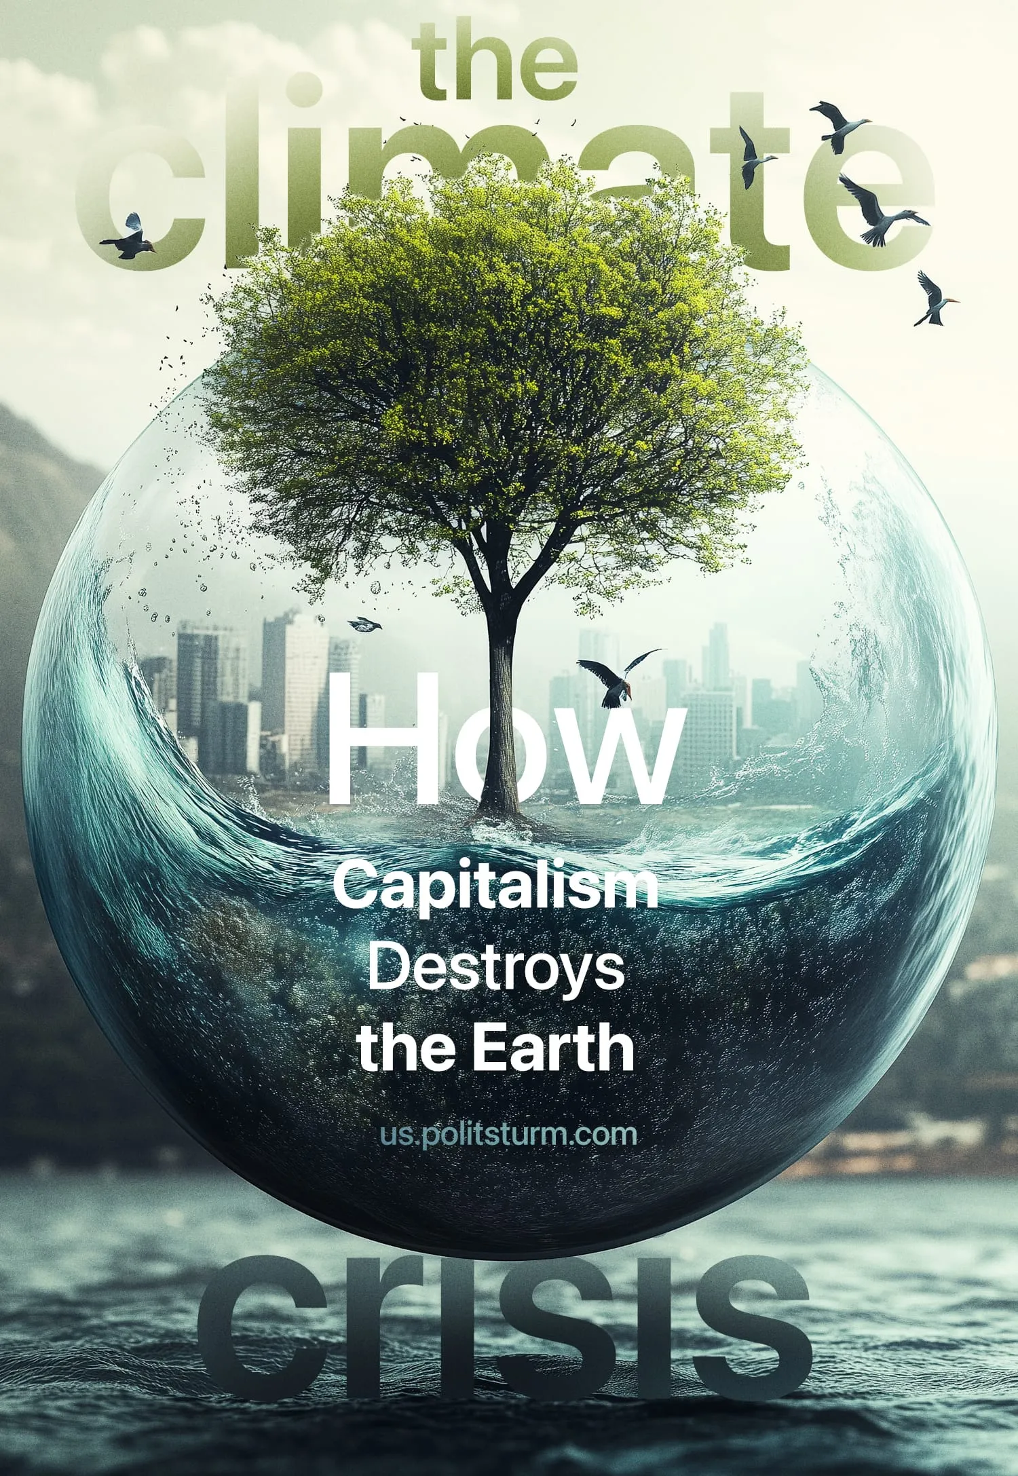

Original article
2024-12-14
42 min read

Nature and humanity are inseparably bound together. To abstract one from the other is to fall into confusion, for humanity itself is a product of nature. Yet under the capitalist system, this bond appears violently severed. A profound rift has been exposed between capitalism and the natural earth on which it depends. The environmental crisis is no longer a distant theoretical threat; we are witnessing the beginnings of its horrors today.
In the 'lungs of the earth', the Amazon rainforest, once a crucial carbon sink, deforestation for resource extraction and agriculture has caused areas to emit more carbon and greenhouse gases than they absorb [1] [2]. The Arctic is losing ice at a devastating rate of 13% per decade. As the permafrost melts, methane is released and creates a deadly feedback loop [3]. The world's coral reefs, which cover just 0.2% of the seabed but support a quarter of all marine life, are dying en masse. The Great Barrier Reef has already lost more than 50% of its coral cover [3]. This is just a scratch on the surface of the huge changes our planet is experiencing.
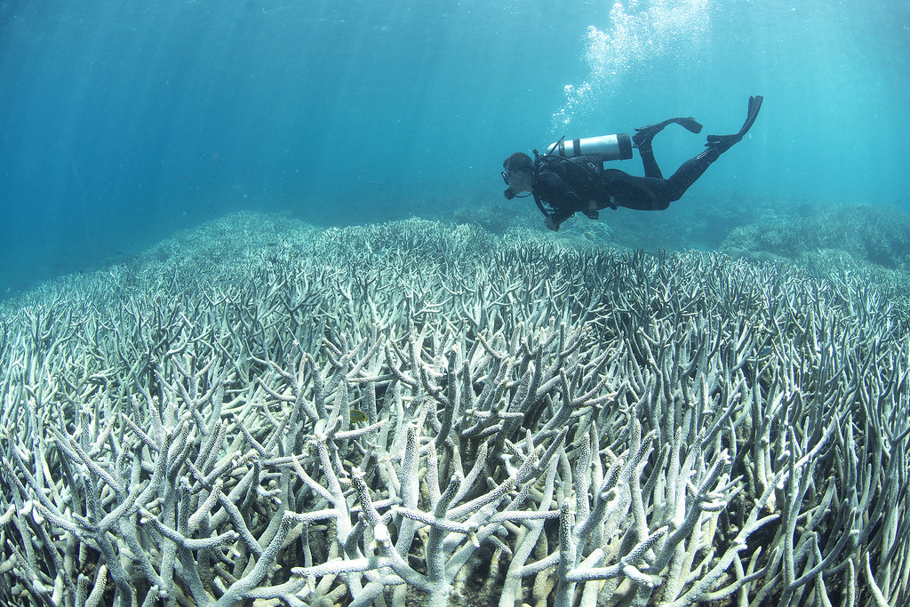
A photo of bleached corals. Source: The Ocean Agency
As a result of dramatic environmental changes and the rapid exploitation of the land, life on Earth is unable to keep up. There is now a growing consensus in the environmental sciences that we are living through the so-called Six Mass Extinction [4].
There is scientific debate about the exact rate and classification of mass extinctions, but there is consensus on the "big five". The previous 5 were due to "natural" causes, the current one being the exception, where it is generally accepted that it is "man-made" in the abstract, apart from the claims of a few reactionary scientists, who claim it too, is “natural” [5].
The world is now permanently losing species at an estimated rate of 100 to 1000 times the natural background rate of extinction, mainly due to deforestation, habitat destruction, overexploitation of natural resources, pollution, invasive species and climate change [4].
This raises a critical question: What is driving this destruction?

The Science Of Climate Change
The fundamental process behind climate change is the greenhouse effect. The Sun is the primary source of energy for the Earth's climate; some of the incoming sunlight is reflected back into space, especially by bright surfaces such as ice and clouds, while the rest is absorbed by the Earth's surface and atmosphere. Some of the absorbed solar energy is then re-emitted as heat; the atmosphere in turn absorbs the heat and distributes it in all directions, some of which escapes into space. "Greenhouse” gases such as carbon dioxide (CO₂), methane (CH₄) and nitrous oxide (N₂O) trap additional heat, making the atmosphere more effective at preventing heat from escaping to space [6].
This natural greenhouse effect keeps the Earth's surface and lower atmosphere warm, without which the complex forms of life and the web of relationships that bind them together could not exist as they do. At the same time, the burning of fossil fuels and deforestation have dramatically increased the concentration of greenhouse gases released into the atmosphere. This man-made phenomenon is known as the enhanced greenhouse effect [6].
Since the Industrial Revolution, atmospheric concentrations of CO₂ have increased by more than 40%, significantly accelerating global warming [6] [7]. As a result, the global average temperature has already risen by more than 1°C compared to pre-industrial levels. This increase has triggered a wide range of environmental impacts as discussed above, including more frequent and severe weather events. A notable example is the recent Hurricane Helene, whose rapid intensification has been attributed to warmer ocean waters [8].
The Earth's climate, like everything else, is in a constant state of change. Over millions of years, the planet has undergone many natural changes, such as the various ice ages. These natural cycles cause the climate to alternate between periods of warming and cooling. Examples of such cycles include the Earth's orbit and axial tilt, volcanic activity, solar radiation and the movement of tectonic plates [9]. It should be noted, however, that natural changes usually occur over thousands or millions of years, giving ecosystems time to adapt. Even the most catastrophic previous extinction event lasted an estimated 8,000 to 100,000 years, the blink of an eye in geological terms, but a long time for life itself, spanning many generations [10].
This brings the current crisis into focus: the speed of “human-induced” climate change is unprecedented. Unlike natural changes that took place over thousands or millions of years, today's changes have occurred in just a few centuries.

The Cause of the Current Climate Crisis
So what is causing the climate crisis? The most basic educational resources on climate change trace it back to around 1750 during the Industrial Revolution when greenhouse gas emissions began to rise due to the use of fossil fuels to power machinery [9]. It has long been recognised that modern climate change is closely linked to everyday capitalist industrial practices. Let's assess some of these practices.
The relentless burning of fossil fuels to generate energy for production and manufacturing is the backbone of modern capitalist industry and commerce. As outlined in the previous section, the extraction and use of non-renewable energy sources - coal, oil and gas - releases vast quantities of carbon dioxide and methane into the atmosphere, the two main greenhouse gases. Around 90% of global CO₂ emissions come from the use of fossil fuels and industrial processes such as cement production. The remaining 10% comes from land-use change, mainly carbon released from trees and vegetation through deforestation [11].
The effects of monopoly are evident here too. Just 20 fossil fuel companies are responsible for about 35% of all energy-related CO₂ and methane emissions worldwide, totalling 480 billion tonnes of CO₂ since 1965. These companies are both state-owned and publicly traded, such as Saudi Aramco, ExxonMobil, Chevron and BP [12].
Transportation is another major contributor to greenhouse gas emissions, accounting for approximately 24% of CO₂ emissions [13]. International shipping alone, which is the backbone of global commerce, accounted for about 2.2% of global CO₂ emissions in 2018 and is projected to grow between 50 and 250% if no action is taken [14]. The aviation industry is unique since, although only making up 2.5% of global CO₂ emissions, it has outsized impacts due to its high altitude, which exacerbates global warming more than ground-level emissions [15].
In Brazil, land-use change is the main driver of emissions from deforestation in the Amazon rainforest, even though the country has a very clean electricity grid, mostly from hydropower [11]. Under capitalism, nature is commodified and exploited for maximum profit. This leads to unsustainable and decentralised practices as different capitalist interests tear up the earth. Logging, cattle ranching, and monoculture agriculture - particularly for products like palm oil and soy - drive widespread forest loss. Between 2001 and 2020, the world lost over 488 million hectares of tree cover, an area larger than India [16].
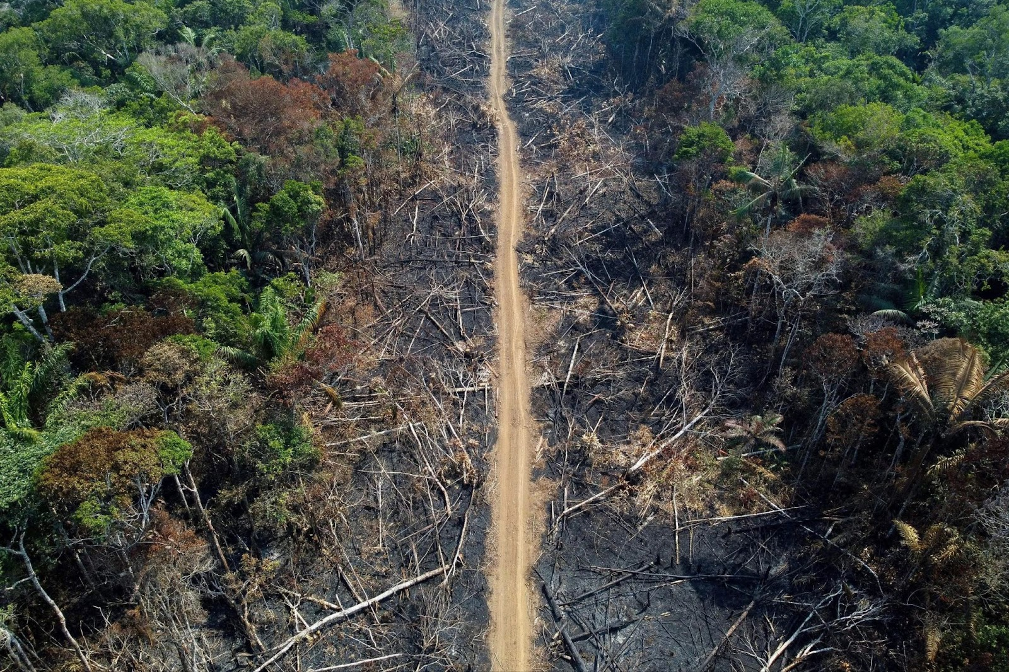
Amazon rainforest deforestation “clear-cut”. Source: WGOQatar
The consequences of deforestation extend beyond carbon emissions. Forests are home to more than 80% of terrestrial species [17], and their destruction leads to a cascading loss of biodiversity. The loss of biodiversity undermines critical ecological functions and relationships, such as pollination, seed dispersal, and population control, which are essential for the stability of natural systems and also agricultural productivity. The loss of forest cover exposes soil to erosion and nutrient depletion, rendering land increasingly infertile.
Marx long ago showed how capitalist production affects soil quality [18]:
“Capitalist production, by collecting the population in great centres, and causing an ever-increasing preponderance of town population, on the one hand concentrates the historical motive power of society; on the other hand, it disturbs the circulation of matter between man and the soil, i.e., prevents the return to the soil of its elements consumed by man in the form of food and clothing; it therefore violates the conditions necessary to lasting fertility of the soil.”
Another material that 'cannot return to the soil' is plastic, the use of which has become widespread under capitalism because of its low cost and wide range of uses. Plastics also have disastrous environmental consequences. In 2021, 139 million tonnes of single-use plastics were produced, 6 million tonnes more than in 2019 [19]. Perhaps more telling is the fact that 79% of all plastic ever produced is still in landfills or in the natural environment, excluding the small amount that has been incinerated or recycled. When plastic sits in landfills, it breaks down into tiny toxic particles that also contaminate soil and waterways, where they are ingested by humans and other animals [20]. Plastic also ends up in the ocean, with an estimated 171 trillion pieces of plastic now floating in the world's oceans [21].
Capitalism has also given way to large-scale industrial dumping. The methods used prioritise cost savings over environmental safety. Toxic waste and sewage are often dumped into rivers, oceans and other ecosystems, often with the complicity of capitalist states. In 2017, for example, US President Donald Trump signed an executive order weakening the Clean Water Act, allowing corporations to dump pollutants into waterways with minimal oversight [23].
For all these issues - greenhouse gas emissions, deforestation, ecosystem collapse, plastic use and industrial waste - there are plenty of solutions that already exist (and do not rely on far-fetched future technology). For fossil fuels, there are renewable and clean energy sources such as nuclear, solar, wind, geothermal and hydro. For transport, there is the development of public transport, high-speed rail and electric or hydrogen technology. For deforestation, there are many ways to reforest and expand forests, large-scale tree planting and strict regulations. This will both help as a carbon sink and restore stability to ecosystems. For plastics and waste, a transition can be made to biodegradable and compostable alternatives that already exist and recycling infrastructure can be improved through strict waste separation and modern technology.
So, how does modern capitalist science explain this crisis? It seeks to obscure its real causes by blaming abstract factors such as 'overpopulation', general (class-blind) 'human activity and development' and individual lifestyle choices, rather than the current economic system, and when targets are missed or sidelined, the blame is typically placed on economic hardship or political discord. These explanations, promoted by capitalist institutions and their ideologues, focus on vague, class-blind and depoliticised causes, shifting the blame onto humanity as a whole or, in the most reactionary cases, naturalising the crisis as inevitable.
One of the most common explanations is the neo-Malthusian claim that overpopulation is the primary driver of environmental degradation. This argument, rooted in the ideas of Thomas Malthus, an 18th-century cleric, suggests that humanity’s growing numbers are placing unsustainable demands on finite resources. Reports like the World Bank’s 2013 assessment reflect this perspective, arguing that population growth in developing nations exacerbates climate change [24]:
“While developed countries are largely responsible for global warming, the brunt of the fallout will be borne by the developing world, in lower agricultural output, poorer health, and more frequent natural disasters. Carbon emissions in the developed world have levelled off, but are projected to rise rapidly in the developing world due to their economic growth and population growth—the latter most notably in the poorest countries. Lowering fertility has many benefits for the poorest countries. Studies indicate that, in high fertility settings, fertility decline facilitates economic growth and poverty reduction.”
Many eco-activists and bourgeois conservationists share this view. For example, the renowned naturalist and documentarian, David Attenborough has said “In the long run population growth has to come to an end” and broadcast it to millions of viewers [25]. He even directly praised Malthus [26].
These types of analyses often advocate for eugenics in the form of “population control” measures as does the World Bank’s assessment, which conveniently shifts blame onto the poorest regions of the world while ignoring the fact that the “high-carbon emission” developed countries have ensnared the poorest regions through relations of imperialist dependence.
Modern capitalist science has no interest in understanding the objective economic processes that have determined the historical development of society. If it did, it would be forced to show that the capitalists are now an obstacle to the historical development of humanity.
In this sense, it becomes clear why other bourgeois scientists promote a mechanistic understanding of human development. They claim that human development/nature is immutable and unchanging, simply a "mechanism" that plays itself out, ignoring the class struggles that have changed and shaped society. This method essentialises the blame equally between exploiters and exploited, between workers who have no say in production and capitalists who have all the say.
A 2022 paper on the sixth mass extinction by Robert H. Cowie, Phillippe Bouchet and Benoît Fontaine [27] promotes the mechanistic view, saying in their section defining the extinction:
“Avise et al., (2008) characterised these [the first expansion of modern humans out of Africa, The neolithic revolution / development of agriculture and the industrial revolution] as the three phases of the Sixth Mass Extinction, implicitly including all human-caused extinctions, and considering the status of biodiversity now to have reached a crisis point. We concur with Avise et al., (2008) in considering the Sixth Mass Extinction, should that be what the current crisis becomes, to include all anthropogenic extinctions”
These explanations are not just flawed or naive, they are dangerous. They depoliticise the crisis, framing it as an unfortunate byproduct of human existence rather than a natural consequence of the inherent contradictions within the capitalist system that drive this crisis forward and in doing so, protect the privileges of the ruling class.
Now, with this in mind, it begins to become clear why the implementation of the already abundant solutions are not implemented. But let us clarify further by breaking down some of these inherent impulses of a capitalist economy.
Marx stated in the preface to "A Contribution to the Critique of Political Economy" that [28]:
“Mankind thus inevitably sets itself only such tasks as it is able to solve, since closer examination will always show that the problem itself arises only when the material conditions for its solution are already present or at least in the course of formation.”
In other words, if humanity with its highly developed productive force can now rapidly alter the Earth's climate, we also possess the same force required to alter it for the better. So why does this not happen? Because the productive forces have outgrown the now long moribund relations of production. The productive forces are internationally social in character but the relations are still of private capitalist interests.
Under capitalism, the thesis that "human activity is to blame for climate change" is only partially true. The control of production and consumption is in the hands of the capitalists, who, due to the competitive conditions of the market, delay the implementation of any real measures because of the potential corporate economic disadvantages that such measures might entail. These interests are materially demonstrated in the huge funding that still goes to climate denial think tanks and the continued subsidies given to the fossil fuel industry globally. In 2013, a study concluded that $1 billion was spent annually to advocate climate denial [29].
In contradiction to Malthusian claims of overpopulation, food and resource production have long outpaced population growth. The competition between capitalists leads to a crisis of overproduction, in which the size of the market has fallen behind the rate at which commodities are produced. This means markets seize up as capitalists fail to sell their products to impoverished workers who cannot afford them. This results in mass layoffs of workers as capitalists try to save their businesses and the destruction of many perfectly good commodities in an effort to drive prices back up.
In the age of imperialist (monopoly) domination, the market has expanded to every corner of the world and only remains to be re-divided among different capitalist interests. Under such conditions, economic crises lead to conflicts as different capitalist blocs try to seize each other's markets in order to temporarily quell the crisis and drive up prices with new demand. The impact of war on the environment and any possible climate strategies is undeniably terrible.
The anarchy of production caused by the private appropriation of the now colossal socialised productive power is one of the essential problems that causes capital to wreak havoc on the earth (and the workers) on which it depends: under private property relations, the 'sustainability' of production can only manifest itself as the sustainability of profits and the expansion of production. Ultimately, capitalists are incapable of consciously controlling production; the relations of capital and the impersonal objective forces embodied in it control their decisions, production and the subsequent effects on nature.
Engels, in his incomplete work “Dialectics of Nature” expressed this clearly [52]:
“the individual manufacturer or merchant sells a manufactured or purchased commodity with the usual coveted profit, he is satisfied and does not concern himself with what afterwards becomes of the commodity and its purchasers. The same thing applies to the natural effects of the same actions. What cared the Spanish planters in Cuba, who burned down forests on the slopes of the mountains and obtained from the ashes sufficient fertiliser for one generation of very highly profitable tropical coffee trees—what cared they that the heavy tropical rainfall afterwards washed away the unprotected upper stratum of the soil, leaving behind only bare rock!”
Under such conditions, let's now assess the “solutions” the capitalists come up with.

The Capitalist Solution
In 1977, ExxonMobil, one of the world’s largest oil corporations, became aware of climate change through its own research. The company hired leading scientists to investigate, collecting empirical data on carbon dioxide and developing models that predicted the trajectory of global warming. Yet, rather than act on these findings, ExxonMobil suppressed the information and actively funded think tanks that propagated climate change denial [30]. This is one of the ways capitalism has responded to the crisis.
As the scientific consensus on climate change grew, capitalist states and corporations could no longer ignore the issue and began to address it more openly. However, the capitalist class could only support "remedies" that preserved its position. So they promote market-based "solutions" that operate within the narrow framework of private capitalist property and competition, again obscuring the root of the crisis. This deception can be seen in the superficial climate summits and meetings convened by the capitalist states in recent decades.
These events have become known to actually host and facilitate fossil fuel deals between capitalists. At COP29 in 2024, a secret recording showed Elnur Soltanov, a senior official of the event, discussing "investment opportunities" in the Azerbaijani state oil and gas company with a man posing as a potential investor [31].
At these international climate summits - such as the COP conferences, the G7 and the UNFCCC meetings - capitalist representatives make a grand show of acknowledging the scale of the crisis and lamenting inadequate progress, "condemning" excessive fossil fuel profits, climate inaction and missed targets. Public figures like UN Secretary-General António Guterres issue urgent calls to action, as seen in his statement [32]:
“We do have a choice: Creating tipping points for climate progress – or careening to tipping points for climate disaster. This is an all-in moment. The United Nations is all-in – working to build trust, find solutions, and inspire the cooperation our world so desperately needs. It’s We the Peoples versus the polluters and the profiteers. Together, we can win.”

The United Nations Secretary-General Antonio Guterres on November 6, 2023. Source: Middle East Monitor
However, these emotive appeals serve to mask class contradictions and present the crisis as a purely moral issue. These summits lay bare the impotence of the capitalist state in the face of capital itself. Far from a neutral body standing "above" class antagonisms, the state was historically developed as a means for the ruling class to maintain control of the exploited lower classes.
The state, as Marx and Engels outlined, is not an impartial "God-given" entity that serves all citizens equally. Instead, it arose naturally to maintain order as society divided into antagonistic economic classes, ensuring that the exploiting minority could control the exploited majority. This control, exercised through special bodies of armed people and institutions such as the police force and prisons, was essential to prevent the exploited from overthrowing their exploiters. The state has thus played a historically necessary role in the development of productive forces but always as an instrument of class rule.
Climate summits like COP often conclude with necessary targets to be reached, such as those set in the Paris Agreement in 2015, which sought to keep the global average temperature increase “well below 2°C above pre-industrial levels” but ideally limit it to 1.5°C [32], a figure well known to scientists as a “tipping point” which will cause a domino effect, triggering other tipping points and rapidly changing the earth's climate [34].
These goals remain largely aspirational, as these summits rely on market mechanisms. Let us assess some of these "solutions":
The Nationally Determined Contributions (NDCs) agreed under the Paris Agreement are voluntary emission reduction targets submitted by each country. These pledges are not enforceable, allowing countries to set and adjust targets based on political and economic considerations. Many of them also rely on future technologies, such as carbon capture, which remain underdeveloped and, ironically, are currently being used in oil extraction to make it more efficient through a process called enhanced oil recovery (EOR) [35].
There is strong support at the summits for carbon markets and emissions trading. These mechanisms allow companies and countries to buy 'carbon credits' to offset their emissions, essentially creating a market in pollution. Instead of reducing emissions or changing the way we produce to be conscious of and utilise the natural cycles of nature, this method allows the rich to continue business as usual and outsource the problem elsewhere. Since this has been implemented, the UN admits that emissions are still rising globally in all major sectors and that all countries are falling far short of their targets [36].
In 2010, at the COP16 summit in Cancun, rich imperialist countries such as the US, Japan, Germany and others pledged "climate finance" to mobilise $100 billion a year from both public and private sources to help developing countries tackle the climate crisis. This target was initially set to be met by 2020 and maintained until 2025 [37]. Since 2013, the target has been missed every year until 2022 [38]. There is already discussion at these summits that the amount is still not enough, with estimates suggesting that $2.4 trillion per year by 2030 would be needed for developing countries to transition away from fossil fuels and adapt to climate change, but negotiations are only proposing an increase to $1 trillion per year [39].
At COP29 in 2024, these negotiations have begun to break down. Developing nations proposed a deal in which $1.3 trillion a year in climate finance would be mobilised. The developed states involved in negotiations only offered $300 billion a year in the form of grants and low-interest loans, the rest coming from private investors [40].
It should also be noted that much of this money comes in the form of loans, allowing the continued parasitic domination of the imperialist countries over the dependent countries. Even in the climate crisis, imperialists are finding a way to exploit it for more profits.
It is clear that the capitalists are in over their heads, unable to cope with the ever-increasing scale of the crisis with mere market reforms. It is also clear that the goals set at the summits show us more and more the necessity of a global planned economy to face the crisis. So let us look at how the USSR, with its planned economy, managed its relationship with nature.

The Communist Solution
The Soviet Union sought a different approach to environmental management, one that was not simply about unbridled exploitation and rapid industrialisation: rather, it was motivated by the goal of building a resilient socialist economy in harmony with natural resources.
The USSR had many environmental practices that flowed naturally from the socialist economy and addressed the issues discussed in previous chapters. This is no surprise to Marxists, as Marx long ago pointed out that with the abolition of private property:
"Society is the complete unity of man with nature - the true resurrection of nature - the consistent naturalism of man and the consistent humanism of nature". [41]
Due to limited availability and high cost, the use of plastic in the USSR was minimal. Instead, citizens commonly used reusable items such as the "avoska", a string bag carried for shopping. This practice significantly reduced reliance on single-use plastic bags. These have even become popular in recent years [42].

“Avoska” string bag. Source: String bag - Wikipedia
The USSR favoured kraft paper for packaging, especially in the food industry. Kraft paper, made from wood pulp, is durable and recyclable, making it an environmentally friendly alternative to plastic packaging [43].
There was also widespread recycling of paper and glass bottles, which were placed in special recycling bins in shops. Citizens were paid a deposit on bottles. This is a system that many countries have started to use in modern times [42].
Voluntary work days called "subbotniks" were organised and many Soviet citizens participated in a variety of tasks. Some were organised to plant trees and collect litter in public places [42].
In the late 1980s, the USSR even experimented with hydrogen fuel technologies. In particular, a modified TU-154 aircraft was developed with a hydrogen-fuelled engine. However, these technologies were not widely adopted at the time due to high costs and low efficiency [44].
Soviet environmentalism has long been criticised or overlooked in Western accounts, but more modern research, even by anti-communist authors, now recognises its achievements.
Ironically, it is often the case that ideas that influence modern environmental scientists were invented by Soviet scientists. This is the case with the concept of the biosphere, which was developed in the late 1920s by the Soviet scientist V. I. Vernadsky. His book “The Biosphere” won the Stalin Prize in 1943.
In the early years of the Soviet Union, state efforts focused on setting aside protected areas, known as 'zapovedniki' (strict nature reserves), to preserve ecosystems for scientific study and maintain ecological stability. Under Lenin's leadership, these reserves were established with a strict mandate of inviolability, meaning that human activity, especially resource extraction, was prohibited or severely restricted. Soviet scientists saw these areas as essential baselines that could guide sustainable land use throughout the USSR [45]. These remained throughout the soviet union and received stricter protection later on during Stalin’s years.
Other areas of environmental policy suffered in the early years from the chaos of the First World War, the February and October Revolutions and then ensuing civil war [46].
This was particularly true of forestry, which we will take as a case study and show the Soviet's approach to environmental problems. In 1918, the 'Basic Law on Forests' was introduced, which established centralised control of forests through the 'Central Administration of the Forests of the Republic' (TsULR), but allowed other agencies access to the forest. This, combined with a temporary sidelining of conservationist efforts, a focus on large monocultures and unauthorised logging by the peasantry, led to severe deforestation in the chaos of these early years [46].
After the civil war, with the end of war communism and the introduction of the NEP, peace allowed the debate on environmental management to resume. The NEP period witnessed the reintegration of the "bourgeois intelligentsia" – highly trained foresters and experts from the tsarist era who had been sidelined under initial Bolshevik policies. Figures like Mikhail Orlov and committees such as the Forestry Scholar Committee (LUK) began to play influential roles, reintroducing conservationist efforts and long-term planning in forestry. Their presence marked a shift away from monocultures and introduced a conservation-oriented approach to better manage Russia’s forests, reflecting an emerging commitment to local environmental stability [46].
With the end of the NEP and the beginning of the Five Year Plans, massive timber yields were called for and an intense debate began over the Soviet Union's approach to environmental management and forestry, pitting industrialists against conservationists. The industrialists argued for mechanised forestry, monocultures and a method that disregarded the time it takes trees to grow. They attacked the conservationists as "reactionary" and "bourgeois" for ideas that they perceived as slowing down socialist development, and managed to temporarily defeat the conservationists [46].
This was, of course, a "left-wing" deviation that didn't recognise the interconnectedness of humanity and nature. In retrospect, the fallacy of this perspective is now obvious. It's not by brute force that nature can be brought into line with human interests but by a deep knowledge and appreciation of the Earth's natural processes and limits.
The 'industrialist' method soon showed its flaws, with timber harvests exceeding annual growth by significant percentages. In the Leningrad province, for example, timber harvests exceeded annual growth by 47%. The negative effect of this overexploitation on the hydrology of the USSR was quickly pointed out in the Soviet's forestry press and the course began to change back towards conservationist methods [46].
Unlike capitalist countries, where new scientific ideas/methods of conservation are out of the question due to the decentralised nature of private property relations. In a socialist country, vigorous scientific debate has borne fruit, as the centralised nature of a planned economy allows scientific methods to be implemented on a large scale and at a rapid pace.
This is well reflected in the desire for nationalisation of the forest in pre-revolutionary Russia by some of the leading forestry theorists, notably, Georgii Morozov. However, his concept of nationalisation was not necessarily aimed at instituting a system of social ownership or socialist principles but rather focused on bringing the forests under centralised state control and as a means to counteract the negative impacts of private ownership and fragmented forest management, which had led to destructive logging practices [44]. It should be pointed out that whilst he did support the February Revolution and saw it as a means of supporting his conservationist approach to forestry through nationalisation. He rejected the Bolshevik Revolution, siding with the White Guardists and allegedly writing an anti-Bolshevik book [46].
In 1931, in order to conserve forests and improve Soviet hydrology, a law was passed dividing all the country's forests into two zones, the industrial-forest zone and the agricultural-forest zone, with different institutions responsible for each. However, regardless of which agency controlled them, the forests in a one-kilometre belt along both banks of the Volga, Dnipro, Don and Ural rivers were off limits to any logging [46].

A poster illustrating the Great Stalin Plan, entitled “Two Worlds—Two Plans”. The captions read: “We are planting life! They are sowing death!”
In 1936, forest protection was further strengthened by greatly expanding the zone of protection. With Stalin's direct involvement, a powerful new administration was created, which stood above all other institutions responsible for forests and whose sole task was to look after "water protection forests". The protective forest belts were strengthened and increased, along the rivers and many of their tributaries, most of the belts reached 20 kilometres wide. In addition, it became a crime to cut down any of these water-protection forests [46].
In 1943, Soviet forest protection expanded once again, dividing forests into three groups, two of which were subject to protective measures. In group I all logging was prohibited, in group II only logging less than or equal to annual growth was allowed. Only in group III were no restrictions imposed. This greatly expanded the 1936 laws; the forests of entire oblasts, including Moscow, Voronezh, Kursk, Smolensk, Vladimir, Tambov, Penza, Riazan', Saratov, Rostov, and Stalingrad, were placed in Groups I and II. Eventually, the size of Group I forests grew to such an extent that they constituted by far the largest protected environment in the world [46]. Finally, in 1947, the Ministry of Forestry (Minleskhoz) was created, a special agency dedicated solely to afforestation.
The last impressive plan to be mentioned is 'The Great Stalin Plan for the Transformation of Nature', described by anti-communist historian Stephan Brain as 'the world's first explicit attempt to reverse human-induced climate change'. In 1948, Stalin laid the groundwork for a fifteen-year project to plant more than 5.7 million hectares of trees in 'field protection belts' to increase agricultural productivity, particularly in the collective farms and forested steppes of European Russia. These forests would surround agricultural fields, blocking wind and allowing ecosystems to develop around agriculture. If these planned forests were arranged in a straight line 30 metres wide, they would circle the Earth 55 times [46].
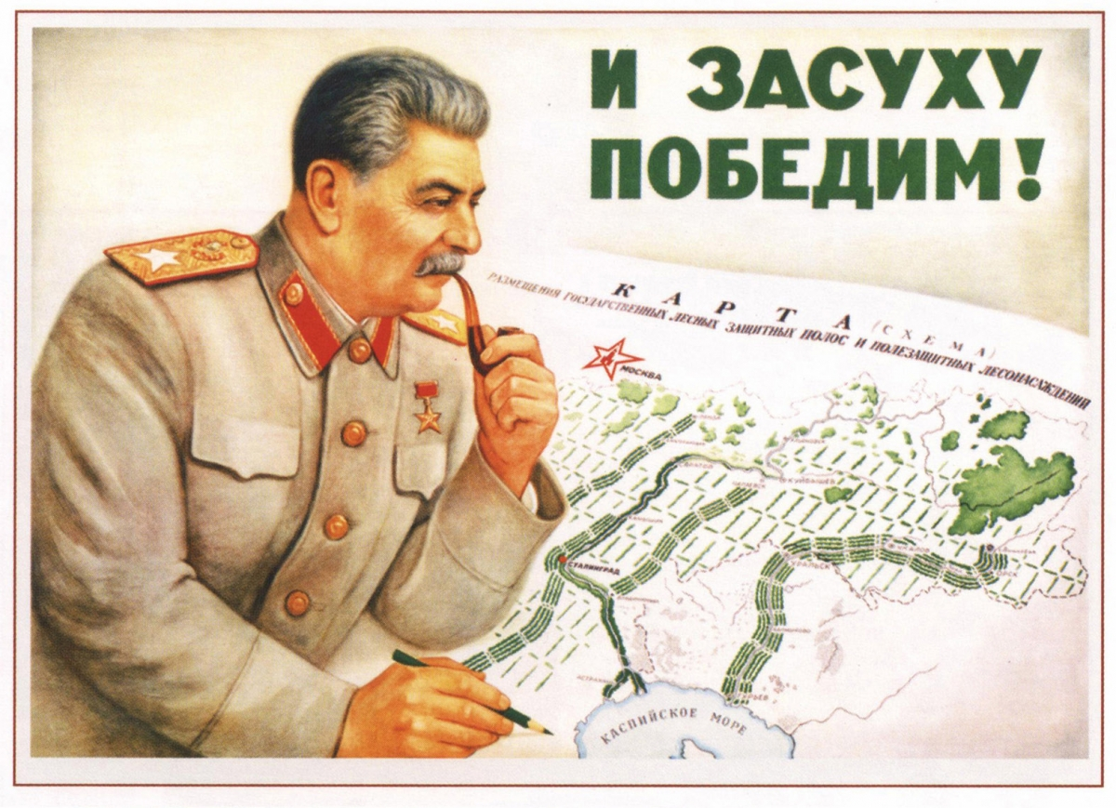
Another poster illustrating the Great Stalin Plan, “We Shall Conquer Drought!”
After Stalin's death, with the coming to power of the Khrushchevites, the conservation bureaus fell from their prominent position [46]. Just six days after his funeral, the Ministry of Forestry was abolished and its activities transferred to the Ministry of Agriculture, and forest conservation fell into a deep decline.
In the 1960s, noting the decline of conservation, Professor Viktor Nesterov of the Timiriazev Agricultural Academy wrote in Pravda on 19 January 1966 that:
“There is a pressing need for an all-Union forest management agency with its own system of subordinate organizations. … Specialists express the opinion that a USSR Ministry of Forestry could become such a competent agency. Incidentally, such a ministry existed from 1947 to 1953.
During that time forest workers managed to do a great deal: The amount of sowing and planting of new groves was sharply expanded, and the trimming of the cutting areas was achieved everywhere. The ministry set up two hundred forest-protection stations outfitted with machinery. The annual volume of forest sowing and planting increased sevenfold. We are by no means thinking of idealising the activity of this ministry, but the results of its work were apparent to everyone who had anything to do with the forests.”
Something must be mentioned about the environmental catastrophes, typically associated with the USSR and “socialism” in the abstract by bourgeois media.
Take for instance the drying of the Aral Sea beginning in the 1960s, in which water from its “feeder” rivers - the Amu Darya and Syr Darya - were diverted to the arid plains of Kazakhstan, Uzbekistan, and Turkmenistan in order to irrigate cotton fields [47]. This was done with the intention of economically developing the Central Asian SSRs and to increase agricultural output in the region and in this regard, it was a success. However, the method of irrigation failed to respect the local ecological conditions and focused on industrial output causing the aral sea to begin a process of drying.
The drying out caused the sea to recede and salt concentrations to increase through evaporation, making the region inhospitable to fish and making summers hotter and winters colder [46]. Much like the mistakes of early forestry, the failure to respect and take into account the Earth's natural processes led to failure. Soviet scientists began to draw up large-scale plans to remedy the situation, but the Soviet Union dissolved before anything was implemented. In 1994, the new states surrounding the Aral Sea set up a joint committee to coordinate efforts to save the sea, but now competition between the states has slowed progress [49]. In the end, it should be noted that most of the drying occurred after the dissolution of the USSR.
The Chernobyl nuclear meltdown is another example which had severe impacts on the local environment and is often cited as a case to equate socialism with negative environmental impacts. The meltdown was caused by a “low-power” test, which led to an explosion and fire that demolished the reactor building. The local town to the reactor was fully evacuated the following day. Other locals were evacuated later on as the radiation spread around the region [50].
Emergency workers were drafted into the area to contain the reactor and prevent further destruction. Despite the scale of the damage, local wildlife has shown incredible resilience in the exclusion zone with even rare species returning [30]. And even with cases like Chernobyl, nuclear energy is far cleaner and safer (i.e. it has led to fewer deaths and disabilities) than fossil fuels (and most renewables), even having fewer deaths caused per unit of energy than wind power [51]. It is being used less and less nowadays, due to its high proportion of constant capital investment and consequent low profitability.
In both cases, either human error or mistakes in planning led to these tragic outcomes. Yet, this is a progression in comparison to capitalism, in which reforms and responses to such environmental problems move at a snail's pace and, in which there is no direct control. As a consequence, the scale of destruction that capitalism causes every day far outpaces the worst cases in socialist countries.
What is clear from this brief history is that the Soviet Union, with its fully nationalised land and industry, was able to develop an incredible, ever-changing and fast-moving environmental policy that puts current capitalist market solutions to climate change to shame.

The Way Out
Engels pointed out in “Dialectics of Nature” that [52]:
“With every day that passes we are acquiring a better understanding of these laws [of nature] and getting to perceive both the more immediate and the more remote consequences of our interference with the traditional course of nature. In particular, after the mighty advances made by the natural sciences in the present century, we are more than ever in a position to realise, and hence to control, even the more remote natural consequences of at least our day-to-day production activities. But the more this progresses the more will men not only feel but also know their oneness with nature, and the more impossible will become the senseless and unnatural idea of a contrast between mind and matter, man and nature, soul and body, such as arose after the decline of classical antiquity in Europe and obtained its highest elaboration in Christianity.”
It is clear that only the abolition of private property in the means of production and the establishment of a centralised, planned economy is the only method to quench the scorched earth that capitalism is conjuring up on an ever-increasing scale. Only this will allow conscious control to apply the solutions that are needed, without the consideration of profit for an exploiting minority.
The solutions are well-known and clear: large-scale environmental projects, reduction of greenhouse gas emissions, transition to renewable and clean energy sources, and abandoning the use of non-biodegradable materials. The interests and pleasures of a minority of exploiters, the capitalist class, stand in the way.
The capitalist class has inadvertently found itself on a suicide mission that could destabilise the very foundations of capitalist production and exchange, and send humanity back to barbarism.
The working class of the world must not hopelessly surrender to such a course but must make every effort to establish socialism. This requires the building of a vanguard party armed with a scientific theory that objectively represents the interests of the working class as revealed by Marxism-Leninism.
At present, many organisations around the world claim to be such "parties", but they unscientifically revise communist theory, thus rendering it impotent, and incapable of providing any credible guidance to mass workers' struggles around the world.
We are in the process of training cadres in the theory and towards the eventual formation of such a party. Join us.
Sources:
[1] Nature — “Amazonia as a carbon source linked to deforestation and climate change” — July 14, 2021
[2] EGU — “ESD - Climate tipping point interactions and cascades: a review” — January 26, 2024
[3] UNEP — “The world’s corals are bleaching. Here’s why and what it means for the ocean’s future.” — June 6, 2024
[4] Oxford Academic — “Ecology in the Sixth Mass Extinction: Detecting and Understanding Rare Biotic Interactions” — March 20, 2019
[5] JSTOR — “The Anthropocene Mass Extinction: An Emerging Curriculum Theme for Science Educators” — February 2011
[6] Royal Society — “Climate change: evidence and causes”
[7] NASA — “Causes | Facts – Climate Change: Vital Signs of the Planet”
[8] Yale Climate Connections — “Four ways climate change likely made Hurricane Helene worse” — September 29, 2024
[9] Met Office — “Causes of climate change - Met Office”
[10] NASA — “The Great Dying - NASA Science” — January 27, 2002
[11] Our World in Data— “Fossil fuels are the biggest source of CO2 emissions in most countries, but there are a few exception” — November 23, 2024
[12] Guardian— “Revealed: the 20 firms behind a third of all carbon emissions” — October 9, 2019
[13] World in Data— “Cars, planes, trains: where do CO₂ emissions from transport come from?” — October 6, 2020
[14] UNFCCC— “World Nations Agree to At Least Halve Shipping Emissions by 2050 ” — April 14, 2018
[15] World in Data— “What share of global CO₂ emissions come from aviation?” — April 9, 2024
[16] GlobalForestWatch— “Global Deforestation Rates & Statistics by Country” — 2023
[17] WWF — “Living among the trees: Five animals that depend on forests” — January 23, 2017
[18] Karl Marx. Capital Volume 1. Progress Publishers: 1887. pp.338.
[19] CNN Business — “The world is creating more single-use plastic waste than ever, report finds” — February 5, 2023
[20] EarthDay — “Fact Sheet: Single Use Plastics” — January 23, 2017
[21] BBC — “Oceans littered with 171 trillion plastic pieces” — March 8, 2023
[23] NBC— “Trump Signs Executive Order to Begin Water Rule Rollback” — February 28, 2017
[24] World Bank — “Population, Poverty, and Climate Change” — October, 2013
[25] EcoWatch — “David Attenborough: 'Population Growth Must Come to an End'” — October 4, 2018
[26] Youtube – “Malthus Was Right - Sir David Attenborough 2011, Full Lecture” – 2011
[27] Robert H. Cowie, Philippe Bouchet, Benoît Fontaine. The Sixth Mass Extinction: fact, fiction or speculation. URL:https://onlinelibrary.wiley.com/doi/full/10.1111/brv.12816?msockid=338d188962236bc136800bf563c36a54 — Date of reference: January 10, 2022
[28] Karl Marx. A Contribution to the Critique of Political Economy. Progress Publishers: 1859. Preface.
[29] NBC— “Conservative groups spend up to $1bn a year to fight action on climate change | Climate science scepticism and denial ” — December 20, 2013
[30] Harvard Gazette — “Exxon scientists predicted global warming with 'shocking skill and accuracy,' Harvard researchers say” — January 12, 2023
[31] BBC News — “COP29 chief secretly filmed promoting fossil fuel deals - BBC News” — November 8, 2024
[32] UN — “Secretary-General's special address on climate action "A Moment of Truth" | United Nations Secretary-General” — June 5, 2024
[33] UNFCCC — “The Paris Agreement | UNFCCC”
[34] WEF — “1.5°C is a physical limit: this climate target can’t be negotiated” — January 16, 2024
[35] Vox — “Climate change: Is enhanced oil recovery a friend or foe?” — December 6, 2019
[36] Climate Promise — “What are carbon markets and why are they important? | Climate Promise” — May 18, 2022
[37] UK Parliament — “COP26: Delivering on $100 billion climate finance” — November 3, 2021
[38] Clean Energy Wire — “Developed countries reach $100 bln annual climate finance target two years late – OECD | Clean Energy Wire” — May 29, 2024
[39] Grist — “Wealthy nations meet $100 billion climate aid goal — two years late” — May 31, 2024
[40] BBC — “Huge COP29 climate deal too little too late, poorer nations say” — November 24, 2024
[41] Karl Marx. Economic and Philosophic Manuscripts of 1844. Progress Publishers: 1974. pp. 92.
[42] Russia Beyond — “Wastes As Value: Sustainable Resources for Pulp and Paper Production in the USSR” — November 20, 2018
[43] Environmental History Now — “Wastes As Value: Sustainable Resources for Pulp and Paper Production in the USSR” — November 25, 2020
[44]Russky mir — “Tu-155, the first hydrogen-powered plane created in the USSR” — March 12, 2023
[45] Weiner, D.R. Models of nature: Ecology, conservation, and cultural revolution in Soviet Russia. Pittsburgh, Pa: University of Pittsburgh Press: 2000
[46] Brain, S. (2011) Song of the forest: Russian forestry and Stalinist environmentalism, 1905-1953. Pittsburgh, PA: University of Pittsburgh Press. In order of use PP. 54-55, 59-60, 67, 122, 117-118, 20, 56, 119, 124, 130- 131, 140-149, 117
[47] NASA — “World of Change: Shrinking Aral Sea”
[48] National Geographic — “Aral Sea's Eastern Basin Is Dry for First Time in 600 Years” — October 2, 2014
[49] Britannica — “Aral Sea | Description, History, Map, Shrinking, & Facts” — November 2, 2024
[50] IAEA — “Frequently Asked Chernobyl Questions | IAEA”
[51] Our World in Data – “Death rates per unit of electricity production” – 2021
[52] Frederick Engels. Dialectics of Nature. Progress Publishers: 1986. PP. 183, 180-181

Original article

