Clara Zetkin on the Modern Women
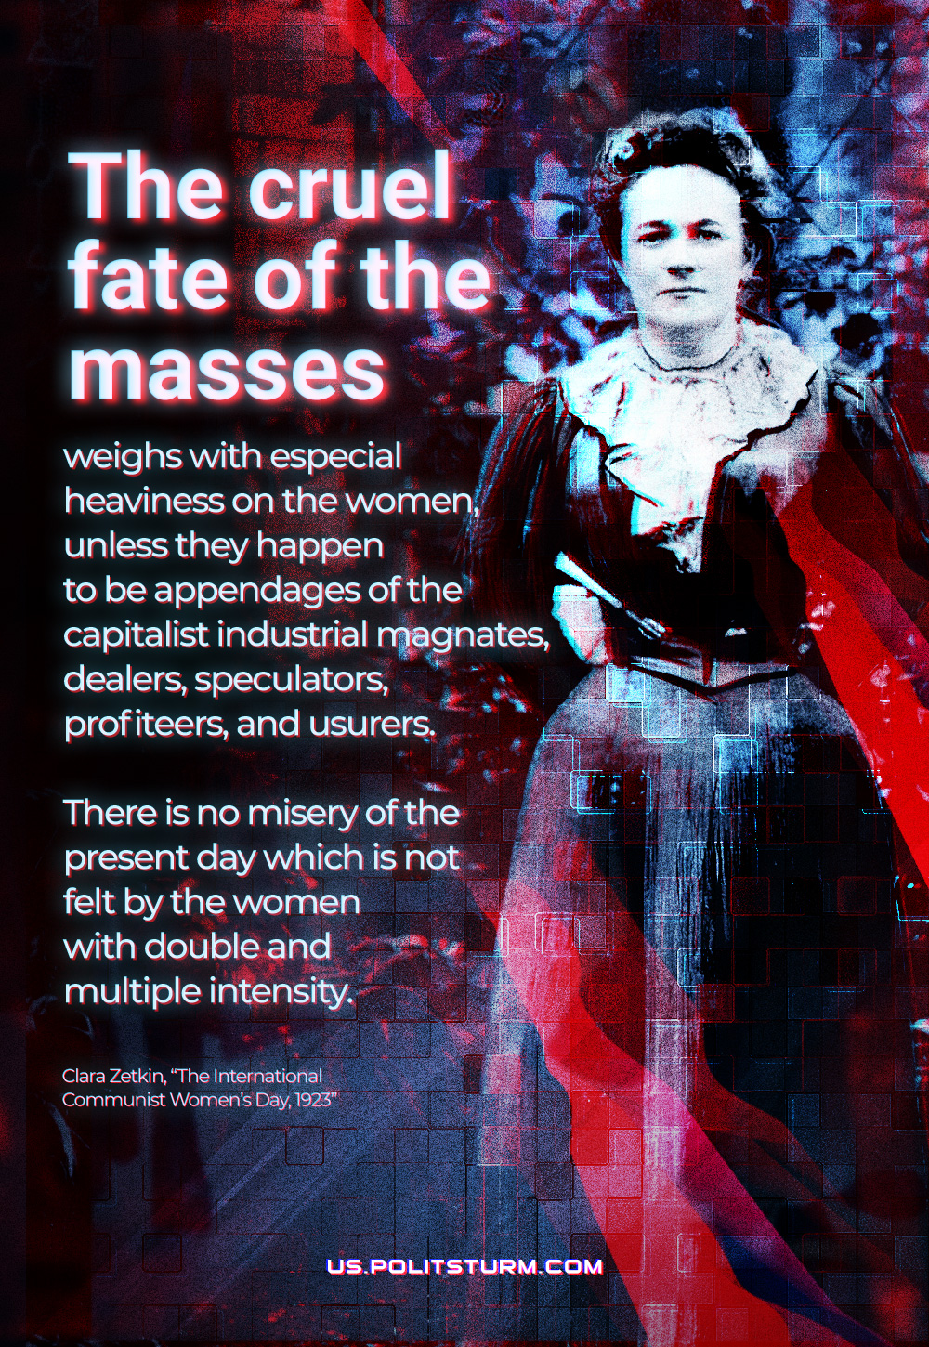

Original article
2022-03-08

The cruel fate of the masses weighs with especial heaviness on the women, unless they happen to be appendages of the capitalist industrial magnates, dealers, speculators, profiteers, and usurers. There is no misery of the present day which is not felt by the women with double and multiple intensity.
Clara Zetkin, March 8: The International Communist Women’s Day, 1923

Original article

