Chipotle to Pay $7.75 Million Over New Jersey Child Labor Violations
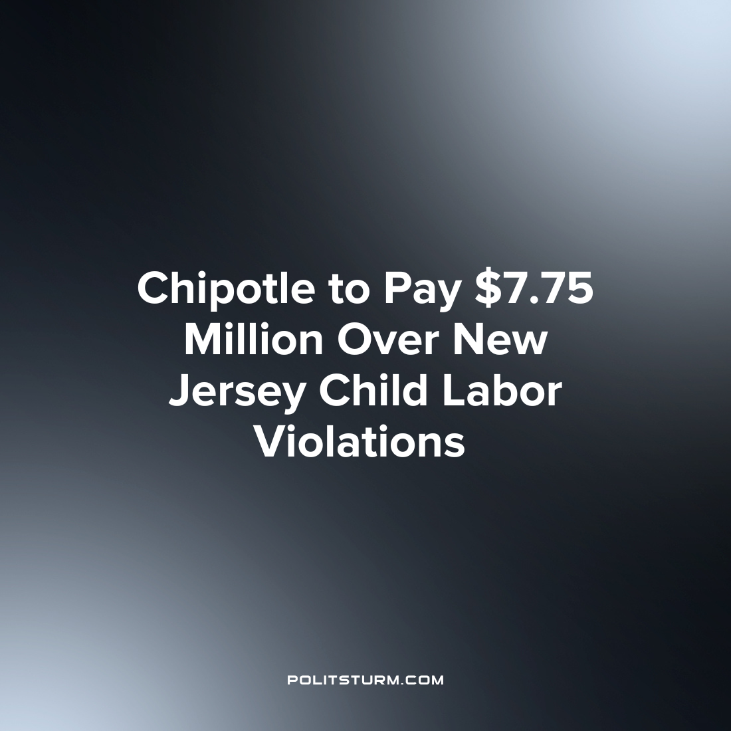

Original article
2022-09-20
1 min read

The New Jersey Department of Labor and Workplace Development came to an agreement with Chipotle Mexican Grill over allegations that the company violated the state’s child labor laws. Chipotle agreed to pay $7.75 million after a 2020 audit of New Jersey Chipotle locations uncovered 30,660 violations involving child labor. In addition the company agreed to a compliance plan for its New Jersey locations with the stated intention of “putting an end to these practices.
The compliance plan includes self-audits, staff training to ‘raise awareness’ and the designation of a child labor compliance official.
“This historic settlement is just one result of the investments we have made throughout the Murphy Administration to proactively enforce our worker protection laws, and it should serve as a message to every employer that if you exploit your workers, you will be held accountable”, said Attorney General Matt Platkin.
While the Attorney General may assert that employers who exploit their workers will be held accountable, the exploitation of workers is the foundation of capitalist profit and the capitalist system. This instance with Chipotle is simply one where the capitalists, in search of maximum profits, ignored and failed to comply with state laws which limit the number of hours minors are able to work. To assert that these employers will be “held accountable” ignores that tens of thousands of systematic violations have occurred for years which profited the employer and the shareholders. The penalties for the violations goes not to the affected workers but will go to the New Jersey Child Labor Law Enforcement Trust Fund, to continue to “educate” employers that it is wrong to violate child labor laws. As long as the capitalist system continues to exist, exploitation of the workers will continue and employers will get a slap on the wrist for any violations from the government officials who ultimately serve their interests.
Source: 1

Original article

