The Chinese In the Russian Revolution
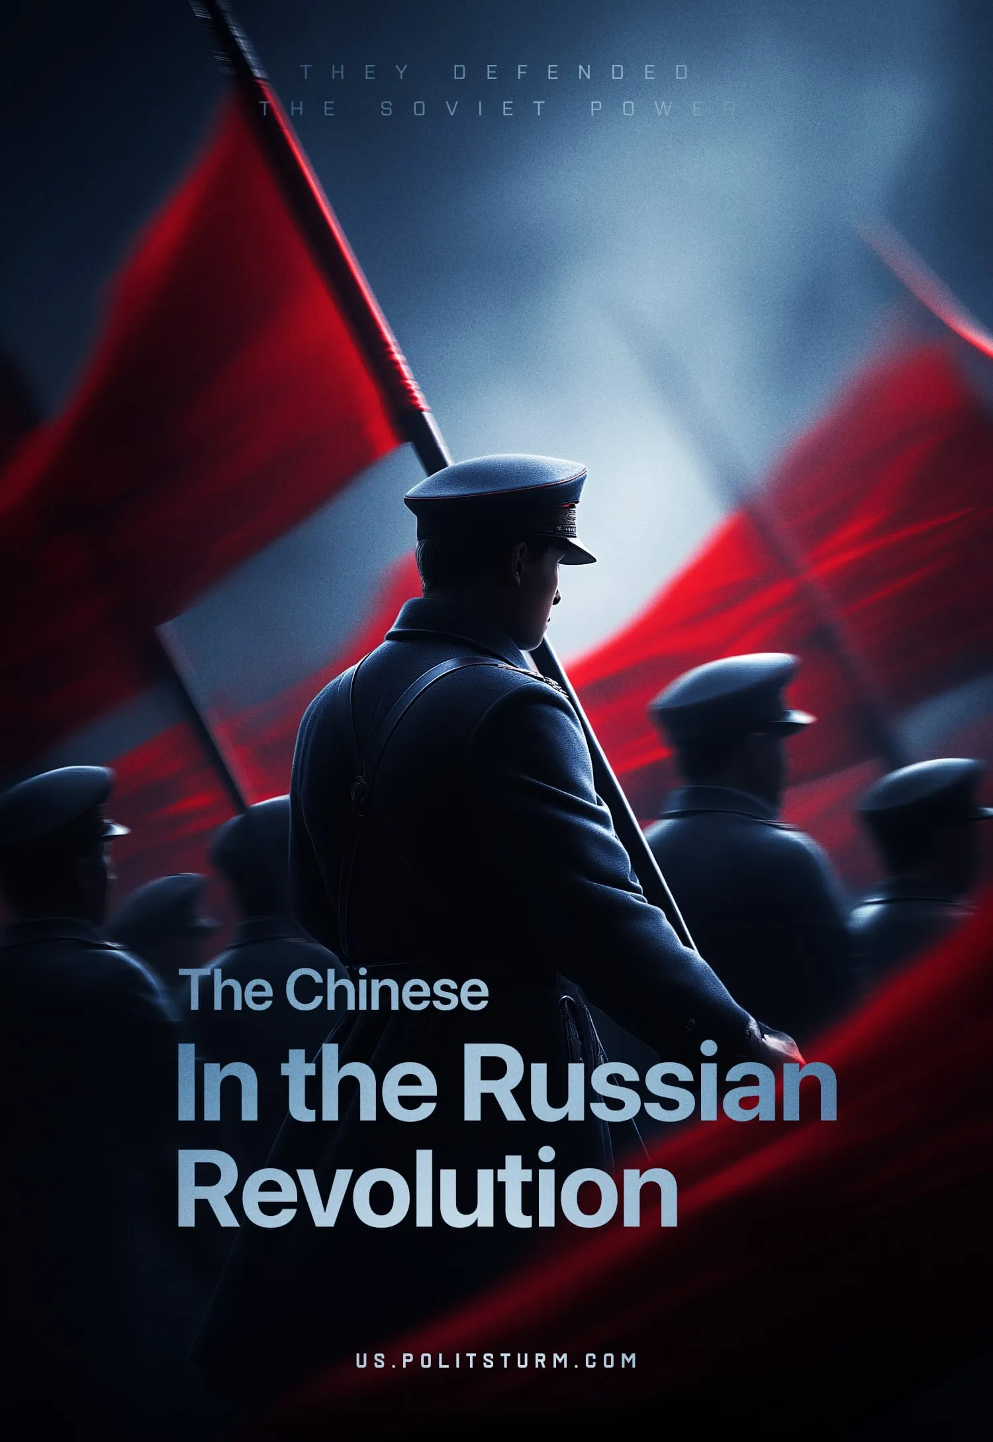

Original article
2025-05-17
32 min read

Preface by Politsturm:
In our previous publication, we translated Grigory Tsidenkov’s article “Red Hussars VS White Cossacks”, which, through the lens of Lajos Wienermann’s life and military achievements, explored the broader contributions of Hungarians who joined the Red Army, embodying ideals of solidarity and collective resistance against reactionary forces. We continue our journey into the diverse roles played in the Russian Revolution with Tsidenkov’s next work, “The Chinese In the Russian Revolution”. In this article, Russian historian Grigory Tsidenkov examines the significant yet often misunderstood impact of Chinese internationalists on the Red Army’s cause. Though not driven by leftist ideology, Tsidenkov provides valuable historical insight, dismantling myths to uncover the true story of these fighters.
This article traces the path of Chinese soldiers who found themselves at the heart of revolutionary Russia, delving into the reasons they joined the Bolshevik struggle and their influence on the battlefield. Tsidenkov’s research highlights their solidarity in the fight for socialism, offering a clear-eyed perspective on the internationalist spirit that helped shape the early Soviet state.
Understanding the role of Chinese internationalists is essential for grasping the broader dynamics of the Russian Civil War and the global currents of revolutionary movements. Their story, marked by courage and conviction, deepens our appreciation of the diverse forces that fought for a new society.
"We are brothers in spirit, comrades in purpose." (我们，在精神上是弟兄，在志向上是同志). From Maxim Gorky's letter to Sun Yat-sen.
In the history of the Russian Civil War, Chinese internationalists left a significant mark – though much of it has been distorted and mythologized. Let’s try to separate fact from tall tales and propaganda, and figure out how so many Chinese came to be in the young Soviet Russia, how many of them fought for the Reds, and what drove them to do so.

I. Chinese Lessons
The battle cry of the Chinese internationalists was “Wei Hongdang!”—“For the Red Party!” They often referred to themselves simply as “Hongdang” (紅黨). Chinese is a complex language, unfamiliar to the Russian ear, yet after just a few battles fought shoulder to shoulder with their Chinese comrades, Red Army soldiers began picking up Chinese words. And woe to anyone who dared to make fun of it.
In combat, when launching an attack, the Chinese would shout “u-lya!” – a distorted version of the Russian “ura!” (an exclamatory interjection used as a triumphant shout expressing elation, joy, general enthusiasm, as well as a battle cry) – which at times struck more terror into the enemy than cannon fire or machine guns. In bayonet charges and hand-to-hand fighting, Chinese soldiers would yell “ji bai” (擊敗). Russian-speaking Red Army soldiers, not too concerned with pronunciation, transformed it into “chipay,” and eagerly used it in battle.
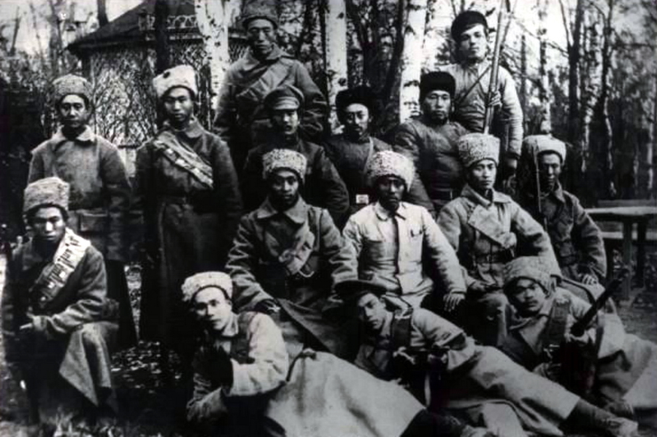
Chinese Red Army soldiers. Ural, 1918
Chinese units fighting on the Southern Front against Denikin’s army had their own distinct battle cry. After the tragedy in Melitopol on March 27, 1919 – when retreating White forces executed 50 Chinese civilians, including 23 women and children – Chinese Red Army soldiers would shout “fu chou” (復仇), meaning “revenge,” before going into battle, working themselves into a state of fury. Often, that cry alone was enough to make inexperienced or demoralized enemies scatter. Chinese fighters referred to their enemies as baiyanlang (白眼狼) – “white-eyed wolves.”
So, who were these Chinese soldiers of the Red Army? What were they fighting for, and what became of them? Over the past 30 years, myths and rumors have surrounded them, no fewer than those surrounding the “Red Magyars”. The main tenets of these myths are as follows:
– The Bolsheviks hired thousands of Chinese cutthroats. Where the Bolsheviks got these Chinese, the believers in this theory either don’t say at all or vaguely claim they were “brought in.”
– The Red Army only fought when driven forward by Hungarian bayonets and Chinese machine-gun squads.
– All Chinese were mercenaries– brutal enforcers and rapists who fought solely for gold.
– These ruthless Chinese mercenaries served only in the Red Army.
– The Soviet Union deliberately concealed Chinese participation in the Civil War.
As for what happened to the “hordes” of Chinese after the war, the theories are more outlandish than the next. So, let’s examine the real story of the Chinese internationalists who fought for the Reds during the Civil War. We’ll begin by looking at how so many of them ended up in the shattered remains of the Russian Empire, how many served in Red Army units, and what drove them to fight. Then, we’ll trace the combat record of the most notable and effective Chinese detachments, explore how they fought, dissect the key propaganda tropes used by their opponents, and address the so-called “women’s question.” Finally, we’ll shed light on the postwar fate of these Chinese internationalists.
Accusations against the Soviet authorities regarding the concealment of information about the participation of Chinese individuals in the Civil War are completely unfounded. The situation mirrors that of the Red Magyars: from the early stages of the Civil War, articles about the Red Chinese frequently appeared in newspapers. A significant number of articles on Chinese internationalists were published in magazines throughout the 1920s and 1930s, including memoirs written by both Chinese individuals themselves and their comrades. The Chinese fighter was a common character in literary works – for example, the character "Hodya" from Bulgakov's "The Chinese History". In the 1950s, during a period of favorable relations between the USSR and the PRC, there was a notable surge in interest regarding Chinese internationalists. Comprehensive monographs were published during this time, and "Red pathfinders" sought out veteran Chinese, organizing trips for them to sites of military and historical significance. In many regions across the country, memorials and obelisks were erected in honor of the Chinese internationalists.
It was only in the late 1960s that the topic of Chinese internationalists began to fade from both popular and scientific literature, and the publication of monographs ceased altogether. This, of course, was due to the sharp deterioration in relations between the countries and the crisis over Damansky Island. In academic publications, references to the Chinese were now made alongside other internationalists, while Uyghurs and Dongans were increasingly highlighted as distinct groups. However, interest in certain notable figures, such as Pau Ti-san, Jen Fu-chen, and Li Fu Qing, continued to remain consistently high. In the 1980s, academic compilations on internationalists once again included separate sections on Chinese fighters, but by the 1990s, for objective reasons, research on this topic had come to a standstill.

II. Who Were the Chinese Internationalists, Where Did They Come From, and What Were They Fighting For?
The first wave of Chinese immigration to the Russian Empire began shortly after the construction of the Chinese Eastern Railway. Chinese migrants mainly settled in Vladivostok, Khabarovsk, and Spassk, typically working as unskilled workers, miners, or small-scale artisans. This immigration was steady, though relatively limited in scale. It increased significantly during the Russo-Japanese War but declined somewhat after the war ended. A modest reverse migration even began: Russian industrialists, entrepreneurs, and wealthy peasants found it more advantageous to hire Korean refugees who had fled en masse to the empire. These Koreans were completely disenfranchised, desperately poor, and willing to accept virtually any kind of work.
According to data published in issue No. 27 (1915) of the journal Industry and Trade, approximately 550,000 people arrived in the Russian Far East from China by 1910. Around 200,000 of them settled there permanently, while the rest – displaced by the growing Korean presence – either moved on to Western Siberia and European Russia or returned home.
With the outbreak of World War I and the mass mobilization that followed, the Russian Empire faced an acute labor shortage – especially of low-cost workers. Although the authorities widely employed prisoners of war from the Central Powers for various types of labor, it wasn’t enough to meet demand. As early as 1914, Russian recruitment offices began operating throughout China, offering Chinese workers a range of standard short-term contracts – typically lasting three to six months – for temporary work in Russia.
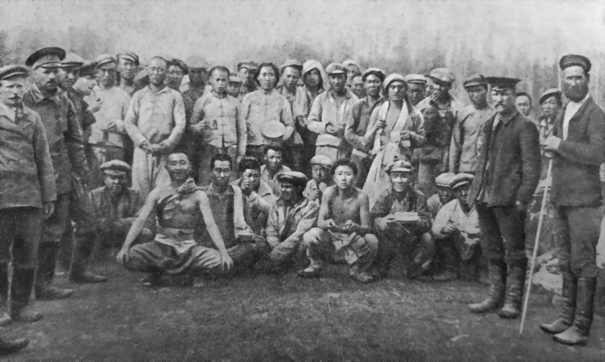
Chinese workers at the construction of the Murmansk railway, 1916
Work was offered far from the front lines – in logging camps, mines, and during the harvest season. The wages promised seemed very generous to impoverished Chinese peasants. Many turned to the recruiters, hoping to earn enough to feed their families back in China – or at the very least, to spare them one extra mouth to feed. Between 1914 and 1916, recruitment centers were opened in Harbin, Changchun, Shenyang, Jilin, and Dalian. These centers soon established branch offices in the provinces. Before long, the entire recruitment effort was handed over by Russian officials to Chinese contractors.
During the war, a total of 80,000 Chinese workers were brought into Russia legally under contract. The number of undocumented migrants is difficult to determine, but even at the time, estimates placed the total number of Chinese workers brought in at around 150,000. Later, some Soviet publications cited a figure of 200,000, though this is not supported by archival documents or by data from the Union of Chinese Workers in Russia.
Most Chinese workers were employed on the railways, at Siberian gold mines, in the coal mines of the Donbas, in logging operations in Karelia, and at factories in Petrograd, Moscow, Kyiv, Odesa, and across the North Caucasus. Many also worked in agriculture throughout the country. At the Lena goldfields, Chinese workers made up 70% of the workforce, while the Abamelek-Lazarev enterprises in the Urals employed as many as 5,000 Chinese workers at once.

Against Slave Labor
In 1959, a retiree from the city of Nalchik, Li Chen-tun, recalled:
"My comrades and I emigrated to Russia, fleeing poverty and hunger. On the outskirts of a Manchurian village stood our dilapidated cottage. I call it the 'House of Tears' when I remember the wretched life of our family. To avoid starving to death, we went into servitude to landlords, all the land was in their hands. Rarely did anyone manage to find work in factories, as there were few enterprises. The colonial policies of the British, Americans, and French hindered industrial development in China. In 1916, during the height of the imperialist war, I was among 12,000 young men from our region who were recruited and sent to Russia. We worked in logging near Petrograd. We sought happiness but ended up in hard labor: Tsarist Russia was ruled by the same predators. Life in the forest was harsh: we worked 15 hours a day, slept in damp dugouts, in cramped and filthy conditions, and received miserable pennies for our labor, barely enough for bread."
The Russian government regarded the Chinese solely as a cheap labor force with no rights. Their upkeep was entirely left to the discretion of contractors and employers. The longer the war dragged on, the more frequently and unscrupulously the contracts of Chinese workers were violated. During recruitment, Chinese contractors promised wages of 100–200 rubles per month, but in reality, few received more than 5–10 rubles in hand, and even then, irregularly. Russian employers imposed elaborate fine systems on the Chinese. A significant portion of the wages was withheld by Chinese contractors. Additionally, translators were imposed by the Russian government, and their labor had to be paid for by the Chinese workers themselves.
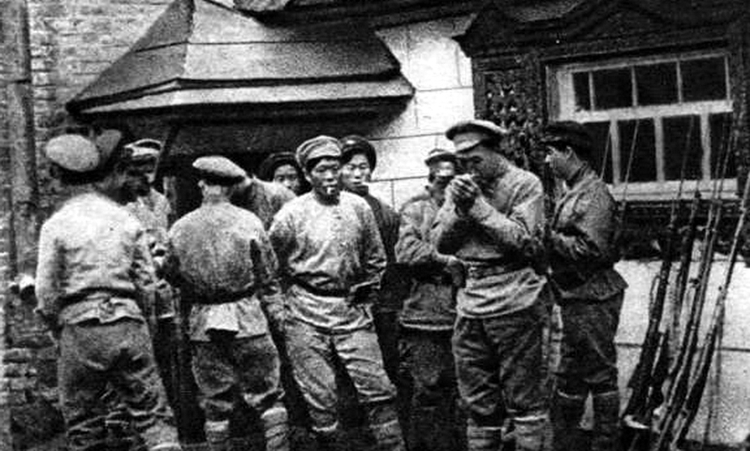
The fighters of one of the Chinese international battalions
According to the recollections of a laborer from Shandong, Yao Xin-chen, who was recruited for logging in Perm, the Russian employer was supposed to pay the worker 8 rubles per cubic meter of wood under the contract. However, in reality, after deductions for the contractor, translator, taxes, and officials, the worker's daily wage amounted to only 5 rubles. From this amount, after deductions for food, only 90 kopecks remained — workers lived deep in the forest, and huge sums were spent on food delivery and its high cost during wartime.
Already in 1915, despite the contracts and norms of international law, the Chinese were sent to dig trenches and foxholes in the frontline area. In 1916, over 10,000 prisoners of war from the Central Powers were sent to build the Murmansk railway, where they died in large numbers from scurvy, typhus, as well as from grueling labor and frostbite. After the intervention of the Red Cross, the Russian authorities were forced to remove the prisoners of war. In their place, immediately, without any consent or prior notice, 10,000 Chinese workers were brought in and settled in unsanitized barracks and dugouts.
During the construction of the Murmansk railway, an English or Canadian worker earned 7–8 rubles in gold per day, a Russian worker earned 1 ruble 20 kopecks, and a Chinese worker earned 80 kopecks, from which, due to the arbitrary system of fines, they received only 30–40% of the amount, and even that irregularly. The workday for the English was 8 hours, while for the Russians and Chinese, it was 10.5 hours or more.

Against Racism
It is no secret that in the Russian Empire, manifestations of racism and nationalism were not only unrestrained (as was the case everywhere at the time), but were also actively encouraged, leading to such infamous policies as the Pale of Settlement for Jews, the forced Russification of the Balts, Finns, and Poles, and the tacit approval of the pogroms carried out by the Black Hundreds, among other things. The Chinese, like all other "Asiatics," were treated as second-class people. In the press, they were openly referred to as "yellow-faced," compared to animals, and so on. On the empire's railways, the Chinese could only travel independently in separate "Chinese" third-class carriages.
The specific anti-Chinese racist propaganda in Russia emerged during the suppression of the Boxer Rebellion in China, in which Russian troops actively participated. The Chinese were depicted as repulsive-looking barbarians.
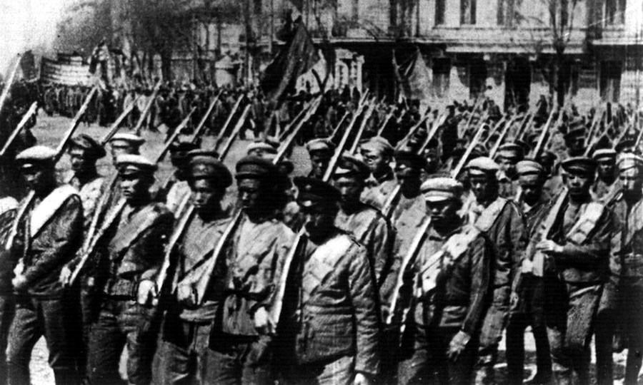
The Chinese in the ranks of the Red Army enter Odessa
From 1914 to 1917, the practically free labor of tens of thousands of utterly powerless Chinese migrants deprived Russian workers and peasants of their earnings. To avoid potential threats, entrepreneurs who hired Chinese workers instead of the Russian ones paid for publications about the "yellow peril" in the press. These publications suggested that the Chinese had come of their own accord to deprive the Orthodox people of their livelihood.
Later, during the course of the escalating Civil War, the propaganda of the White movement completely stripped the Chinese of any human qualities, portraying them solely as bloodthirsty monsters living through violence and looting. Of course, such behavior from the Russian authorities, employers, and Chinese contractors, along with blatant racism and unbearable living conditions, could not help but provoke outrage among the "coolie" (a term used in the early 20th century to refer to cheap hired workers from China).

III. European Barbarity
As early as November 1915, 1,700 Chinese workers at the Gubakha coal mines, owned by Prince Abamelek-Lazarev, went on strike. The workers were outraged by the complete lack of days off and the overseers' abuse. The strike was brutally suppressed, and the instigators were flogged with whips.
In the spring of 1916, 2,600 Chinese workers at logging sites for the Alapaevsk factories, near the Mugai River, went on strike. They demanded that at least one bathhouse be opened, that their food be improved, and that they be paid according to their contracts. In response, the administration fired their foremen and banned all gatherings. The Chinese refused to end the strike, and then a bailiff arrived with a reinforced detachment of guards, who opened fire on the crowd. Instead of scattering from the bullets, the Chinese began throwing stones at the guards, seriously injuring the bailiff. Having exhausted their ammunition, the guards rode away. The provincial authorities sent a military unit to suppress the unrest, and the press ran headlines like "Riot of the Yellows" (referring to the Chinese workers).
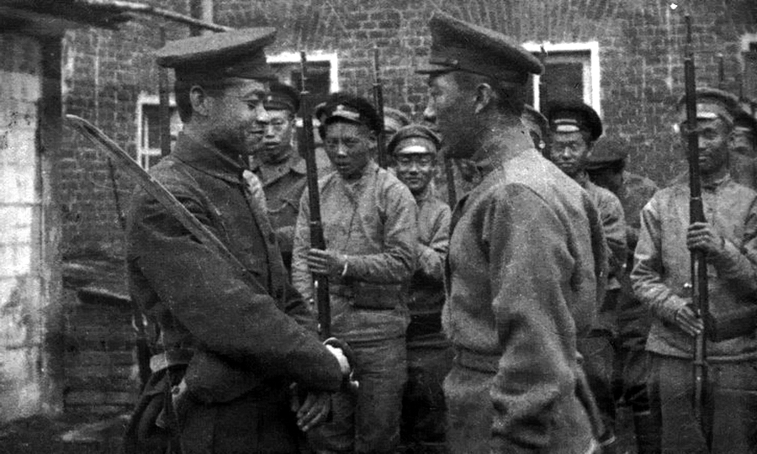
Soldiers of one of the Chinese international battalions
In September 1916, 580 Chinese workers at logging sites for Frontostroy ("Front Construction", likely referring to construction for the war effort) at the 712th verst (an old Russian unit of distance, approximately 1.07 km or 0.66 miles) of the Alexandrovskaya Railway (also known as the Moscow-Brest Railway) stopped working. Their contractor, Lin Chen, was dividing the entire salary of his compatriots, as well as their food rations, with the military and railway administration. For more than a month, the workers had been living on nothing but bread (which was unbearable for those used to a Chinese rice diet), grass, and berries, and their clothing was completely worn out by the hard labor. Nevertheless, the guards drove the Chinese to work every day. On September 20, 400 workers, armed with axes, went to the administration office, demanding that Lin Chen be handed over to them. In response, the precinct chief ordered the summoned guards to open fire. Three Chinese were killed, and 43 were seriously wounded. News of the massacre immediately spread to all the Chinese working on the railway, and the strike engulfed 1,500 workers. The situation escalated to such an extent that the Ministry of Internal Affairs (MVD, the Russian equivalent of the Department of Interior) launched an investigation.
In October 1916, 10,000 Chinese workers on the construction of the Murmansk Railway went on strike. The strike lasted for two days and ended only after the construction administration forbade the Cossacks and soldiers from arbitrarily beating the Chinese.
In the autumn of 1916, the comprador Zhou Mian from the Chankun Company "Yicheng" recruited 20,000 lumberjacks in the provinces of Shandong and Hebei and sent them to Russia. According to the contract, they were heading to the Smolensk Governorate for 5 months exclusively to work on logging. However, upon arrival in Russia, the local authorities, despite energetic protests, divided the Chinese into detachments and sent some of them to the Southwestern Front for rear work and digging trenches. They were not provided with any protective clothing, and the quality of food was terrible. Many Chinese died from disease, starvation, and shelling. Those who fled were caught and severely flogged. Three of them managed to escape and return to China in January 1917. The newspaper Mingguo Ribao (民国日报, likely translated as "The Republic Daily"), in its issues of January 12 and February 9, 1917, published interviews with them, which stirred up all of Chinese society. These tricked lumberjacks later formed the core of the very first Tiraspol Chinese Battalion in the Red Army Commander Iona Yakir's detachment.
In December 1916, Chinese loaders at the Chascha station near Petrograd went on strike due to unpaid wages. The police opened fire and killed ten. The remaining 40 loaders were imprisoned.

The Road to Revolution
Following the February Revolution of 1917, the living and working conditions of Chinese laborers deteriorated significantly. Many stopped receiving wages altogether and subsisted solely on provisions from their employers. Those who found work in defense-related industries fared somewhat better. Simultaneously, the Chinese increasingly took an interest in the political events unfolding in the country. Like most of the empire's population, they pinned their hopes for a better future on a swift end to the war. The vast majority of Chinese workers anticipated returning home as soon as peace was established, as doing so was virtually impossible during wartime.
It was only natural that the few Chinese workers who could read Russian and access Russian newspapers ardently supported the political forces advocating for a prompt peace.
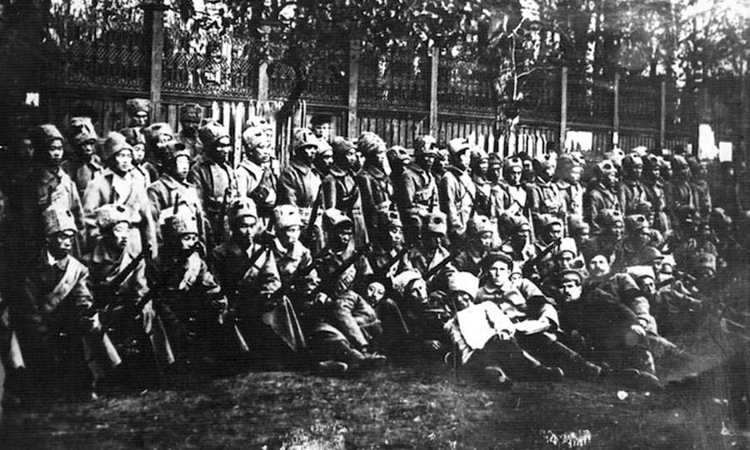
Soldiers of a Chinese unit before being sent to the front
At that time, the bulk of the Chinese population was not yet familiar with the Bolsheviks, living as they did in the closed world of their artels [Unlike later Soviet artels, which were workers’ cooperatives, artels in the Russian Empire did not imply common ownership. They were groups of workers united to carry out specific tasks, often under the supervision of an intermediary or contractor, where workers shared earnings or jointly managed everyday needs (such as housing and food) – PS ]. However, those who found themselves working in factories and mines often encountered Bolsheviks and their sympathizers. The Bolsheviks recognized no national prejudice, viewing the Chinese as brothers, fellow oppressed proletarians. The Chinese workers, accustomed to dismissive treatment from the Russian authorities, found such individuals intensely interesting and sympathetic. Their ideas, presented in the simplest and most understandable terms, resonated deeply. The Chinese willingly joined the first factory and plant units of the Red Guard, particularly cherishing their newfound status and the address of "comrade." San Tan-fan, a Red Guard from a confectionery factory in Petrograd, recalled:
"I was standing guard at the factory entrance when an elderly woman approached me and asked:
'What are you doing here, khodya [Russian derogatory term for a Chinese person, literally "walker"]?'
'I'm guarding the factory.'
'Why are you guarding it? Is it yours?'
'It's mine. Yours. Everyone's.'
'Now that's the right talk,' the woman said. 'I wish you a good shift, comrade.'
She called me comrade. And that sounded a thousand times better than 'khodya'."
The first Chinese individuals appeared in the Red Guard units as early as 1917, even before the October Revolution. These were primarily workers from the Petrograd Shipyard and several Moscow factories. There were only a couple of dozen of them at that time, and all are known by name. Several Chinese even managed to participate in the suppression of General Kornilov's revolt. Petrograd workers Liu Fu-chen and Fun Za-vya took part in the storming of the Winter Palace. By this time, all of them spoke Russian well, understood the political situation, and were staunch Bolsheviks.
Upon coming to power, the Bolsheviks proclaimed equality in international relations as one of their principles. The Soviet government officially annulled all secret treaties of the Tsarist government that infringed upon China's interests, renounced the Boxer Indemnity, and all privileges and concessions imposed on China by force of arms. At the same time, all Chinese workers and their families were granted the right to unimpeded travel to their homeland. Due to the deplorable state of the railway transport and the overall high cost of travel, only about 40,000 Chinese managed to take advantage of this right before the outbreak of the Czech Legion Revolt.
In October-November 1917, the first all-Chinese Red Guard detachments began to form in support of the new government.

War
The formation of Chinese detachments can be roughly divided into two stages.
The first period — from autumn 1917 to spring 1918 — saw the spontaneous emergence of Chinese detachments in major cities, where Chinese people had more frequent and closer contact with Russian workers, and in the front-line zone, where they were strongly influenced by anti-war propaganda. Most Chinese people were still poorly versed in the political situation and either sought to return home as soon as possible or were completely unaware of what was happening in the country. However, this period marked the beginning of the forging of the first military cadres of Chinese battalions, the emergence of charismatic leaders, and growing interest in the ideas of communism. Rumors began to circulate among Chinese labor associations (known as artels) that life could be drastically changed for the better by trusting the Bolsheviks.
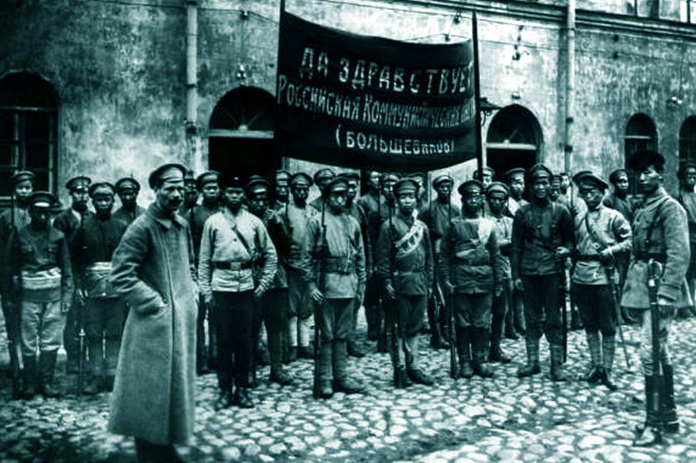
Soldiers of one of the Chinese international battalions
The second period, from the late spring of 1918 until the end of the Civil War and the final victory over widespread banditry, was characterized by two important developments. First, the Bolsheviks were able to establish effective propaganda and agitation among Chinese workers, explaining what they were fighting for. The first Chinese newspapers began to be published in the country: "Chinese Worker" and "Great Equality" in Petrograd, "Red Army" in Petrograd and Moscow, and "Communist Star" in Vladivostok and Khabarovsk. Second, communication with China was interrupted, and a large-scale foreign intervention began. In this environment, Chinese workers clearly recognized who their main enemies were, and many of them had very old scores to settle with some of the interventionists.
From the summer of 1918, Chinese companies and battalions began to be formed in an organized manner throughout the country, and their numbers constantly grew due to the surge of volunteers.
A separate category is the Chinese detachments that fought as part of partisan units in Transbaikalia and the Far East. Here, Chinese fighters had a stable connection with their homeland, with Chinese socialists and revolutionaries. Many residents of border fanzas (Chinese settlements/villages) joined the partisans due to the repression of Japanese interventionists and Cossack ataman (chieftain) forces. Commanders of the Chinese detachments were most often former members of the Yihetuan (Boxer Rebellion) and revolutionary officers of the Chinese army. The intervention of the Chinese government in the form of the Amur River Flotilla added a great deal of color to the actions of Chinese detachments in this theater of military operations.

IV. What the Chinese fighters fought for
The motives of the Chinese for joining the Red Guard and Red Army units are clear and obvious.
First, there is the complete alignment of interests between the Chinese workers and the Bolsheviks. Here we must note the general extreme dissatisfaction with the policies of the tsarist authorities and the Provisional Government; the equal and comradely relations of the Bolsheviks with the Chinese and the consequent sympathy of the Chinese with the Russian workers and peasants; the hope of a world socialist revolution and of a revolution in China: Sun Yat-sen not only warmly welcomed the October Revolution, but also wrote that in China "From now on the revolution can never succeed unless China takes Russia as its teacher”. Chinese workers understood the meaning of solidarity. Thus, at the meeting of Chinese workers in Verkhneudinsk, a resolution was adopted:
"We consider it necessary to defend the conquests of the revolution of the Russian proletariat, and for this purpose, together with the workers and peasants of Russia and Siberia, we will fight shoulder to shoulder to defend the rights of the workers of the whole world”.
This included training in class struggle and revolutionary tactics, which was later repeatedly emphasized by the veterans of the international detachments who returned to China to continue the revolutionary struggle.
Second, the proper staging of agitation by the Bolsheviks and the production of Chinese-language newspapers. Lenin's article "The Chinese War" of 1900 had a very strong influence on agitation. From it, the Chinese learned that Lenin was the only one in Russia who openly condemned the tsarist government for its role in the bloody suppression of the Boxer Rebellion. To direct and coordinate the recruitment of international units, the Military Commission for the Formation of International Units of the Red Army under the Central Federation of Foreign Groups of the RCP(B) was established in Moscow. Now, specially authorized commissars traveled throughout the country, agitating for the formation of international units and submitting lists of volunteers to the commission. This meant that the Chinese workers were contacted by their own countrymen, who knew the political situation well and gave direct answers to the most important questions. The most famous Chinese commissar was Shen Chen-ho.
Third, for most Chinese volunteers, joining the Red Army meant gaining a measure of stability and a permanent livelihood. An important component of this was the honesty of Red commanders in fulfilling their obligations regarding uniforms, food, and allowances. This was not due to greed on the part of the Chinese but to an elementary thirst for honesty in contractual relations after several years of continuous deception and trickery. For them, the timely payment of allowances was a confirmation of the honesty of the Russian comrades' struggle and their trust in them. The conviction of the honesty of the Bolsheviks and the perfidy of the whites played an extraordinary role in the morale of the Chinese.
Fourth, compatriotism. Holding on to one's fellow countrymen was an extremely important motive. Xu Mo-lin, a fighter in Yakir's detachment, recalled:
"We came (there were several of us) to a farm about a kilometer from the northwestern outskirts of Tiraspol, and we saw a strange flag flying - red, and a Chinese fighter standing near the flag. And for people who had suffered sorrow in a foreign land, to meet a fellow countryman is such a happiness that words cannot express. We approached the fighter, greeted him, and had a heart-to-heart talk with him. It turned out that it was a Bolshevik detachment and that there were many Chinese in it. We asked: "Can we join your unit?" The soldier immediately called the commander. We told him how we had come to the farm. When he found out that we had not eaten for three days, he immediately ordered us to be fed. So we became soldiers of the Tiraspol detachment of the Red Army”.
Fifth, revenge motives. Many Chinese workers and laborers joined partisan and Red Army units to take revenge on their former Russian employers. The Chinese batraks in Siberia especially hated their kulak employers, whom they called “evil eyes”. The Chinese also had many accounts with the Japanese invaders. Veterans of the Ihetuan uprising, who had served time in British and German concentration camps, should be singled out here. Many of them got to the construction of the Murmansk railroad. Thus, Wang Shu-shan from Shandong recalled:
"At first we did not understand the agitators. But then it was explained to us that we were called to kill the English".
More often, however, the motives were all there at the same time.
In December 1918, the Union of Chinese Workers was founded in Petrograd to address the pressing problems of Chinese coolie: employment, working conditions, information about the situation in the country, and mutual assistance. The organization was headed by Lau Siu-Jau (Liu Shaoju), a well-known Chinese revolutionary and extraordinary personality. The Chinese Workers' Union finally gave the Chinese a sense of security and protection from the Bolshevik government, which also raised the spirit of the Chinese fighting units.

Number of Chinese fighters
The historian N.A. Popov set the lower limit at 10,000. He counted only Red Army fighters, excluding Siberian partisans, the first Red Guards, and VKH officers. The Chinese researcher Pyn Min cited a figure of 40,000, which he considered minimal. However, in his research, he accepted without reservation the data on the number of Siberian partisan detachments, which were overestimated by the Reds for understandable reasons: the Whites often intercepted reports on the Siberian partisans, and those specially prepared for the enemy's counterintelligence overestimated their number in order to make them appear more formidable. From this number, it is necessary to subtract about 5000 Chinese workers who did not hold weapons in their hands but helped to restore the national economy and worked on railroads and factories.
As a result, Soviet and Chinese historians found a compromise: in the scientific literature, the number of Chinese internationalists in the Red Army began to be indicated as follows: "about 40,000 people, according to minimum estimates". We have the most accurate figures only for the fronts in the European part of Russia, where most rumors about the mass of Chinese in the Red Army originated: it is from 8,900 to 11,000 Chinese fighters for the entire period of the Civil War. The first number is the number of Red Army registration cards, the second is a count based on lists of Red Guard units and other documents of the time. It should be taken into account, as N.A. Popov noted that most of the Chinese from the Red Guards later served in the Red Army and could be counted twice.
In 1920-1922, the 56th (later 15th) Cavalry Regiment of the Red Army, with a strength of 800 men under the command of Ma San-chi, fought on the Turkestan Front, which was a separate theater of military operations. This regiment was formed on the basis of the Separate Dungan Cavalry Regiment and the Uyghur Cavalry Division, and all the Dungans and Uyghurs serving in it were Chinese subjects.
There is no data on the number of Chinese in the troops of the All-Union Cheka-OGPU, but the personnel there came from the active army, so the vast majority of Chinese Chekists should already be included in the above figures.
In the author's view, the 11,000 Chinese who fought at various times on different fronts as part of the five-million-strong Red Army undermine the myth of "hordes of Chinese mercenaries".
Myths about Chinese guerrillas in the Far East were virtually never created. All the opposing sides in this theater of war were clear about the motives of the Chinese, so their participation in the hostilities seemed completely organic. Unfortunately, as mentioned above, we do not know the exact number of these fighters.
Sources:
- Battles for Tsaritsyn: a collection of memoirs — Stalingrad: Stalingrad Book Publishing House, 1959
- Friendship forged in blood. Collection of memoirs of Chinese comrades – participants of the Great October Socialist Revolution and the Civil War in the USSR. Edited by Liu Yun-an - M.: Voenizdat, 1959
- Chinese volunteers in the battles for Soviet Russia (1918-1922). Institute of the Peoples of Asia of the USSR - Moscow: Publishing House of Oriental Literature, 1961
- Cao Baiying, Ning Yanhong. Chinese workers as a significant force in the spread of Marxism" // Tambov University. Series: Humanities - Issue No. 1 (153), 2016
- Li Yun-an. People of International Duty — M.: Gospolitizdat, 1959
- Novogrudsky G.S., Dunayevsky A.M. In the Footsteps of Pau — M.: Voenizdat, 1962
- Novogrudsky G.S., Dunayevsky A.M. Comrades Chinese fighters — M.: Voenizdat, 1959
- They remain with us. Edited by Y.A. Polyakov, compiled by V.R. Tomin. V.R. Tomin. Book 2 - M.: Politizdat, 1987
- Popov N.A. Participation of Chinese international divisions in the defense of the Soviet Republic during the Civil War (1918-1920 years) // “Questions of History” - 1957 - № 10
- Pyn Min. History of Chinese-Soviet friendship - M.: Publishing House of Socio-Economic Literature, 1959
- Xu Te-li. Influence of the Great October Socialist Revolution on the Chinese Revolution - M.: Gospolitizdat, 1957
- Tarasov V.V. Struggle with interventionists on Murman in 1918-1920. - L.: Leningrad newspaper, magazine and book publishing house,1948
- Heifetz A.N. From the history of the joint struggle of Russian and Chinese workers of the CEL against the interventionists and White Guards (1918-1920) // “Questions of History” - 1958 - № 4
- Yakir I.E. Memories of the Civil War - M.: Voenizdat, 1957.

Original article

