Chinese Expansion into the Russian Car Market


Original article
2023-08-21
2 min read

Chinese automakers exported more cars to Russia in bulk than anywhere else in the first five months of this year, filling the void created after the withdrawal of world manufacturers from the market due to a special military operation in Ukraine.
According to customs data released by the Chinese Automobile Manufacturers Association on Tuesday, China exported about 287,000 finished cars to Russia from January to May, almost twice as many as the next largest and largest destination last year, Mexico, which received 159,000 vehicles. [1]
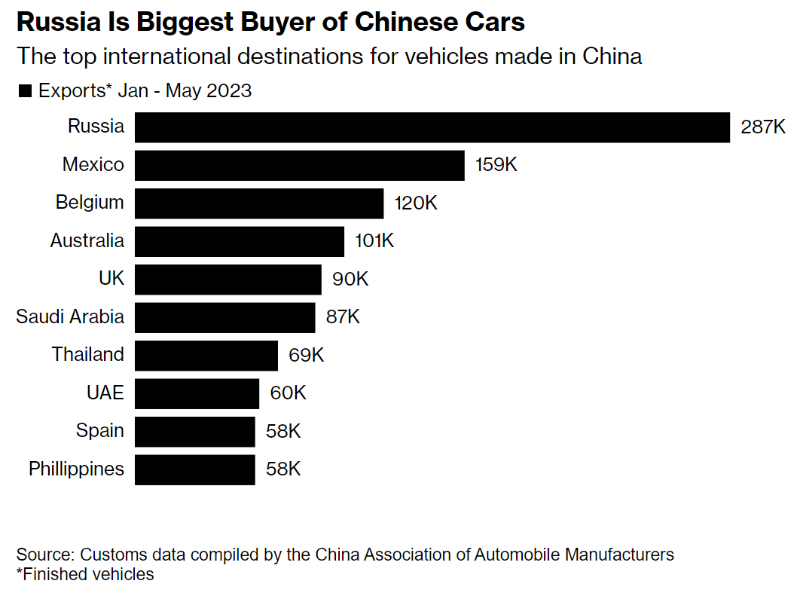
Officially, by the end of 2022, only 14 brands out of 60 that were functioning at the beginning of 2022 continue to fully operate on the Russian market. Three of them are Russian: Lada, GAZ and UAZ. The rest are "Chinese": Changan, Chery, Dongfeng, Exeed, FAW, Foton, GAC, Geely, Haval, Jac, Omoda.
6 Russian car factories from those that were working at the beginning of 2022 are "on pause"[2]:
- PSMA Rus (Peugeot, Citroen, Opel and Mitsubishi were assembled) in Kaluga
- Mazda in Vladivostok
- Mercedes-Benz in the Moscow region
- Nissan in St. Petersburg
- Toyota in St. Petersburg
- Volkswagen in Kaluga.
It is important to note that Chinese capital does not just replace Western capital, but also completely makes the Russian auto industry dependent by "modernizing" production, supplying machines and parts from China.
For example, the release of the X-cross 5 crossover, aka the Chinese FAW Besturn T77, has already begun under the Lada brand. Chinese cars are planned to be produced at two other AvtoVAZ factories, in Togliatti and Izhevsk.
AvtoVAZ will take over the management of the former Nissan factory in St. Petersburg. They also plan to assemble Chinese car models there. [3]
What is Chinese capital fighting for?
According to the National Bureau of Credit Histories (NBCH), from January to October 2022, Russians collected car loans worth $ 5.7 billion, this is 41% less than in the same period of 2021.[4]
In 2023, according to the NBCH, in January-June, car loans were issued in the amount of $ 5.3 billion, almost reaching the figures for the whole of 2022.[5]
We see how the Russian car market, freed from Western manufacturers, quickly mastered Chinese capital. Maybe Russian workers are so rich that they will only be happy to buy unusual Chinese cars?
The credit oppression of the population is increasing, the debts of Russians to banks reached a record $ 312 billion by July 1, 2023, or more than $ 2,100 per inhabitant of the country, follows from the data of the Central Bank of the Russian Federation [6].To understand the scale of the problem - the median salary in Russia in March 2023 was 40 000 rubles, or a little more than $ 420 - half of the country's residents receive even less.[7]
Is China a socialist country after all? The Chinese-capitalist specifics clearly prove the opposite to us, seizing all new markets with only one goal - reaching profit. The remaining Russian manufacturers are massively re-equipped for the production of Chinese car models, which tells us about the imperialist nature of the so-called People's Republic of China.
Sources:
1 2 3 4 5 6 7

Original article

