How is China Subjugating the Russian Economy?
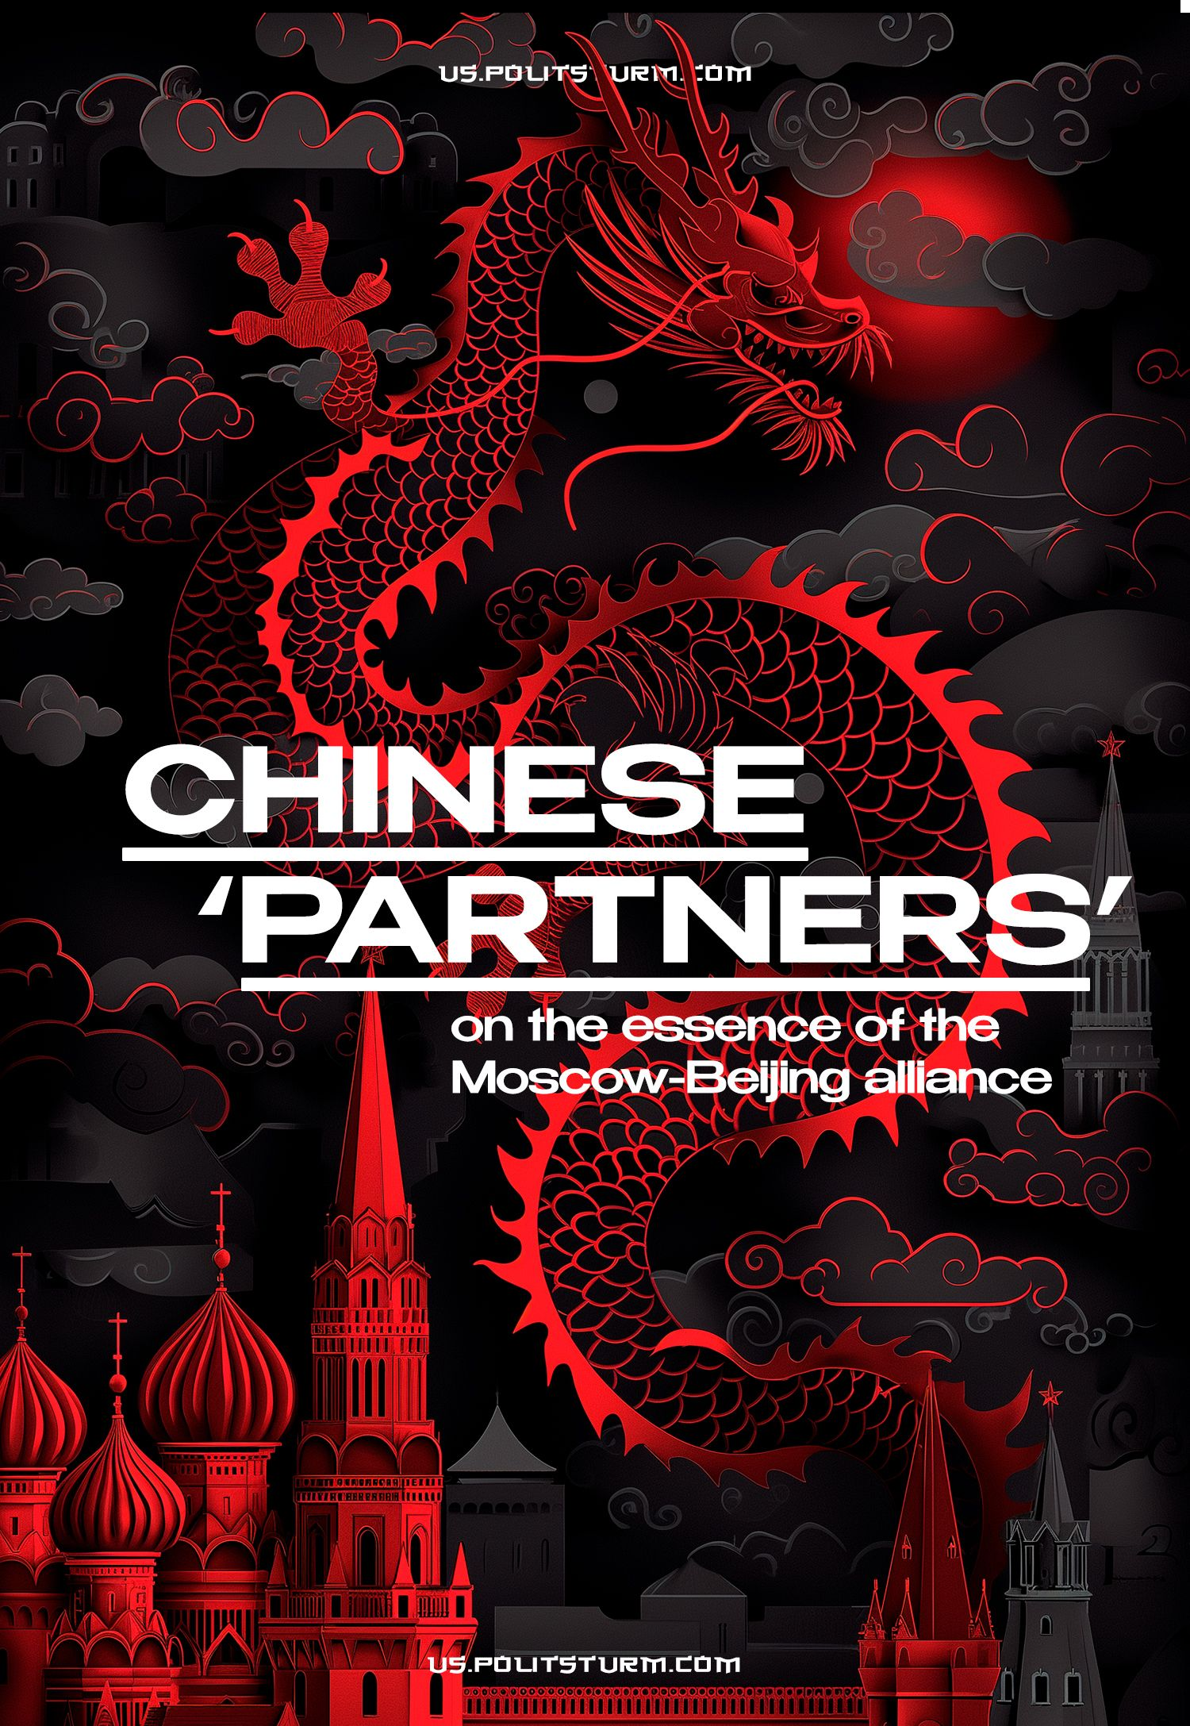

Original article
2024-06-01
41 min read

After the start of the Russian so-called “Special Military Operation”, Russian propaganda and authorities began to more actively promote the narrative of “alliance” and “friendship” with China. This is also facilitated by the preservation of outwardly friendly relations between the Russian Federation and the PRC and frequent mutual visits of Russian and Chinese politicians to each other. “Economic cooperation” has indeed increased between the countries since the beginning of the Russian “Special Military Operation”, but the real relations between Russia and China are far from the model of “political union” and “bloc confrontation” with the West presented by Russian media.
● In recent years, China has become Russia's main trading partner: a third of Russia's foreign trade (exports and imports) comes from China. Russia is becoming dependent on Chinese goods;
● Extensive trade does not mean that Chinese capital will invest in the development of Russian production. Chinese investments in the Russian Federation are reluctant, and China mainly takes advantage of Russia’s dependent position, extracting for itself unprecedented discounts on gas, tax breaks for shareholders, etc.;
● Increasing the presence of Chinese capital in Russian markets does not at all mean political support for Russia by China. The PRC has much more extensive economic ties with Western countries than with the Russian Federation, and even complies with Western sanctions against Russia;
● Russia’s growing dependence on China and continued dependence on Western countries gives rise to a dual political course of the Russian Federation. Statements of friendship with China are interspersed with ingratiation to “Western partners.”
● At the same time, in the conflict between Russia and Ukraine, China is trying to maintain a line of political neutrality, playing the role of a mediator. The PRC provides almost no political support to the Russian Federation and has not yet openly joined the fight against Western states. What is much more important to China is its influence and profits in international and, above all, Western markets.

I. Export of Chinese capital to Russia
Chinese capital is actively capturing new spaces. In terms of outward foreign direct investment (FDI), China ranks second in the world. Thus, at the end of 2021, China had accumulated $2.79 trillion in investments in other countries [1].
One of the tools for distributing Chinese capital is the “Belt and Road” project, which began in 2013. The essence of the project is to create the infrastructure of a trade route that will connect the countries of Africa, Asia and Europe. This project opens the gateway for the export of Chinese goods and the import of natural resources into China. The “New Silk Road” serves as a tool for Chinese monopolies to seize sources of raw materials and markets.
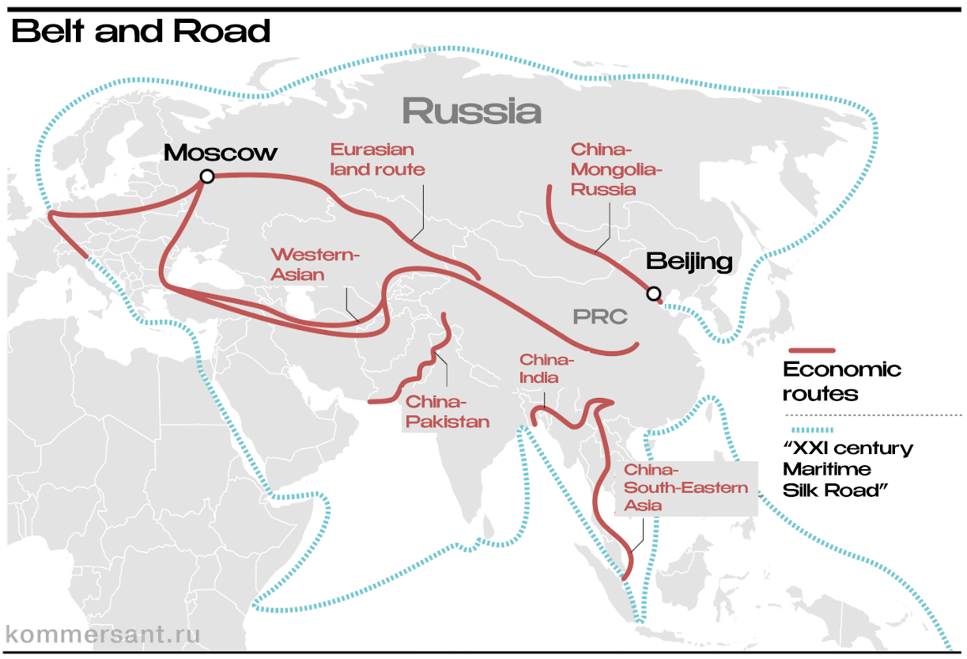
Map of the “Belt and Road” route [2].
By 2022, China has already invested $932 billion in the project [3]. And these investments are producing results: China’s annual trade turnover with countries located along the “Belt and Road” has already reached $2 trillion [2].
The export of Chinese capital also affected Russia. Trade turnover between Russia and China is growing from year to year. Now China is the main trading partner of the Russian Federation. But is the increase in trade turnover related to Chinese investment? Do these investments play a key role in Russia's development?

1.1 The size and significance of Chinese investments in the Russian Federation
An important source for analysis on this issue is data on FDI from the Central Bank of the Russian Federation [4]. The latest published data covers the period from 2007 to 2021. In the table below, Chinese FDI is summed up with FDI from Hong Kong, China's financial gateway.
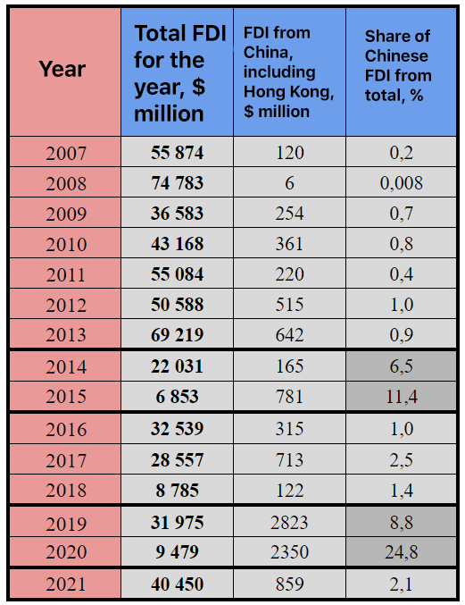
Data foreign direct investment in the Russian Federation by year. Compiled based on data from the Central Bank of Russia [4].
From the data presented it is clear that investments are distributed unevenly over the years. This is due to the fact that large investments from China are associated with only a few projects in the Russian Federation, i.e. they are of a targeted, non-permanent nature. The overall share of Chinese investment is relatively small. They acquired significant weight only against the background of a decrease in the overall flow of foreign capital into the Russian Federation (2015, 2020).
European countries continue to be the leaders in investing in the Russian Federation. To compare the volume of accumulated investments:
– by the beginning of 2022, China and Hong Kong had $3.3 and $2.4 billion of accumulated investments in the Russian Federation, respectively;
– Germany: $25.4 billion;
– France: $24 billion;
– Great Britain: $53.5 billion [5].
However, it is worth noting the conditionality of any statistics in a capitalist economy.
For example, in the cited sources of the Central Bank [4][5], the main investor in the Russian economy is Cyprus, which “invested” $28 billion in the Russian economy in 2021, or 67% of the total investment for this year. The total accumulated investments from Cyprus for all years is $182 billion. Bermuda has more accumulated investments by 2022 than France and Germany combined - $62 billion. Luxembourg - $30 billion, and the Bahamas - $25 billion.
Such statistical “anomalies” are associated with ordinary financial fraud, as openly discussed in the media:
“More than half of the accumulated foreign investment in the Russian economy comes from “phantom” foreign corporations, that is, carried out by shell companies hiding the country - the true source of these investments.” [6]
“It is known that, according to various estimates, up to 70% of FDI in the Russian Federation until recently was Russian capital passing through third countries, including to optimize taxation.” [7]
However, even taking into account financial fraud, Chinese investments in the Russian Federation are several times less than FDI from European countries.
Other sources cite higher amounts of Chinese investment. Thus, according to the Eurasian Development Bank, by 2022 China has accumulated 12.5 billion dollars in the Russian Federation out of $67.5 billion invested in the CIS countries [8]. But even this assessment does not make Chinese investments key for the Russian Federation.
All the above data refer to the period up to 2022. Has the situation changed in recent years, since the outbreak of the conflict in Ukraine? In 2022, not only did other states not invest in Russia, but also a large outflow of capital began.
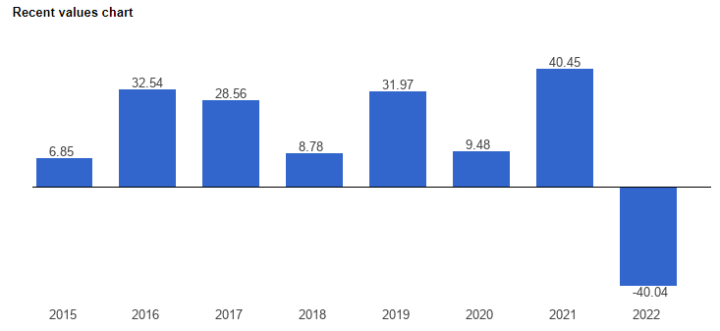
Graphic FDI in the Russian Federation by year in billions of dollars [9]. Negative values ​​correspond to capital outflow.
The same trend has affected Chinese investments. According to RBC, China's investments in Russia within the framework of the “Belt and Road” project in 2022 were the same as usual, mathematically speaking - zero. The reason is fear of sanctions. China invested $28.4 billion in other countries in the first half of 2022 alone [10].
However, on November 8, 2022, at the intergovernmental Russian-Chinese Commission on Investment Cooperation, the Chinese representative stated that:
“According to Chinese statistics, in the first 8 months of 2022, Chinese investment in Russia amounted to $450 million, an increase of 150% compared to the same period last year.” [11]
It is worth noting that various media outlets exaggerate Chinese investments and replicate data on Chinese investments amounting to $165 billion. But they forget to mention that all these billions are just project investments and unsigned contracts about investments. As practice shows, not all projects go beyond discussions. Official statistics are much more stingy with Chinese money than journalists.
From the collected data it is clear that Chinese capital is not at all committed to massive large-scale investments in the Russian Federation, even against the backdrop of the departure of Western companies. According to the President of the Russian-Asian Union of Industrialists and Entrepreneurs (RAUIE), Vitaly Mankevich said:
“China is currently in 22nd place among all direct investors in the Russian Federation, and the main direction of Chinese investment in the Russian Federation is replacing departed enterprises.” [12]
Chinese capital flows to other countries more willingly. While in the Russian Federation China has accumulated $12.5 billion in investments (an optimistic estimate), according to President Tokayev, in Kazakhstan China has accumulated $23 billion [13].
And suppose you pay attention to a higher priority direction for China compared to the Russian Federation, Africa. In that case, you will find that, for example, Kenya has much greater claims to the role of China’s “main ally and partner” - $18 billion by 2018:
“According to estimates by the American Enterprise Institute, from 2010 to 2018, China invested $246.6 billion in sub-Saharan Africa, and specifically in Kenya - $18.3 billion. In 2017 alone, China invested more than $5 billion in the country (more received than only Nigeria, Angola and Ethiopia).” [14]
Oddly enough, one of the leaders in attracting Chinese capital is the United States. In 2014-18 China invested more than $100 billion in American companies, and the share of Chinese FDI out of all FDI entering the United States reached 9.5% in 2016, after which it began to decline [15].
In general, Chinese investments are not the basis for rapprochement between the Russian Federation and the PRC, contrary to the statements of propaganda and Russian politicians. Investments are inconsistent, few and far between, and investment projects are often frozen or postponed. This is due to the fact that Russia is under sanctions, to which China is also subject. But even before the sanctions, Chinese capital did not see any significant investment attractiveness in Russia compared to other countries.
All this contradicts the image that Russian state propaganda paints: hundreds of billions of Chinese investments that will supposedly be invested in the Russian economy. The reality is much more prosaic: the flow of Chinese capital is an order of magnitude smaller than pre-sanction European investments, and, in principle, is not capable of replacing them. This is where the Russian state’s still-lingering hopes for a return rapprochement with Western countries stems.

1.2 Investment projects from China
We found out the general significance of Chinese investments in the Russian Federation. But what specific projects is China investing in?
The overall contribution of Chinese investments to the Russian economy is small, but individual Chinese projects are of great regional importance. Among the main areas of Chinese investment in the Russian Federation are energy, mechanical engineering and real estate.

Energy
An article in Neftegaz magazine dated June 2020 provides the following information:
Since 2014, the share of Chinese energy investments in Russia has been significantly higher than in other countries of the world. Thus, if in 2019 the share of energy investments in the total flow of Chinese investments in the world was 34%, then in Russia it was 90.2%. [17]
In 2011, this share was 77.9%, in 2014 – 93%, in 2015 – 63.6%, in 2016 and 2017 – 100% [17].
Let us give examples of the largest energy projects with the participation of Chinese capital.
Yamal LNG. Construction of enterprises for the production and liquefaction of natural gas (LNG). Construction of this facility began in 2013. Currently, $27 billion has been invested in the project, of which Chinese sources:
– a loan from a syndicate of Chinese banks in the amount of $13 billion;
– purchase by the Silk Road Fund of 9.9% of the shares of enterprises for $1.2 billion;
– purchase by a Chinese company CNPC 20% shares for $1.48 billion.
The remaining funds were invested, including Sberbank and Gazprombank - $4.4 billion, the Russian National Wealth Fund - $2.6 billion and the French company total for the purchase of 20% of shares - $0.425 billion. At the moment, Total plans to sell its share, which is claimed by companies from China and Japan [17][18].
This example shows that China is more willing to give loans rather than act as an investor: $13 billion in loans versus $2.68 billion in investments. The practice of extensive lending is in principle typical for the imperialist powers and serves to subjugate other countries. Long-term loans from China have already put a number of industries and even entire countries in Central Asia and Africa in a dependent position. A similar fate could befall the Russian LNG industry.
In total for 2023-2024, Chinese shareholders should receive about 100-110 billion rubles in dividends for their share in Yamal LNG [19].
Economic sanctions from Western countries have stopped the flow of Chinese capital into this project. Taking advantage of the situation, Chinese investors are demanding a reduction in taxes on dividends. Money saved from taxes is supposed to be reinvested into Novatek projects. Thus, instead of going to the budget of the Russian Federation, about 10 billion rubles of taxes on dividends will annually remain in the hands of investors [19][20].
Arctic LNG-2. As in the case of Yamal LNG, the largest foreign investor in this project is China. Chinese companies CNPC and CNOOC became owners of 20% of the project shares. The transaction price is not disclosed. It can be assumed that Chinese investors invested about $2.6 billion since it is known that the French total paid 1.3 billion dollars in 2019 for the purchase of a 10% stake in the enterprise [21]. There was also lending: Chinese banks issued a loan of 2.5 billion euros for this project [72].
However, at the end of 2023 it became known that the project came under US sanctions, and the Chinese shareholders, along with other foreign participants - the French TotalEnergies, a consortium of Japanese Mitsui and JOGMEC - announced “Force Majeure”, which meant stopping funding [22].
The launch of the Yamal LNG and Arctic LNG-2 projects ensured a significant increase in Russian LNG supplies to China. This allowed the PRC to obtain another source of fuel and a new route for its delivery. The main suppliers of LNG to China are Australia, Malaysia, Qatar and Indonesia. The routes pass through the South China Sea, including the narrow Strait of Malacca.
Despite its interest in Russian gas, China values ​​more its extensive ties with Western countries. Thus, we are aware of the request of Chinese companies to the US government to exclude Arctic LNG-2 from sanctions [73]. This fact once again confirms that Chinese capital takes into account American sanctions.
At the moment, the enterprise is idle due to the refusal of South Korean shipyards to supply tankers for gas transportation - due to the same sanctions.
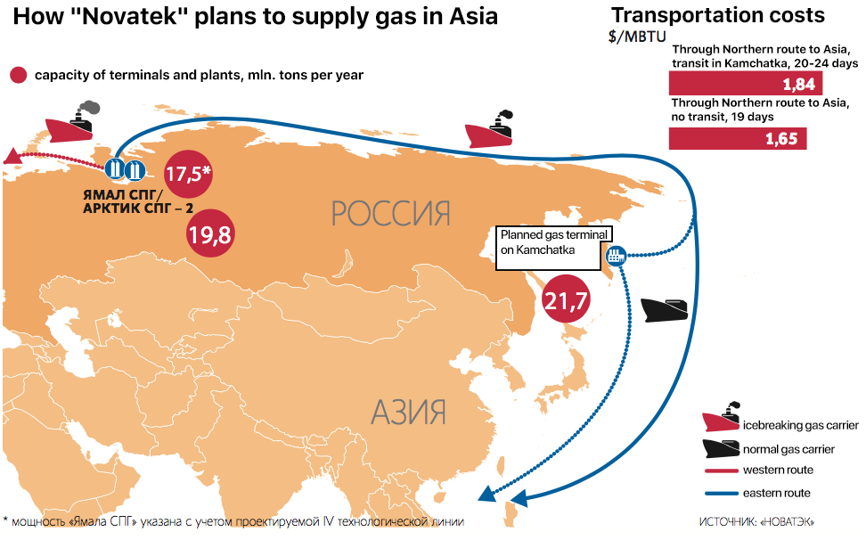
Route supplies of liquefied natural gas to China from the Russian Federation.
In addition to gas, China is also interested in Russian oil.
Udmurtneft. In 2006, Sinopec bought a 96.9% stake in Udmurtneft from TNK-BP Holding for $3.5 billion. Subsequently, Rosneft bought 51% of the company’s shares from Sinopec. This is the largest enterprise in the region, producing 60% of the oil in Udmurtia [23].
JSC "VCNG". In 2016, the Chinese Beijing Gas Group bought 20% of Verkhnechonskneftegaz PJSC from Rosneft for $1.1 billion [24].
No matter how large these projects are, Chinese investment does not play a key role in Russian oil and gas production. For comparison, the investment program of Gazprom alone in the Russian gas industry for 2023 is 2.3 trillion rubles, or $25 billion [25]. Total investments in the oil industry in the Russian Federation in 2023 are 2.7 trillion rubles or $29 billion [26].
Gazprom's annual investment program alone is twice the amount of Chinese investment for all years and in all industries.
Chinese capital, unlike goods, flows into Russia reluctantly. This is largely due to the fact that Russia does not need massive investments from China, since it basically has all the necessary enterprises for the extraction of natural resources. Another thing is that due to sanctions, the Russian Federation has lost fuel markets.
Taking advantage of the decrease in Russian gas supplies to the European Union, China is seeking to reduce prices for gas purchases. This policy led to delays in negotiations on the construction of the “Power of Siberia - 2” gas pipeline. A Gazprom representative “refuted” this information with a reference to the book “Heart of a Dog”, saying: “Don’t read Soviet newspapers” [27]. Such a rigorous “refutation” can instead be taken as a confirmation of the delay.
At the same time, China has accelerated the construction of a competitive gas pipeline from Turkmenistan. Its capacity is 50 billion cubic meters. m – like “Power of Siberia - 2” [28].

Mechanical engineering
Investments in mechanical engineering are directly related to increased trade turnover. Most of the newly opened factories are engaged only in assembling equipment from Chinese components for sale in Russia. Here are examples of the largest of these projects.
Great Wall. The company opened a plant in the Tula region, which produces cars of the Chinese brand Haval. Initial investment: $500 million. Currently, the plant employs about 2 thousand people [29].
“According to Autostat, in 2023, 112 thousand Haval cars were sold in Russia (an increase of 2.3 times). Haval's market share in Russia at the end of 2023 was 10.55% (in 2022 - 5.45%). The most popular foreign car was the Haval Jolion crossover assembled in Russia.” [30]
Cars are produced from Chinese components, and only by 2029 is it planned to increase the localization of production to 70% [31]. The same Haval company launched a plant for the production of automobile engines in the Tula region with 300 jobs. The planned capacity is 100 thousand engines per year. [29][31].
Haier. This company opened a number of factories for the production of household appliances in Naberezhnye Chelny, with a total planned investment of $1 billion. In addition, in the spring of 2022, negotiations were held on the opening of production sites in the Lipetsk region [32].
"DMTG RUS". Factory for assembly metalworking machines in the Moscow region supporting 300 jobs. The Chinese company Dalian Machine Tool Group (DMTG) has 49% ownership, and 51% is owned by the Russian company Gazdevice. Joint investments amounted to 1.2 billion rubles. In the future, investments of up to 8 billion rubles are planned [33].
It is easy to notice that China's largest investment projects in the field of manufacturing concern only consumer goods: cars, refrigerators, washing machines, kitchens and other household appliances. Investments in the production of machines and equipment are an order of magnitude less.

Real estate
Chinese investments in Russian real estate are mainly aimed at creating rental space for offices and exhibitions. But part of their “investments” are directed to ordinary speculative real estate transactions. Let's look at a few examples.
The Greenwood Complex in the Moscow region, where offices and representative offices of various companies are located. The exhibition and office complex was purchased by the Chinese corporation Chentong in 2010 for $350 million. The complex has 14 thousand square meters of exhibition space and 23 thousand square meters of office space. In 2017, the Chinese owners invested another $150 million in the construction of new areas for the complex. $6 billion of the total annual trade turnover between the Russian Federation and China is facilitated and passes through this complex [34][35].
Huaming Park. Investments amounted to $350 million. The area of ​​the business center is 100 thousand square meters [36].
"Park Huaming" is a Chinese business center that is designed to promote the development and strengthening of business ties between entrepreneurs from Russia and China [37].
Buying building Voentorg in 2017 for 172 million in the center of Moscow by the Fosun Group of businessman Guo Guangchang. The area of ​​the office center is 70 thousand square meters. The Chinese owners subsequently resold the complex [38].
We can also consider other areas of investment of Chinese capital in the Russian Federation: the chemical industry, agriculture, ore mining, metallurgy, etc. However, all these projects are of a secondary nature and do not play a significant role in the economy of the Russian Federation, as well as for China itself.
The Russian economy differs significantly from the so-called “developing countries” of Asia and Africa, which are enslaved by the export of Chinese capital. The export of capital to these countries is aimed at the construction and operation of the largest enterprises, and infrastructure facilities, as well as for lending and, ultimately, the enslavement of these states. Russia is not such a promising destination, and therefore less attractive for the export of Chinese capital. In addition, China does not want to risk its investments due to sanctions, no matter what Russian state media say about it on this matter.
Russia’s dependence on China is built primarily on trade turnover, namely on the supply of Russian energy resources to China and Chinese equipment to Russia. However, another type of dependence does not mean no dependence at all.

II. Trade turnover
Below are data on trade turnover between countries. The past few years have seen a period of rapid growth.
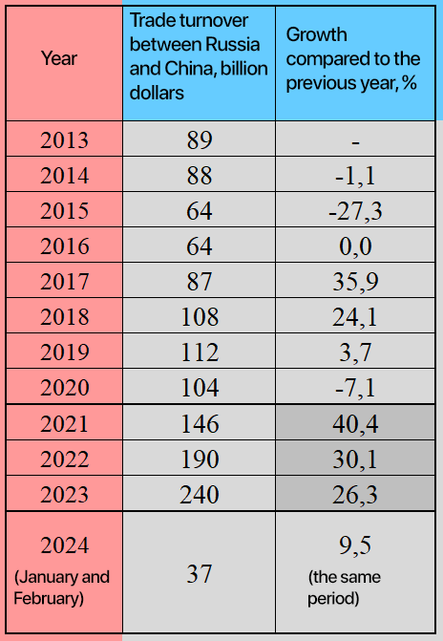
Statistics trade turnover between China and the Russian Federation. Compiled based on data from RuStat, TASS and RBC [39][40][41][42][43].
If you transfer the data to a graph, you can see a general trend towards growth in trade turnover over the past decade.
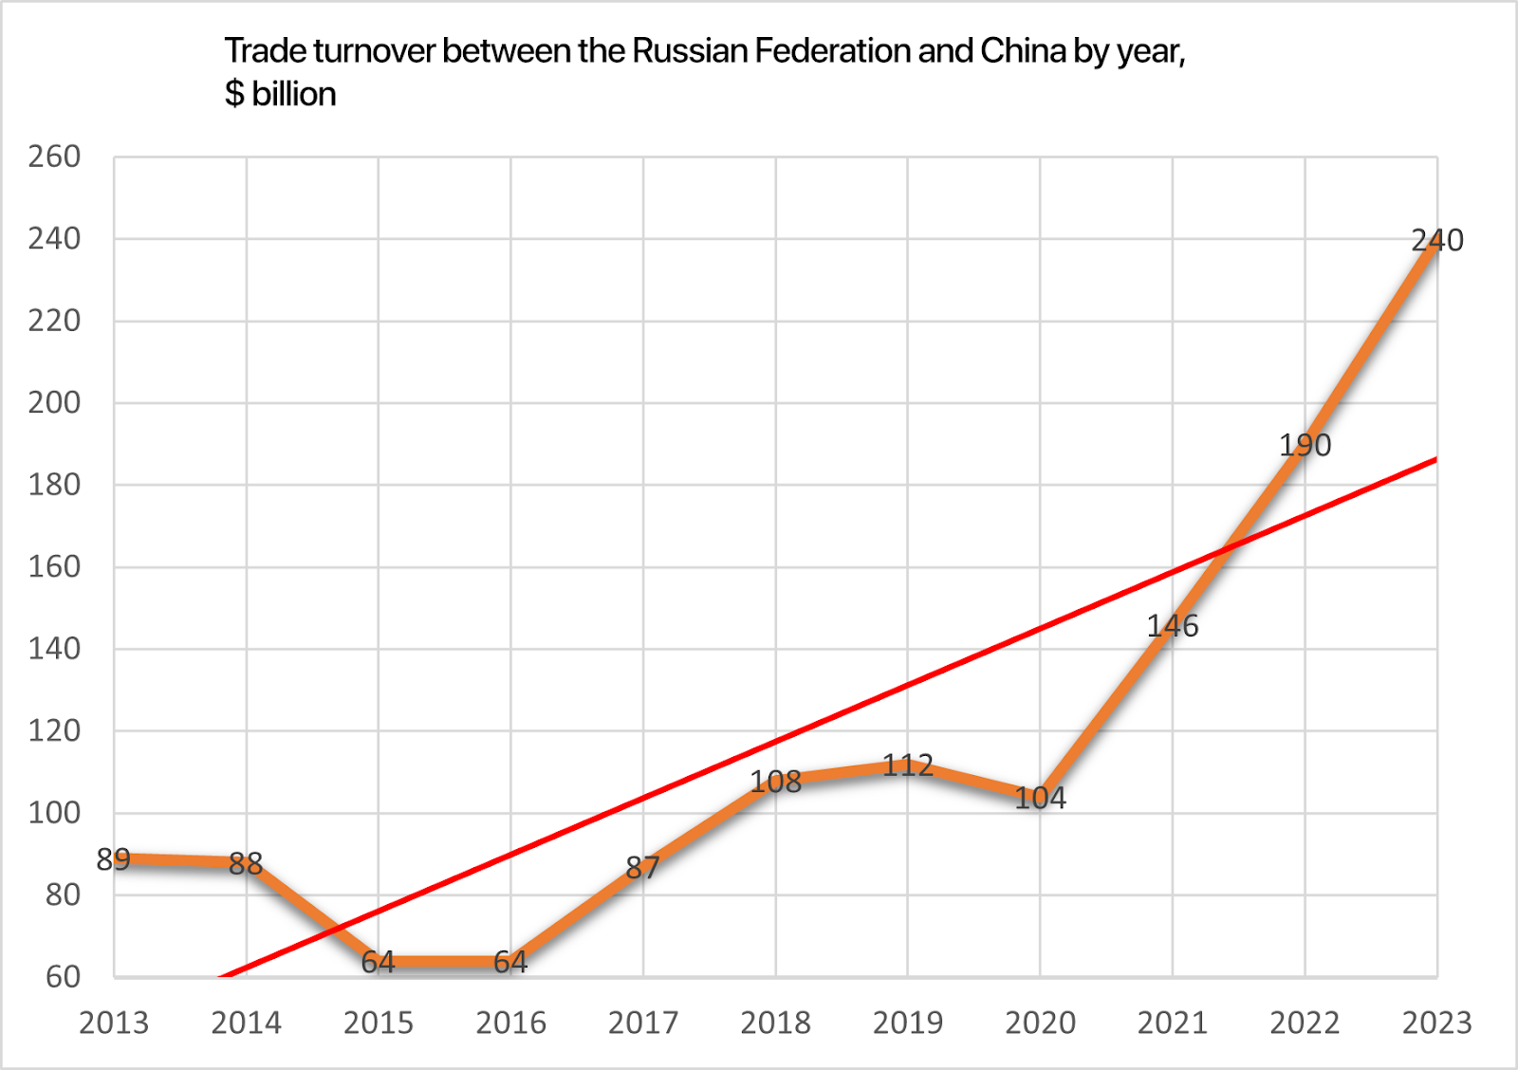
Graphic growth in trade turnover between the Russian Federation and China by year.
Growth is interrupted only by temporary periods of crises, 2014-15 and 2019-20 - common to the whole world, as the graph below demonstrates.
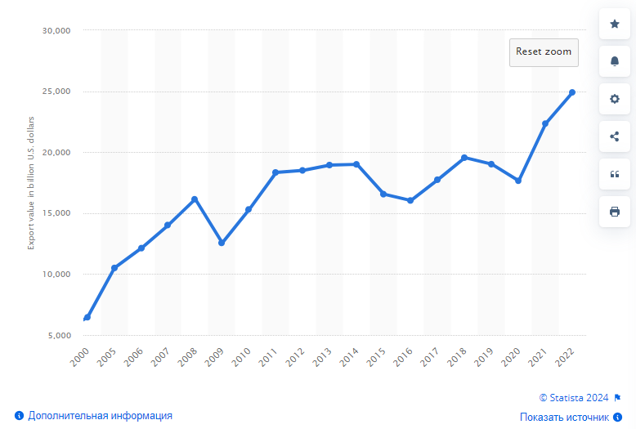
Statistics of global trade turnover in billions of dollars [45].
However, already in 2024 growth slowed down. In 2023 the average annual growth of trade was 26%, in January 2024 - 13%, and in February - 6%. In March, there was a complete decline in Chinese exports by 16% compared to the same month in 2023 [44].
In general, the growth of trade turnover means that countries are moving closer together economically and that they are becoming more and more dependent on each other. However, is this dependence equivalent? Below is data on what share China occupies in total trade turnover with the Russian Federation.
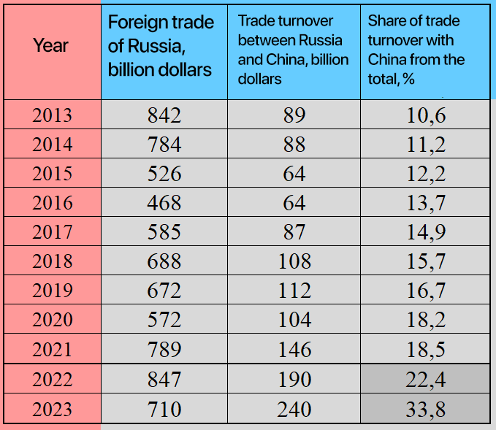
Part of China in foreign trade with the Russian Federation [46].
The data shows that from year to year, the share of China in trade with Russia is growing, and in 2023 it already amounted to a third of the total foreign trade of the Russian Federation - 33.8%. However, Russia is a much less important trading partner for China.
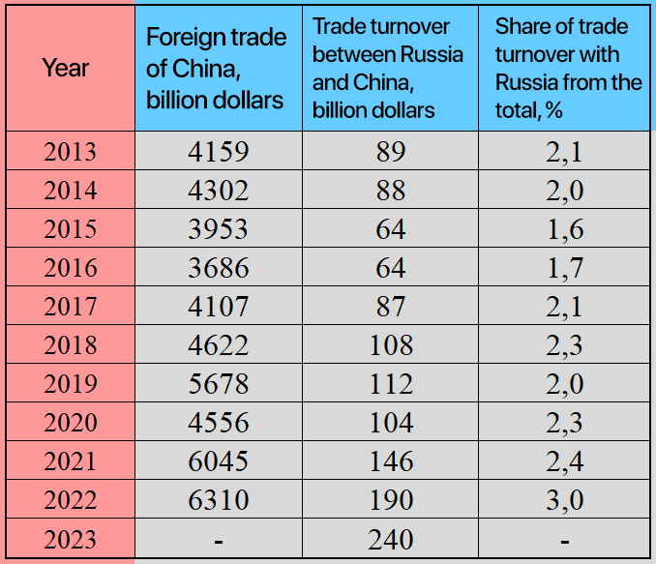
Part of Russia's foreign trade with China [47].
Thus, in recent years, Russia’s share in total Chinese trade turnover has increased only from 2% to 3%. Already from this data, it is clear how Russian and Chinese capitals correlate. But this is only the quantitative side of the issue. Let's see what goods the countries trade.
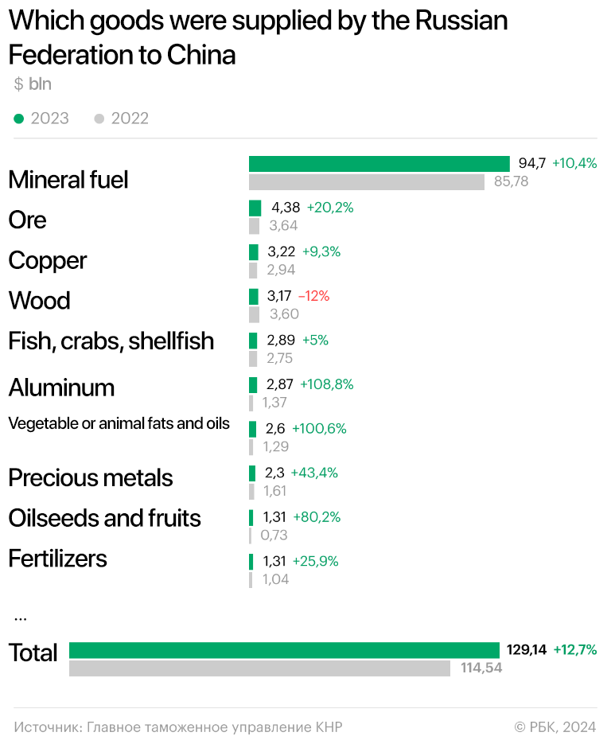
Which goods were supplied by the Russian Federation to China in 2022-23 [48].
3/4 of all Russian exports are mineral fuels: oil and gas. Of the remainder, the majority comes from other natural resources and metals, as well as agricultural products. Over the period 2022-23, exports increased by $14.6 billion; $8.9 billion of this increase is occupied by oil and gas resources.
China supplies high-value-added products to Russia: machinery, electrical equipment, and vehicles.
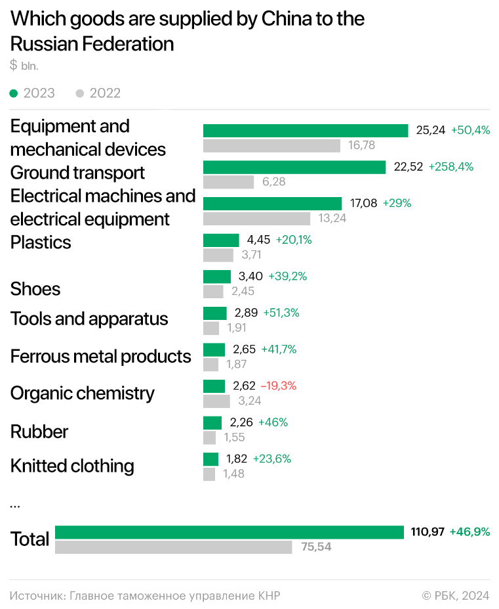
Which goods are supplied by China to the Russian Federation [48].
Over the period 2022-23, imports of Chinese goods to Russia increased by $35 billion, of which $16 billion were in the category “land transport”, $10.5 billion – “equipment and mechanical devices”, and $4 billion – “Electrical machines and electrical equipment”.
In total, goods from these categories account for about 2/3 of total Chinese imports.
This situation is associated with a decrease in trade with the countries of the European Union, which used to be the main supplier of technical devices to the Russian market. Thus, at the beginning of 2022, Russia accounted for 9.5% of total European imports and 4% of exports, while by the end of 2023, imports dropped to 2% and exports to 1.5%.
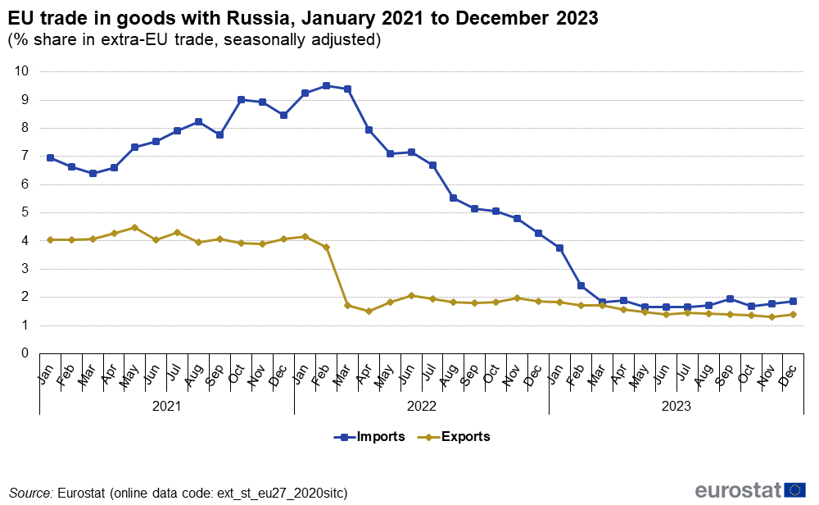
Fate Russian Federation in foreign trade of the European Union [49].
In turn, in 2023, Russian exports to the EU decreased threefold compared to 2021 [50]. Accordingly, the EU’s share in Russia’s foreign trade has also fallen: from 38% in 2021 to 18% in 2023 [51].
The sharp drop in trade with EU countries in 2023 coincides with the largest increase in trade with China in the same year: an increase of $50 billion in one year.
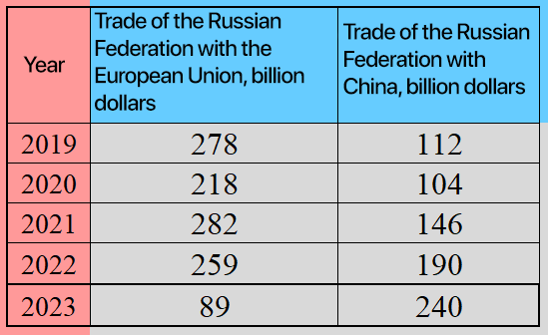
Comparison trade of the Russian Federation with the EU and China [50][52][53][54].
In 2023, China overtook the EU for the first time to become Russia's top trading partner.
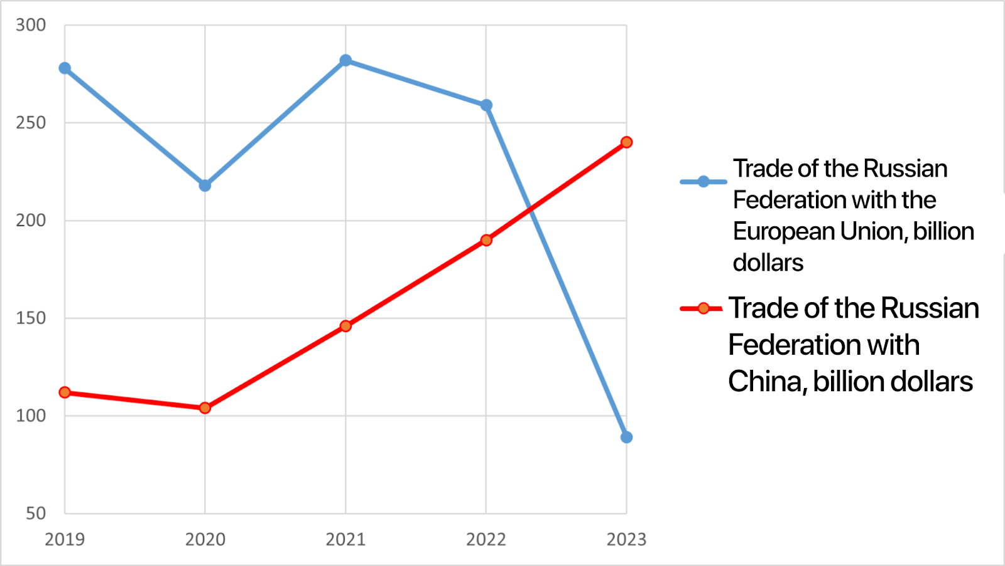
Comparison trade of the Russian Federation with the EU and China on the chart.
What conclusion can be drawn from the given data? The import dependence of the Russian Federation on the European Union is being replaced by dependence on China. The fall in oil and gas supplies to the EU is accompanied by a simultaneous increase in supplies to China. The fall in supplies of machinery and technical goods from the EU occurs simultaneously with an increase in supplies of these goods from China.
The economic essence of these phenomena is clear: Chinese capital is seizing Russian sales markets and sources of raw materials that have become free from their “European partners.” This reveals exactly the same process in relationships that could be observed for decades in relations between Russia and Western countries.

III. Between West and East
In the international arena, the tendency towards the formation of two separate imperialist camps is becoming more and more pronounced.
So, for example, at the third forum dedicated to the “Belt and Road” project held in China in October 2023, there were almost no politicians from Western countries present. The only representative of the European Union is Hungarian Prime Minister Viktor Orban, who is in opposition to the EU. Earlier, in 2019, the second “Belt and Road” Forum was attended by representatives of the largest EU countries, as well as representatives of the IMF and the UN. Already in 2023, none of them received an invitation.
In the same October 2023, the EU countries held their forum dedicated to the Global Gateway infrastructure project, the European analogue of the “Belt and Road” [55].
Russia occupies an intermediate position in this confrontation between the two camps. The Russian economy is already dependent on China but still remains somewhat dependent on trade with the European Union, relations with which have deteriorated significantly against the backdrop of the Russian so-called “Special Military Operation”. This forces Russian politicians to “sit on two chairs.”
For example, Vladimir Putin, who attended the aforementioned Chinese forum in 2023, assured Viktor Orban that “relations with many European countries are maintained and developing”. However, this did not stop Putin and Xi Jinping from routinely declaring at the end of the forum that “The political interaction between the two countries is strengthening, and the strategic interaction remains close and effective.” [56]
The rhetoric of the Russian authorities towards China concerns mainly economic interaction.
“Russia is ready to switch to payments in yuan in trade with other countries, Vladimir Putin said during Russian-Chinese negotiations in an expanded format.” [57]
Previously, Putin announced the goal of achieving trade turnover between countries at around $200 billion [58]. Mishustin expresses hopes for cooperation in the field of high technology:
“Russia and China can exchange advanced technologies within the framework of cooperation,” Prime Minister Mikhail Mishustin said at the Russian-Chinese Business Forum in Shanghai. According to him, cooperation between the two countries may also affect the production of civilian drones and equipment for oil refining.” [59]
The rhetoric of senior officials is quite soft and restrained. The Russian authorities always “hope” for the best in relations with the PRC and try to oppose Western countries to an alliance between Russia and China, which is largely a propaganda fiction. The same Prime Minister Mishustin, after a meeting with the leadership of the PRC:
“Our countries have historical relations of friendship and mutual respect. And now they are growing stronger, despite all the sanctions, due to the actions of our opponents.” [60]
At the same time, the statements of Chinese officials are much more restrained and neutral, “closer to reality.” The PRC does not seek to “protect” Russia in any way on the international stage or to contrast its ties with the Russian Federation with ties with Western countries.
This policy can be explained by the fact that China has significant economic ties with the United States and the European Union. In 2023 the trade turnover of China with the Russian Federation amounted to $240 billion, compared with the USA - 664 billion dollars, and with the European Union - $783 billion.
China also conducts a significant amount of trade with other countries that have joined the sanctions against the Russian Federation. Thus, in 2022, the record for trade between China and Canada was updated: $100 billion in imports of Chinese goods and $28 billion in exports from Canada [61].
Total trade volume with Japan in 2022: $126 billion [62], with South Korea - $150 billion (together with Hong Kong) [63], Australia - $122 billion [64], etc.
Economic ties and fundamental interests simply do not allow Chinese politicians to completely sever contact with Western countries, especially for the sake of the relatively small Russian market.
The characteristic point is that China is subject to Western sanctions against Russia, which Russian politicians complain about. Thus, Peskov stated:
“The United States and the European Union continue to exert unprecedented pressure on the People’s Republic of China, including in the context of relations with us. This, of course, creates certain problems, but cannot become an obstacle to the further development of our trade and economic relations.” [65]
Due to fears of falling under secondary sanctions, Chinese banks began to refuse transfers to Russian companies:
“Chinese banks have begun to reject Russian payments for components for electronics assembly, even if there is a long-term contract. Previously, the blockage concerned the supply of finished goods, not parts.” [66]
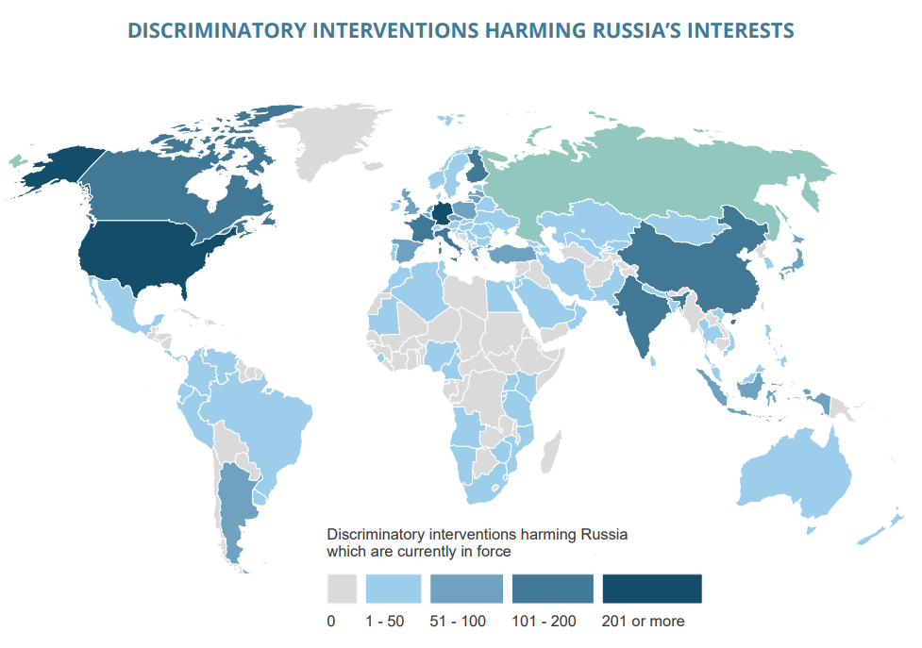
Illustration countries that have restrictions on the Russian Federation for 2021 [67].
However, the Russian Federation previously adopted a number of restrictions against the PRC, as shown in the illustrations below. However, one should not exaggerate the size of these restrictions. For example, the include things like: restrictions on the export of unprocessed wood.
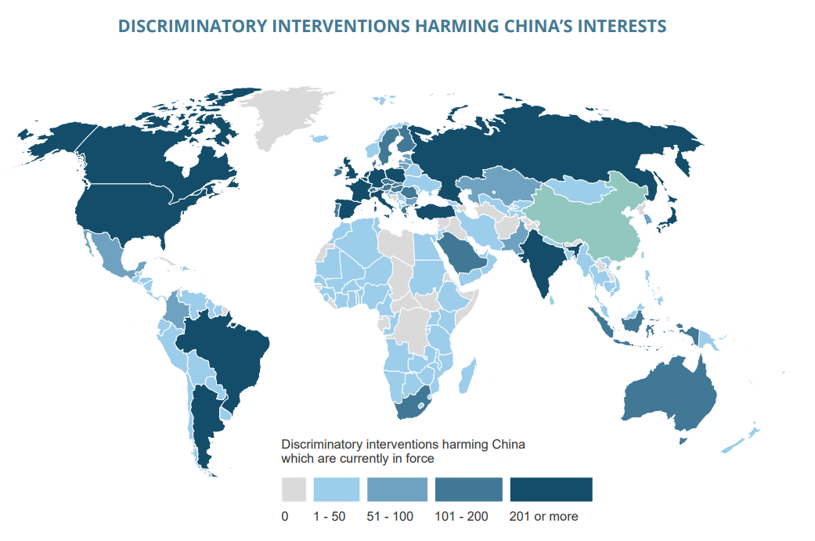
Illustration countries that have restrictions on China [68].
Regarding the conflict in Ukraine, China has never clearly taken the side of the Russian Federation and has not supported any of the slogans or narratives of the Russian authorities. On the contrary, it is known that China is trying to act as a mediator in the conflict and, for these purposes, is in every possible way replicating its own peace initiative.
“With regard to the Ukrainian issue... China supports the convening of an international conference, in which Russia and Ukraine would confirm participation, as well as with equal participation of all parties and with the discussion of all peace plans” [69].
But even in this case, China does not provide obvious political support to the Russian Federation. China’s peace formula does not include points that clearly put China on the side of the Russian Federation. The leaders of the PRC are limited to only general words about friendship and do not commit to anything.
Xi Jinping stated:
“China supports the Russian people in following their chosen path of national revival and protection of state sovereignty, security and development interests.
The PRC is ready to develop ties with Russia, including working more actively to unite the countries of the global South in the spirit of equality, openness and inclusiveness.” Beijing is also interested in cooperation with Moscow on reforming the global governance system, the Chinese leader specified [70].
In addition, China supported with its voice the well-known UN resolution in which Russia is called an “aggressor country” [71].
The PRC government is pursuing exactly the same dual policy as the Russian Federation: outwardly it condemns Western countries but continues to trade with them. However, Russian capital is an order of magnitude smaller than Chinese capital, which determines its hierarchy in the imperialist system. If China is a saviour for the Russian Federation, replacing the European Union, then the Russian Federation for China is just another captured market. At the same time, their attitude towards their newly acquired trophy is quite restrained. If political conditions turn out differently for China, it will easily abandon it. There can be no talk of any kind of equal cooperation, let alone a “union” or even a “bloc”.
Ultimately, Chinese capital simply took advantage of a convenient situation to capture the Russian market. Any development of Russian industry or investments will not follow from such a market capture. There will also not be any significant political support for Russia from China, since its economic ties with Western countries are still strong.

What's the result?
In general, we can say that the Russian Federation is becoming dependent on the PRC. Chinese capital is actively taking advantage of this dependence, further increasing the export of its goods to the world market. At the same time, it is absolutely impossible to talk about a “union” between the two countries. The most that can be allowed in this sense is the recognition of the existence of a temporary tactical regime of external goodwill towards each other.
The Russian Federation supplies China with the resources it needs at a large discount, and China does not actively oppose Russian foreign policy.
How will relations between China and the Russian Federation develop further?
Firstly, China’s expansion into the Russian domestic market will obviously continue. However, the pace of this expansion may soon slow down, as the rapid growth of trade is associated with the replacement of European supplies. This effect is short-term.
Russian oil and gas supplies to China will also grow, but will not become as key for China, as they were for the EU. This is due to the fact that China has a wide network of trade routes with countries in Asia and Africa, as well as extensive internal sources. This means that China’s pressure on the Russian Federation will continue in order to extract favorable prices for Russian resources.
Secondly, Russia’s dependence on the EU is simply being replaced by dependence on China. There is no talk of any import substitution or economic sovereignty. In 2023, trade turnover with the EU decreased by $164 billion compared to 2019. Trade with China increased by $128 billion, with the most significant changes occurring in the last two years.
Third, Western countries still remain an important trading partner of the Russian Federation: China has not yet completely supplanted them. Even despite the sharp decline in trade, EU countries still account for a fifth of Russian trade. This dual situation forces the Russian leadership to bow down to both Chinese and European partners. Loud, pompous statements from Western politicians and some Russian propagandists have little impact on ongoing real trade with the US and EU.
It is also possible that a scenario in which, in order to restore old ties with Western countries, Russia may move away from the PRC. Of course, the bloc of Western states could potentially want to use the Russian Federation to put pressure on China in the future.
Fourth, one should not expect an increase in political support for Russia from China: the PRC is only interested in the Russian market and sources of raw materials. In addition, Chinese capital benefits from the role of intermediary between Western countries and the Russian Federation.
However, if during the Russian so-called “Special Military Operation”, the conflict between China and the United States reaches the stage of a full-scale war, a sharper rapprochement between Russia and China is possible. In this case, the Russian Federation can itself take the place of a mediator between the PRC and Western countries, since Russia is not interested in a direct military conflict with NATO.
If the current vector of relations between the Russian Federation and the PRC remains unchanged, then the economic dominance of Chinese capital will sooner or later lead to political dominance. It is quite obvious what place the Russian Federation will occupy both in future armed confrontations between imperialist blocs and in China's “community of the common destiny of mankind”. The PRC, sooner or later, will take advantage of Russia’s dependence, just as the Entente countries once took advantage of the dependence of the Russian Empire, in order to use Russian workers and peasants as cannon fodder against the Kaiser’s troops.
There is not and will not be any “prosperity” for the Russian economy from rapprochement with China. One major imperialist is simply being replaced by another - this is the objective reality.

Sources
- Information service "Russia-China: the main thing" – China's overseas direct investment has ranked among the top three in the world for ten years in a row from 09.11.2022
- Kommersant –“One Belt, One Road”: what you need to know about the project from 18.10.2023
- RBC – Investments in Russia through China's global project have dropped to zero from 25.07.2022
- Website of the Central Bank of the Russian Federation - data on the volume of FDI in the Russian Federation. Dated from 04/15/2024
- Website of the Central Bank of the Russian Federation – Interactive presentation of up-to-date statistical data “Accumulated direct investment by geographical regions of the world, countries, instruments and types of economic activities.” Dated from: 04/15/2024
- RBC –The IMF assessed the share of “phantom” foreign investments in Russia from 18.12.2019
- Kommersant –Plus or minus foreign direct investment from 17.07.2023
- Eurasian Development Bank –Monitoring of mutual investments of the EDB – 2022 from 20.12.2022
- TheGlobalEconomy.com – Russia: Direct foreign investments, billion dollars Dated from 04/15/2024
- RBC –Investments in Russia through China's global project have dropped to zero from 25.07.2022
- Ministry of Economic Development of the Russian Federation –Russia and China plan to invest another $1.3 billion in joint projects from 08.11.2022
- Ministry of Economic Development of the Russian Federation –Russia and China plan to invest another $1.3 billion in joint projects from 08.11.2022
- TuranTimes – “We are grateful to the Chinese government,” Tokayev on Chinese investments in Kazakhstan from 19.05.2023
- Kommersant –China invests and discriminates from 20.10.2018
- Starchukova Ksenia Dmitrievna Main trends in FDI movement in the development of investment cooperation between the USA and China, taking into account the national interests of economies // Innovations and investments. 2020. No. 7, p. 28 URL (dated from: 04/17/2024).
- Neftegaz.RU – Russia and China: From energy trade to investment cooperation from 19.10.2020
- Pro-arctic.ru – Chinese participation in the Russian Arctic, access date 04/17/2024
- Forbes – Total paid Novatek $425 million for 20% of Yamal LNG from 11.11.2011
- Forbes – Novatek asked to introduce benefits for Chinese investors in Yamal LNG from 07.06.2023
- MASHNEWS – China is ready to invest in Russian LNG projects. But only in exchange for tax breaks from 03.07.2023
- RBC –The Chinese have become the largest foreign investors in the NOVATEK plant from 25.04.2019
- Neftegaz.RU – Foreign shareholders of the Arctic LNG-2 project declared force majeure on participation in the project from 25.12.2023
- RBC –TNK-BP sold Udmurtneft to China for $3.5 billion from 11.08.2006
- Finmarket -Chinese Beijing Gas Group buys 20% in VChN from Rosneft from 07.11.2016
- Russian newspaper -Russian oil and gas companies are ready to continue investing in the industry, despite geopolitical difficulties from 14.06.2023
- Vedomosti –Investments in the oil industry in Russia in 2023 reached 2.7 trillion rubles from 29.01.2024
- RBC –Gazprom responded to FT data about China’s delay in the construction of Power of Siberia-2 from 25.05.2023
- RBC –Reuters learned that China will speed up the construction of a gas pipeline from Turkmenistan from 25.05.2023
- NTV –A plant for the production of Haval engines was launched in the Tula region from 06.03.2024
- Ixbt.com – The Russian Haval plant has reached its design capacity. The level of production localization should reach 70% by 2029 from 11.02.2022
- Forbes – A plant for the production of engines for Haval cars was launched in the Tula region from 06.03.2024
- RBC –The governor of the Lipetsk region discussed prospects for cooperation with Haier from 18.05.2022
- Website of the Moscow Region Government -A plant for the production of metalworking equipment was opened in the Leninsky district from 07.12.2017
- RBC –The Chinese are investing $150 million in the construction of a business park in the Moscow region from 28.11.2017
- Rambler –Vorobyov discussed with partners from China the construction of the second stage of the business park from 19.10.2023
- RBC –The Park Huaming business center has been completed in Moscow from 06.12.2021
- TASS -The Chinese park in the northeast of Moscow is planned to open in 2023 from 29.03.2022
- RBC –Chinese investors bought the Voentorg building from billionaire Rybolovlev from 29.03.2022
- RuStat –Export and import of Russia by goods and countries – date of access: 04/18/2024
- TASS -Trade turnover between Russia and China in 2021 reached a record $146.88 billion from 14.01.2022
- RBC –Russia's trade with China reaches a record from 13.01.2023
- RBC –Trade turnover between Russia and China in 2023 broke a record from 19.01.2024
- Infranews –Trade turnover between Russia and China for 2 months of 2024 increased by 9% from 20.03.2024
- Kommersant –Bloomberg: China's exports to Russia fell by 16% in March from 17.04.2024
- Statesman –Trends in global export value of trade in goods from 1950 to 2022 – dated from: 04/18/2024
- World finance –Foreign trade of Russia: 1994 – 2024 – dated from: 04/18/2024
- SVSPB – China's foreign trade – dated from: 04/18/2024
- RBC –What Russia sold to China in 2023 and what it bought from it from 24.01.2024
- Eurostat – EU trade with Russia - latest developments – dated from: 04/18/2024
- Report – Trade turnover between the EU and the Russian Federation in 2023 decreased by 2.9 times from 16.02.2024
- TASS -The Federal Customs Service stated that the share of Russia’s trade turnover with EU countries is now 18% from 15.06.2023
- Federal State Statistics Service –About foreign trade in 2020 – dated from: 04/18/2024
- Federal State Statistics Service –About foreign trade in 2021 18.04.2024
- RBC –The Federal Customs Service revealed the volume of Russian foreign trade in 2023 11/14/2023
- Vedomosti –The European Union has prepared a response to the Chinese Belt and Road Forum from 20.10.2020
- RBC –Putin and Xi held confidential talks “over a cup of tea” from 18.10.2023
- RBC –Putin announced Russia's readiness to switch to the yuan in foreign trade from 21.03.2023
- RIA news -Putin assessed the prospects for growth in trade turnover between China and Russia from 16.10.2023
- Kommersant –Mishustin: Russia and China can cooperate in the production of civilian drones from 25.05.2023
- RIA news -Mishustin said that relations between Russia and China are only getting stronger from 25.05.2023
- Chinaved – China's annual exports to Canada exceed $100 billion
- World's Top Exports – Japan’s Top Trading Partners – dated from 04/18/2024
- World's Top Exports – South Korea’s Top Trading Partners – dated from 04/18/2024
- World's Top Exports – Australia’s Top Trading Partners – dated from 04/18/2024
- RBC –The Kremlin appreciated the refusal of Chinese banks to accept payments from Russia from 21.03.2024
- Moscow's komsomolets -Chinese banks have driven Russian business to a dead end: they refuse to accept payments 12/04/2024
- The 28th Global Trade Alert Report, p. 85
- The 28th Global Trade Alert Report, p. 125
- RIA –China supports convening a conference on the Ukrainian issue from 04/09/2024
- Parliamentary newspaper –The head of the People's Republic of China assessed Russian-Chinese relations from 10.04.2024
- Channel 5 –Position unchanged: Beijing vote opened failure of the UN from 06.05.2023
- Investing.com – Arctic LNG-2 will receive a loan of up to 9.5 billion euros, including 2.5 billion euros from Chinese banks from 30.11.2021
- RBC –Chinese companies asked the US for exceptions to sanctions against Russia from 23.12.2023

Original article

