Chinese Imperialism and the Debt Trap System
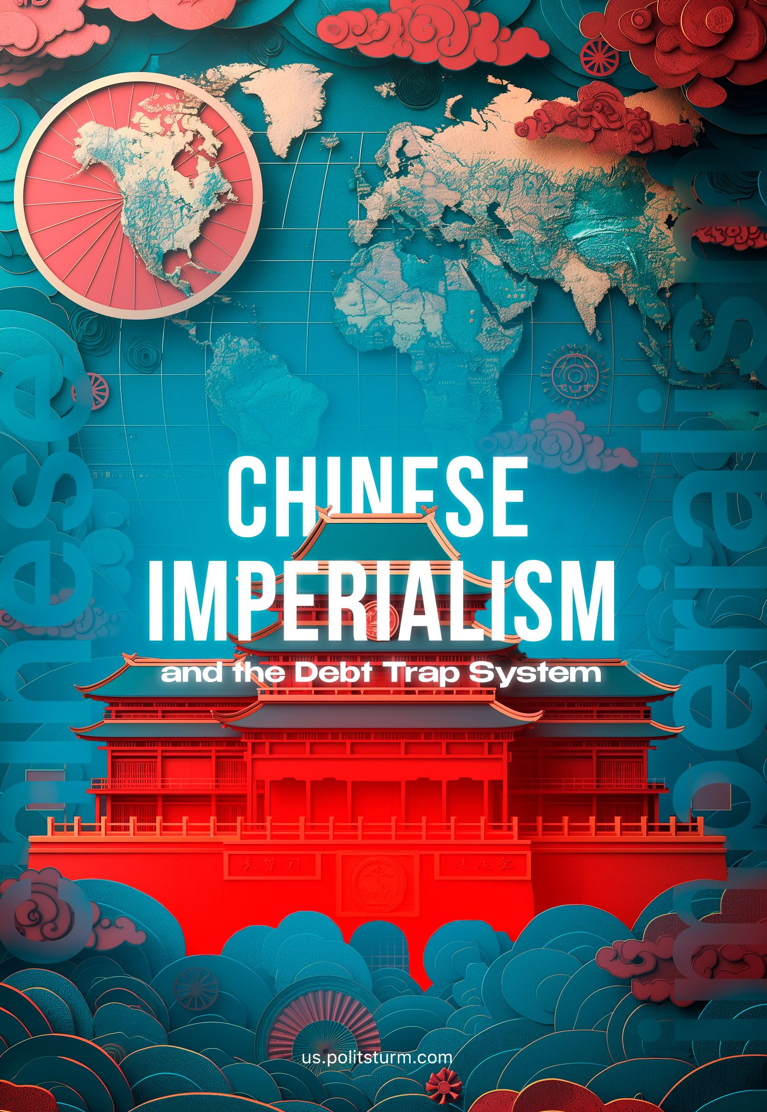

Original article
2024-03-31
27 min read

In recent years, China's increasing economic presence in the global arena has been met with both fascination and apprehension. One particular aspect of China's international engagement that has generated significant debate is its so-called “debt trap diplomacy”. Is it true and what are the interests of China and the Western countries opposing the PRC?

Introduction
This term refers to the strategy whereby China provides loans to developing countries for infrastructure projects, often leading to high levels of debt that can be difficult to repay, and leading to China taking ownership of certain assets and enacting political change.
China’s debt trap diplomacy has been called a myth by The Atlantic [1], Bloomberg [2], The Spectator [3] and other monopoly-owned media outlets. They call it a myth since it isn't significantly different to the actions of the Western liberal states which they uphold by their nature as bourgeois publications.
They recognise that it is not part of some grand Chinese conspiracy to take over the world, but the everyday actions of the world capitalist system, every bit beset by the problems of disunity and competition as are Western capital exports. As they are liberal publications, they believe that this sort of investment and infrastructure construction (as well as the world capitalist system as a whole) is good.
Yet many leftists, pseudo-socialists and 'communists' defend China in this regard. Some outright cite the aforementioned publications, like the so-called “Communist Party of Ireland” [4]. Others, like “Friends of Socialist China” [5], the CPUSA's newspaper “People's World” [6] and “The International” [7] provide many lengthy refutations regarding China's debt trap. Additionally, organisations like the PSL [8] in the US, and the CPB [9] in Britain, deny that China is capitalist and therefore deny Chinese imperialism in its entirety. Finally, the most cunning of these opportunists admit that China is capitalist, but deny that it is imperialist, like the CPGB-ML [10] in Britain.
All of them use similar arguments and talking points (which we will address in detail) to justify their beliefs – however, their position is irreconcilable with Marxism-Leninism and the real interests of the working class. Lenin states in his work “Imperialism, the Highest Stage of Capitalism”:
“The building of railways seems to be a simple, natural, democratic, cultural and civilising enterprise; that is what it is in the opinion of the bourgeois professors who are paid to depict capitalist slavery in bright colours, and in the opinion of petty-bourgeois philistines. But as a matter of fact the capitalist threads, which in thousands of different intercrossings bind these enterprises with private property in the means of production in general, have converted this railway construction into an instrument for oppressing a thousand million people (in the colonies and semicolonies), that is, more than half the population of the globe that inhabits the dependent countries, as well as the wage-slaves of capital in the “civilised” countries.”
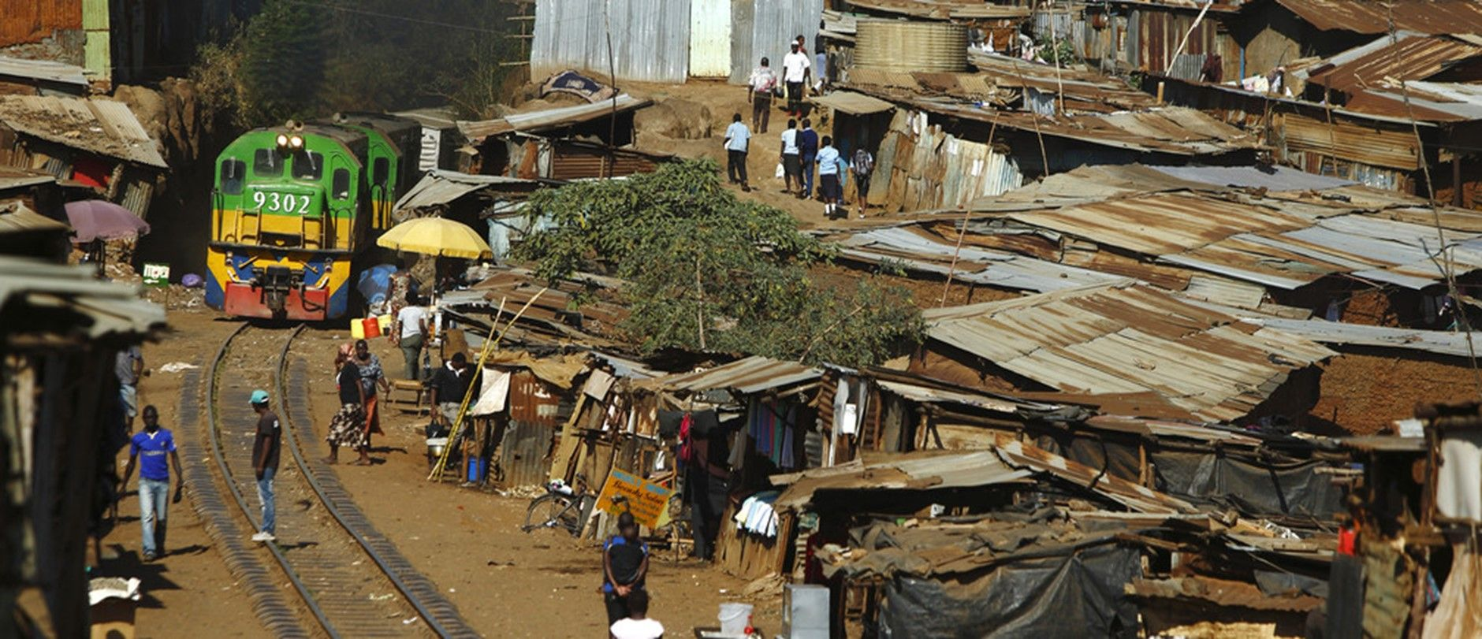
We must recognise that what may appear to be the successes of development are simultaneously advances of imperialist powers towards establishing strong relations of exploitation, sending super-profits to the funder of this railway or highway development project. Lenin went on to define an important feature of imperialism when:
“...the export of capital as distinguished from the export of commodities acquires exceptional importance” – Lenin, “Imperialism, the Highest Stage of Capitalism”
In the 21st century, imperialism has emerged as a fully integrated global system, with the last vestiges of feudalism being systemically dissolved and the communist movement in total retreat. While many things have changed since Lenin’s time, the essence of imperialist capitalism remains the same, as do its features. One of the particular forms that “the export of capital” assumes in the modern day is the “debt trap”.

The Mechanism of the Debt Trap
As we shall see in greater detail from the examples below, many of the capital exports of the E.U., U.S. and China share the same essential features and often assume the same form – the debt trap. They are not only interested in accruing greater profits by investment in dependent countries where the concentration of capital is lower but also “entrapping” the dependent country with the political leverage and control resulting from its rising debt. Furthermore, the dependent country is also “entrapped” in a cycle of taking new debts to refinance its old ones.
The monopoly capitalists of the dependant nation are more than happy to see their national debt rise as they are the ones who receive the investment and can expand their own operations and profits in assisting the looting of their nation by the imperialists, while by and large, it is the workers via taxation who will be repaying the loan and its interest.
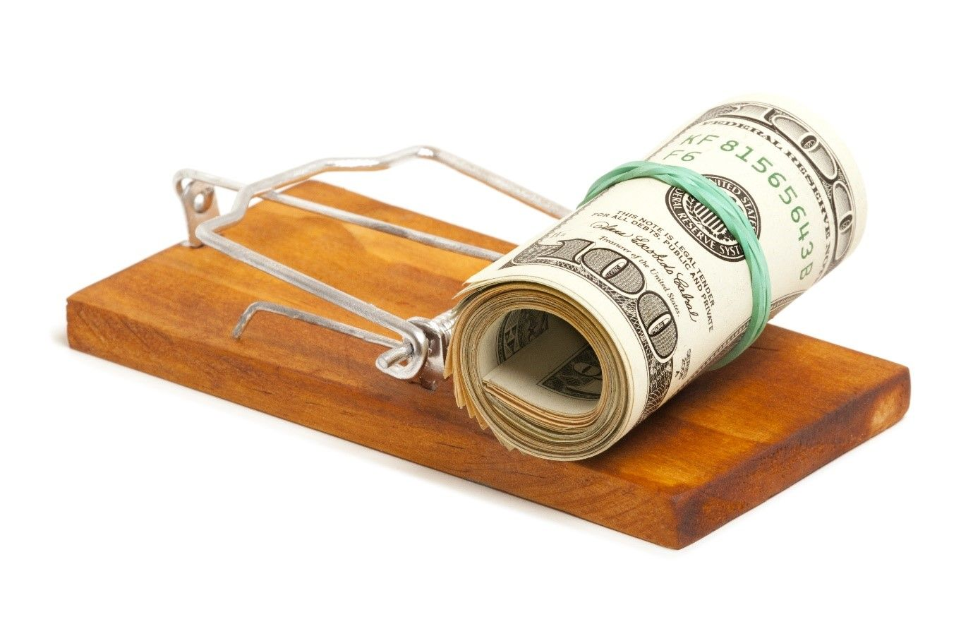
Once the national debt has reached a certain portion of the GDP and has become too large a burden to repay, all imperialists seek to use this political control to further cement the relation of national dependence, transforming the country into an extraction base for raw materials, a source of cheap labour and a captive market. They often do this through political reforms, controlling the policy of the dependent nation-state to make it more welcoming to foreign monopolies. These reforms often consist of austerity, privatisation, market deregulation, repeal of workers’ rights, selling off state property to foreign companies (or losing it as collateral) etc.
Global institutions and States with the means to do this, do so in the interests of the biggest monopolies that control them, feeding the monopolists’ industry by ensuring the flow of cheap resources, as well as markets for them to export to. They ruin smaller local producers in the dependent country as well as further bind the country into dependence.

Examples of the Debt Trap
Examples are innumerable. The E.U. (under the leading banner of German imperialism) exploits Greece, Italy, Ukraine and many more countries under the pretexts of “bailouts” and “assistance”.

Greece
The debt has ballooned to over €400 billion at the end of 2023 [10], primarily owned by the German Federal Bank, various Frankfurt banks, as well as the European Central Bank (dominated by German bankers). Greece’s crippling and increasingly unpayable debt spurred a crisis 15 years ago from which Greece has yet to recover. To raise the money demanded by the German bankers, government spending was slashed (including massive pension cuts) and the number of public sector jobs was greatly reduced, while taxes were increased. This led to a 25% contraction of the Greek economy, leading to mass unemployment and poverty.
Along with extracting the wealth created by the Greek workers using the national debt and taxes collected to pay it, German capitalists also had more direct ways of robbing the Greek workers. For example, the German infrastructure company Hochtief was commissioned to construct roads by the Greek government, however, they also placed toll booths on the roads to draw a tithe from every Greek who wished to use them [11].
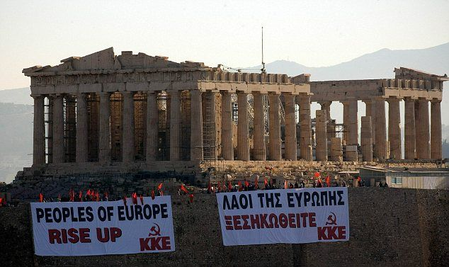
The KKE protesting against austerity in 2010
The Greek working class was involved in many acts of civil disobedience, riots and strikes as a response to their increasing debt and poverty. In addition, in 2015 a new government was elected that promised to end austerity. After a big spectacle, this “radical leftist” Syriza government obediently bowed down to the pressure of German capital, instituting, even more, austerity and privatisation measures – demonstrating very clearly the utter paucity of democracy under capitalism for the working class, the class nature of the state, and which class maintains control of it regardless of which of its representatives serve as its face.
As we can see German capital exports to Greece are not just for a return on investment, but also to impose austerity (i.e., the dismantling of the welfare state, labour rights, social spending etc.). In addition, they aim to further open up the country to a vicious cycle of foreign exploitation in order to pay off the ever-increasing debt.
Similarly, the IMF and World Bank (acting on behalf of primarily American imperialism) exploit most of the world in this way, and we have previously outlined the debt trap in Ukraine in detail, for example. But the fastest-rising creditor is modern China. Therefore, the precise examples of Chinese involvement in world imperialism are extensive and varied, however, we will examine two cases in further detail, namely China’s establishment of relations of exploitation in Zambia and Sri Lanka.

Zambia
Zambia is one of the most copper-rich countries in the world, drawing the attention of American, Canadian, French, Swiss, and Chinese capitalists.
China has invested $1.2 billion in the largest infrastructure and roads projects in the country’s history [12], $0.8 billion in a large copper mine [13] and even more in many smaller ones. But why should we complain about the development of a barren landscape such as Zambia's, which is also one of Africa's minerally wealthiest nations? In only ten years, from 2010-2020, debt grew from 16% of the country's GDP to 140%. In 2022 Zambia defaulted on a loan payment of its $17 billion external debt (about 1/3 of which is owed to China) [14] and went further into crisis, going into debt restructuring talks with Chinese representatives [15].
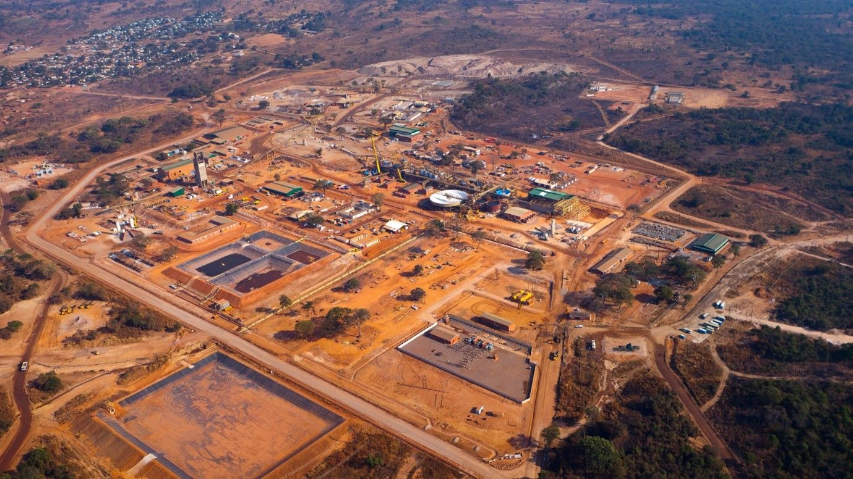
Copper mine in Zambia
The spokeswoman from the Chinese Foreign Ministry said that the key to easing Zambia’s debt burden “lies in the participation of multilateral financial institutions and commercial creditors in the debt-relief efforts” [16], while the President of the World Bank blamed China for its lack of a deal in the “restructuring” of Zambia’s debts, following visits by IMF and U.S. state officials in late January 2023 [17]. Zambia has since reached a $6 billion relief deal with the IMF that will require extensive “restructuring”; however, it is not enough to cover the entirety of the country’s national debt, let alone the debt to private lenders. This means that the debt will likely remain as interest accumulates and the country is forced to borrow more to refinance old debt [18].
Through these renegotiated loans and debt restructuring, China (as the main debtor but other imperialists also) effectively extends its influence over Zambia's economy, replicating historically prevalent imperialist strategies of financial dominance. The consequences for Zambia's working people are dire, as they bear the brunt of austerity measures and economic instability imposed to service the country's ballooning debt.
So, as we can see, China initially invested in Zambia’s infrastructure, facilitating market entry. Once Zambia had exhausted the initial investments and struggled to repay, China extended new debts to refinance the old ones, deepening dependence. This parallels the U.S.'s 20th-century rise to dominance, through which it managed to establish the dollar as the primary currency for international transactions.
In the international area, Zambia's predicament highlights the convergence of interests among global powers in exploiting resource-rich African nations. While Western imperialists and China vie for economic supremacy, they ultimately share a common goal: the extraction of wealth from Zambia at the expense of its people. This unity in exploitation underscores the imperialist nature of their actions, revealing an entire world system built on the subjugation of dependent nations and the exploitation of their labour.

Sri Lanka
The geographic location of Sri Lanka holds immense strategic significance, situated along crucial maritime trade routes connecting the East and West. More than 80% of all global trade passes through a shipping lane just off the coast of Sri Lanka. So, as a key node in global trade, any control exerted over Sri Lanka's ports translates into substantial political leverage. China, recognising this strategic advantage, has positioned itself to capitalise on Sri Lanka's maritime importance as part of its broader regional strategy.
By securing a foothold in a Sri Lankan port, China aims to bolster its maritime presence in the Indian Ocean, enabling greater access to vital trade routes and enhancing its naval power projection capabilities. This aligns with China's broader ambitions of expanding its influence across the Indo-Pacific region, challenging the dominance of Western powers, and continuing to establish itself as a major player in global affairs.
Despite not being able to afford and manage it, the Sri Lankan government contracted the construction of Hambantota port to a Chinese company in 2009. After proving unable to continue to fund it, in 2017, China was given a 99-year lease of Hambantota port and the surrounding land in exchange for further investment. This did not in any way cancel Sri Lanka’s debt to China which was nearly $2 billion and has since risen to over $7 billion (around 1/5 of the country’s total external debt) [19].
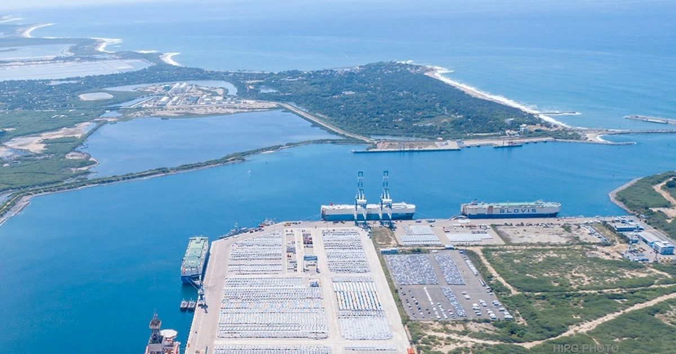
Hambantota Port
The Sri Lankan government has since defaulted on its loans, has been unable to ensure the provision of basic necessities to its people and has been mired by political crisis and social unrest, including the president fleeing the country after his house was stormed by protesters last year. Sri Lanka's inability to meet its debt obligations to China has revealed the nation’s ensnarement in a debt trap, with the port deal serving as a glaring example of predatory lending practices.
The astronomical rise in Sri Lanka's debt burden to China has severely hampered the government's capacity to manage its finances effectively, diverting its scarce resources away from essential basic social services. As a result, ordinary Sri Lankans have borne the brunt of the economic fallout, grappling with rising poverty, unemployment, and diminished living standards.
China was, for a while, engaged in “restructuring” talks with Sri Lanka and supported an IMF deal in March 2023 [20]. After securing a $3 billion loan from the IMF, Sri Lanka has now also reached a deal with China to restructure its debt [21]. As we can see, China works hand in hand with the IMF and Western countries to perpetuate the cycle of debts, forcing austerity and restructuring as Sri Lanka takes on new debts to repay its old ones.
By investing in projects like the Hambantota port, China seeks to reshape the global economic landscape, expanding its sphere of influence and cementing its status as a major player in 21st-century world imperialism.

Apologia for the Debt Trap
Various apologists for imperialism of both the liberal and opportunist variety would take issue with the Communist framing of this. They would argue that as a principle: investment is good. Or, even more opportunistically, that it's only good when their own ruling capitalists do it and not their competitors on the world stage. They would claim that the recipients of the capital exports have asked for them, that the interest is “reasonable”, that on occasion loans are forgiven, that the terms are flexible and assert that investment is what drives the development of productive forces and economic growth. We shall examine these claims in greater detail.

“But it's Recipient-Driven!”
Regarding the Sri Lankan port, liberal publications such as The Atlantic, as well as the official newspaper of the CPC, People’s Daily [22], claim that it was recipient-driven and only resulted in Chinese ownership because of a “lack of due diligence”. This ridiculous assertion is reminiscent of narratives about colonial powers sleepwalking into their position of dominance. Like the British bourgeois professor of history at Cambridge, John Seeley says: “the [British] empire was acquired in a fit of absent-mindedness”. The peoples' treasures robbed and expropriated by the British colonial government sometimes took on the guise of gifts from the local leadership – like the “legal” acquisition of the Koh-I-Noor diamond via the treaty of Lahore.
And while outright colonialism is a vestige of the past, national oppression has not disappeared but has merely changed form. Modern imperialist exploitation would not be possible if not for the expressed consent of the ruling class of dependent nations. The same ruling class has erected a brutal dictatorship of capital over their own workers, oppressing them both by nation and class. The ruling class of the indebted country is seldom willing to resist the sale of their national sovereignty as they personally benefit from a cut of the spoils. After all, capitalists commodify everything and things like national sovereignty and dignity are no exception.
Referring back to the Sri Lankan example; the Sri Lankan government in power had been greatly assisted by China in winning the brutal civil war against the nationally oppressed Tamils. During the final stages of the civil war, the government resorted to the indiscriminate bombardment of civilians leading to 75,000 civilian deaths and even more wounded, according to UN estimates [23]. All of this was with material, diplomatic, and military support from China, which sought to gain from future investments [24]. Such is the human cost of imperialist development and “recipient-driven” capital exports; brilliantly demonstrating the correctness of Lenin’s thesis.

Sri Lankan Tamil Tiger fighter

“But the interest rates are ‘reasonable’!”
Others claim that the interest rates are “reasonable”, especially the zero interest and concessionary loans. However, it is not necessarily a 0-6% interest rate that makes a loan unpayable, but the overpricing of hidden costs within it (e.g., designs, engineering services, equipment loans, contracting of imported Western or Chinese labour-aristocrats and “experts”). The burden on the debtor is often higher than the interest rate indicates. However, while interest on capital exports is a part of imperialism, it is not the part that makes the specific capital export a “debt trap”.
Utilising the political leverage as a creditor when a loan becomes unpayable together with predatory clauses within the loan contract to enact reforms or assume control is what constitutes a “debt trap”. It is done to ensure and increase the flow and decrease the price of raw resource commodities as well as to gain control of a captive market for export, which is fundamentally where the biggest profits are made. In addition, the local petty proprietors, and often small and middle capitalists too are unable to compete with the influx of manufactured commodities from larger foreign monopolies and are ruined, further cementing the relation of national dependence and the dominance of monopoly capital.
Likewise, debt forgiveness is not some act of kindness by the imperialists, nor is it unique to China. The IMF cancels debt on occasion and in the past, even Saudi Arabia forgave 80 per cent of Iraqi debt [25]. This is ultimately done for the same reason banks forgive certain loans to the public; small amounts of unrecoverable and crippling debt are relieved in order for debtors to continue to be able to repay as well as to strengthen the debt system as a whole.
Overall, the forgiven loans form a small fraction of what would be the total income gained from the export of capital and are generally pretty insignificant: it’s fundamentally about the resources. Debt forgiveness is often in conjunction with some form of “restructuring” which counters the claim that the terms of these loans are flexible. The IMF’s restructuring approach to countries in debt crisis is well known, forcing the debtor country to enact privatisation, deregulation of markets, and austerity in exchange for debt relief.
China too utilises “restructuring” measures. In 2021, China 'helped' the Republic of Congo unlock additional IMF loans which had been denied to them due to formal bars on excessive amounts of national debt, by restructuring $2.4 billion in loans. The IMF and China work hand-in-hand when it comes to debt, each leaning on the other to advance the deepening imperial relations.
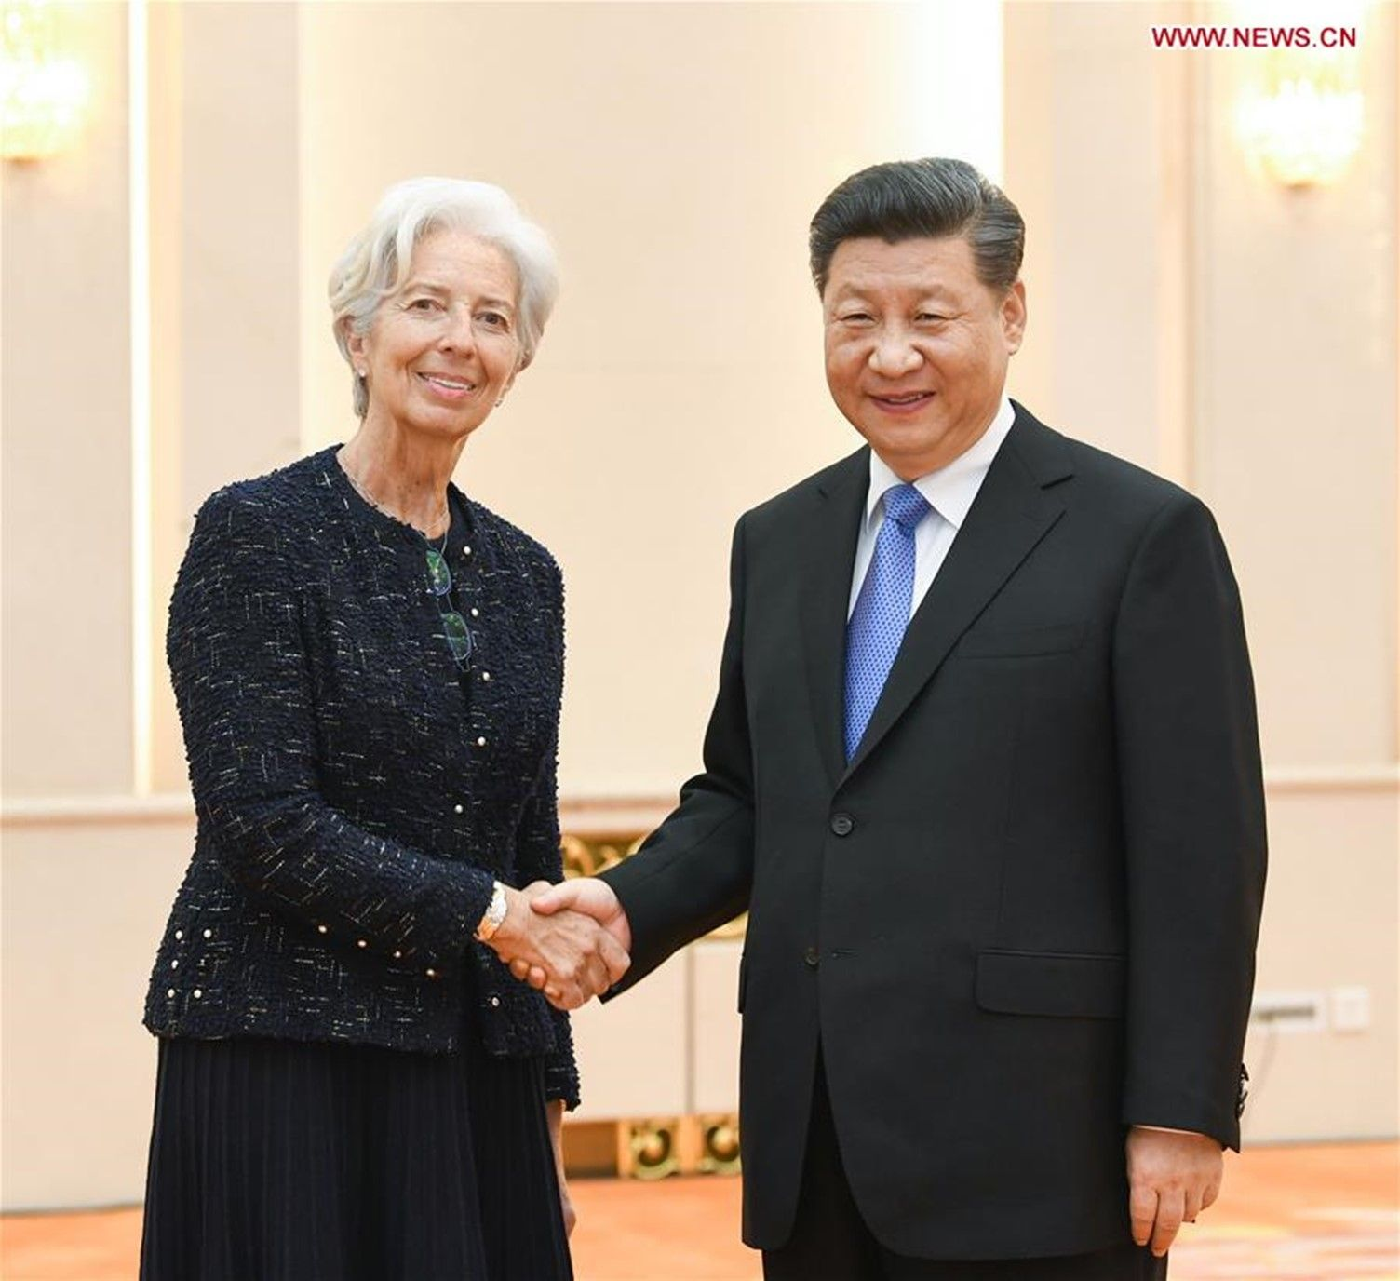
Xi Jinping meets with Christine Lagarde, then acting as Managing Director of the IMF
According to the report “How China Lends” [26]:
“50 per cent of CDB [China Development Bank] contracts in our sample include cross-default clauses that can be triggered by actions ranging from expropriation to actions broadly defined by the sovereign debtor as adverse to the interests of a “PRC entity”. These terms seem designed to protect a wide swath of Chinese direct investment and other dealings inside the borrowing country, with no apparent connection to the underlying CDB credits”.
“All CDB contracts in our sample include the termination of diplomatic relations between China and the borrowing country among the events of default, which entitle the lender to demand immediate repayment.”
The report identifies that 90% of the Chinese loan contracts examined have clauses “that allow the creditor to terminate the contract and demand immediate repayment in case of significant law or policy changes in the debtor or creditor country” and “30 per cent of Chinese contracts also contain stabilization clauses, common to non-recourse project finance, whereby the sovereign debtor assumes all the costs of change in its environmental and labour policies”. This aptly demonstrates how these loans are used to control dependent nations. If the indebted country is unable to fulfil this obligation of repayment, then the creditor country can take ownership of certain assets as collateral within it, demand “restructuring” (i.e., privatisation of state assets and social services) as well as otherwise give them incredible control within the country.

“But investment is a good thing!”
Others say that these investments, despite the dirtiness, profiteering and corruption involved are, all-in-all a good thing; that they allow for the development of the less developed country’s productive forces which is, after all, a prerequisite for socialism.
This neglects the fact that most capital exports cement the relation of dependence: the infrastructure and means of production built are for the extraction of resources, not the consolidation of national wealth. This is the rule, not the exception and it is possible for a formerly oppressed nation to climb the imperial hierarchy, as the U.S. did on the back of British capital exports and as China has done using U.S. capital exports.
We are seeing the beginning of this process in other countries as China has already begun the process of exporting its production to places with a lower concentration of constant capital, lower wages, a less crowded market and higher profitability, like Vietnam, Malaysia, Bangladesh, and India. However, is this a desirable outcome for communists? Is a “multipolar” world something we should strive for? The Communist Party of Sweden has addressed this question in detail well and we have published the translation of their material.
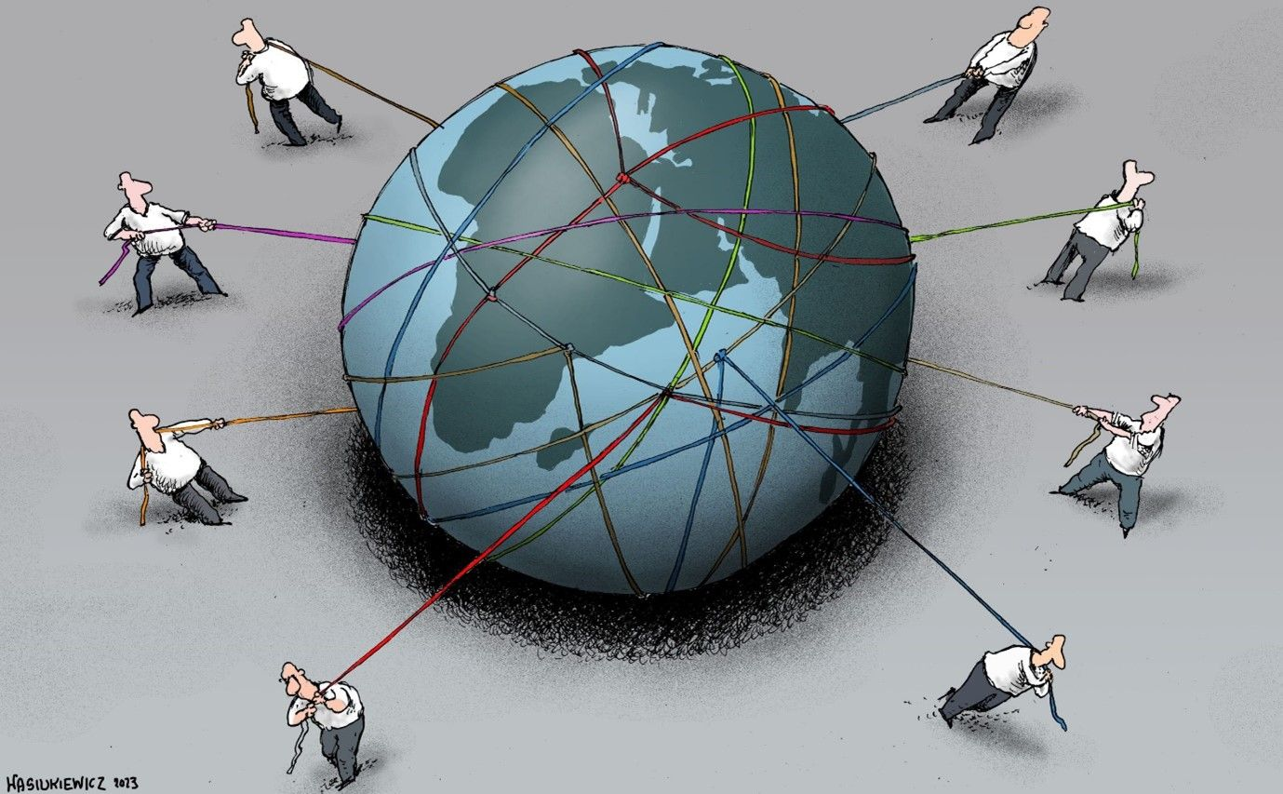
In addition, this argument relies heavily on a mechanistic conception of productive forces. The productive forces are not just the tools, infrastructure and machinery used for production, but crucially also those who work the tools and machinery in order to produce things – the workers. And this human component of the productive forces remains degraded by the austerity that these debts lead to specifically, but the basic contradiction between labour and capital that defines capitalism in general. Productive forces do not exist in a vacuum, they are interlinked with and dialectically related to productive relations. As a result, in all countries, the productive forces are hindered by the currently dominant capitalist social relations.

“But what about the Soviet Union?”
“The Soviet Union also helped developing countries. Do you want to call them bad as well?” – the opportunists may ask. Indeed, what about the U.S.S.R.? It did have investments in less developed countries – $18 million worth in 1979 according to a thorough study by the U.S. Congress. Almost all of it was in things that facilitated Soviet trade, like advertising, however, it also had a total of six of these investments in natural resource extraction. All of these investments were fish processing plants worth around $0.5 million each and were 50-50 joint ventures with the local countries. The Soviet fishing fleet brought in its catch to these nearby countries and half the fish processed went to said local country [27].
That is all the natural resource extraction that the U.S.S.R. did. It was thousands of times quantitively less than the U.S. or China, and it was qualitatively different. The American and Chinese imperialists have their own transcontinental monopolies and control their investments. Because the Soviet Union had virtually no meaningful foreign investments, they had no stake in preserving capitalist relations and private property within these countries. Resultantly, they had no need to enforce relations of dependence, 'restructuring' and austerity to reap greater profits.

But did the Soviet Union also not support foreign countries and governments with aid? Yes, but it was either to a qualitatively different regime – towards the socialist and progressive camp (e.g. aid to the Eastern bloc, Vietnam, Cuba etc.), or it was to foster splits in the imperialist camp (which occurred even under Lenin, who gave aid to Kemalist Turkey)
“To carry on a war for the overthrow of the international bourgeoisie, a war which is a hundred times more difficult, protracted and complex than the most stubborn of ordinary wars between states, and to renounce in advance any change of tack, or any utilisation of a conflict of interests (even if temporary) among one’s enemies, or any conciliation or compromise with possible allies (even if they are temporary, unstable, vacillating or conditional allies)—is that not ridiculous in the extreme?” – Lenin, “Left-Wing” Communism: an Infantile Disorder
And surely none of our opportunists are willing to stoop low enough to declare that any and all trade as a principle is imperialist – and no different to the actions of modern China or the U.S.? However, even in this field the majority of Soviet trade was with Eastern Europe and the U.S.S.R. paid a far higher price to that of the world market – there was a large subsidy component. Similarly, the U.S.S.R. bought Cuban sugar at 2.5 times the price on the world market.
“When we are victorious on a world scale I think we shall use gold for the purpose of building public lavatories in the streets of some of the largest cities of the world. This would be the most “just” and most educational way of utilising gold for the benefit of these generations which have not forgotten how, for the sake of gold, ten million men were killed and thirty million maimed in the “great war for freedom”, the war of 1914-18...
...But however “just”, useful, or humane it would be to utilise gold for this purpose, we nevertheless say that we must work for another decade or two with the same intensity and with the same success as in the 1917-21 period, only in a much wider field, in order to reach this state. Meanwhile, we must save the gold in the R.S.F.S.R., sell it at the highest price, buy goods with it at the lowest price. When you live among wolves, you must howl like a wolf, while as for exterminating all the wolves, as should be done in a rational human society, we shall act up to the wise Russian proverb: “Boast not before but after the battle.” – Lenin, The Importance Of Gold Now And After The Complete Victory Of Socialism.
[The advent of microelectronics that utilise gold’s conductivity and inertness was after Lenin’s time and would probably be a more rational usage of gold after the victory of the world revolution, however the sentiment and essence of what he is saying remains important - PS]
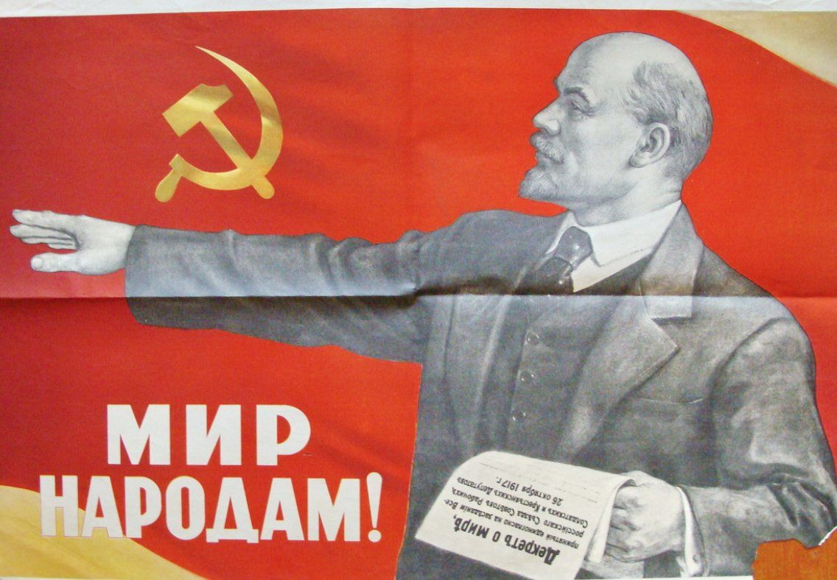
"Peace to all nations!"

Conclusion
As we have clearly demonstrated, capital exports remain a keystone of imperialism and the modern debt trap is a particular form of it. Modern China, as a keystone of the imperialist system, uses investments and the credit system to bind many dependent countries closer to the interests of Chinese capital.
The Communist solution to foreign capital exports, especially for workers in dependent countries, is the nationalisation of the infrastructure and means of production owned or operated by foreign monopolies without any compensation to the capitalists, by a worker’s state; led by a communist party.
In the modern age where imperialist capitalism has become fully global, and the capitalists of oppressed nations have no historically progressive tasks left (like the formation of a national market and the dissolution of predominant feudal relations), they can only seek to sell their nation to differing foreign monopolists and delude the workers with bourgeois nationalism. It is now only the working class that is capable of leading and winning the struggle for national liberation by ushering in a Communist society – bereft of exploitative relations on both the interpersonal and national levels.

Sources:
[1] https://www.theatlantic.com/international/archive/2021/02/china-debt-trap-diplomacy/617953/
[2] https://www.bloomberg.com/news/articles/2022-03-17/the-myth-of-chinese-debt-trap-diplomacy-in-africa?leadSource=uverify%20wall
[3] https://www.spectator.co.uk/article/the-myth-of-china-s-debt-trap-diplomacy/
[4] https://socialistvoice.ie/2021/03/opinion-in-defence-of-china/
[5] https://socialistchina.org/2022/12/20/why-chinese-debt-trap-diplomacy-is-a-lie/#more-3508
[6] https://www.peoplesworld.org/article/correcting-the-record-on-china-and-africa/
[7] https://www.internationalmagz.com/articles/why-chinese-debt-trap-diplomacy-is-a-lie
[8] https://www.liberationschool.org/china-class-4/
[9] https://morningstaronline.co.uk/article/f/what-did-british-communists-make-socialism-chinese-characteristics-2019
[10] https://thecommunists.org/2021/11/23/news/comrade-ella-our-enemy-is-here-at-home-not-in-china-britain-uk-war/
[10] https://tradingeconomics.com/greece/government-debt
[11] https://www.reuters.com/article/hochtief-results-idUKL5E7ME09G20111114
[12] https://www.enr.com/articles/42847-chinese-contractor-awarded-12-bil-zambia-road-project
[13] https://www.reuters.com/article/us-zambia-mining-idUSKCN1L71P7
[14] https://www.voaafrica.com/a/china-holds-back-while-zambia-hurts/6596647.html
[15] https://www.bloomberg.com/news/articles/2023-04-19/china-led-lenders-to-reconvene-next-month-for-zambia-debt-talks
[16] https://www.bloomberg.com/news/articles/2023-01-31/china-wants-the-world-bank-to-offer-debt-relief-to-zambia
[17] https://www.bloomberg.com/news/articles/2023-01-24/world-bank-chief-says-china-s-actions-delay-zambia-restructuring
[18] https://www.bbc.co.uk/news/world-africa-65997830
[19] https://www.hindustantimes.com/world-news/was-cash-strapped-sri-lanka-duped-by-china-in-hambantota-port-101656205405799.html
[20] https://www.aljazeera.com/news/2023/3/20/imf-approves-sri-lankas-2-9bn-bailout
[21] https://www.bbc.co.uk/news/business-67097443
[22] http://en.people.cn/n3/2023/0109/c90000-10193205.html
[23] https://www.securitycouncilreport.org/atf/cf/%7B65BFCF9B-6D27-4E9C-8CD3-CF6E4FF96FF9%7D/POC%20Rep%20on%20Account%20in%20Sri%20Lanka.pdf
[24] https://www.army.lk/news/china-backs-lankan-fight-against-ltte
[25] https://www.nbcnews.com/id/wbna18164425
[26] https://docs.aiddata.org/ad4/pdfs/How_China_Lends__A_Rare_Look_into_100_Debt_Contracts_with_Foreign_Governments.pdf
[27] https://www.marxists.org/history/erol/ncm-7/rcp-soviet-debate-2.pdf

Original article

