China Moves to Counter US Foreign Policy
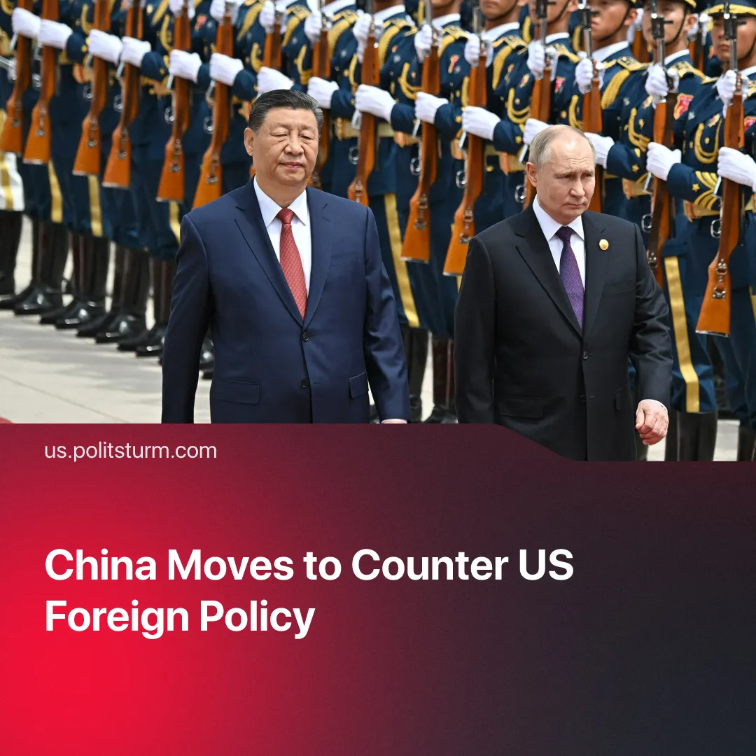

Original article
2025-09-13
2 min read

China used the 80th anniversary of the end of WWII to tighten its control over its client states.
Details. China recently hosted the largest ever Shanghai Cooperation Organisation (SCO) summit, bringing together member states such as Russia and India, as well as several other observer and dialogue partner states.
▶ Following the summit, on the 80th anniversary of the end of WWII, China also held a large military parade, which showcased a wide range of high-tech weaponry in a show of power to the US.
▶ China aims to strengthen its ties with strategic partners to counteract US foreign policy. For example, China has signed 70 agreements with Kazakhstan and 22 cooperation agreements with Russia, including a memorandum on the Power of Siberia 2 gas pipeline project, which has cemented relations between the two powers.
▶ The summit discussed important matters on developing energy, infrastructure, green industry, digital economy, sci-tech innovation and artificial intelligence through cooperation between states. In total, 24 documents were approved relating to these issues.
▶ Chinese President, Xi Jinping, agreed to increase investments and loans to members, and the summit agreed that a SCO Development Bank is to be set up “as soon as possible.”
▶ Prime Minister of India, Narendra Modi, said in a joint declaration with Xi that they “are partners, not rivals.” Both countries agreed to a diplomatic reset, resuming trade, establishing economic cooperation and reaffirming their roles in shaping regional stability and advancing development.
▶ Similarly, Xi has secured cooperation commitments and agreements with Azerbaijan, with Xi saying he supports the country’s entry into the SCO. Azerbaijan stated that it recognises only one China, and recognises Taiwan as a part of the PRC.
▶ After the summit, Donald Trump said that the US had “lost India and Russia to deepest, darkest, China.”
Context. The summit comes after a turbulent period in which US foreign policy employed economic pressure, through the use of tariffs, to secure markets for Washington and, consequently, reduce Chinese market access. As a rival imperialist power, Beijing is seeking to strengthen its own dependencies and counter the US.
▶ Trump imposed heavy tariffs on India over Modi’s continued purchase of Russian Oil, in an attempt to exert pressure on Russia to end its Special Military Operation. These tariffs now appear to have pushed India towards China, with the US holding talks with India before the SCO summit but yielding no results.
▶ In August 2025, Putin and Trump met in Alaska to discuss a possible ceasefire between Russia and Ukraine. Trump hoped that a deal could be struck that would move Russia farther away from the influence of Chinese capital. However, no public deal has yet been struck.
▶ Trump also aimed at conducting a “peace campaign”, in which he mediated peace deals or froze conflicts between belligerent countries and secured US-favourable deals. He succeeded in getting Azerbaijan and Armenia to sign a peace deal, which would see US control over a vital transit corridor, bypassing China’s Belt and Road initiative. Azerbaijan’s continued partnership with China highlights that this wasn’t the clear-cut win Trump had hoped for.
For a deeper analysis of the China–US rivalry, see our in-depth article on this subject.

Original article

