China Replaces Russia as Cuba’s Key Economic Partner
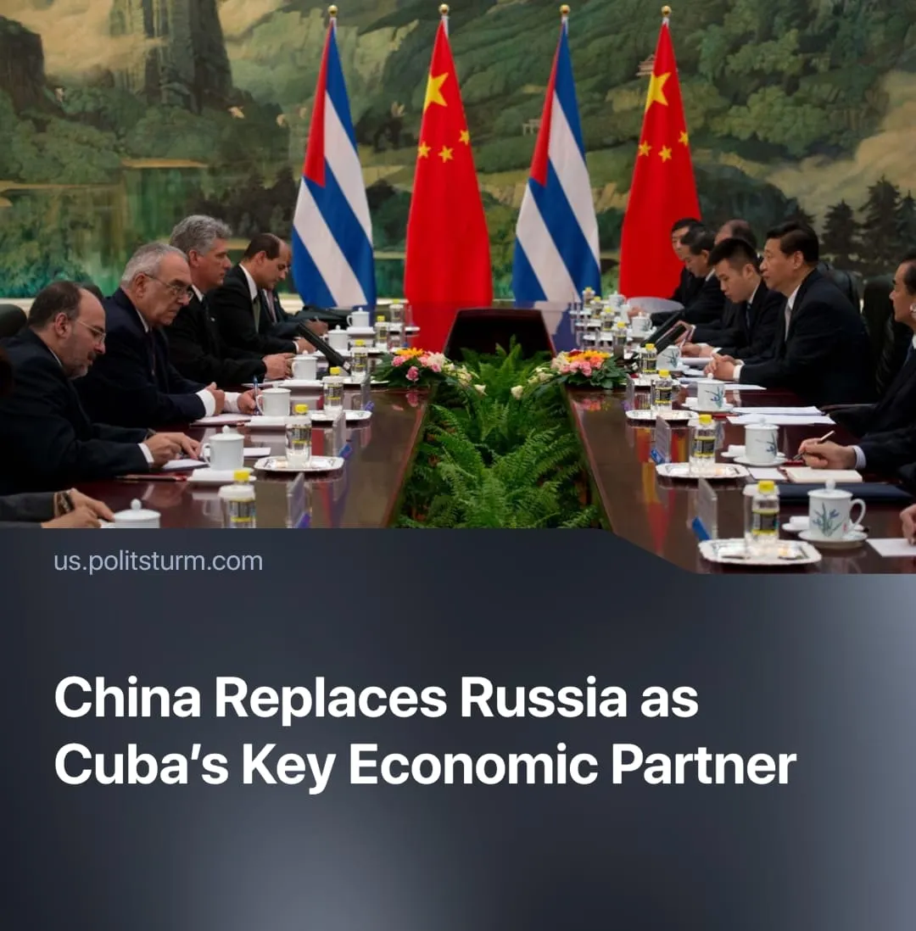

Original article
2025-07-10
2 min read

China has overtaken Russia as Cuba’s main economic partner, expanding its influence through large-scale infrastructure projects to secure new markets for its exports and capital.
Details. In 2025, China began constructing 55 solar parks across Cuba, with an additional 37 planned by 2028. These are projected to cover two-thirds of daytime electricity needs.
► China is modernising Cuba’s power grid, telecoms, ports, and transport systems, while also boosting tourism and providing interest-free loans.
► These investments are backed by the Belt and Road Initiative, which Cuba officially joined in 2018.
Context. China’s turn to Cuba is driven by falling profit rates and industrial overproduction, intensified by the US trade war.
► The US blockade on Cuba has been in place since 1962, cutting Cuba off from Western financial systems and trade. Losses to the Cuban economy are estimated at over $150 billion.
► During the Soviet era, Cuba relied heavily on the USSR for trade, credit, and subsidies. When this support collapsed in the early 1990s, it triggered the “Special Period”, a deep economic crisis that led to Cuba opening up to foreign investments and integrating into global markets.
► In recent years, Russia has promised renewed investment, but its role continues to shrink. Projects like the Jatibonico sugar mill, foreign bank offices, and national hotel renovations remain stalled or abandoned, as Moscow redirects resources to military expenses and faces a deepening economic crisis.
► Meanwhile, China–Cuba trade surpassed $1.3 billion by 2021, marking China’s rise as Cuba’s dominant economic partner through consistent infrastructure investment and capital export.
Important to Know. Unlike previous gestures of “solidarity,” this support comes with deep economic ties and long-term dependency. Chinese capital must find new markets, and Cuba, isolated by the blockade and left behind by Russia, offers a low-cost outlet for expansion.
► Russia’s role in Cuba has diminished due to its economic crisis and military overextension. In 2022, Armenia distanced itself from the Collective Security Treaty Organisation (CSTO). In 2024, Russia was forced to cut back aid to Syria.
► The blockade makes Cuba an ideal target for Chinese investment: low competition, guaranteed dependency, and strong political alignment.
► Cuba’s geographic location—just 90 miles off the U.S. coast—makes it a potentially valuable military and logistical outpost for China.

Original article

