Chile's Lithium 'Nationalization'
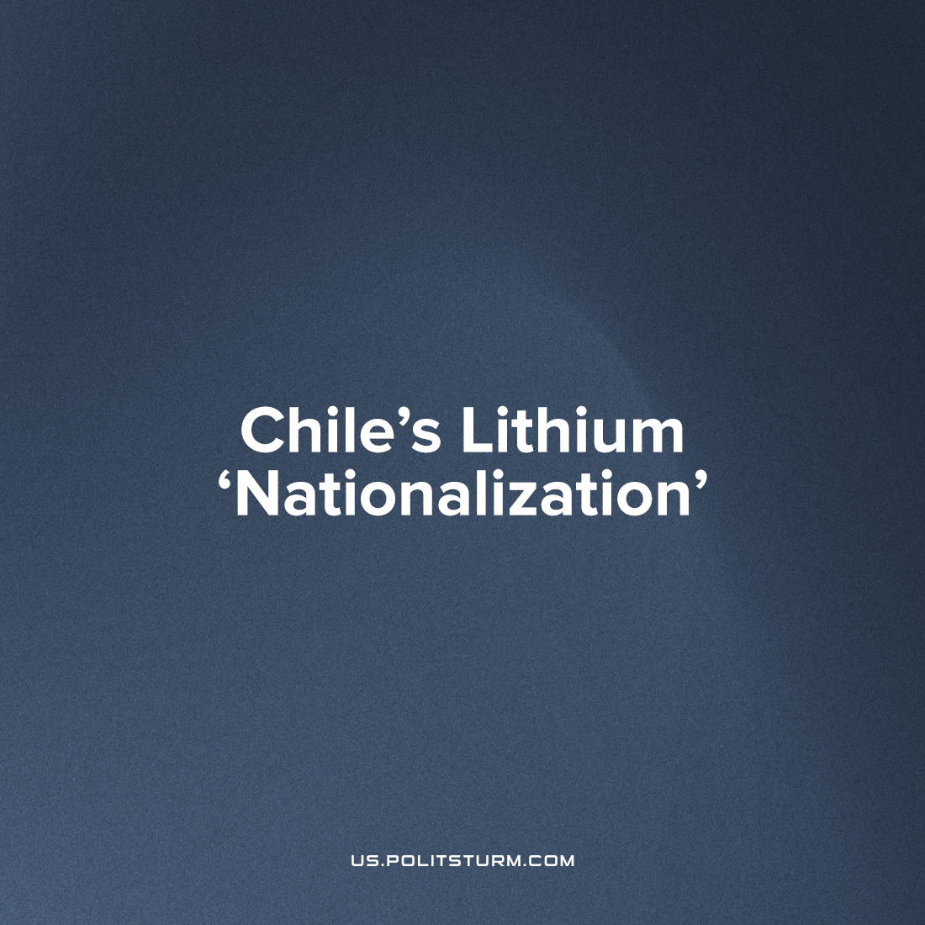

Original article
2023-05-13
4 min read

On Thursday, April 20, during a televised address to the nation, President Boric outlined a master plan for Chile's gradual transformation into a global lithium 'superpower'. The core of this plan is "the active participation of the state in the full production cycle of lithium" and the implementation of direct control over the various stages of its extraction and processing, for which it is planned to create a state-owned national lithium company. Social democrats celebrated this announcement, making huge declarations of their own about the shining prospects of a "New Allende" increasing state 'ownership' of a profitable national industry at the heart of the world's supply chain for the next wave of industrial production based on lithium batteries.
Chile is currently the world's second largest producer of lithium raw materials. According to the latest estimates of the research company Benchmark Mineral Intelligence (BMI), it accounts for about 32% of its global supplies (39 thousand tons, according to preliminary results of 2022), while Australia accounts for 45% (61 thousand tons), and China, which occupies the third line, still about 13% (19 thousand tons).[1]
According to the Central Bank of Chile, lithium carbonate exports increased 777% compared to 2021. [2]
According to the plan, which by the way has yet to be approved by the National Congress (in which the supporters of the leftist president do not have a majority of votes), the Chilean copper producer Codelco will be instructed to negotiate with two leading companies in the country engaged in the extraction and processing of lithium raw materials — the local Sociedad Quimica y Minera de Chile (SQM, ex-state company, the current main owner of which is one of the richest oligarchs of the country, Julio Ponce Leroux, son-in-law of Chilean dictator Augusto Pinochet) and the American multinational giant Albemarle — on obtaining a controlling stake in their current concession agreements, which formally expire in 2030 and 2043, respectively.
The existing contracts will not be terminated, but the state will seek to obtain a share in the contracts of SQM and Albemarle for the development of the Salar de Atacama salt marsh before the expiration of their licenses in 2030 and 2043, respectively.[3]
Error loading image

What is true nature of this reform?
Albemarle and SQM are now in fact the main beneficiaries of such reforms, confirmed by the official statements of the company's management that the new policy is a new opportunity to get more profit. [4]
While lithium for years has typically been produced using open-pit mines or evaporation ponds, Boric’s plan relies on the wide scale deployment of direct lithium extraction (DLE) technologies that have so far never worked in commercial operations, but which Albemarle and its peers are studying.
Albemarle and SQM’s contracts only grant access to the Atacama salt flats, or salars, but Boric hopes to open up many other salars across his country for lithium production, a step that will require DLE technologies.
Many DLE technologies use lots of potable water and electricity, a limitation that Albemarle has acknowledged and one it is working to limit. None have yet to work independently at commercial scale. Chile and Albemarle could cement their dominant role in the global lithium and EV industries if they can get one or more DLE technology to succeed.
At the moment, a technological race will unfold for new deposits and, accordingly, sources of profit, which Albemarle has the advantage of.
It would seem that another superiority of an American company, but the most interesting thing is not who will get the raw materials, but who will process it with more surplus value, and then the “most unexpected” opens up - the growing monopolization of Chinese industry.

A little excursion into the economy:
the largest lithium reserves have been identified in Bolivia and Argentina — 21 and 20 million tons, respectively, while Chile, which has started an industrial redistribution of property, has 11 million tons (the USA also has very significant reserves — 12 million tons — but so far they have the only operating production facility — the salt brine evaporation complex in Silver Peak (Nevada), which is operated by the Albemarle company mentioned above.
However, according to the results of industrial processing of raw materials, the overall situation is changing dramatically. China already controls almost 60% of the world's total capacity for industrial processing and production of various chemical components from lithium raw materials with a high degree of purification, mainly battery powder lithium carbonate, although Chile still retains the second place in this key category with about the same share - 31% (according to the USGS, currently, it is car batteries that provide about 80% of the total global demand for lithium).
In particular, almost all lithium raw materials obtained from spodumene ores (rocks) in Australia are then sent for in—depth processing and purification - high-tech membrane electrolysis — to China.
The leading Chinese private companies dominating the global lithium market, primarily Jiangxi Ganfeng Lithium and Tianqi Lithium, have a powerful and extensive network of mining and processing production facilities both inside China and around the world, including, of course, in Latin America.
So, about 25% of the shares in the aforementioned Chilean SQM belong to Tianqi Lithium, and another key player already in the "big electric car market", the Chinese automaker BYD, the day after the loud speech of the Chilean president, as if nothing had happened, announced its plans to build a new cathode factory in Antofagasta — the main lithium province of the country. This $290 million factory will annually produce 50,000 tons of lithium-iron phosphate for battery cathodes, using lithium carbonate as an intermediate raw material.
And, as analysts of Chemical & Engineering News honestly admitted in their big review last year, "at present, Chinese companies clearly have no equal in the world in the field of lithium-ion battery chemistry."[5]
As a result, the “left” president only serves as a tool for further enrichment of American and Chinese capital. They intend to keep nations such as Chile from reaching healthy development, so they will remain cheap sources for resource exports. This nationalization has exactly that aim - to reinforce the dependency of Chile's economy on foreign buyers. Under the capitalist system, the nationalization does not mean ‘ours’, and its access is expanded chiefly for the capitalist class, so whether the Chilean workers will get crumbs from the master's table is a rhetorical question, because while the means of production are privately owned, the only task they solve is the enrichment of a few and the exploitation of the rest of the population.
Sources: 1,2,3,4,5

Original article

