Child Labor Found in Kia-Hyundai Supply Chain
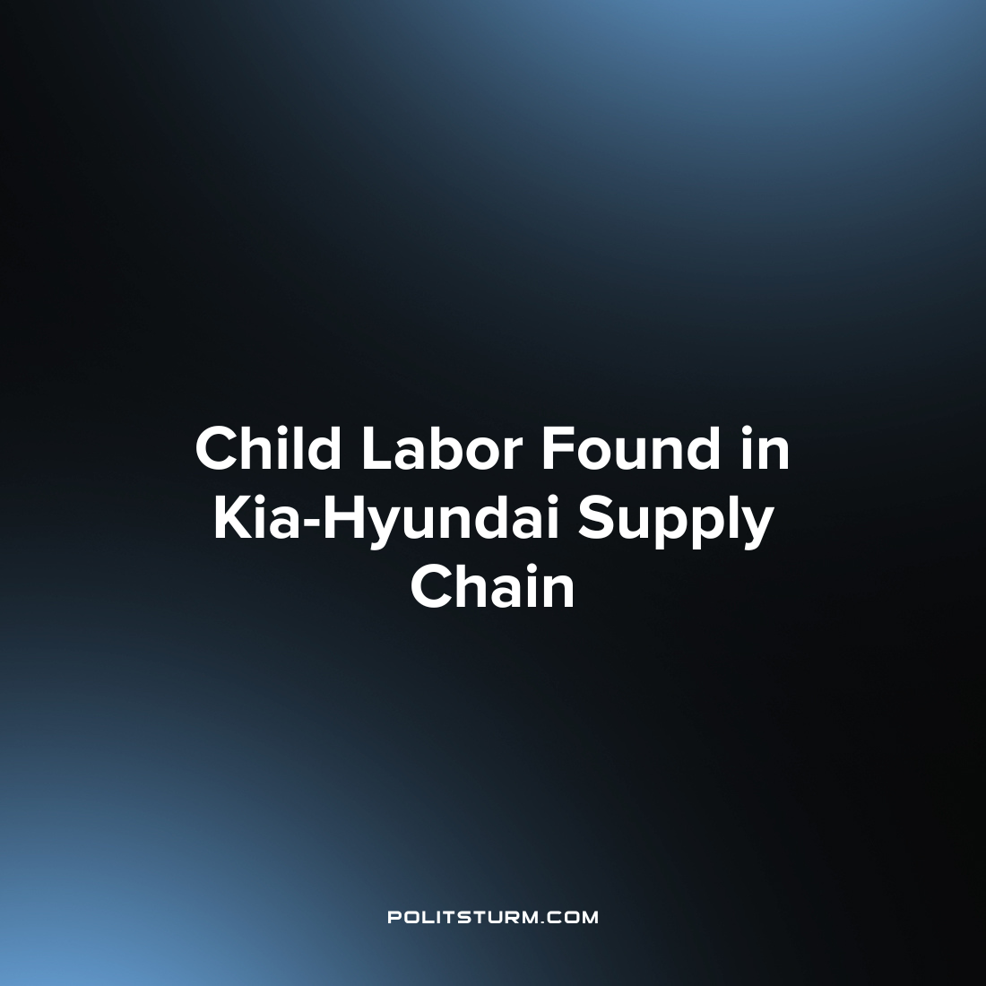

Original article
2022-12-25
1 min read

An investigative report by Reuters found that children have worked at found Alabama parts suppliers to auto manufacturers Kia and Hyundai. Federal and state agencies are now investigating whether as many as 6 additional manufacturers may be utilizing child labor in Kia and Hyundai’s supply chain.
Earlier in the year, Reuters reported that it uncovered child labor being used at SMART Alabama, LLC and SL Alabama. Now a 14-year-old Guatemalan girl was reported to have worked at Hwashin American Corp. in Greenville, Alabama according to interviews with the child’s father and law enforcement. In addition, auto part manufacturer Ajin Industrial Co, in Cusseta, Alabama is reported to have employed child labor according to multiple ex-employees at the company.
Hyundai stated that it did not condone or tolerate violations of labor law whereas Kia stated that it condemns the practice of child labor and does not tolerate “unlawful or unethical workplace practices.”
While the companies may publicly condone the practice of child labor, it is apparent that the previous incidents in July were not isolated and are widespread in the supply chain. The capitalist economic system, predicated upon the maximization of profit for the owners of capital, will utilize all available means to maximize profit including the utilization of child labor. While the Fair Labor Standards Act prohibits the utilization of certain hazardous child labor as unlawful, the capitalists are willing to overlook these requirements to the extent that they are able if it bolsters their bottom line. Capitalism has a long history of the employment of child labor, and as long as it continues to exist it will always be a possibility and a reality.
Source: 1

Original article

