Charlie Kirk Memorial Used to Promote Nationalism
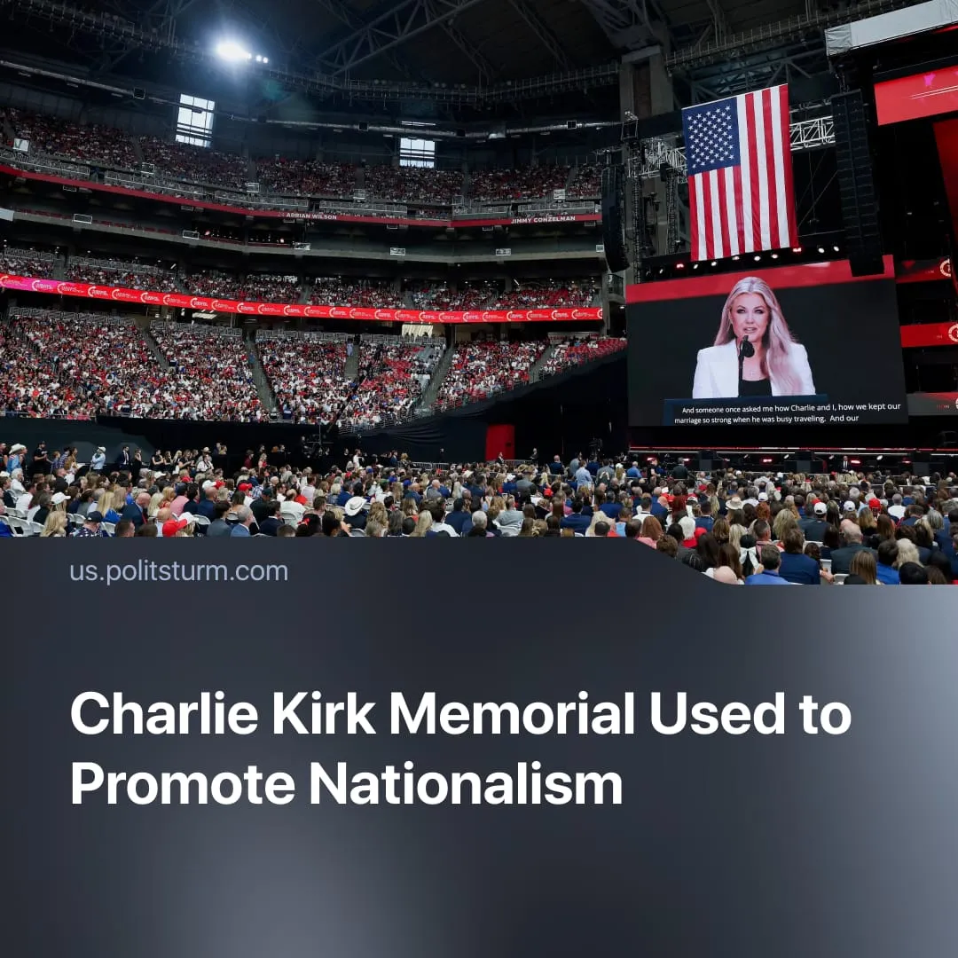

Original article
2025-10-01
2 min read

Trump blamed the "radical left" for violence during the Charlie Kirk memorial. In reality, right-wing extremism has been responsible for more attacks over the last decade.
Details. On September 21st, Turning Point USA held a televised memorial service for Charlie Kirk at a stadium in Glendale, Arizona. The event had up to 200,000 attendees in multiple venues, and over 20 million watched from home, with federal security costing millions. The event’s extravagant style, including American and Christian symbols, reinforced patriotic–religious themes.
► The memorial speeches by prominent Republican and right-wing figures lionised Charlie Kirk as a “missionary”, “a warrior for country, a warrior for Christ,” and a “martyr”. President Trump offered high praise, but distanced himself from Charlie Kirk’s supposedly conciliatory approach to politics, declaring that “I hate my opponent, and I don’t want the best for them.”
► In his speech, Trump promoted a myth that “violence comes largely from the left.” The President stated that his regime would now crack down harshly on “networks of radical left maniacs” and that “we’re going to have Charlie very much in mind when we go in”, referencing his deployments of the US military in American cities.
► Whether intentional or not, Trump advisor Stephen Miller gave a memorial speech for Kirk that drew attention for its resemblance to a 1932 speech by Nazi head propagandist Goebbels, following the assassination of SA member Horst Wessel. Miller’s lines — “we dedicate ourselves to finishing his mission,” warnings to “our enemies,” and “we are the storm” — resembled Goebbels’ words, “we are fulfilling his prophecy,” “15 million people have joined in an army of revenge,” and “storm, break loose.”
Context. Charlie Kirk’s alleged assassin was immediately branded as “radical left” before being caught or a motive understood. From the outset, Kirk has been used as a martyr to justify the Trump administration’s agenda. The scale of the funeral highlights how his murder is being amplified politically.
► Christian nationalism has long served US capital. Puritans sanctified colonisation efforts as a divine mission; “Manifest Destiny” fused expansion with God’s will. In the 20th century, Cold War anti-communism cast communists as “godless” and “immoral,” embedding “under God” into the Pledge and making Christianity synonymous with loyalty to capitalism and the “free world.”
► The US is preparing for intra-imperialist rivalry with China and must secure support at home. Propaganda casts America as the “bulwark of democracy” and China as a “new empire of evil” and a hidden domestic threat, echoing Cold War anti-communist campaigns. This rhetoric rallies the population, suppresses dissent, and lays the groundwork to target communists — the only consistent opponents of imperialist war.

Original article

