Charlie Kirk Assassinated
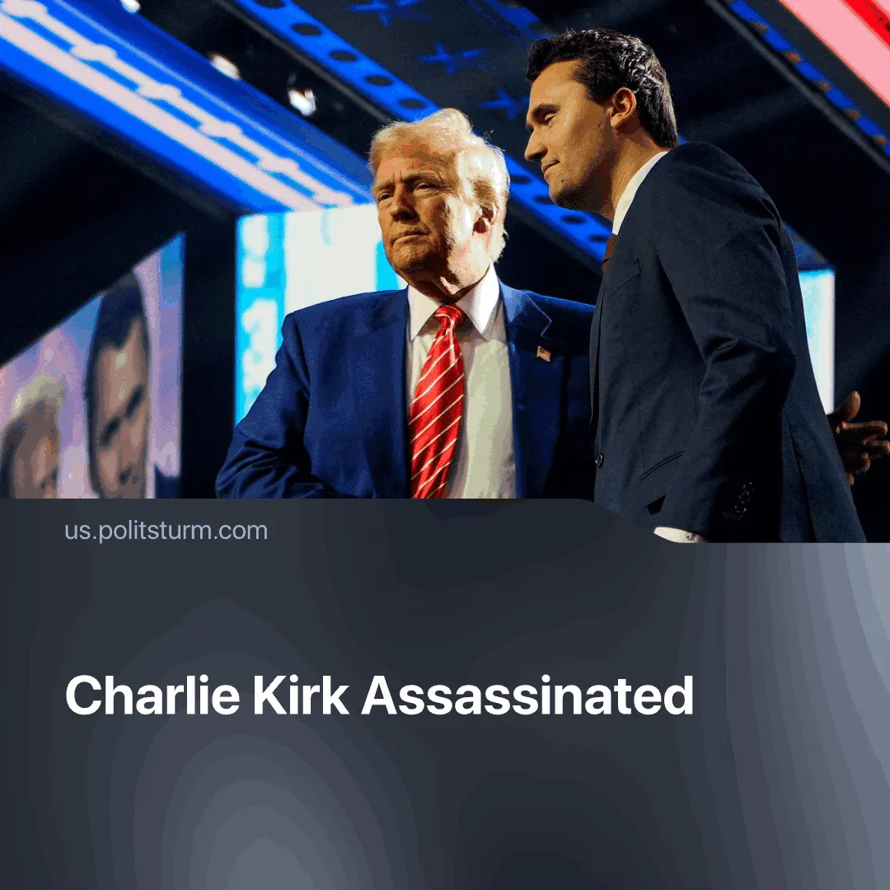

Original article
2025-09-15
2 min read

Whose interests will the MAGA figurehead’s death serve?
Details. Charlie Kirk, a founder of Turning Point USA and a prominent reactionary figure with direct personal access to Trump, sought to mobilise youth in defence of free markets, nationalism, and white supremacy. He built his reputation on aggressive online campaigns and campus “open debates”, once writing on X that “the radical left wants to destroy our country — we must crush them at the ballot box and in the streets.”
► Before the suspect was even caught, in a national address, Trump condemned the killing, called Kirk a “martyr,” blamed the “radical left” for “terrorism,” and vowed to find “every one of those who contributed to this atrocity.” The state lowered flags to half-mast, and Kirk is set to receive a posthumous Medal of Freedom. Elon Musk echoed this, calling Kirk a martyr and labelling the left a ‘party of murderers.’
► The alleged shooter was reportedly turned in by his father. Police recovered a rifle loaded with unspent bullets engraved with online memes, the phrase “Hey Fascist! Catch!”, and lyrics from the partisan song “Bella Ciao.” Authorities say he acted alone. Despite the anti-fascist slogans, little is currently known about his political views or motives.
Context. This assassination comes amid a year of multiple political killings and attempts in the US. While Trump and Musk point to “left-wing violence,” research by the Centre for Strategic and International Studies (CSIS) and the ADL documents that far-right attacks account for the overwhelming majority of ideologically motivated attacks in recent years.
► Simultaneously, the state is escalating violence and militarisation: deportations have surged past 200,000 in the first half of 2025, the National Guard has been repeatedly deployed against domestic protests, and US defence spending is projected to reach $1 trillion in 2026, reflecting both global and domestic militarisation.
► Propaganda immediately after Kirk’s assassination mirrors the Nazi use of Horst Wessel case, after which they framed all socialists and communists as murderous enemies to mobilise supporters and justify paramilitary repression. Similarly, Kirk is being portrayed as a martyr and a victim of left-wing terrorism, creating a pretext for increased repression, militarisation, and attacks on organised workers and communist movements.

Original article

