New German Chancellor Pledges to Put Germany at EU’s Forefront
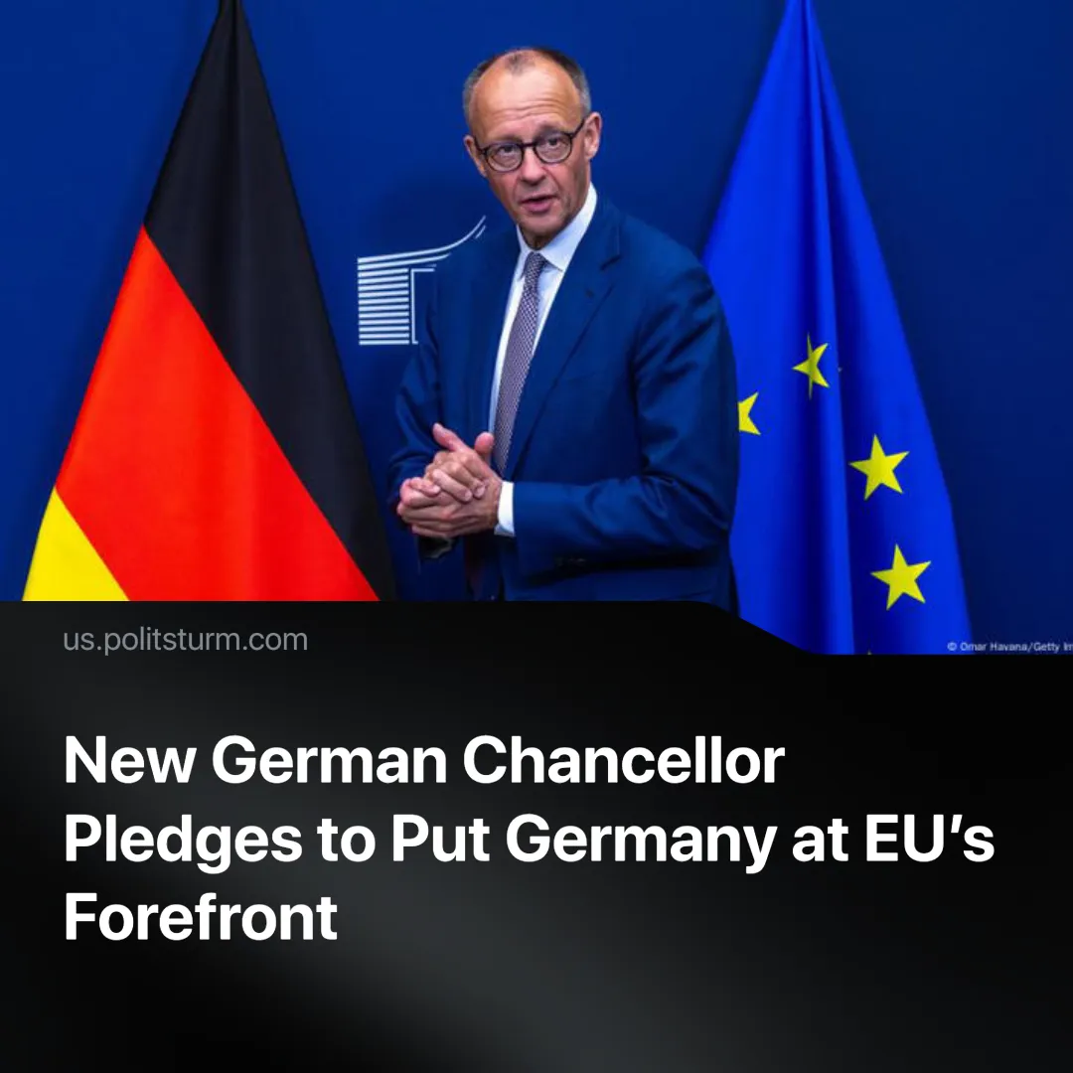

Original article
2025-05-18
2 min read

Germany is attempting to consolidate its leadership within the EU, with new Chancellor Friedrich Merz pushing to reshape the bloc’s political and military direction. He has promised “a strong plan to bring our country to the forefront again.”
Details. Merz recently met with EU leaders in Brussels to discuss Germany’s ambitions to reshape EU policy. Talks focused on joint borrowing for defence, fiscal reforms, and “strategic autonomy.”
► Merz supports deregulation in the EU, aiming to loosen supply chain rules and environmental standards for corporations. He also calls for rolling back green policies, which he claims burden businesses.
► Merz has called for Germany to reclaim European leadership and deepen Franco-German defence cooperation. He emphasised the need to reduce dependency on the United States, especially in response to recent statements by Donald Trump on NATO and tariffs.
Context. Merz’s visit follows the Christian Democratic Union’s (CDU) snap election victory and the collapse of Scholz’s Social Democratic Party (SPD)-led coalition. The country is politically fragmented—CDU dominant in the West, with Alternative für Deutschland (AfD) and Die Linke gaining ground in the East. These divisions were underscored when Merz failed to secure a majority in the first chancellor vote—an unprecedented event in German history.
► As calls grow within the EU to reduce reliance on the United States, Merz has aligned with France’s push for “strategic autonomy.” This comes as tensions with the US sharpen over trade disputes and the US's unilateral role in Ukraine negotiations.
► The EU has begun massive increases in military spending; Merz has already adjusted the German constitution to allow large-scale military borrowing and has vowed to build the largest army in Europe.
► As anti-EU sentiment grows—especially among nationalist parties in peripheral states like Romania—the bloc has relied on political repression to maintain unity. In Germany, the secret service recently labelled the Eurosceptic AfD an extremist group, only to temporarily suspend the classification while continuing legal surveillance.
Important to Know. Germany is Europe's largest economy, accounting for about 24.2% of its total GDP. As the bloc’s dominant economic force, it plays a major role in EU politics. Merz’s actions reflect German monopoly capital’s effort to reassert dominance across the bloc — economically, politically and militarily.
► EU deregulation and reindustrialisation, which Merz supports, benefit dominant economies like Germany while deepening inequality across the bloc. This approach pushes smaller, more vulnerable member states—such as Greece, already hit hard by EU-imposed austerity—into even greater dependence on Germany.
►The slogan of “strategic autonomy” means preparing the EU for imperialist war without US oversight—an agenda funded through austerity imposed on the working class. Merz’s push for constitutional changes and expanded military spending reflects Germany’s leading role in advancing this strategy.
► As Germany reasserts its role in the EU, managing internal threats like the AfD has become a key priority. The party’s anti-EU stance makes it both a risk and a useful pressure valve. Though the extremist label was recently suspended, it still permits full surveillance, allowing the state to keep the AfD in check without banning it.

Original article

