Chair of the Russian Bank Denounces Planned Economy
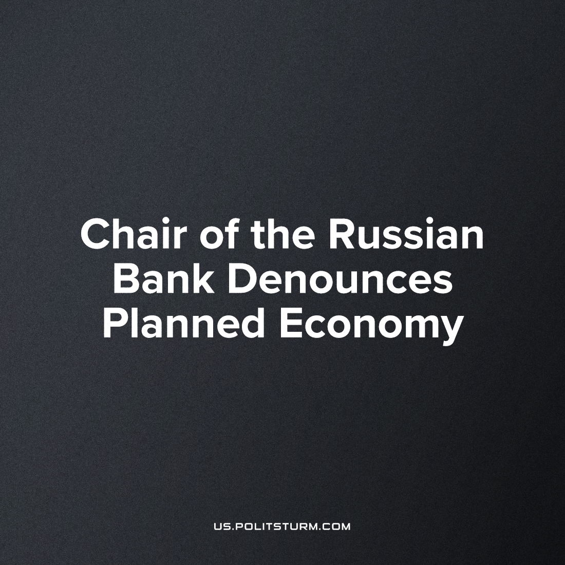

Original article
2023-06-19
2 min read

Elvira Nabiullina, Chairman of the Central Bank of the Russian Federation, expressed her opinion on state intervention in the economy.
"There are risks that we confuse the activity of the state during the crisis, which should be, with the fact that we want to constantly manage the economy and this temptation to manage can lead to the suppression of private initiative
...
in fact it is enough for the state to concentrate the right to decide which industries, which projects should be developed and where to direct financial resources instead of private initiative. And, in my opinion, this is a big risk. Because what structural adjustment is not is definitely not about making a big breakthrough in a wide range of industries through budget spending, through public debt."
Mrs. Nabiullina, occupying one of the key positions in the state apparatus for managing Russia's economy, believes that there is absolutely no need to manage the economy. This is truly ridiculous since it is due to the lack of management that the economy of capitalist countries suffer so many economic crises today, which are actually crises of overproduction. Due to free market leadership in the economy, planned development becomes impossible, causing the epidemics of inefficient, wasteful allocation of resources which plague the whole world.
Why then does Mrs. Nabiullina utter such nonsense in public? There are two reasons for this:
1) Mrs. Nabiullina, although she occupies a high position, does not communicate a deep understanding of how the capitalist economy is organized, even the simplest principles and logical connections of this sector seem to be inaccessible to her, although she is professionally engaged in macroeconomics. Her understanding is totally reflective of liberal doctrine.
2) Mrs. Nabiullina openly expresses the interests of big capital. All that she talks about cannot permit improving the situation of the Russian economy, but gives the opportunity to argue for the profits of big businessmen, even of other countries, reduce their costs, strengthen their right to the private appropriation of the results of labor of entire nations.
Of course, the planned economy is a huge danger for global capitalism, because the arrangement of the economy according to the planned principle will make big business unnecessary. It will simply disappear, as feudalism and feudal lords disappeared in the past, when they became an obsolete model of economic management. Big business, as we can see, makes every effort to emphasize its importance, claiming they are the only ones who can best coordinate large-scale production, and so try to prevent the average person from even thinking about a planned economy.
Sourсe: 1

Original article

