CEO Pay 320 Times a Typical Worker
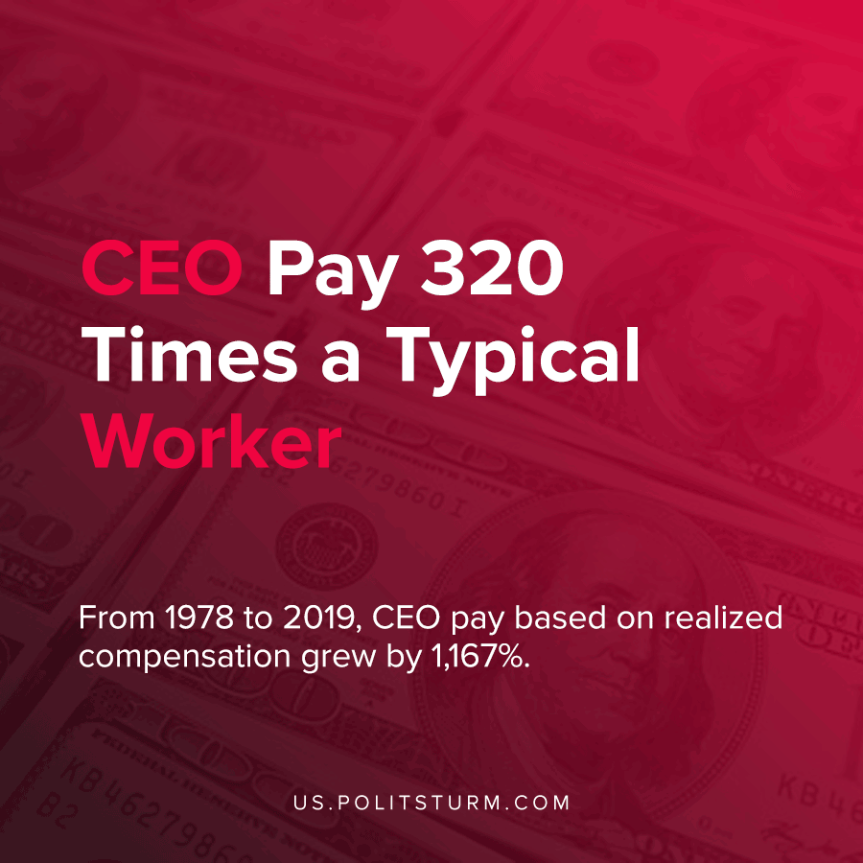

Original article
2021-04-08
1 min read

According to a recent analysis by the Economic Policy Institute (EPI), the authors found that in 2019 the average CEO of a U.S. public company made 320 times more than the typical worker. The ratio between CEO compensation and what a typical worker earns has increased from 21 times in 1965.
The analysis determined that this massive increase was fueled by the fact that CEOs were largely compensated in the form of stocks and awards.

“From 1978 to 2019, CEO pay based on realized compensation grew by 1,167%, far outstripping S&P stock market growth (741%) and top 0.1% earnings growth (which was 337% between 1978 and 2018, the latest data year available).
In contrast, compensation of the typical worker grew by just 13.7% from 1978 to 2019.”
As the authors correctly identify CEOs, through their private ownership of the means of production, are able to tremendously enrich themselves. The executives exploit the workers to maximize their profits. Ultimately, the reason why they are able to do this is due to the lack of social ownership over the means of production by the workers and the existing class dictatorship of the bourgeoisie.

Source: 1

Original article

