CEO Compensation Skyrockets 1,167%, Worker Pay Stagnant
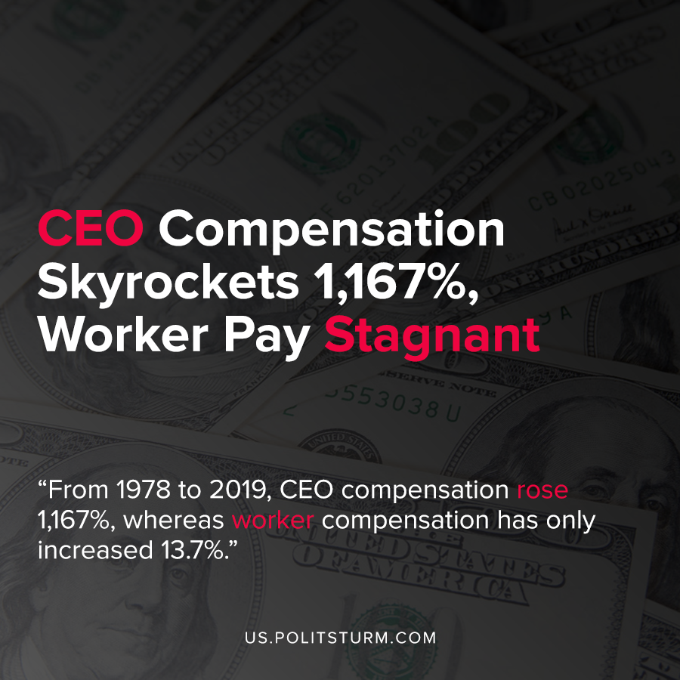

Original article
2020-08-20
1 min read

According to a recent release by the Economic Policy Institute, CEO pay has skyrocketed, while worker pay has been stagnant. From 1978 to 2019, CEO compensation rose 1,167%, whereas worker compensation has only increased 13.7%.
In recent years, nearly half of the compensation for executives has been in the form of vested stock options. With the rise of the stock market, corporate executives have been able to cash in due to their large shareholdings and subsequently reap massive profits.
Under capitalism, ownership of the means of production is private in nature. As such, the intent of the capitalists is to enrich themselves through the maximization of profits to obtain the largest return on investment.
By contrast, the workers who do not own the means of production do not have large, private ownership stakes in corporations. The working class collectively produces the profits which are privately appropriated by the capitalists.
While the Economic Policy Institute recommends various policy measures to remediate the excessive pay of executives, it is inherent in the capitalist system. As long as the ownership of the means of production is private, production will remain both anarchic and oriented towards profit extraction at the expense of the workers. Only the replacement of capitalism with socialism will eliminate the exploitation of man by man which is a constant under capitalist economic relations.

Source: 1

Original article

