American Corporation Centrus Requests Permission to Purchase Russian Uranium
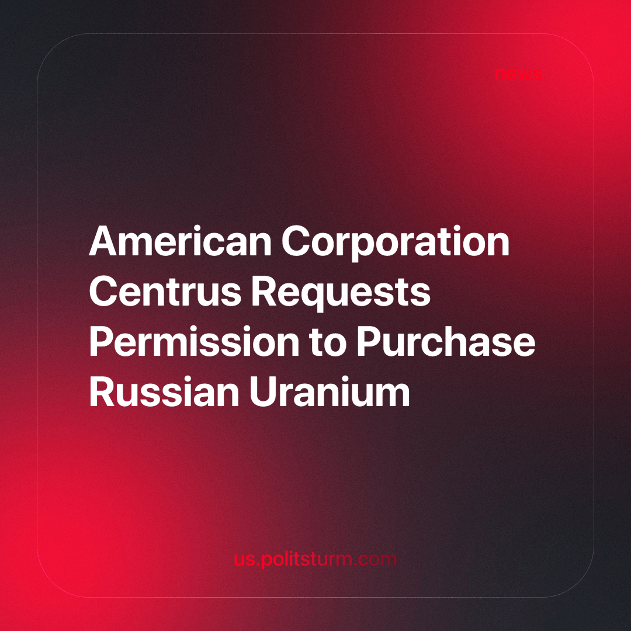

Original article
2024-06-03
1 min read

Centrus, the largest U.S. nuclear fuel cycle company, has asked the relevant governmental departments to grant it an exception from the ban on uranium imports from Russia.
“When the law is enacted, we will apply for an exemption from the Secretary of Energy and other relevant government agencies to request permission to continue supplying low-enriched uranium to our customers,” the company said.
On April 30, the US Senate approved HR 1042, which will take effect 90 days after it is signed by the President. This law prohibits the import of low-enriched uranium from Russia until 2040. However, under certain circumstances, that being the “national interest” of the USA, it gives the energy minister the power to lift the ban.
Despite all the statements about economic war, in reality, we see that while capitalists set workers of different countries against each other, they, if it is profitable, continue to do business with each other.
If workers want to free themselves from exploitation, then they need to discard capitalist-imposed nationalist ideas. Only on the basis of worker’s internationalism will it be possible to build a new society in which there will be no exploitation or destruction of man by man.
Source: URA.ru - “American company asks to allow import of Russian uranium” from May 10, 2024.

Original article

