Ceasefire Falls Apart as Israel Renews Its Offensive
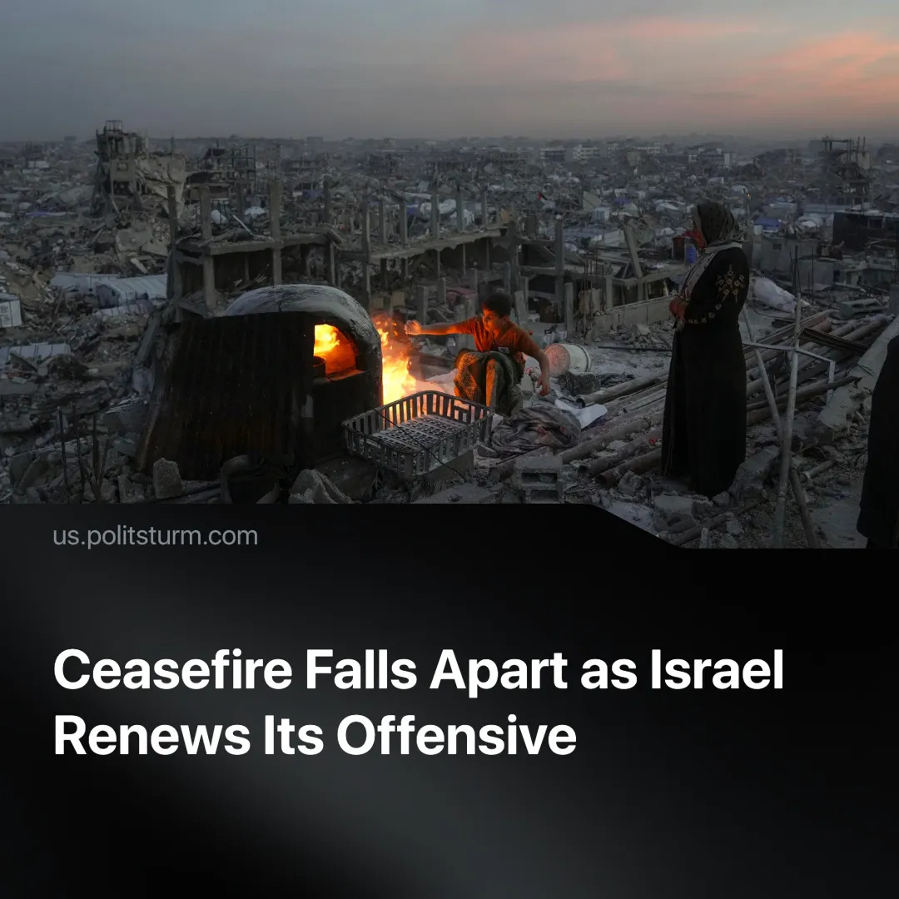

Original article
2025-03-22
2 min read

The ceasefire between Israel and Hamas collapsed as Israel launched airstrikes and ground operations in Gaza. Prime Minister Netanyahu stated he remains committed to rescuing hostages.
Details. On 18 March, Israel began air-striking Gaza, breaking the two-month ceasefire.
► Recent airstrikes have killed at least 591 Palestinians, including over 200 children, and the UN has reported that one of its workers was killed. In retaliation, Hamas has begun launching rockets at Tel Aviv.
► Hamas called Israel’s attacks a unilateral cancellation of the ceasefire that began on 19 January. While Israel has not formally declared the ceasefire over, senior officials have indicated that the assault on Gaza will continue.
► Israeli strikes have hit refugee shelters and have killed aid workers.
► The Israeli military stated that the attacks were "pre-emptive strikes... based on Hamas's readiness to execute terror attacks, build up force and re-arm." Netanyahu has said that fighting will resume with "full force".
► Family members of Israeli hostages gathered outside the parliament building in protest, fearing that these attacks would endanger the safe return of their relatives.
Context. After more than 46,000 Palestinian deaths, a ceasefire was reached. It had three stages, aiming to exchange hostages and begin Gaza’s reconstruction. The ceasefire had been on shaky ground for weeks, with Israel violating it multiple times.
► Israel requested a 50-day extension of the first stage — proposed by U.S. envoy Steve Witkoff — which allowed Israeli troops to stay near Gaza’s borders. Hamas refused, calling it "a blatant attempt to evade the agreement and avoid entering into negotiations for the second."
► On 2 March, all humanitarian aid to Gaza was halted, and reports indicate that on 9 March energy supplies were also cut off, aiming to pressure Hamas into releasing hostages.
► Stage two would have included a permanent ceasefire, the return of all living Israeli hostages, and the withdrawal of all Israeli forces.
► Despite claiming credit for the ceasefire, U.S. President Trump has resumed bomb deliveries to Israel, lifted sanctions on settlers, restricted the ICC after warrants for Netanyahu and Gallant, hosted Netanyahu, and proposed turning Gaza into a U.S.-controlled seaside resort.
Important to Know. The Middle East remains a battleground for imperialist powers. Israel serves as a pillar of Western imperialism, while states and organisations aligned with Iranian imperialism — including Hamas, funded by members of the so-called "axis of resistance" — aim to expand their own spheres of influence.
► Israel’s renewed offensive comes amid rising tensions across the region. The U.S. has launched airstrikes against the Houthis in Yemen and adopted a much tougher stance toward Iran. In Syria, imperialist-backed factions are clashing.
► Protests against Netanyahu highlight growing domestic discontent. Before this escalation, workers staged industrial strike action on 2 September 2024 to demand the release of hostages.
► Notably, the 2023 workers’ strikes have shown that Israeli workers are capable of organisational activity. This action could be turned against capitalism and united in solidarity with the Palestinian workers, but only under the leadership of a genuine communist party, which does not currently exist in Israel or Palestine.
► Hamas, a reactionary Islamist organisation, does not stand for Palestinian liberation, but its subjugation under different imperialists. Additionally, Israel has previously used Hamas to divide resistance.
Conclusion. The renewed offensive, the collapse of the ceasefire, and simultaneous regional escalations highlight that monopoly capitalism cannot produce lasting peace. While imperialist powers present themselves as defenders of “peace” or “resistance”, they only perpetuate exploitation. True liberation — for Palestinians, Israeli workers, and all peoples in the region — can only come through international working-class struggle against all imperialist forces.

Original article

