Capitalists Say AC is “Selfish”
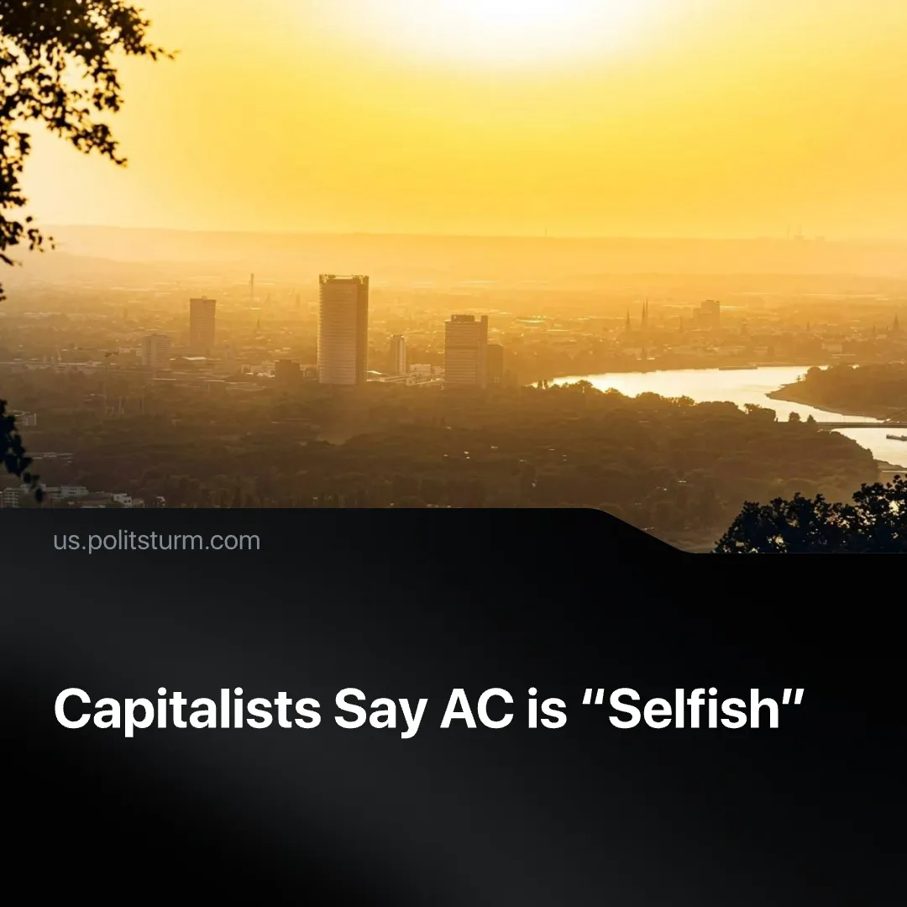

Original article
2026-07-13
2 min read

As Europe's heatwave killed an estimated 20,000 people, capitalist officials and media turned to whether air conditioning is "selfish.”
Details. ​A recent record-breaking heatwave, which has claimed an estimated 20,000 lives in Europe, sparked intense debates on French social media after the far-right National Rally initially proposed a vague but populist plan of mass installation of air con – though this ended up being just a poorly thought-out plan for zero-interest loans. Opponents from the environmentalist left argue that it would produce even more heat, though some have since admitted its necessity. The Paris Mayor called “individual air conditioning is a scourge”.
► Debates are also going on beyond France. Good Morning Britain ran a programme on whether air con is selfish. Meanwhile the European Commission has decided to remain neutral in the debates, saying they prefer to focus on achieving “climate neutrality”.
► Western mass media have long been raising individual guilt for climate change. Back in 2019, a Guardian opinion article claimed that the human body can handle the heat without AC. A United Nations’ interview echoed anti-AC rhetoric in 2023, linking its damage to growing energy consumption. Later in 2025, a Time article reported that some people feel guilty for using their AC due to its potential climate damage.
Context. Just 20 fossil fuel companies are responsible for almost 35% of all energy-related greenhouse gas emissions worldwide, and 90% of all emissions are caused by fossil fuel use. The capitalist system of production is the main cause of climate change because it prioritizes individual capitalist profits over long-term environmental consequences.
► The environmental impact of AC use is largely determined by the electricity source, with individual AC use remaining far less damaging and localized. France, a country where these debates were especially intense, generates most of its energy through nuclear power.
► In practice, debates over AC-use shift the guilt from the capitalist system to individual workers who are simply trying to survive the intensifying effects of climate change. This strategy was adopted long ago when British Petroleum popularized the idea of a “carbon footprint”, i.e. the individual impact that each worker has in damaging the environment. But even by this metric, it is acknowledged that the wealthiest cause far more damage.

Original article

