Capitalist Healthcare Is Unable To Handle Covid-19
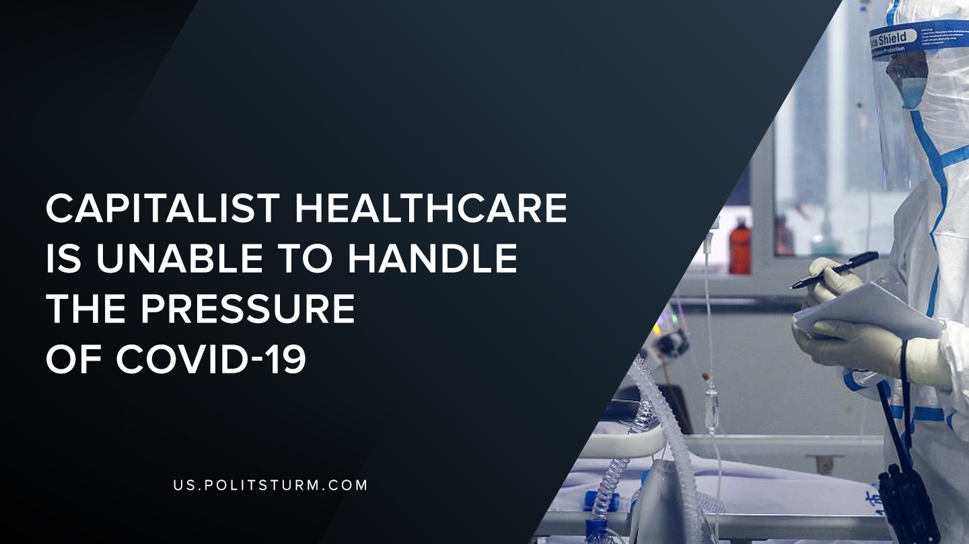

Original article
2020-03-12
1 min read

A few days ago Poland’s hospitals had reported that they simply do not have enough equipment to deal with Covid-19 (corona-virus).
“Basic medical supplies, including disinfectants, sanitizers and masks, have surged in price internationally in recent weeks. China, which accounts for about 80 percent of the global production of masks, reportedly all but stopped exports in January to confront the massive outbreak of Covid-19 within its borders.”
“In a poll conducted last year, 92 percent of Polish hospitals indicated that they were running on a deficit, up from 51.21 percent in 2015.”
With an increase in need for medical provision and global crisis, we face the battle between Covid-19 and capitalist healthcare. One of the many countries that is facing the issue of underprovision of supplies is Poland. However just like everywhere else, the deficit of supplies was prominent long before the outbreak. China was the main source of supplies for the entire world and because capitalism would not allow for industries being located in home countries, as profits would be tremendously reduced.
“A few corporations control most of the market for each of the commodities they produce. In these corporations, a very small sector of a board of directors and majority shareholders makes essentially all of the decisions on what to produce, where to produce and how to distribute profits.”
The capitalists with the pursuit of profits will and must disregard the health and wellbeing of the proletariat, being the patient or the doctor. As a result of that the poor handling of the covid-19 is not subjective on this one occasion, but was an inherent flaw of the capitalist system. Only socialism with planning and dictatorship of the proletariat will control the system that will allow for them to build an environment that would benefit them and not the capitalists.

Original article

