Capitalist Basis Can't Handle Supply and Demand
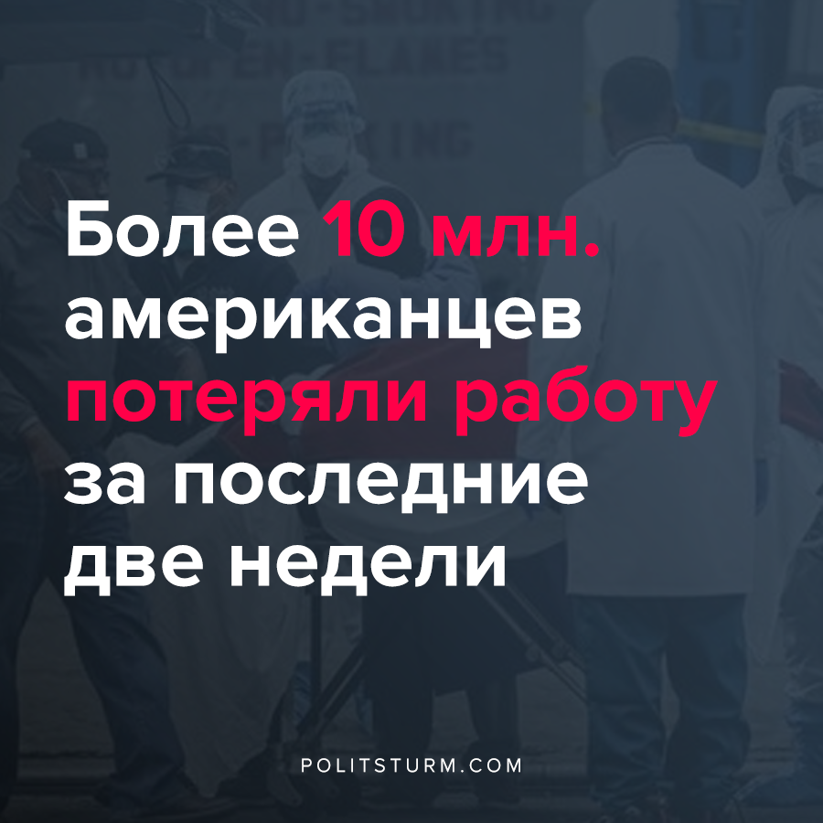

Original article
2020-04-05
2 min read

As the epidemic grows, we see how the worlds number one economy attempts to handle through the reliance of the free market.
“There are folks who say that every night they take the mask home, they spray both sides with bleach and they hang it up to dry and they hope that’s gonna work,” said Laura Wooster, associate executive director of public affairs at the American College of Emergency Physicians, a member organization of ER doctors.
“We’re getting some distributions from the national stockpile. We got some stuff delivered yesterday. It’s not nearly enough,” said Maryland Gov. Larry Hogan (R), who is also chairman of the National Governors Association.
The lack of essential resources in times of desperate need seems to be ever depleting with active failure from both the free market of the USA and the regulated markets of Europe. Capitalism fails to fulfil peoples needs and the only need that is once more placed as the emphasis is profit. Because affordable healthcare violates the pursuit for profit, the capitalist will swipe the problem off as normal occurrences and would simply proclaim to the proletariat to slowly recover as they are unable to provide respirators to this class. While prior to the outbreak we would repeatedly hear of the efficiency of the market.
To see the alternative the is little need to go far, as countries like USSR and the rest of the Warsaw pact, were fully able to provide gas masks and medical supplies to their population in the need would arise. USSR despite complete isolation from the entire world, devastating war, the historical circumstances at which USSR was placed in competition with the USA, while the USA had a long history of development behind it, still would have a country like USSR that was formerly treated as a colony could reach the point of being the second world economy and fully provide for the needs of their citizens. USSR through planning had been able to provide civilian preparation if a pandemic would occur and stop it before it would escalate. Cuba with their planned economy was capable of stopping the AIDs epidemic, even today to help alleviate medical problems not only at home but also around the world they would send their doctors abroad. Only socialism will be able to provide and fulfil the needs of the population, as it had before and would even more effectively do today.

Critical supplies shortage hampers hospitals, health providers

Unsupported element: IFRAME

Original article

