Capitalism and War. Part I: The Reasons and Role in History
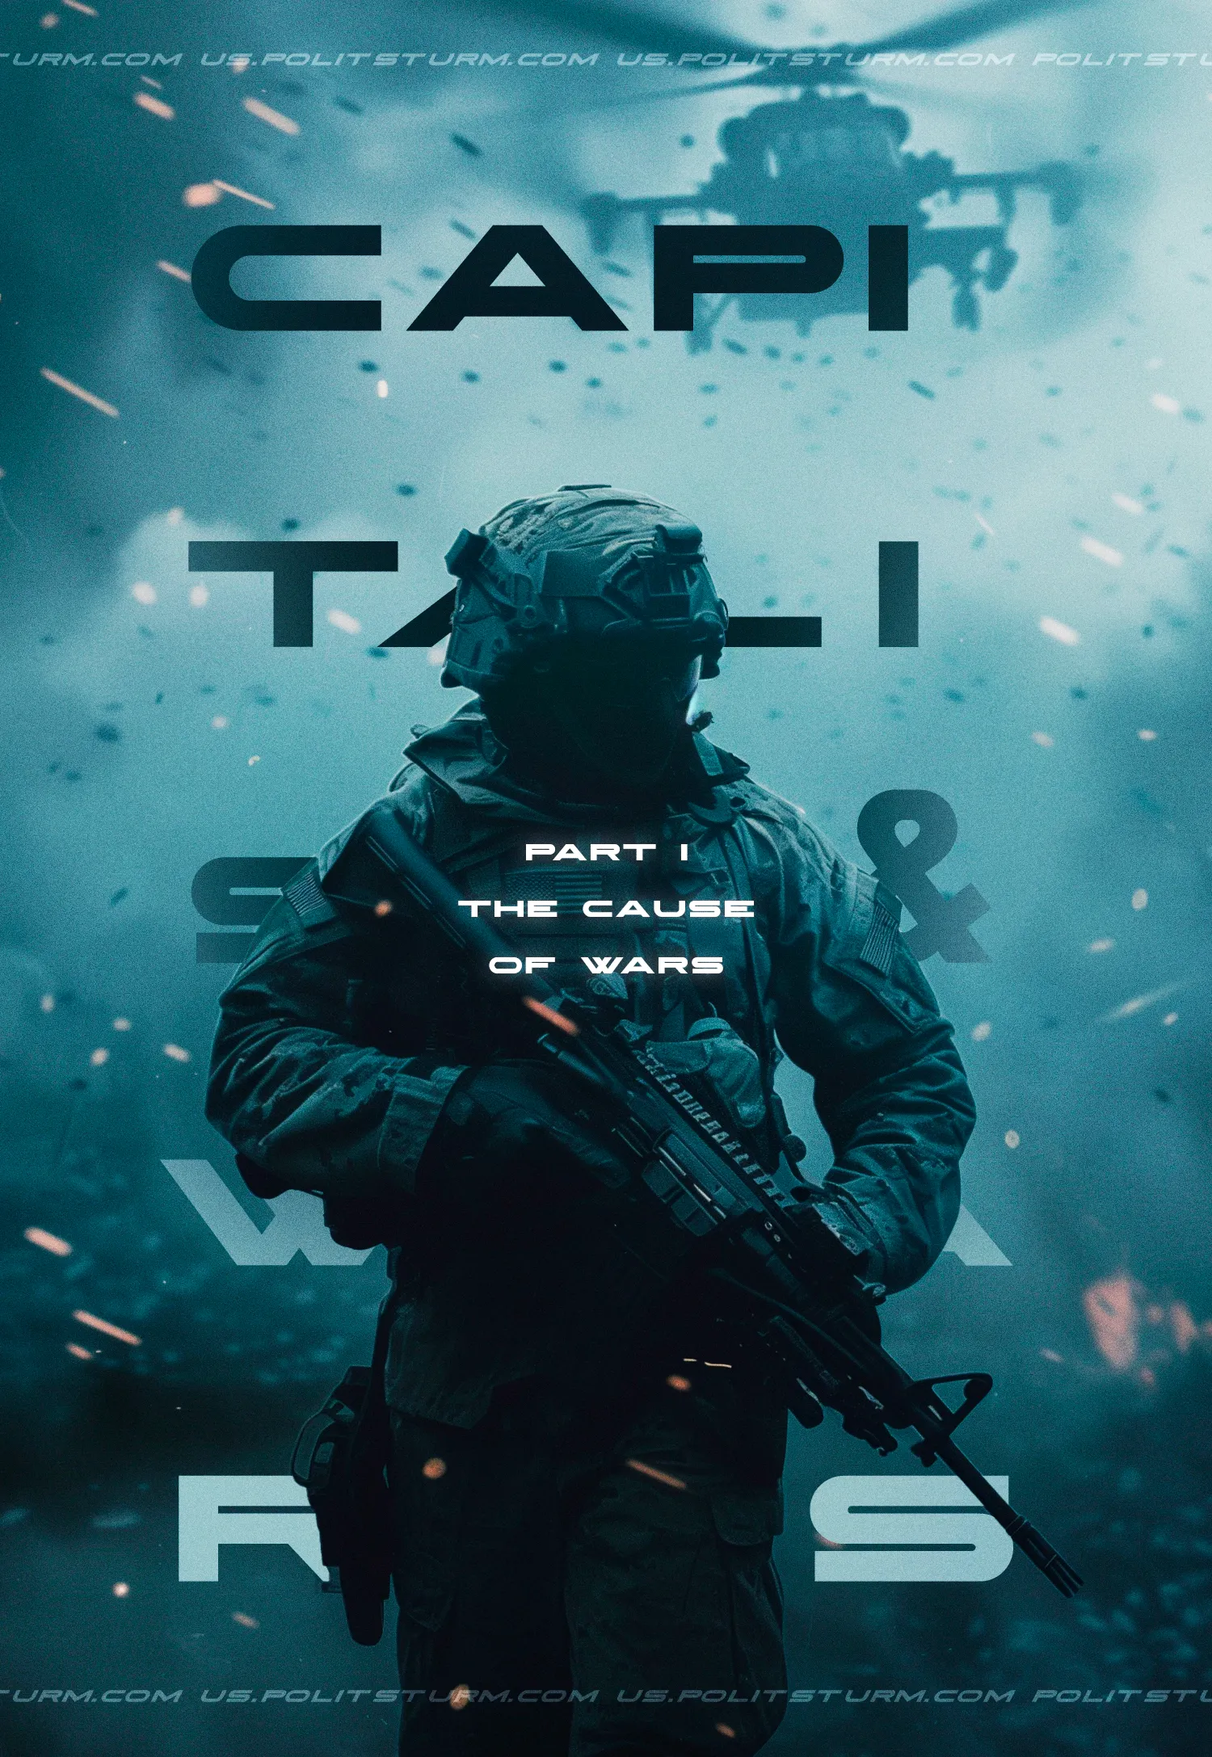

Original article
2024-03-10
75 min read

The constant companion of class society since its inception has been war. It has accompanied humanity at all socio-economic stages of development based on private ownership of the means of production.
Capitalist society was no exception. Due to the antagonistic contradictions inherent in this system, wars are an integral part of capitalism. Contrary to popular myths, capitalism does not outlast wars but raises them to a new, more destructive level. There can be no capitalism without wars.
In the first part of our material, devoted to the Marxist-Leninist analysis of the essence and content of war, we will consider why capitalism generates wars and what place war occupies in the history of the development of capitalism.

1. What is war?
From the moment when the development of productive forces made it possible to obtain surpluses in the production process, the history of the constant companion of any class society - war - began.
The emergence of private property led to the formation of classes and the state; an instrument of suppression of one class by another. The exploiting class, which had seized the means of production, could no longer do without wars as a means of enslaving other peoples and strengthening its influence within a given country.
While the armed conflict of the period of primitive communal economy took place in the form of a struggle for the creation of conditions of existence and was characterized by random fights for the expansion of territories that had become insufficient or revenge for an attack on a neighboring tribe, then with the advent of antagonistic classes, armed violence acquired a new meaning.

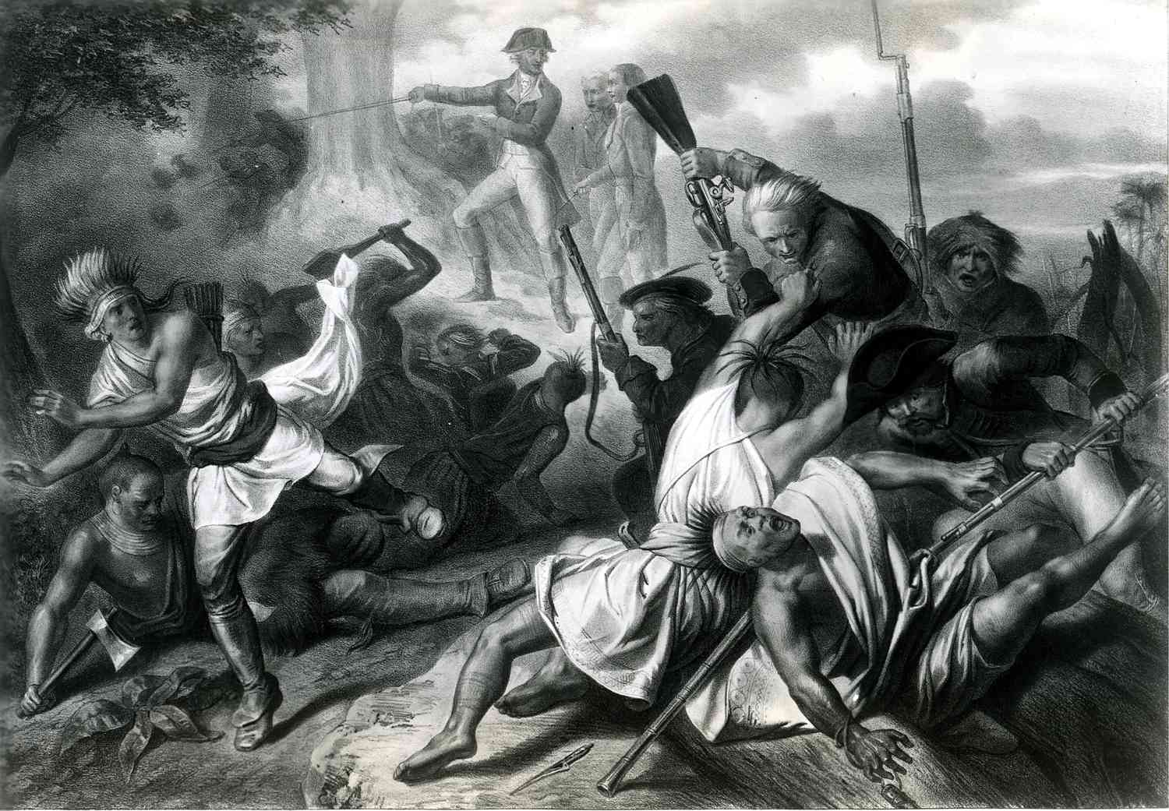
All wars, without exception, are the result of socio-economic processes within society. The engine of the development of this society is the class struggle, in which the ruling classes, striving for constant enrichment, have made armed violence a permanent element of their politics. The economic interests of the owners of the means of production are embodied in their politics which are a "concentrated expression of their economics".
Thus, the origin of wars lies in the most antagonistic class society based on private ownership of the means of production and the exploitation of labor. War as a socio-historical phenomenon is brought to life by the functioning of a given class society.
If the task is to analyze and understand a specific war and its causes, then it is necessary to analyze and understand the policy of the ruling, war-interested class that preceded the war. To do this, it is necessary to consider the totality of socioeconomic and political relations in each state and the group of states that participate in the war.
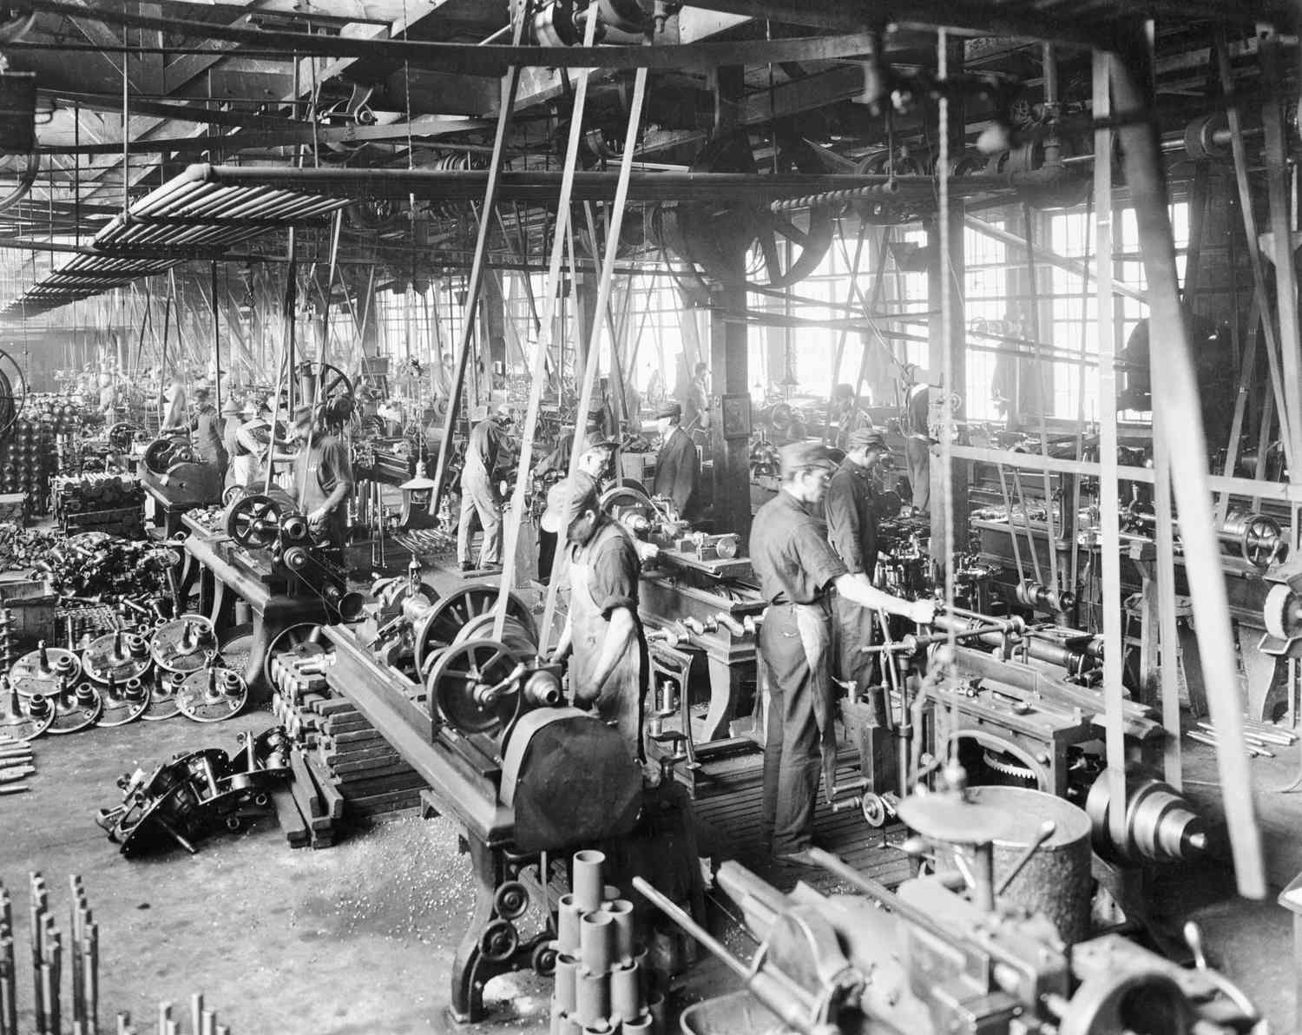
It is necessary to consider war not as a supra-class phenomenon exclusively of foreign policy, but in dialectical unity with the economic structure, internal politics, and inter-class relations. Domestic policy more fully and deeply reflects the fundamental interests of the forces interested in the war.
It is this policy that the ruling class will continue during the war, changing only its form. The goals that the class of the owners of the means of production set for themselves before the war — namely, increasing their own enrichment — they will continue to carry out in a different way during the war. They do this when peaceful methods will no longer be enough to overcome contradictions.
War is merely the continuation of a certain policy of a particular class in a specific form of armed violence.
The policy determines the direction and nature of the preparation for war, sets criteria for readiness, outlines goals, controls the actions of military forces, specific ways of fighting and, in general, the course of the war. Politics, even in the midst of war, uses additional means to achieve the goals of the ruling class — economic struggle, active diplomatic activity, ideological and psychological influence on the enemy.
This determines the primacy of class interests over forms of warfare and the ability to organize the use of all forms of struggle to achieve victory over the enemy.
Just as there is no above class politics, there is also no war that does not pursue economic and political (in short - class) goals. The nature of the political goal has a decisive influence on the conduct of the war.
«...the nature of the war and its success depend most of all on the internal order of the country that enters the war, that the war is a reflection of the internal policy that this country conducts before the war" [1].

2. Why do wars happen?

2.1 Causes of war
Bourgeois propaganda and science are trying their best to justify the waging of wars of conquest, to divert the attention of the working class from their real causes and to present them as an eternal and obligatory companion of human society. This is how the inevitability of wars is justified, and therefore the senselessness of fighting against them.
Ethical theories represent wars as a high "moral principle" in the life of peoples and states; biological ones show them as a natural biological law inherent in the life of peoples and assert that the origin of wars lies in the biological aggressive characteristics of man. Their varieties and the result of this intertwining are Malthusian theory, racial theory, geopolitics and rampant nationalism.
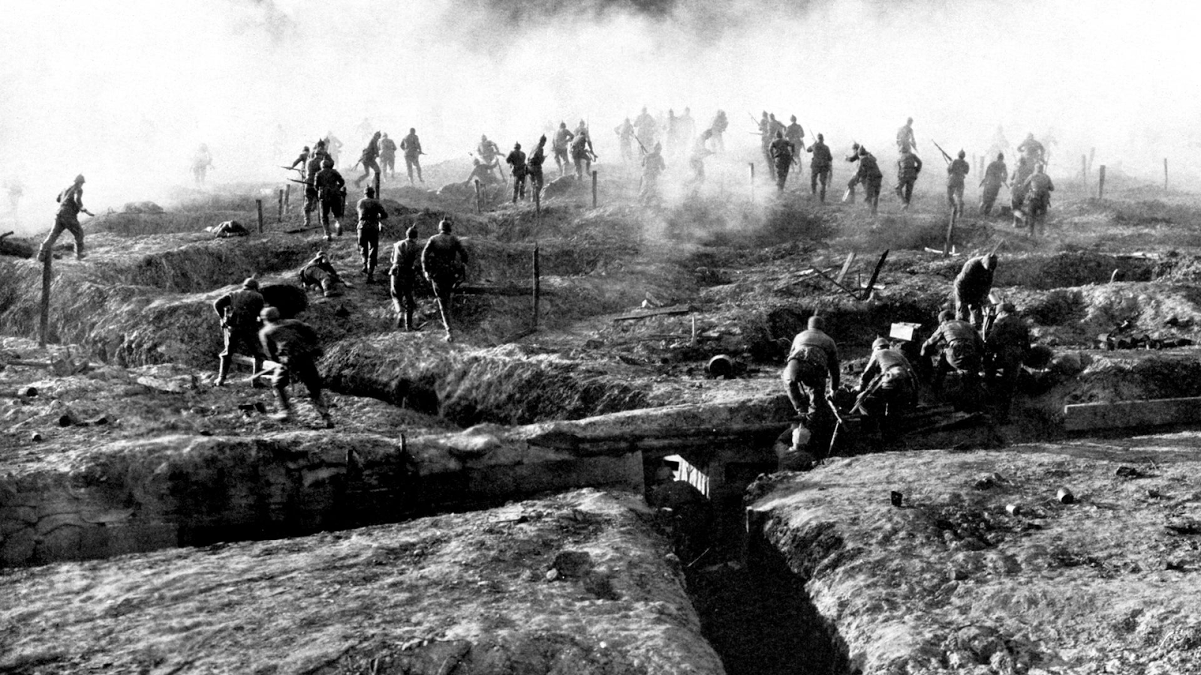
The arguments of the modern militant "patriots" of each country are based on nothing new and repeat old misanthropic theories. They are also far from a real scientific analysis, as well as from the class approach used by Marxism-Leninism.
All wars are based on an objective, material basis. The desire to seize the territories of other states has existed throughout the entirety of class society. Due to the decisive role of the economic basis, the emergence of wars could only be accelerated or postponed depending on the subjective actions of individuals or secondary causes. But what makes war an objectively inevitable phenomenon of capitalism? It is the objective laws of the development of capitalist society.
Since the pre-monopoly stage, the development of capitalism has been characterized by inequality. Individual enterprises, industries and countries have developed unevenly. This is a consequence of the fundamental contradictions of this mode of production.
If, with uncontrolled capitalist competition and chaotic production, the law "everyone against everyone" applies, then there can be no other development other than the interlinked and inverse advancement of individual enterprises, industries and countries on the one hand — and the lagging behind of others. With these or other advantages, companies develop faster, thereby weakening, and often directly ruining their competitors.
This, in turn, increases the unevenness of development even more — lagging enterprises are closed or absorbed by larger ones. Technical achievements and their implementation in factories play a special role. Specific natural geographical, historical and political conditions are also important.
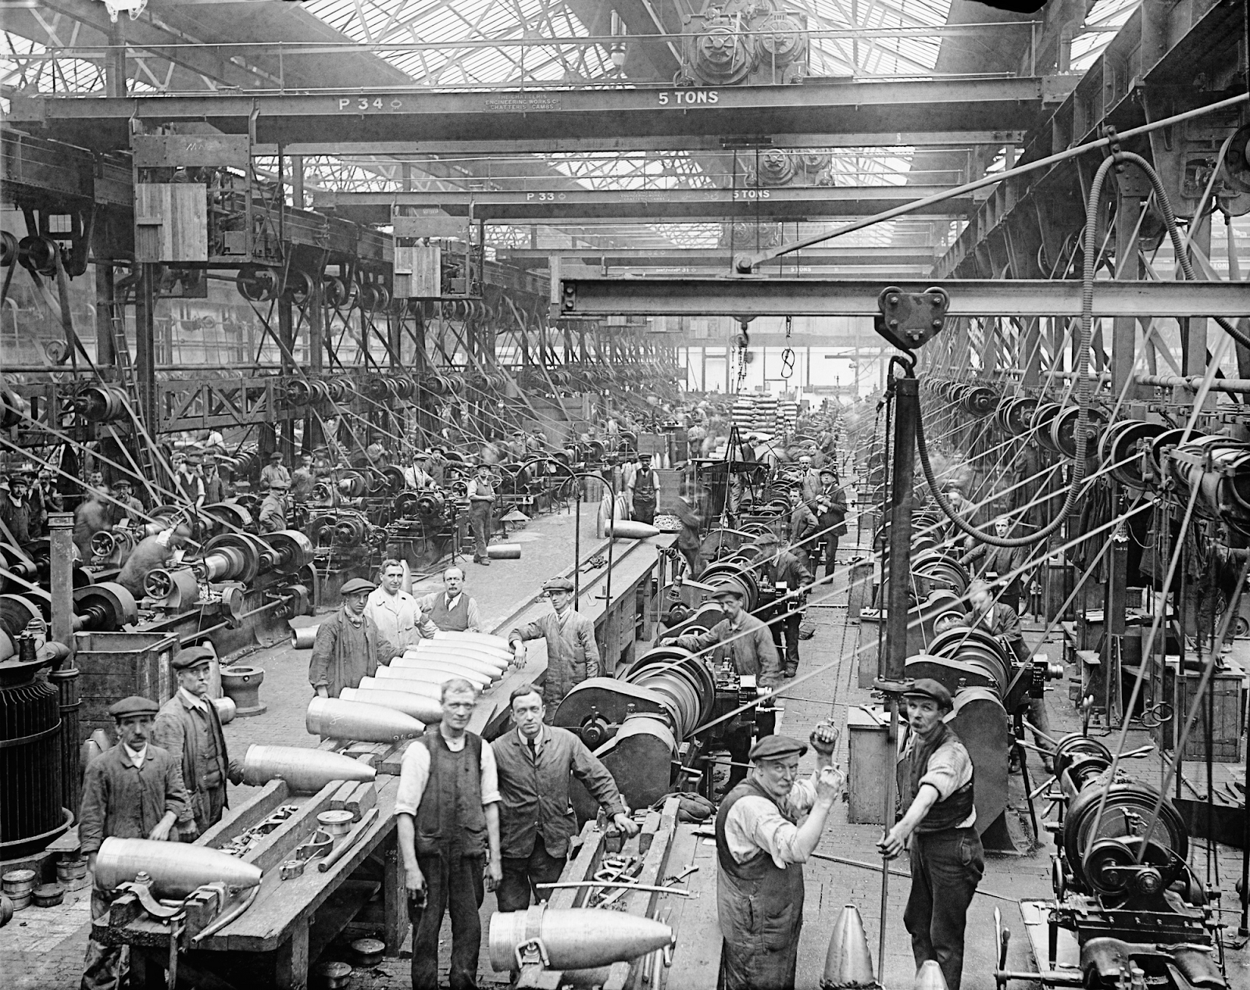
Under pre-monopoly capitalism, development took place relatively evenly, evolutionarily and without catastrophic leaps and world wars. There was no need for this since there were large territories that were not divided between strong countries, sales markets were not yet fully loaded, and there were no monopolistic unions. With the transition to the modern stage of imperialism, all the contradictions of capitalism have worsened, including uneven development.
"There was also unevenness in the period of pre-monopolistic capitalism, as Marx knew and as Lenin wrote in his Development of Capitalism. At that time, the development of capitalism proceeded more or less smoothly, more or less evolutionarily, and some countries were ahead of others for a long period of time without leaps and without obligatory military clashes on a global scale. It is no longer about this unevenness. What, then, is the law of uneven development under imperialism? The law of uneven development during the period of imperialism means the abrupt development of some countries in relation to others, the rapid displacement of some countries from the world market by others, periodic redistribution of the already divided world in the order of military clashes and military catastrophes" [2].
Thus, the special imprint of the modern era of the domination of financial capital on the nature of uneven development is as follows:
First, all the territories of the world have already been divided among the richest countries in one way or another and the division of land is over. In order to get a raw material region or a market, it must be taken away from another country. Hence the special cruelty of the struggle for the redistribution of the world, leading to wars.
Secondly, the development of technology has reached unprecedented proportions. The introduction of new production methods and equipment with huge material resources of monopolies allows even relatively weak companies and countries to get ahead dramatically. In addition, countries that have embarked on the path of large-scale industrialization for the first time receive an additional boost when using advanced scientific achievements.
Thirdly, the dominance of monopolies gives additional features to this process. The intensification of competition between monopolies that receive superprofits and non-monopolistic "wild" enterprises, which sometimes do not receive even average profits, accelerates the concentration of production and capital in the hands of a few. Monopolies with enormous power use a variety of methods to suppress competitors — from buying shares and sanctioning governments to violent destruction. The development of individual industries may be accelerated by the introduction of technology and the availability of raw materials, or it may be slowed down to maintain monopoly prices.
Fourth, each temporarily established distribution of spheres of influence between the largest monopolies constantly experiences shifts in the balance of power. In these conditions, the unevenness of economic development of various countries increases. This is where the inevitability of aggressive policies to capture markets and spheres of influence in favor of rapidly developing countries arises.
Over time, uneven development leads to the fact that a group of capitalist countries with the greatest economic and military power, but deprived of markets and raw materials, are no longer ready to put up with the existing situation. Then these countries begin the redistribution of the already divided world - the wish to alter existing conditions through armed conflicts, which, under the domination of monopolies, inevitably escalate into world wars. The contradictions of imperialism reach their highest point and become insurmountable in no other way than in a new war.
"To test the real strength of the capitalist state, there is and cannot be any other means than war" [3].
Since even catastrophes like world wars are unable to resolve the contradictions of the mode of production, the breaks between wars cannot be long. Hence the inevitability of imperialist wars for another redistribution of the world.
The intertwining of contradictions forces countries to form coalitions based on economic, political and military ties within them. At the same time, the coalitions themselves are full of contradictions: their members are unequal and depend on each other, enjoy mutual weakening, and exert pressure on each other. Thus, the unevenness of development increases further. The unleashed wars have the opposite effect on the economy, accelerating the concentration of capital and the outgrowth of monopolistic capitalism into state-monopolistic capitalism.
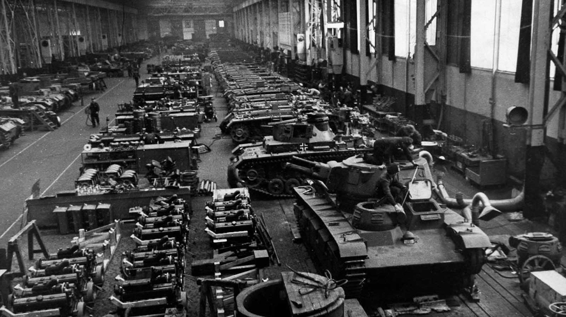
However, the root causes of war can also be influenced by specific historical conditions, the social situation and certain class antagonisms. The historical situation is dialectically correlated with the root cause of wars. This is the essence of the specific causes of wars.
As long as capitalism persists, the root cause of the war remains in force. However, there may be specific factors that can both accelerate the outbreak of war and prevent it. Such factors may be the preponderance of forces over the aggressor state, a strong international democratic movement against the war, or the existence of a group of socialist states.
There are also subjective reasons. These reasons only concretize the manifestation of the main engines of war, but they are still decisive. These may be the actions of certain individuals with authority, social groups, or random factors that bring war closer or further away. The propaganda of the ruling class elevates specific and particular causes to the absolute, accusing its competitors of fomenting war or appealing to the "difficult" historical situation the aggressor state finds itself in.
The unity of these types of causes manifests itself each time in a unique, peculiar way, while the main role of the contradictions of an exploitative society is maintained as the root cause.
Now the world is in the same state when world imperialism is boiling with accumulated contradictions: We are on the verge of World War III. The balance of power that developed after World War II was maintained by the existence of the USSR and its policy of preserving peace. After the loss of Soviet power and the restoration of capitalism, a further delay was obtained, necessary for the development of sales markets and spheres of influence in the territory of former socialist countries.
Now this has come to an end, and the world, once again, is fully divided. Over the past two decades, a new center of power has emerged in the system of world imperialism, which does not want to put up with the dominant position of American monopolistic capital. This rapidly developing, but already experiencing problems of overproduction, pole is imperialist China. Its large-scale Eurasian initiatives are no longer able to solve the problem of sales markets - entire countries become indebted to China and become enslaved to its production and banks. China is preparing for a decisive battle for the redistribution of the world. There is no hiding the division into coalitions between countries, the undisguised build-up of weapons, all-around preparations for world war and the local conflicts preceding it.

2.2 Wars and armed conflicts in the history of capitalism
The idea of the essence, role and tasks of war under capitalism is given by a concrete analysis of the material causes and policies of the ruling classes before the war. We will consider several striking examples that clearly demonstrate the importance and role of war under capitalism and its organic connection with this mode of production.

The Opium Wars
The heyday of pre-monopoly capitalism was not without colonial conquests and wars of subjugation of weak countries. The Opium Wars of 1840-1842 and 1856-1860 are examples of such predatory policies of the European powers and America.
Until the middle of the 19th century, the trade of European countries with imperial China was limited to a small turnover, in which the share of Chinese goods being exported compared to the European goods imported was overwhelming. The ruling Qing Dynasty pursued a policy of isolation — maritime trade was prohibited, and foreign merchants had access to China only through the port of Guangzhou; for the Chinese themselves, only a guild of 12 merchants had the opportunity to do business with foreigners [4]. However, by the 1830s, a European product had become popular in China, the spread of which could not be stopped by any embargo and borders. It was opium.
In 1834, the East India Company was deprived of the right to trade with China - from then on it became a privilege of the British government [5], with the support of which the import of opium, despite complete illegality, increased to 2 thousand tons by 1835. This accounted for three-quarters of all imports into the country at that time and became a real tragedy for the Chinese people. Karl Marx wrote about it:
"The corruption that permeated the entire bureaucracy of the Celestial Empire and destroyed the stronghold of the patriarchal way of life was smuggled into the empire along with boxes of opium from British warehouse ships anchored in Whampoa. Fueled by the East India Company, unsuccessfully banned by the central government in Beijing, the opium trade steadily increased in volume and in 1816 was already expressed in the amount of about 2,500,000 dollars ... In 1820, the number of boxes smuggled into China reached 5,147, in 1821 — 7,000, and in 1824 — 12,639... Already in 1837, despite the desperate resistance of the government of the Celestial Empire, 39 thousand boxes of opium worth $25 million were smuggled into China... In 1837, the Chinese government finally found itself in a position where it was necessary to take decisive measures immediately" [6].
Along with the opposition to the importation of opium into China, tensions gradually began to increase in coastal waters and ports, where the British fleet had been stationed since the mid-1830s. The UK had set a course for the forceful scrapping of China’s isolation and the opening of the Chinese market.
In 1839, China demanded the surrender of all opium and the abandonment of its trade for all foreign entrepreneurs. Companies that did not give a receipt for such an agreement were blocked by Chinese troops from all communication with the population. In December of the same year, after minor successes, the emperor declared China completely closed to businessmen from India and England — all ships, along with goods, were removed from the port of Guangzhou. 20,000 cases of the drug were confiscated, some opium traffickers were arrested and even executed, and the places of residence of foreigners were blocked [5]. After this, the declaration of war by England became a matter of time.
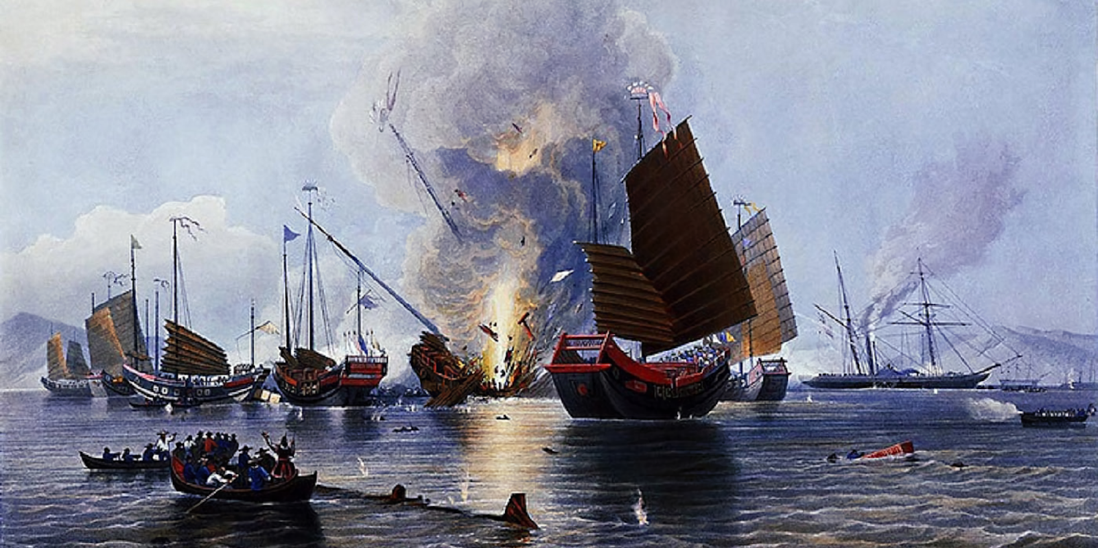
The poorly trained and technically backward Chinese army could not oppose the British ships and troops. After a short period of hostilities, on August 29, 1842, the Treaty of Nanjing was signed, according to which imperial China turned into a semi-colony of England and was subject to a huge contribution of $21 million [5].
The goals that Britain set before the war — the legalization of opium sales, the opening of additional ports for trade and the subordination of a territory with a huge domestic market — were achieved with the support of the United States and France. Over the next decade, the penetration of the capital of the great powers into China continued. Following Nanjing, similar unequal treaties were concluded with France and the United States. Great Britain continued to demand the expansion of trade zones, threatening a new invasion, achieving freedom of settlement for foreigners, freedom to conclude concessions, lease land, and reduce customs duties [7].
The crisis of power, the impotence of the imperial court, the deterioration of the lives of workers, and the unprecedented growth of drug trafficking led to the rise of the peasant national liberation movement - in 1850, the Taiping Uprising began. The struggle of the peasants against the exploiting feudal lords was combined with the struggle against the Manchu dynasty. In a short time, the rebels inflicted several crushing defeats on government troops and besieged Beijing in 1853. The richest provinces and waterways were captured.
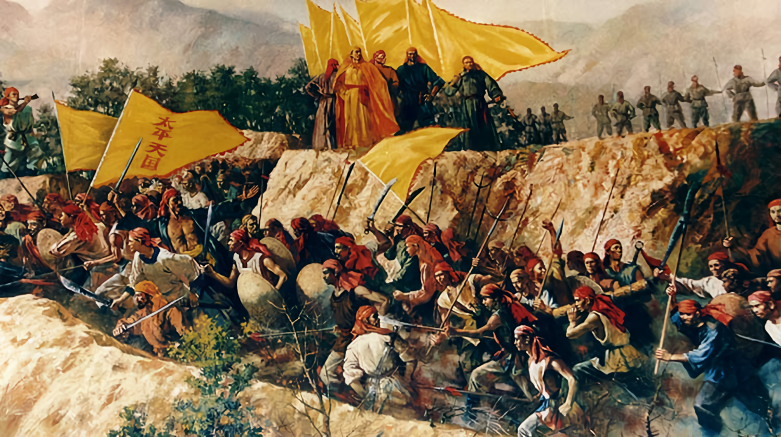
European countries dissatisfied with the policy of the Manchu dynasty took a neutral position, expecting either a weakening of the dynasty or new privileges that they would receive from the Taiping in the event of their victory. It is worth noting that the Taiping did not interfere with European trade, trying not to give a reason for the intervention of England and France in internal affairs [8]. However, in 1856, England, taking advantage of the civil war, launched a new invasion, which ended with the defeat of China in the second "opium war" and the signing of another bonded Tianjin Treaty.
Since 1860, the Manchu dynasty made new concessions and requested the help of European countries in suppressing the Taiping rebellion. By 1864, the rebels were finished [8]. This is how the reactionary feudal elites of the Chinese dynasty formed an alliance with the ruling classes of England, the USA and France [9]. Opium was fully legalized under the system of unequal treaties, embassies were opened in Beijing, the right for foreign powers to trade in cities and along rivers was obtained, and missionary activity began. China had lost its independence in trade and political relations — it had completely turned into a semi-colony of Western powers [5].

Intervention in China in 1898 (suppression of the Yihetuan Uprising)
By the end of the 19th century, there was an active differentiation of spheres of influence between the imperialist countries, and in some places, a policy of direct occupation of China under the guise of a "long-term lease" or on the basis of concessions for the construction of railways and the use of ports [9, 10]. The northern provinces, such as Shandong, Zhili and Shanxi, where large foreign railway concessions, banks, marinas, firms and enterprises were located, suffered especially severely from the capital penetration of Western powers.
Every year, the number of imported goods increased many times, which led to the ruin of the local population. At the same time, there was a significant part of the population that was interested in maintaining economic ties with foreign capital: part of the merchant class, the rural population that sold food to foreigners and workers employed in factories, coal mines and railway construction. However, the introduction of a new mode of production in the country took place by force, which was accompanied by merciless exploitation in the interests of capitalists in other countries.
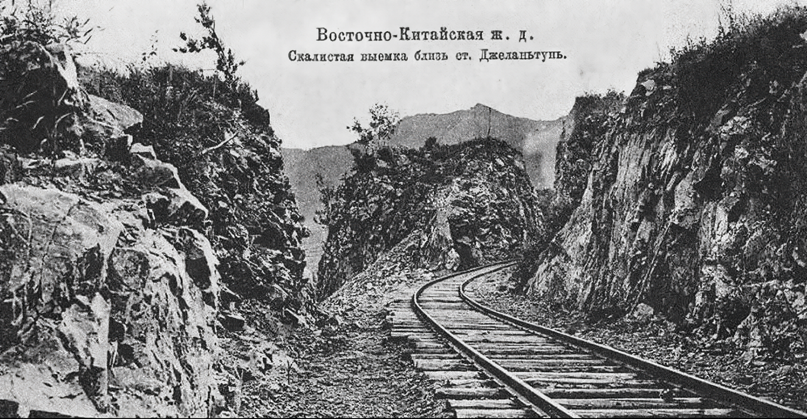
The construction of railway tracks was supposed to open up a huge market for foreign companies after the defeat in the Sino-Japanese War of 1894-1895. By 1898, bonded loans from England, Russia, Germany and France totaling 54 million pounds were imposed on the Qing government, and the right to establish enterprises was obtained [10]. Steamship transport, telegraphy and mail appeared, and imports of foreign goods increased, with which local producers, often engaged in small-scale handicrafts, could not compete. In the 7 years from 1892 to 1899, imports of goods doubled. The emergence of such a powerful network of communication routes (at the end of the XIX century, 11 foreign railway companies operated [10]) led to the ruin of a huge number of workers of traditional Chinese transport (boatmen, teamsters, cabbies, movers, coolies, etc.) and mail [11]. The laying of railway roads required the cleaning of the territories of former pastures and lands. Since 1897, the Russian Empire began construction of the China-Eastern Railway (CER), which ran through the northeastern part of China and connected Chita with Port Arthur. The future highway of the CER brought ruin to peasant farms in a vast territory.
Painful for the local population was the exponentially increasing number of Christian missionaries, who were granted privileges from both the colonial authorities and local officials. The missionaries received the best lands, while the peasantry suffered from landlessness and high feudal duties. In addition, they received legal protection, which Christian preachers almost indiscriminately provided to their "flock" of parasitic and sometimes criminal elements of society in disputes with the Chinese [11]. In addition, educational institutions, hospitals and shops were transferred to their control [10].
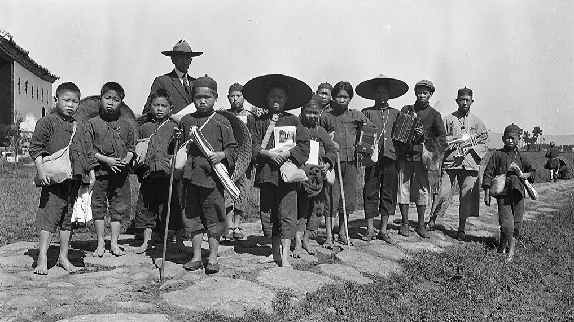
By 1899, the contradictions within China had escalated. Due to the financial dependence of the Qing government and the disintegration of the bureaucracy, taxes have tripled. Household incomes have fallen due to a slower increase in grain prices relative to manufactured goods. In 1898-1899, after several decades of alternating natural disasters, a new wave of drought and floods covered the northern provinces. This led to a new spike in food prices and a surge in popular discontent.
The long—term exploitation of the region and the sharp deterioration of the living conditions of the workers resulted in an uprising led by a religious sect, the Yihetuan. The special historical situation caused the uprising to take on an anti-feudal, anti-Christian character and opposed the colonial enslavement of the country. The internal peasant war in China was used by the major powers to launch an intervention in the region.
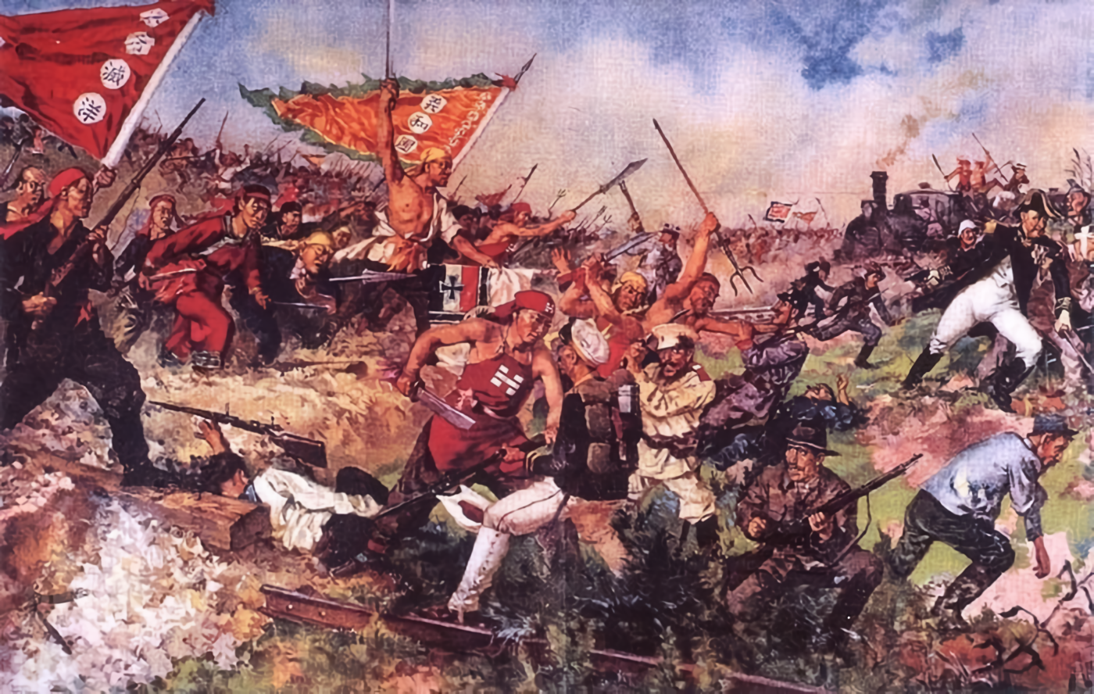
Despite the selfless struggle of the rebels, the uprising was doomed to defeat due to its weak organization and technical equipment. Seeing that the spheres of influence were in danger, the Western powers began a brutal suppression of the uprising. It was attended by 8 countries that formed a 60,000-strong contingent: Russia, England, France, the USA, Germany, Japan, Italy and Austria-Hungary [12]. Although at the initial stage, the Empress supported the speech of the people, after several defeats she came to an agreement with the interventionists and turned away from the rebels. At the same time, some military units of the Chinese army fought the peasants side by side to the end. By 1901, the last pockets of the uprising had been suppressed. On September 7, another unequal agreement between the coalition countries and China was signed, implying huge contributions and the construction of retail outlets [13]. The Western powers gained the right to further plunder China, unequal treaties and huge sales markets.
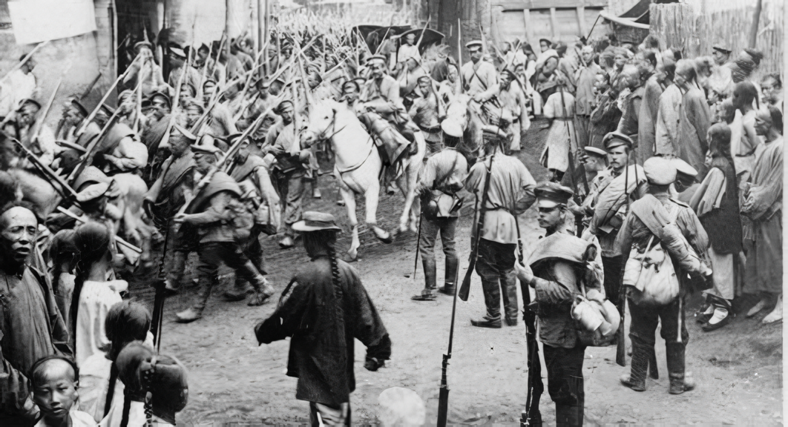
It is worth mentioning that the troops of the Russian Empire took an active part in suppressing popular protests in China [14]. After the Ihetuan rebels took control of almost the entire CER and cut off the city of Harbin from the outside world, while besieging the embassy quarter in Beijing, the introduction of Russian troops into Chinese territory followed. They were the first to break into besieged Beijing. As a result of the uprising, the Russian Empire finally secured the right to Manchuria within its sphere of influence.

Russian-Japanese War (1904-1905)
One of the first military conflicts of the coming era of imperialism was the Russian-Japanese War. The clash of interests over the partition of Korea and Northeast China, the rapidly developing Japan and the Russian Empire became the root cause of the war, which claimed about 300 thousand lives.
The beginning of the XX century. For Japan, it was marked by the formation and gradual strengthening of financial monopolistic capital. At this time, large banking associations (Japanese zaibatsu) appeared — Mitsubishi, Mitsui, Yasuda and others. There is a rapid centralization of production and capital. The financial oligarchy is merging with the state apparatus.
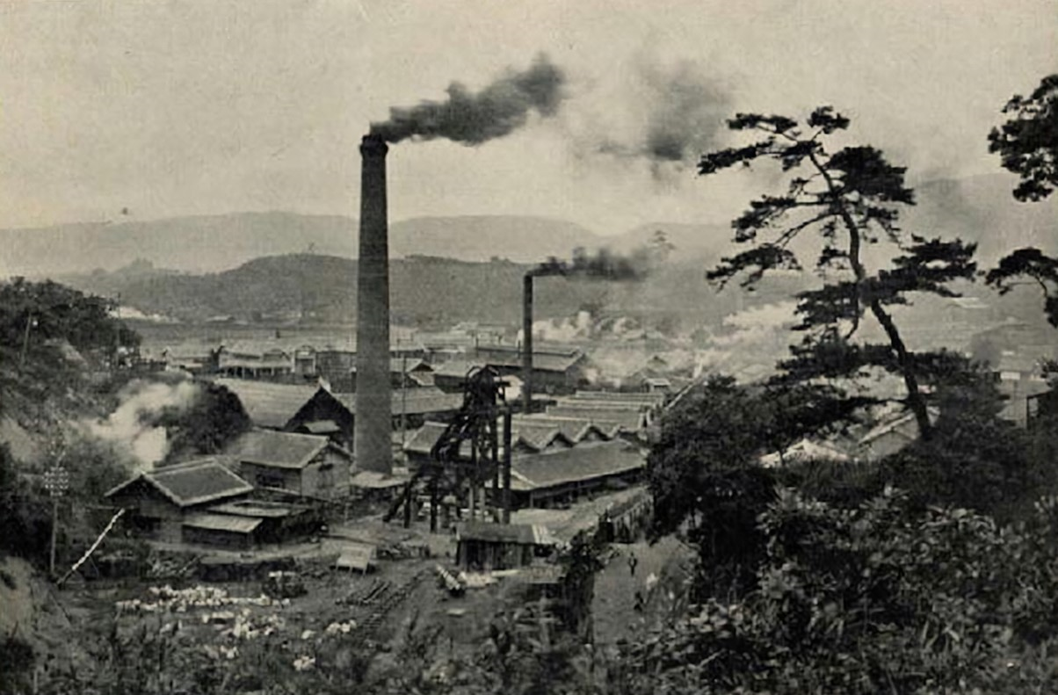
Despite its rapid development, Japan lagged far behind the leading powers in economic terms due to the incompleteness of the bourgeois revolution of 1868, which left feudal remnants that hindered the growth of capitalism in all sectors. The country's extreme dependence on strategic raw materials also played a role [9]. Given its financial and economic backwardness, Japanese imperialism could not count on conquering new territories with rich raw materials through economic competition. For this, it needed large amounts of capital, which Japan did not have.
Instead of economic expansion, Japan switched to a particularly aggressive policy of colonial conquests in China and Korea. Since 1895, intensive economic preparations for war with Russia, which had its own interests in these countries, were underway. Branches of heavy industry related to the production of weapons were created, and the army was reorganized. The sources of funds for such training were the contributions received from China after the war of 1894-1895, and the increased exploitation of Japanese workers.
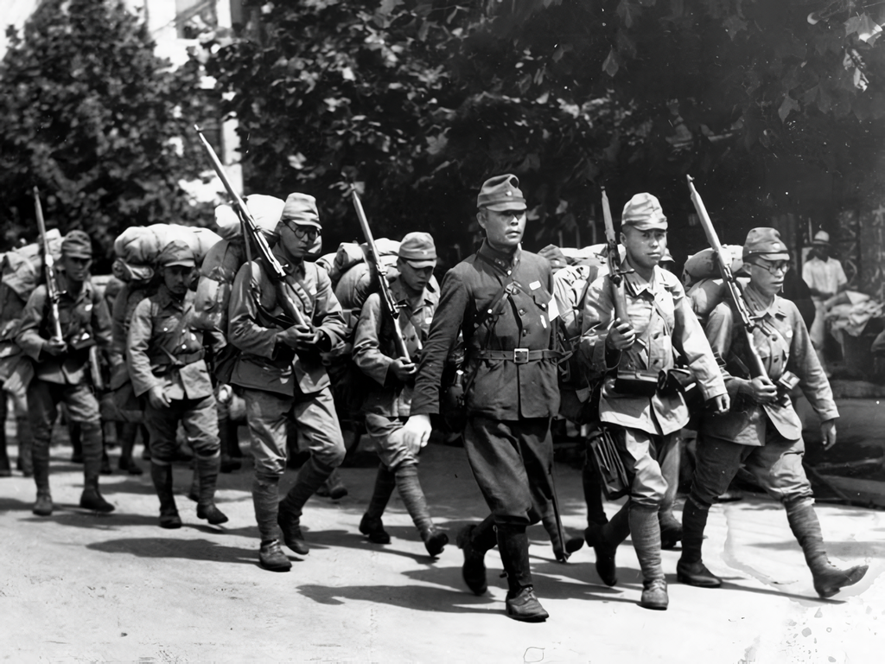
The closest object to the aspirations of Japanese imperialism was Korea, where, until 1898, the interests of the Russian Empire occupied a special position. Since the enslavement of Manchuria was the first place for Russian tsarism, Japan was granted freedom of economic activity in Korea by mutual agreement. The Japanese had two railways under construction, concessions for the development of ore deposits, post offices and insurance companies in their hands. 72% of Korea's trade turnover was Japanese [9]. 88.9% of all Korean food exports went to Japan. The country was flooded by Japanese merchants, and the purchase of precious metals by the largest Japanese banks led to the dependence of the government treasury on Japanese loans [15].
Japan's next target was Manchuria. Since 1891, Japanese capital had been intensively penetrating the region through the port of Newchwang. During the Sino-Japanese War, part of Manchuria was occupied by Japanese troops, but under pressure from Western powers and Russia, it was returned to China. During the occupation of these territories, the soybean harvest, more than half of Manchurian cotton exports, and almost all rice, coal and iron were exported to Japan [16].
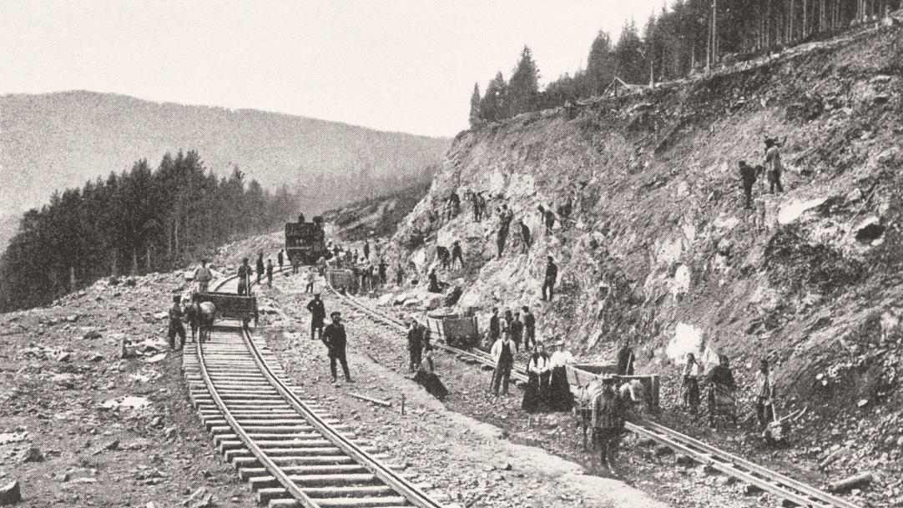
In 1891, Russia began construction of the Trans-Siberian Railway, the southern branch of which was formed by the KVZhD, which, in turn, was to connect with the South Manchurian Railway through another branch [17]. The commissioning of the greatest railway with a length of 7 thousand km was of great importance for the development of capitalism in Russia. Attracting foreign capital to the development of the subsoil of Siberia, the export of landowner wheat, reducing the time for transporting goods, opening huge markets in Asian countries, and strengthening the military presence in China and the Far East — all this made the protection of the CER a vital goal of the Russian Empire [9][17].
In 1900, taking advantage of participation in the suppression of the Boxer Rebellion, Russian tsarism almost completely captured Manchuria. Tsarism also left no room for expansion in Korea. Since 1896, the country had agreed to conduct exercises with Russian troops, and the military industry had come under Russian control.
Russia's penetration into Korea was explained by a number of economic factors: mining, logging, whaling bases, control over customs and finances of the country, and joint banking enterprises with Korea [15]. In addition, the Russian monarchy was actively pushed to war with Japan over Korea by the court group of A.M. Bezobrazov [15][17].
In 1898, Russia leased the Kwantung Peninsula from China with Port Arthur and the right to establish a military base on it. Japanese imperialism, which was no less interested in owning Chinese railways and the Korean market, began to prepare for war by concluding an Anglo-Japanese alliance in 1902. The refusal of the Russian government to Japan's demands to withdraw troops from Manchuria and Korea gave rise to the outbreak of war. The Russian-Japanese war began, which in its goals and content was a struggle between two imperialist powers for spheres of influence, markets and raw materials in Asia.
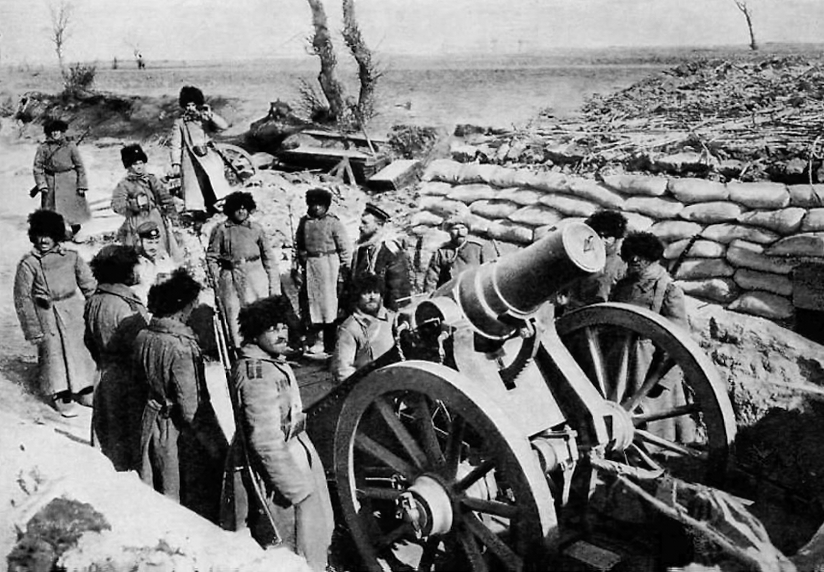
The failures in the war, the retreat, and the outbreak of the first Russian Revolution led to the loss of Korea, the Port Arthur base, the southern branch of the CER, part of Sakhalin, and Russia's defeat in the war.

Japanese aggression in the East
Japanese monopoly capital pursued the same policy of active expansion in Asia until the Second World War.
The Annexation of Korea (1910). After the Russian-Japanese War, Japanese capital gained freedom of action in Korea and Manchuria. By agreement with Britain and the United States in 1905, Korea became a protectorate of Japan, and lost control of finances and independence in foreign policy. In fact, it was the occupation of the country. Along with the first Russian revolution, the national liberation movement began to grow in Korea, until in 1910 Korea was finally annexed and the partisan forces were defeated.
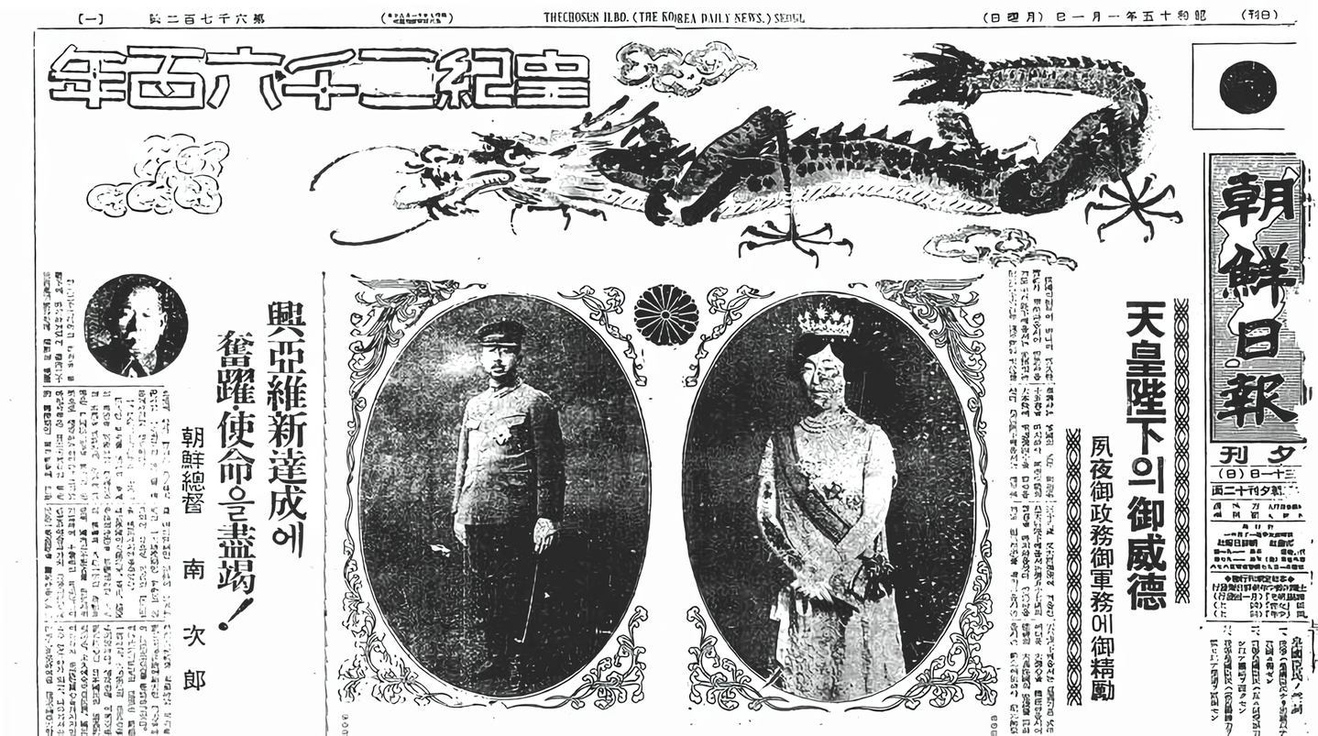
Since 1910, Korea became a colonial appendage for the sale of goods and a raw material base for Japanese firms. 70% of imports to Korea were Japanese, and 93% of exports went to Japan [18]. At the same time, more than half of Korean enterprises were engaged in servicing Japanese capital. The peasants' lands and state property were expropriated, followed by the creation of Japanese land companies on them. In 1911, out of 164 joint—stock companies, only 29 belonged to Korean capital; Korean capitalists were infringed on at the legislative level - according to the Companies Act of 1910, a Korean enterprise could be closed at any time [19]. Korea was in colonial dependence until the defeat of the Japanese militarists in 1945.
The Occupation of Manchuria (1931). The global economic crisis of 1929-1933 particularly affected the Japanese economy. The cost of industrial products from 1929 to 1931 fell by 32.5%, agricultural products — by 40%, and unemployment rose to the level of 3 million people. In 1931, Japanese exports fell sharply (to 50% [20]) to both the United States and Manchuria. At the same time, American capital in the region became more active. The Manchurian market became a means of salvation for Japan from the crisis — the restriction of coal exports and dumping made it possible to maintain high prices in Japan itself [21]. By the beginning of the crisis, the region had become an agrarian and raw material appendage of Japanese militarism [22]. The rate of return on invested capital in Manchuria was one and a half times higher than in Japan itself [21].
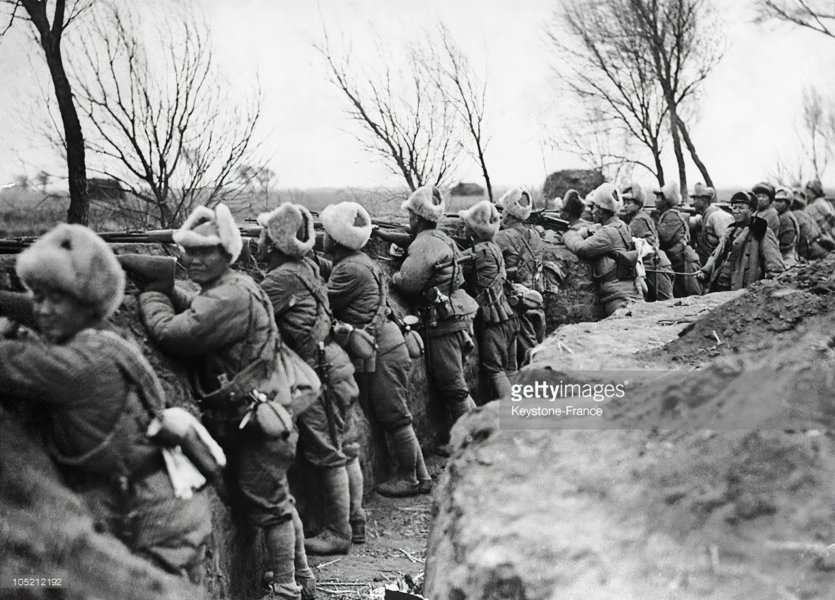
All of the above pushed the Japanese military, which supports the fascist regime inside the country, to a new redistribution of colonies. The pursuit of colonial superprofits and the organization of a military base for a future war with the USSR was the main engine of the occupation of Manchuria. In 1931-1932, the entire territory of Manchuria was occupied, and a puppet descendant of the Daiqing dynasty, Pu Yi, was placed on the throne [23]. In March 1932, in response to the Japanese intervention in the Shanghai area, the Soviet Union demanded that the League of Nations impose harsh sanctions against Japan [24]. The refusal of the League of Nations to recognize the created puppet state of Manchukuo, as well as the fear of a protracted war, forced Japan to withdraw troops from Shanghai.
The invasion of China in World War II. By 1937, Japanese militarism was on the path of direct preparation for a new imperialist war, having concluded an alliance with Hitler's Germany and Italy within the framework of the Anti-Comintern Pact of 1936.
Before the outbreak of World War II, the contradictions between large monopolistic unions increased dramatically [24]. The desire to unleash a new war was intensified by the growth of a new economic crisis and the aggravation of the class struggle.
In 1937, a new Japanese invasion of China began [25]. By 1938, the provinces of northern China had been captured: Nanjing, Wuhan, and important regions in southern China, including Guangzhou. The Kuomintang government could not offer any serious resistance, despite the large support of the country from the USSR [26]. The liberation of the Chinese people was realized only with the defeat of the Japanese army by Soviet troops in 1945.

The Vietnam War (1960-1975)
The Vietnam War is a vivid example of the rivalry of the imperialist powers for the partition of colonial countries and, at the same time, an example of a heroic national liberation struggle.
The Second World War called into question the preservation of France's colonial possessions, of which Vietnam was a part of. As France weakened during the war, it was forced to increasingly resort to American aid and loans. The number of American trade and military advisers in the country increased until the entire policy of South Vietnam was determined by the monopolistic circles of the United States [27]. However, even during the subsequent American occupation, about 90 French companies with a total capital of $250 million continued to operate in Vietnam [28]. This determined the role of France as an active mediator in the 1973 Paris peace talks between North Vietnam, South Vietnam and the United States following the American invasion.
Having freed itself from French colonial rule during the first Indochina War of 1946-1954, Vietnam faced the growing US presence in the region. This was caused by the aggravation of inter-imperialist contradictions between American and French capitals. The latter traditionally had interests in Southeast Asia and was in no hurry to part with its colonies.
Since 1954, after the ousting of the French administration, a pro-American puppet regime was created in Vietnam, and since 1960, under the guise of helping South Vietnam, an American contingent began to build up in the region. After 1963, the northern part of the country began to get involved in the conflict. The war lasted until 1975, when, with the capture of Saigon by the troops of the Democratic Republic of Vietnam, the withdrawal of American troops from the country and compliance with the Paris Agreements were ensured.
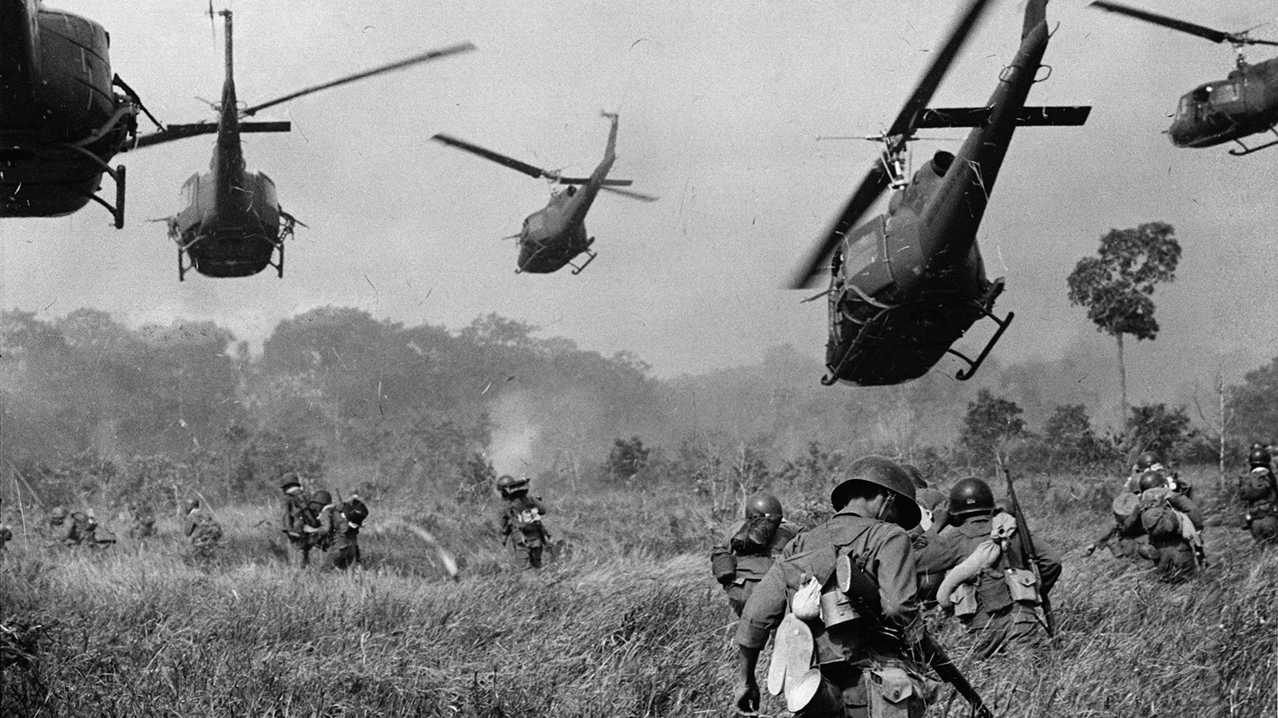
The intensification of revolutionary processes in Asia and the emergence of an anti-imperialist regime in Vietnam threatened the complete loss of imperialist control over Indochina. However, the United States had not only political but also purely economic reasons for invading Vietnam. Since the strengthening of the United States in the region, their interest in the construction of airfields, ports, power plants, etc. began to grow. Those monopolists who invested their capital in these projects were waiting for tax holidays in South Vietnam.
In 1966, financing of seismic tests for the laying of oil wells and the subsequent development of oil fields in South Vietnam began — daily production was supposed to amount to 60 million tons [27]. 27 firms, including those owned by the Rockefellers, sought permission to build wells in Saigon. Ten companies received permission from the South Vietnamese government to install them in the Mekong Delta. The huge sums that were planned to be invested in oil production, as well as the fact that the process of field development is a long—term enterprise, large monopolistic capital had to receive appropriate guarantees from the American state for the safety of their capital in Vietnam. In addition, Vietnam was a major source of tungsten and tin.
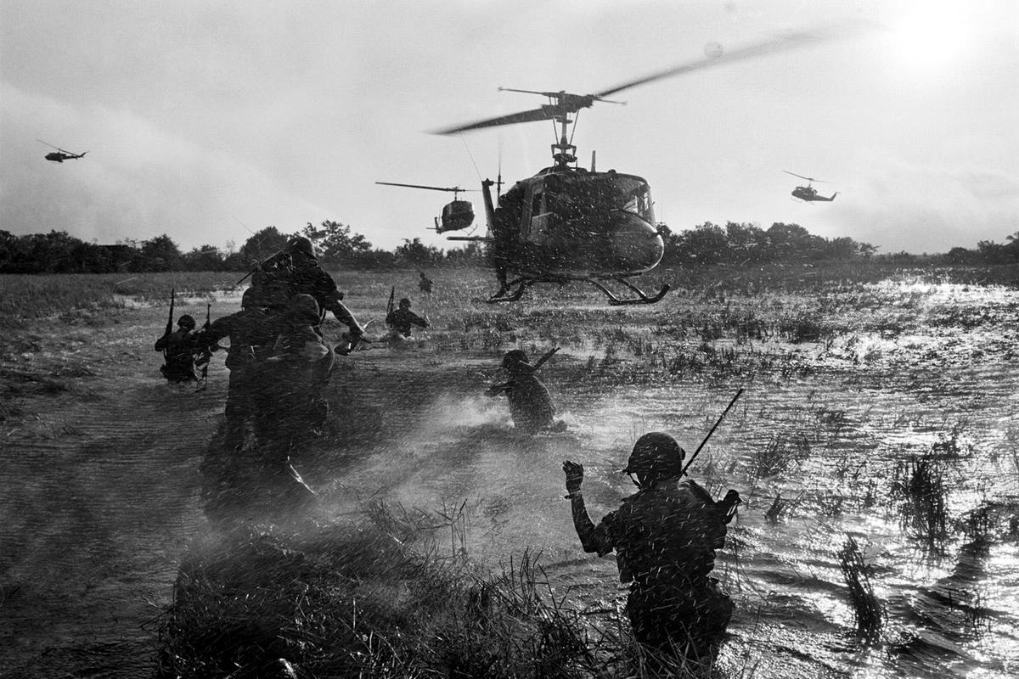
Another reason for the invasion of Vietnam was the economic crisis in the United States, which had been growing since 1967. The American economy was trying to cope with the crisis with the help of a huge increase in military supplies to Vietnam. While $100 million was spent on the military campaign in 1965-1967, then in 1969 it was more than $28 billion; the growth of military production outstripped the growth of the gross national product [29]. The 15 largest arms manufacturing companies received government orders worth $64 billion in 1961-1967. At the same time, the 10 largest manufacturers associated with the Pentagon accounted for a third of all government orders [30]. Thus, the Vietnam War was not just a struggle for a sphere of influence, but an important factor in the development of the American economy.

The Iran-Iraq War (1980-1988)
In 1980, one of the largest military conflicts of the second half of the 20th century began in the Middle East, which ended with the death of about a million people and the destruction of key sectors of the economy of two major oil—producing countries - Iran and Iraq.
On September 22, 1980, Iraq began advancing in the direction of the Iranian province of Khuzestan and the Shatt al-Arab River. After the initial successes, the initiative passed to Iran until the end of the war, when the situation changed again and Iraq, supported by a number of countries, did not force Tehran to conclude a truce. The conflict, deservedly called a "war of attrition" lasted for 8 years with varying success and led to nothing but devastation, inflation and enslavement of countries — Iraq suffered damage of $188 billion, Iran — $369 billion, both owed huge sums to its creditors [31][32].
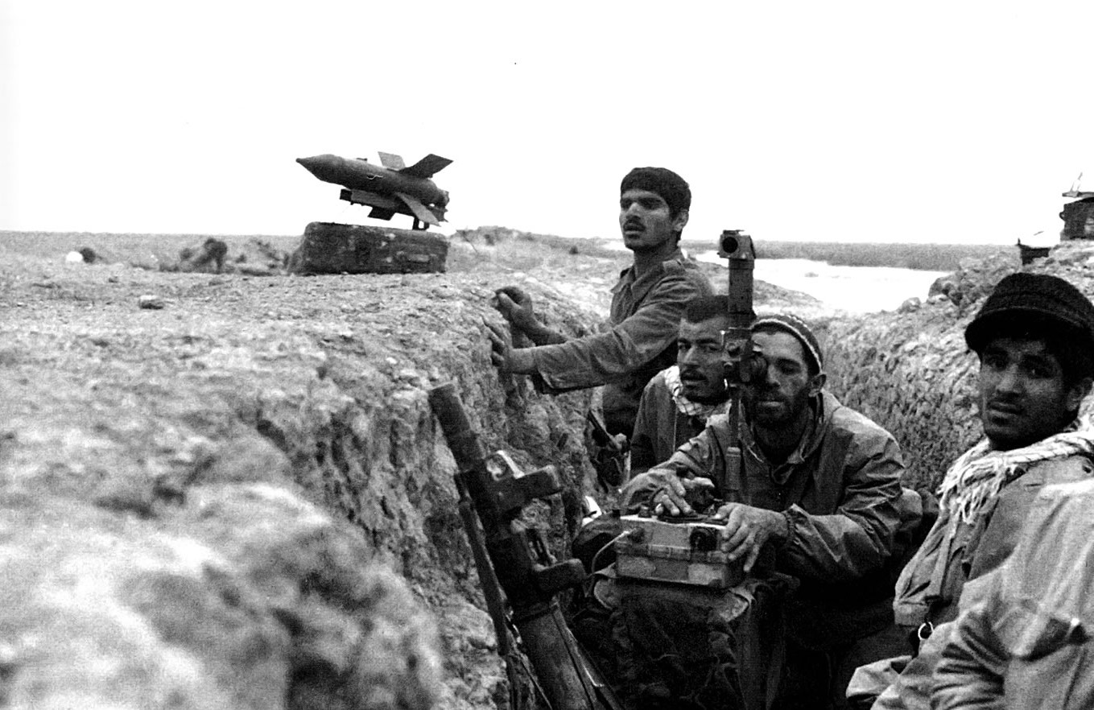
Since the colonial rule of Great Britain, the basis of the economy of the two countries had been oil production and small-scale agricultural production. After 1968, the Baath Party, which came to power in Iraq, proclaimed the beginning of reforms and nationalization of the largest oil-producing companies (Iraq Petroleum Company, Standard Oil of New Jersey, etc.) [32-34]. However, nationalization turned out to be inconsistent, as was the whole policy of this petty-bourgeois party. Oil was sold to Europe at a large discount, and companies from Arab countries began to come to the region instead of Western capital. [35]. By 1974, the public sector accounted for only 16% of large enterprises [34]. In the second half of the 1970s, a shift away from transformation and a return to dependence on oil exports began. Iraq had become the second Middle Eastern trading partner of Western countries. The issue of the stability of oil revenues was the most important [37].
From 1972 to 1975, Iraq's oil revenues increased from $75 million to $8 billion [32], on which the existence of thousands of bureaucrats and small local bourgeois contractors depended [36]. In addition, Iraq had three routes for oil exports: two pipelines through Syria and Turkey, as well as filling terminals on the Persian Gulf coast. Due to the changing political environment, pipelines were not a reliable means of export. The narrow strip of coast not the Gulf coast did not allow for increasing the cargo flow of tankers through the terminals, therefore, the possession of the Shatt Al-Arab waterway leading into the gulf, along which the border with Iran passed, became vital for the Iraqi ruling class [32][38][39].
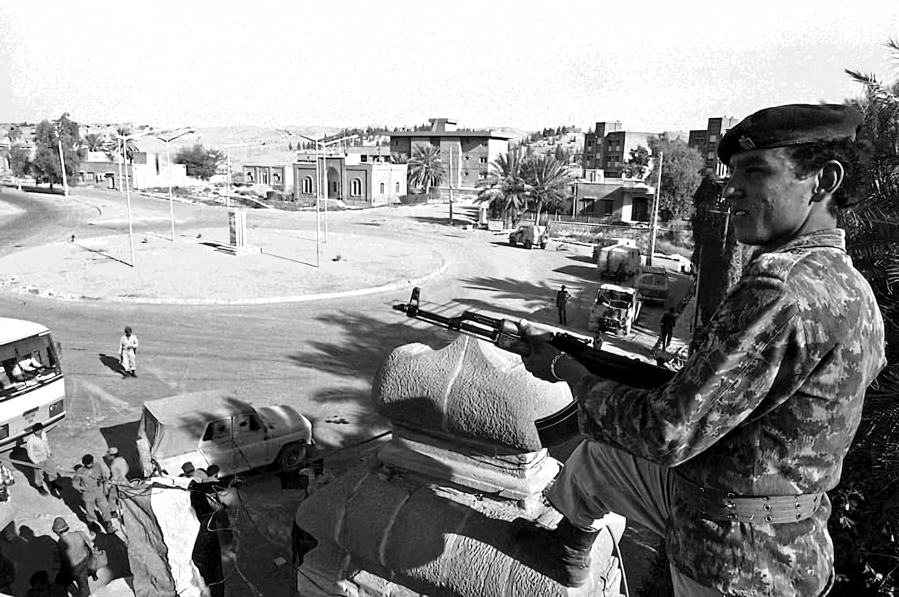
By 1979, oil monopolies occupied a dominant position in the country's economy. Oil production was controlled by 8 Western companies, but the country received only half of the profits [40]. The crisis of the 1970s also alienated the petty bourgeoisie, which was the social basis of the ulema, from the Shah [36]. Islamic clergy who actively participated in the nationalization of the country's oil industry 1951–1953 under the temporary rule of Mossadegh, became the main opponent of the Shah, who returned the oil industry of the USA and England. In addition, the Shah abolished the institution of waqfs — the transfer of property from the state to the church [41]. By 1978, when the economic crisis in the country sharply intensified, the clergy, thanks to a wide network of mosques, became the organizing force of the uprising that arose.
After the 1979 coup, a new round of "nationalization" began, but already of the property of the Shah's supporters (about 75% of Iran's large industry). It was managed by only about 50 large owners under the Shah [41]. At the same time, the property was transferred not to individual religious figures, but through specially organized Islamic foundations — bonyads [41; 40]. The ban on waqfs was lifted, and banks were forcibly enlarged [42]. The entire large oil industry came under state control. At the beginning of the Iran-Iraq war, the Shiite clergy and close circles of large capitalists were vitally interested in increasing revenues from the export of raw materials and controlling fuel prices.
The "Islamic Revolution" was followed by mutual provocations of the two countries and the escalation of military hysteria. Taking advantage of Iran's weakness, under the pretext of combating the "export" of the Islamic Revolution, Saddam Hussein demanded the return of full control over the Shatt al-Arab River and three islands in the Strait of Hormuz. Iran's refusal was followed by the denunciation of the Algiers Agreements of 1975 regulating the joint use of the waterway and the crossing of the Iranian border by Iraqi units.

The War in Syria (2011 – present)
From 2011 to the present day, a military conflict has been ongoing in Syria, which is one of the most obvious examples of the struggle of imperialist groups for raw material areas and hydrocarbon markets.
The 2011 civil unrest in Syria had objective causes. From 1995 to 2012, the level of crude oil production, one of the main sources of income, fell sharply. Youth unemployment and social inequality began to rise, and subsidies to farmers for the purchase of fuel and food decreased [43]. In 2006, the country suffered a severe drought that lasted 3 years. This led to a twofold increase in prices for wheat, rice and feed, and by 2010 to the severe destruction of livestock (up to 85%) [44]. Up to a million people were on the verge of starvation [45].
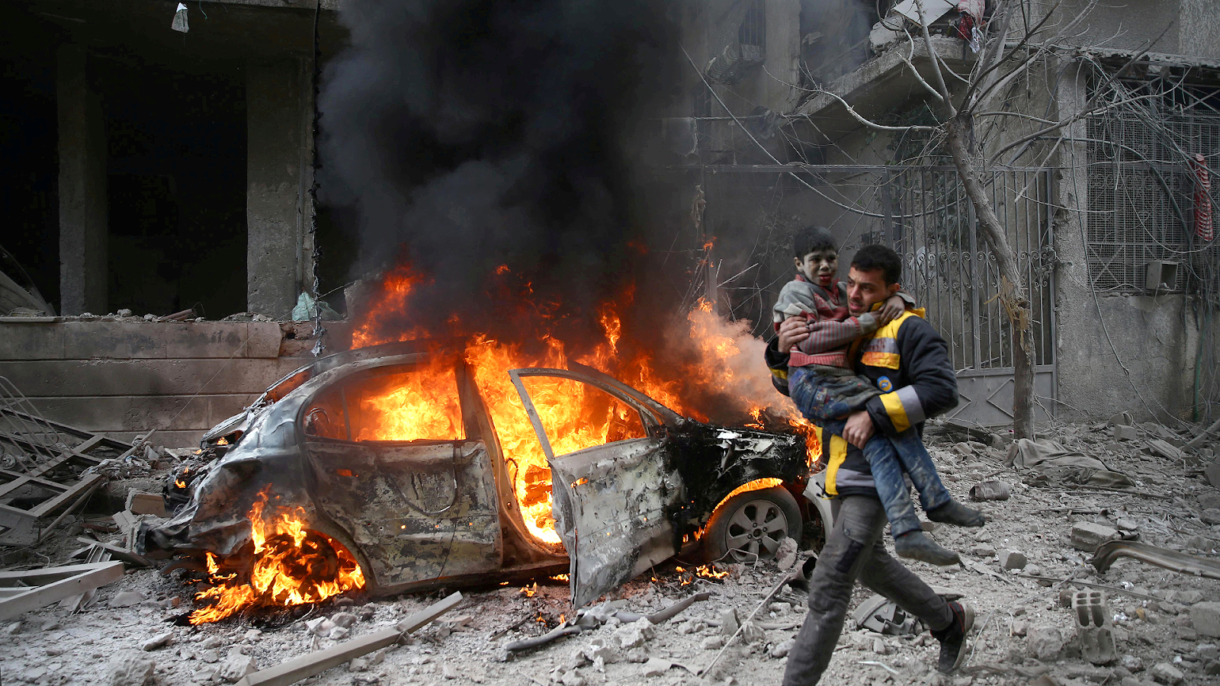
Amid falling living standards, spontaneous protests began in a number of cities in the spring of 2011. Interreligious strife received a new impetus [46]. In response to the brutality of the police actions, the role of fundamentalists and tribal unions increased, which quickly became the main driving force of the opposition. Islamist terrorist groups and military contingents have become tools in the hands of major powers surrounding strategically important Syria.
The special interest of the major imperialist powers in Syria is explained by its role in the global hydrocarbon market. On the one hand, 90% of its oil exports go to the EU. The country has 8.5 trillion cubic feet of estimated natural gas reserves and is a major exporter of it [43]. In addition, in 2009, the US Geological Survey exploration company reported the discovery of the Jabal Nafta oil field with huge reserves from 3 to 17 billion barrels [47].
On the other hand, the war in Syria is linked to the struggle for the EU as a huge gas market [48-50]. By 2012, Russia was the largest exporter to the EU (36% of all imports). Qatar, which has large gas reserves (3rd place in the world), like Western capital, was interested in violating the semi-monopoly position of the Russian Federation in European markets. Since the second half of the 2000s, various options for the pipeline route have been proposed, which would connect Middle Eastern gas suppliers with the EU, bring down prices for it, reduce the role of the Russian Federation for EU gas imports and change the balance of power between imperialist countries. All these options were united by the fact that they pass through Syria [51][52].
At the time of the outbreak of the civil war in Syria, there were two main options for laying a gas pipeline. The first was the gas pipeline project proposed by Qatar in 2009, which was supposed to pass through Saudi Arabia and Syria and, connecting to the Arab pipeline, bring gas to the Turkish Nabucco. By 2011, Qatar had already agreed on laying through Saudi Arabia and connecting with gas pipelines in Jordan and Turkey. The latter received benefits from gas transit, which was also offered to Syria in the case of the construction of this branch on its territory.
The second possible route of the gas pipeline was the Islamic pipeline, which was supposed to run from the giant Iranian South Pars gas field in the Persian Gulf, then across Iraq and Syria, taking their share of gas, and liquefy on the Mediterranean coast for sea transportation [53], thus bypassing Turkey [49; 45][43]. An agreement between the governments of Syria, Iran and Iraq on the construction of a $10 billion pipeline [54] designed for 40 billion cubic meters per year [47] was signed in July 2011, shortly after the outbreak of the Syrian civil war.
The "Iranian" decision could not please Qatar, Saudi Arabia and Turkey, which, after Assad's decision in favor of the "Arab" pipe, actively joined in support of the Syrian opposition [48; 50][46][47]. On the contrary, the Iran-Syria gas pipeline was the best choice for Russian capital, which, by alliance with Iran and Syria, could control the volume of exported Eastern gas.
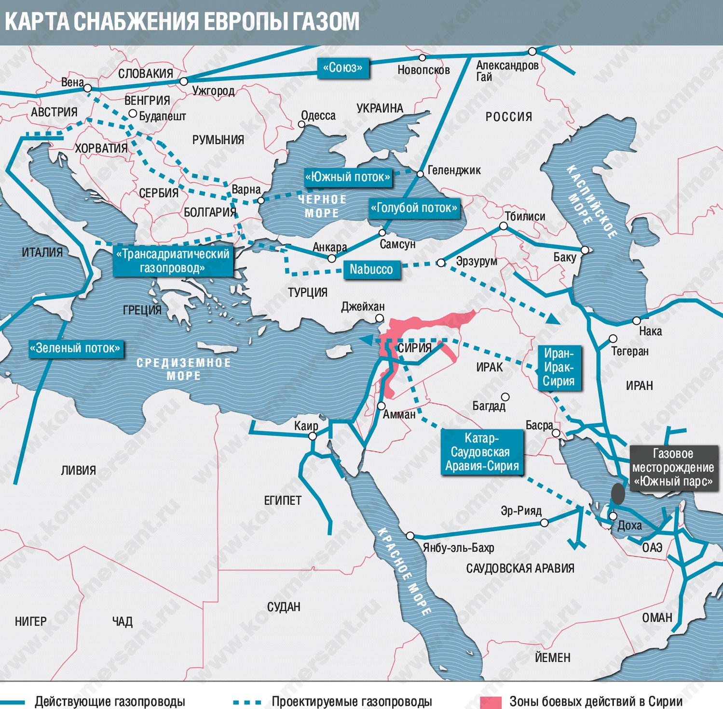
The map of European gas supplies. Blue lines mark working gas pipelines, dotted lines are pipeline projects and red area indicates the Syrian conflict
Qatar is one of the largest LNG exporters, and a possible alternative to suppliers from Russia and has become one of the active participants in the war in Syria [47]. Strangely enough, Homs and the environs of Damascus, areas where rebel detachments with the support of the United States, Qatar and Turkey operated, coincide with the route along which the Qatari gas pipeline was supposed to pass [53]. Qatar's main competitor is Iran, which shares the South Pars field with it [47].
Together with Saudi Arabia, Qatar claims dominance in gas production and transportation in the Middle East. Both want to oust Shiite Iran from the markets with its ability to block the straits [52][55]. Turkey, interested in becoming the main transport hub in the gas supply chains to Europe, has become a pillar of anti-government forces [46; 53]. The United States and Western imperialists also wanted Iran and Russia to be isolated from sales markets in Europe and their companies (Pecten, Marathon, Shell-LF-Total, Devon Energy, etc. [56]) to retain the right to develop Syrian fields.
Russian capital did not stand aside either. Assad has also opened access to Syrian resources for Russian companies. In 2005-2010, Gazprom PJSC began operating in the country through its own structures [56]. Before the outbreak of the war, Russian companies were building a gas processing plant in the Palmyra area, it was planned to build a gas processing plant near Raqqa, and exploration and drilling were carried out near the city of Latakia, as well as on the shelf of the Mediterranean Sea [56].
A number of companies have received orders for the construction of export pipelines. In January 2018, Russian and Syrian agencies signed an agreement that provides for Russia's restoration of energy facilities in Syria and the construction of new ones on the basis of an agreement that grants Russia exclusive rights to oil and gas production in Syria for the next 49 years [49]. In 2018, a contract was signed with Stroytransgaz Logistics for the development of Syrian phosphate deposits [49].
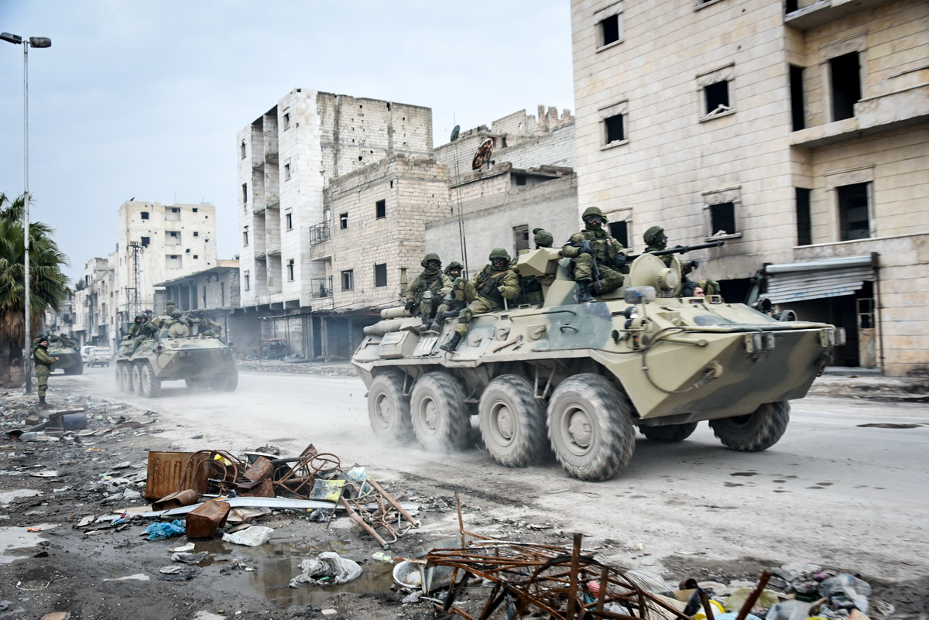
The civil war in Syria and the disasters of hundreds of thousands of people have become the subject of speculation by imperialists in order to preserve monopoly superprofits for gas supplies and redistribute spheres of influence between the dominant groups of commodity oligarchs, where on the one hand the United States, Qatar, Saudi Arabia, and on the other — Russia, Iran and, having huge influence in Iran, Syria, and China [43][44][51][53][56].

Russian ‘Special Military Operation’ in Ukraine (2022 – present)
The material causes of the conflict that began on February 24, 2022, between Russia and Ukraine and continues to this day lie in the tangle of contradictions that have developed between Russian, Ukrainian, Western and Chinese capitals. The aggravation of these contradictions between the imperialist countries for 8 years after the events of 2014 lies at the heart of the military clash in Ukraine.
Due to the close economic, logistical and mining ties inherited from the USSR, capitalist Russia has occupied an important place in the economy of Ukraine for three decades. Since the 90s, Russian capitalists had large stakes in Ukrainian enterprises, and enjoyed a huge sales market, local resources and semi-finished products. Russian capitalists were actively engaged in applying their capital to an industrially developed region. Ukraine was the largest recipient of Russian direct investment in the post-Soviet space, which reached $17 billion at its peak. Even after the 2014 coup, they amounted to almost $10 billion [57].
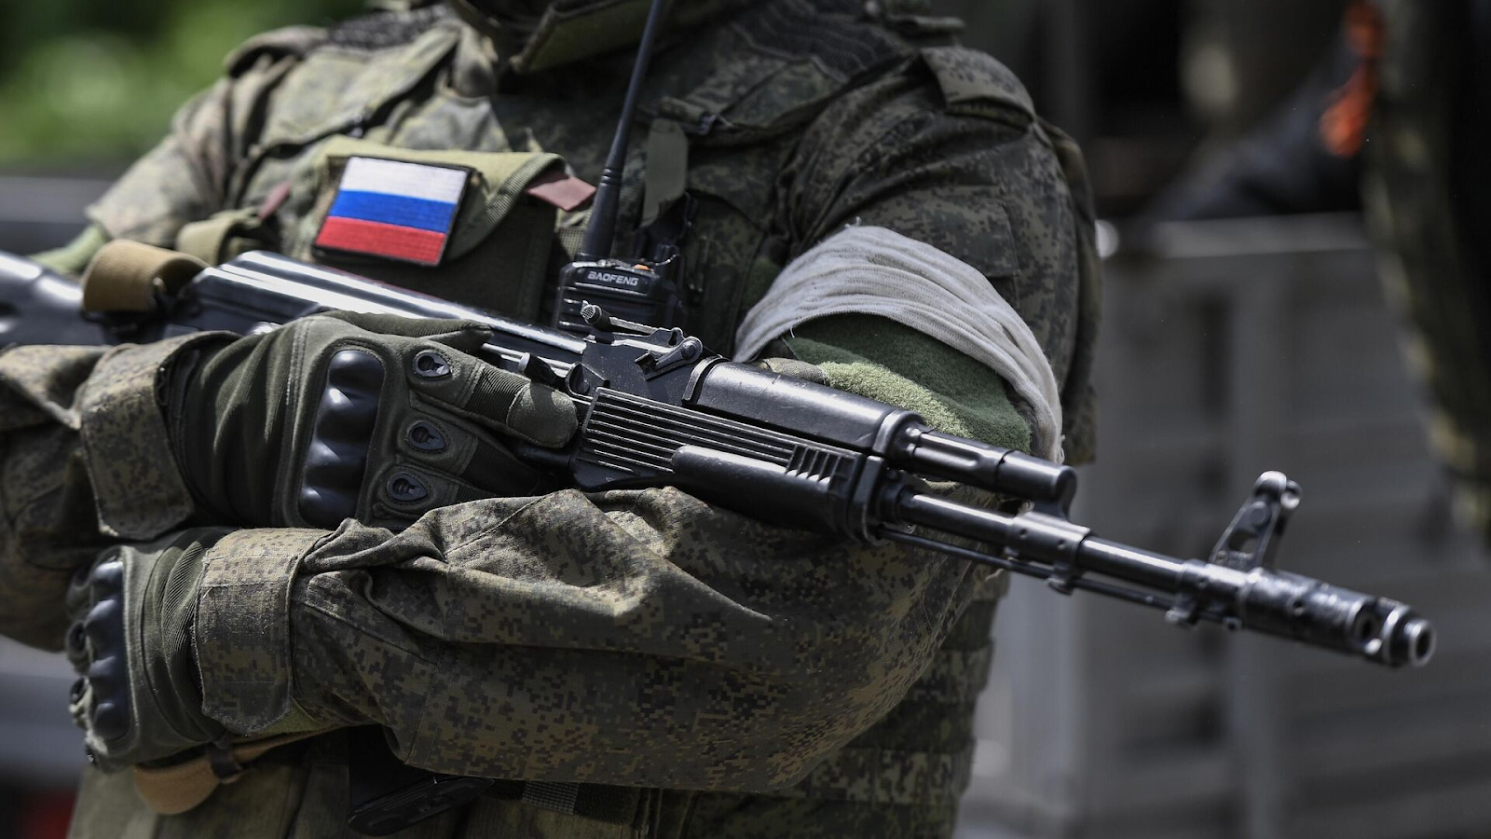
For three decades, Russian capital has been striving to gain a dominant position in the CIS countries and dominate the markets of these countries. Russian state propaganda, confused in its ideological constructions, tries to present itself as a struggle to protect the Russian population in Ukraine and the sovereignty of the millennial "Russian world" — the special operation is conducted primarily for spheres of influence, sales markets and labor resources. Russian capital has multibillion-dollar interests in the most important sectors of Ukrainian industry.
The main Russian multinational corporations operating in the country were Gazprom and Lukoil. Until 2006, Russian companies controlled 90% of oil refining and 85% of oil supplies in Ukraine. After the annexation of Crimea, Chernomorneftegaz, which produced gas and oil on the territory of the peninsula and the shelf of the Black Sea, left the Russian capital.
Exports of metal and semi—finished products play an important role for both Ukraine and Russia - they jointly control 84% of the EU market, 57% of the US market and 23% of Asia. The main Russian companies in this industry in Ukraine were Metalloinvest by Alisher Usmanov and Severstal PJSC by Alexey Mordashov. In addition, the Evraz concern controlled by Roman Abramovich [58] owned metallurgical plants — GOK EVRAZ Sukha Balka (one of the leading enterprises of the industry in Ukraine), Evraz — DMZ named after Petrovsky" and "Metalloprom" [59].
In the banking sector, representatives of Russian capital in Ukraine were Prominvestbank, a subsidiary of Vnesheconombank, VTB Bank, Alfa—Bank and Sberbank, which turned out to be comparable in terms of transactions with European competitors: Raiffeisen of Austrian origin, Ukrsotsbank, owned by the Italian Unicredit and subsidiaries of Hungarian OTP and French BNP Paribas.
The telecommunications sector in Ukraine was represented by such Russian TNCs as VimpelCom and MTS. They could crowd European competitors, as, for example, with the purchase of MTS by UMS, a company originally founded with the participation of Danish, Dutch and German investors.
However, since 2012, when the interests of Russian capital clashed with the interests of European corporations and closely intertwined Ukrainian capital, the situation began to change. In all spheres, Russian oligarchs began to face opposition from competitors and were being pushed out of their usual sales markets.
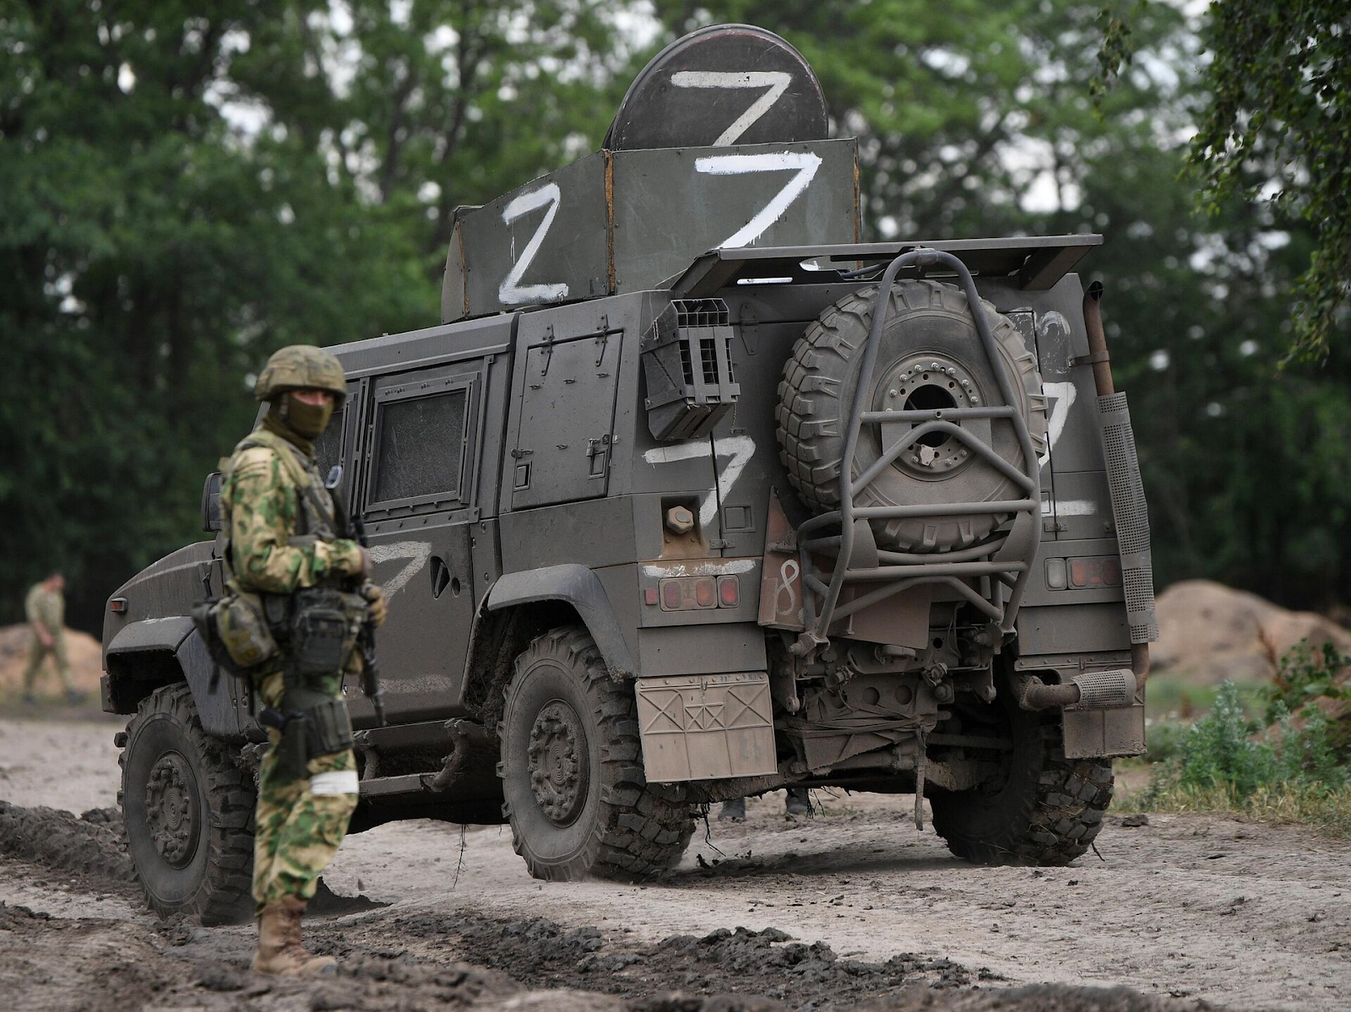
In 2012, a competition was held for the development of the Yuzovsky (Donetsk region) shale gas field. Of the three participants — Russian TNK-BP, Exxon Mobil and Shell — preference is given to British Shell. The American Chevron won the competition for the development of the Oleska gas area in the Lviv region. In 2013 Ukraine and Shell signed a production sharing agreement [60]. At the same time, a PSA was signed with a consortium led by Exxon Mobil for the development of the offshore Scythian gas field [61]. In 2014, the oil product pipelines of Transneft PrykarpatZapadtrans were nationalized. In 2021, Ukrainian Naftogaz began the development of the Svyatogorskoye field. All this created a potential threat to the monopoly of Russian gas on the European market: Lukoil sold gas station networks to an Austrian investor, estimated at 30-50% below their real value.
In metallurgy, Russian Metalloinvest and Severstal came across competition from Metinvest (Azovstal and Mariupol Metallurgical Combine named after Ilyich") Rinat Akhmetov, Sergei Taruta's Industrial Union of Donbass Corporation and Viktor Pinchuk's Interpipe [61]. The struggle for the redistribution of the world scrap metal market led to a trade war and a mutual increase in duties on rolled pipes. Competition intensified due to duties on Ukrainian steel exports to the United States and Europe in 2018-2019. In 2021, metallurgical companies in Ukraine provided 34% of the EU's demand for slabs and 50% for square billets. In 2015, the Zaporizhia Aluminum Plant of Rusal was nationalized.
Contradictions were also growing in agriculture — there was a struggle for world markets for agricultural products. In 2013 and 2017, Russia forced out Ukrainian food producers with the help of export duties. In 2018-2021, in the European and Asian markets, the growth of the Russian agro—industrial complex encountered the growth of the Ukrainian one - in the European market, the growth was 240% for Ukraine and 44% for Russia, and in the Asian market — 17% against 142%, respectively. From 2011 to 2020. Ukraine has increased grain exports by more than 2.5 times, ranked 5th in the world in exports of corn and wheat, and 4th in exports of barley. With the arrival of the pandemic and the economic downturn, the struggle has only intensified.
Hundreds of millions of dollars of losses were incurred by telecommunications companies VimpelCom and MTS, as well as banks Vnesheconombank, VTB, Sberbank and Alfa-Bank, which were forced to recapitalize their branches in Ukraine. Since Russian TNCs actively used "transhipment bases" in Cyprus and the Netherlands, of which the volume of investments in Ukrainian industry exceeded the official one by 3-5 times, this helped to preserve some assets until 2022 [57; 59]. In the field of mass media, an example is the sale by Channel One of 29% of the Inter TV channel to the Ukrainian oligarch Firtash.
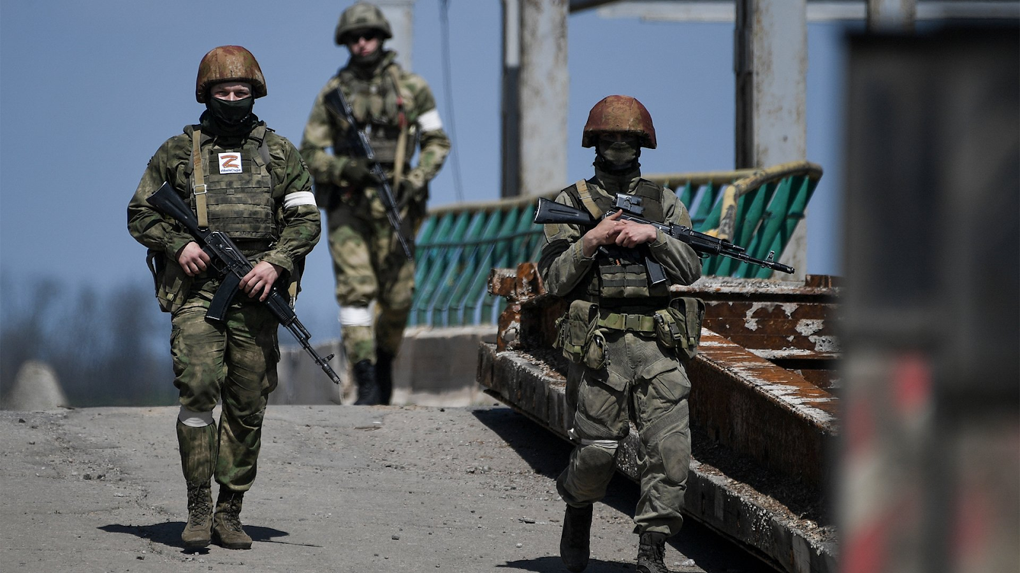
Other imperialist powers also had interests in Ukraine. For example, the United States, among other things, was interested in supplying its own coking coal, superfluous after the shale revolution, to Ukrainian enterprises of the metallurgical and cement industries, consuming 12-14 million tons per year. Ukraine's own capacities could produce only 3.5 million tons. Strangely enough, most of the mines were located in the Donbas. In addition, the danger for US oil and gas companies, which recently won tenders for field development, was represented by the Russian-Ukrainian agreements on December 17, 2013, under which Ukraine was provided with a loan of $15 billion and a discount on gas supplies.
China, the largest consumer of grain, was extremely interested in getting rid of dependence on the supply of American grain. Even before the bourgeois coup, China issued loans to Ukraine in the amount of $3 billion, in the form of payment for which Ukraine pledged to supply grain to China at 4 and 4.5 million tons in 2014 and 2015, respectively, at below-market prices. Already in December 2013, China refused a batch of American corn, which led to a 20% drop in prices for American products.
Until 2013 The Vostochny Mining and Processing Plant of the Nuclear Fuel of Ukraine company, in close cooperation with the Russian fuel company TVEL, was engaged in the extraction of uranium ore, a strategic raw material. In 2013, plans to create a joint venture for the production of fuel assemblies for nuclear power plants worth 300-400 million dollars went to waste due to the refusal of the Ukrainian side to fulfill its obligations. At the same time, the Russian company allocated $42 million for this. However, immediately after the coup, Nuclear Fuel of Ukraine began negotiations with the French operator of the uranium industry Areva and announced the resumption of cooperation, which was interrupted in 2012 [61].
Thus, by 2022, a whole tangle of inter-imperialist contradictions and conflicts of interest had formed, which, including due to the global economic crisis caused by the coronavirus pandemic, required resolution. Ukraine's production facilities and resource base could enhance the wealth of the Russian bourgeoisie, including with the help of cheap labor.
The conflict with Ukraine was probably also perceived by the Russian bourgeoisie as a solution to a number of domestic political problems: the fallen rating of the government, the irritation of the population with pension reform and the difficulties of the pandemic.
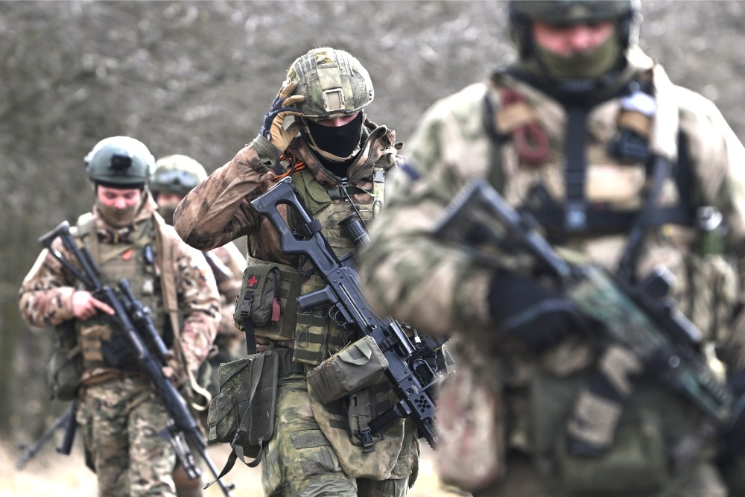
Ultimately, the penetration of Western capital into Ukraine and the displacement of Russian capital from it could not last forever in the form of peaceful competition. After the government of Ukraine, with the help of customs duties, and nationalization of enterprises, courts and police, embarked on the path of direct displacement of Russian business, the armed conflict became only a matter of time. In an effort to protect and expand its spheres of influence, the Russian ruling class first created a buffer zone of its influence in the form of the puppet DNR and LNR, and later, under the slogan of protecting "national interests" and directing armed conflict.

2.3 World Wars for the redistribution of the world
The causes of wars lie in the antagonistic nature of capitalism, where armed struggle becomes an instrument of the policy of the ruling classes to preserve and increase profits. However, having entered the era of monopolistic capitalism, humanity discovered a new phenomenon for itself — imperialist wars. What has become characteristic of world capitalism — the dominance of monopolies, the concentration of capital, the interconnectedness of production and individual industries on a global scale — has found expression in the special nature of wars.
The clashes between the imperialist powers over the redistribution of sales markets, the possession of raw material regions and areas of capital application began to involve dozens of countries in their orbit and acquired the character of particularly destructive world wars.
The First World War (1914-1918) was a struggle between two groups of imperialist countries.
The first group (the Triple Alliance) consisted of Germany, Austria-Hungary, Turkey and Bulgaria (initially Italy also belonged to it). The second group (Entente): Great Britain, France, Russia, Italy, Japan and others. Interested in the redistribution of colonies and markets, in world domination, both coalitions waged an unfair, aggressive war, as a result of which the number of people killed amounted to 10 million.
The war was the result of an extreme aggravation of inter-imperialist relations. Germany, by 1914, growing faster than England and France in economic development, in a short time became a new imperialist state, which was deprived of colonies and access to many markets, and therefore needed a new redistribution of the world. Inferior to Germany and the United States in industrial production, England maintained primacy in the export of capital, which increased by more than 6 times from 1900 to 1912, and the exploitation of huge colonial possessions, of which it had 10 times more than Germany [62]. However, the German Empire was distinguished by a more intensive concentration of production and the speed of formation of monopolies, a more organized financial capital and a wide coverage of monopolies of the entire national economy [63].
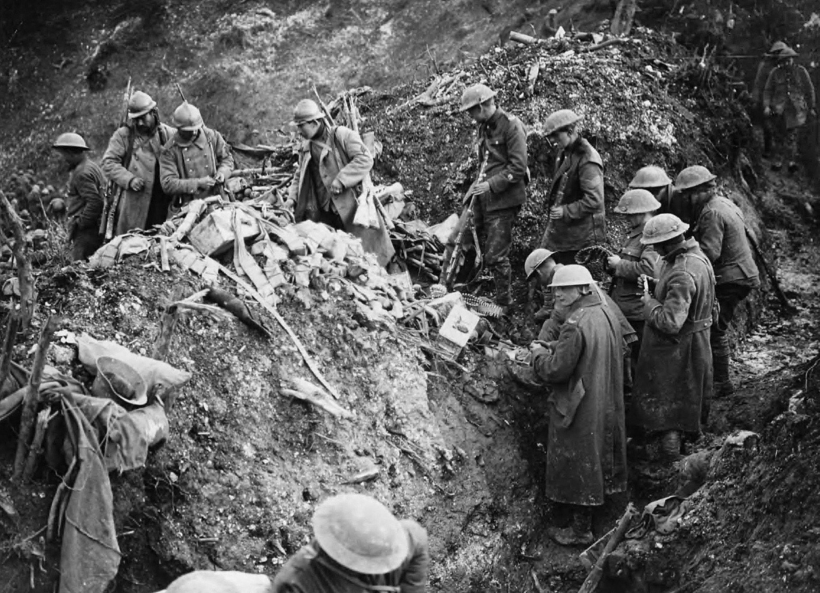
The development of German imperialism was resisted by Britain in Africa, East Asia and the Middle East. The first clash took place in the gold and diamond-rich South African Boer Republic of Transvaal. In 1897, when the Germans annexed the port of Jiaozhou and subordinated the Shandong Peninsula, Germany began to penetrate into China, which was a traditional place of British exploitation.
In the Middle East, the expansion of German imperialism was expressed in the construction of the Baghdad Railway, which posed a great threat to British sea and land routes to India. In the 1880s and 1890s, Germany seized a number of colonies in Africa: Togo, Cameroon and East Africa. As well as islands in the Pacific Ocean: Samoa and the Carolinas. Further expansion could only come at the expense of foreign colonies, primarily British ones. Thus, Anglo-German imperialist antagonism played one of the most important roles in the outbreak of the First World War [64].
But there were other contradictions. France is another imperialist power whose interests were infringed as a result of the rise of Germany. Having lost 15 billion francs in the war with Prussia in 1870-1871 and having paid a huge indemnity of 5 billion francs at that time, France lost an industrially developed area — Alsace-Lorraine, which was one of the largest iron ore basins in Europe.
The lag in the development of heavy industry existed along with a high concentration of banks and the export of capital, as one of the characteristic features of French imperialism [62]. The export of French capital required new areas of application, new markets for goods, as well as protection from the actions of German banks in Europe.
Germany sought to permanently consolidate Alsace and Lorraine, which had been torn away from France, which made the latter dependent on Germany for coal. At the same time, there was an inverse dependence of Germany on France for iron ore. Clashes in the North African arena over colonial possessions, in particular Morocco in 1905 and 1911, intensified the antagonism of the two countries.
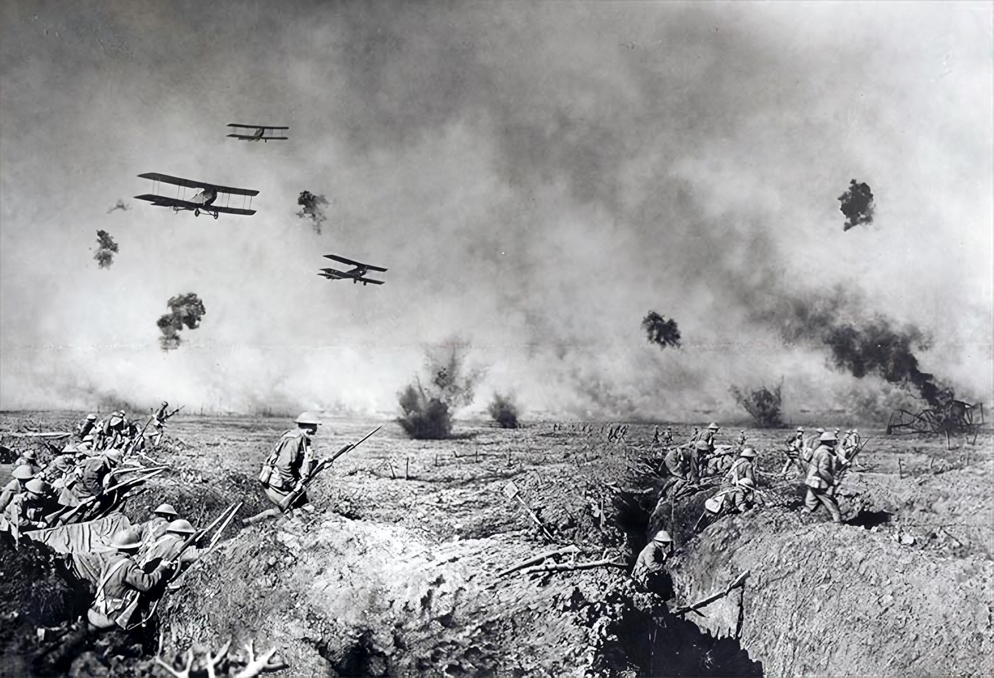
On the other side of Europe, contradictions between Germany and Russia were growing, resulting in a customs war between the two countries. Germany was one of the most important importers of Russian raw materials in 1897. It imported 30% of Russia's total exports, which in turn was a major consumer of industrial goods from Germany. Two-thirds of Russian car imports were from Germany. The latter wanted to make a permanent market out of the Russian Empire while limiting the import of Russian agricultural goods.
In 1887, the first mutual increase in duties took place. Russian Tsarism was forced to make concessions after the Russo-Japanese War: it agreed to a new increase in duties on Russian bread imported into Germany and an increase in the import of German goods. In 1914, Russia itself increased duties on imported German bread, which spoiled trade relations with Germany. At the same time, Germany's rapid penetration into the Middle East intensified contradictions with the Russian landlords and the bourgeoisie, who faced competition with Germany there.
Of particular importance to Russia was the issue of the Straits — the Bosphorus and the Dardanelles. Unlike the Baltic ports, through which 11% of bread was exported, the Black Sea ports handled 80% of exports. 37% of all Russian exports occurred through these straits. Therefore, Russian imperialism could not allow Germany to seize the Black Sea Straits; ideally, the tsarist government dreamed of its own control over them. In addition, German monopolists actively penetrated the Balkan Peninsula, where tsarism had its own interests from time immemorial.
Part of the tangle of contradictions that caused the First World War was also the struggle of the United States and Germany for markets in Latin America and the interests of Italian imperialism in North Africa and the Balkans.
Thus, by 1914, there were a number of contradictions in the world between the largest imperialist countries, which rapidly worsened with the economic development of the countries. Two groups of powers were formed that embarked on the path of armed redistribution of the world: the Triple Alliance, which concluded in 1882, and the Entente, which took shape in 1907. The growth of the labor movement and the intensification of the internal crisis in some imperialist countries, and the aggravation of economic relations pushed for the early outbreak of a war for a new redistribution of the world. And the war broke out: on July 28, 1914, cannons rumbled in Europe.
World War II (1939-1945). The World War of 1914-1918 did not resolve the contradictions of capitalism. The formation of the world's first socialist state, the USSR, and the exclusion of vast territories from the world system of imperialism contributed to the beginning of the general crisis of capitalism.
The aggravation of the contradiction between labor and capital led to an intensification of the increasingly protracted economic crises of overproduction; chronic underutilization of enterprises and unemployment. The problem of markets has worsened, which became even smaller after the emergence of the Russian Soviet Republic.
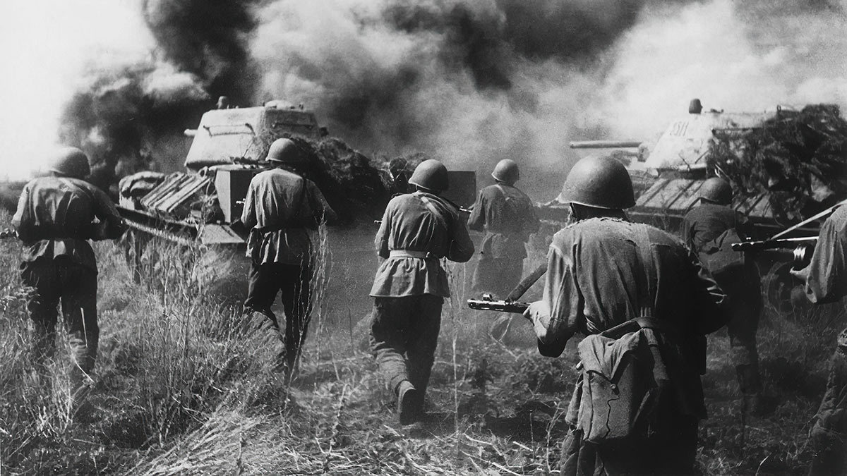
From the end of the First World War to 1939, world imperialism went through a series of upheavals. The years 1921-1923 brought an economic crisis to Western countries, followed by a temporary stabilization of capitalism. In 1929, the most devastating crisis at that time began, followed by a prolonged depression. In 1937, another crisis began to emerge in some countries, the development of which was interrupted by the war. The ruling class of a number of countries has set a course to resolve the accumulated contradictions with the help of a new war.
After the end of the First World War, the victorious countries - England, France and the USA — tried to fix a new redistribution of the world: the distribution of colonies, spheres of influence, and the established system of reparations payments.
Germany, deprived of colonies and having lost in the First World War, was obliged to pay a huge contribution. In 1923, Belgium and France occupied the rich industrial region of the Ruhr, which was an additional blow to the destroyed and devastated Germany. It seemed to the victorious countries that the revival of the German economy would be delayed for many years and this competitor would be eliminated.
However, starting in 1923, the restoration of German industry began with the help of American monopolists, for whom low production costs in Germany opened up a wide scope for action. In addition, the monopolies were interested in creating a stronghold of imperialism and reaction in the center of Europe. The revanchist sentiments of the German military found support from both German and foreign concerns.
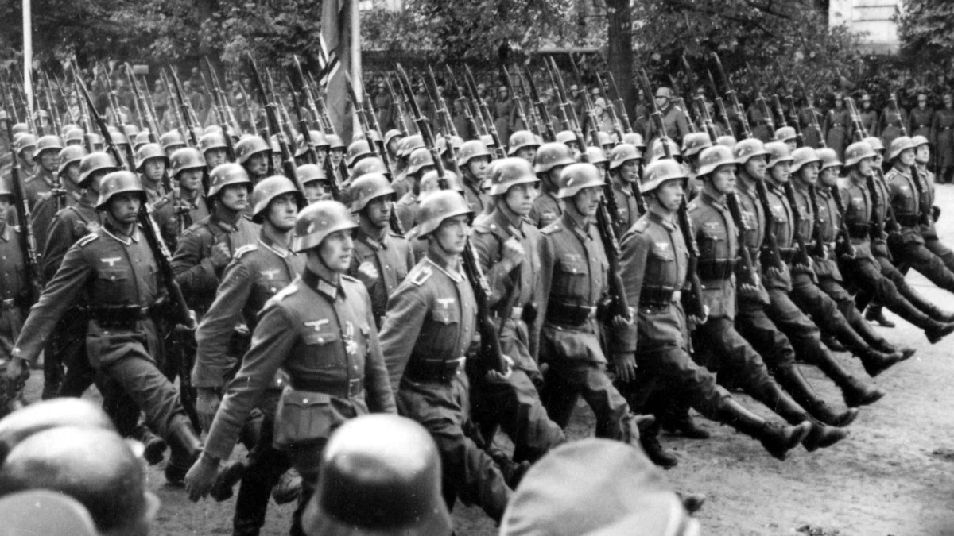
Attempts to create an instrument of anti-Soviet policy in Europe grew into the "Dawes plan" of 1924, thanks to which loans were provided to Germany to revive its military potential. Within 5-6 years, heavy industry was recreated, and reparations were paid by increasing taxes on consumer goods. The production of synthetic fuels, the production of industrial raw materials was started, and military monopolies got a second chance. American capital participated in the Opel automobile company, the Lorenz and Mix-Genest radio companies, the Hugo Stinnes coal concern, the IG Farben industrial chemical concern, Ford factories and many other German enterprises.
The world crisis of 1929-1933 particularly affected the German economy — the unemployment rate and labor exploitation increased sharply. Occupying the third place in the world exports of capitalist countries, Germany again faced the question of seizing new markets. The country overcame the consequences of the crisis relatively quickly, whereas the United States, Britain and France even in 1935 had production levels below pre-crisis levels.
Under these conditions, the main economic rival of England was the United States, which replaced Germany in commercial matters and in the field of maritime power, pushed England away from financial control over the world market and put its colonies at risk. Japan's development was especially rapid. U.S. interests in Southeast Asia and the Pacific region ran into Japanese militarism, which gained access to the markets of many Western countries. However, there was no disagreement between Britain and the United States regarding the USSR and Germany's role in the fight against the Soviet state.
After the First World War, France, having lost tsarist Russia as a major ally, went on to create military blocs with Poland and with the countries of the Balkans within the framework of the so-called Small Entente. For a long time, French foreign policy was anti-Soviet in nature.
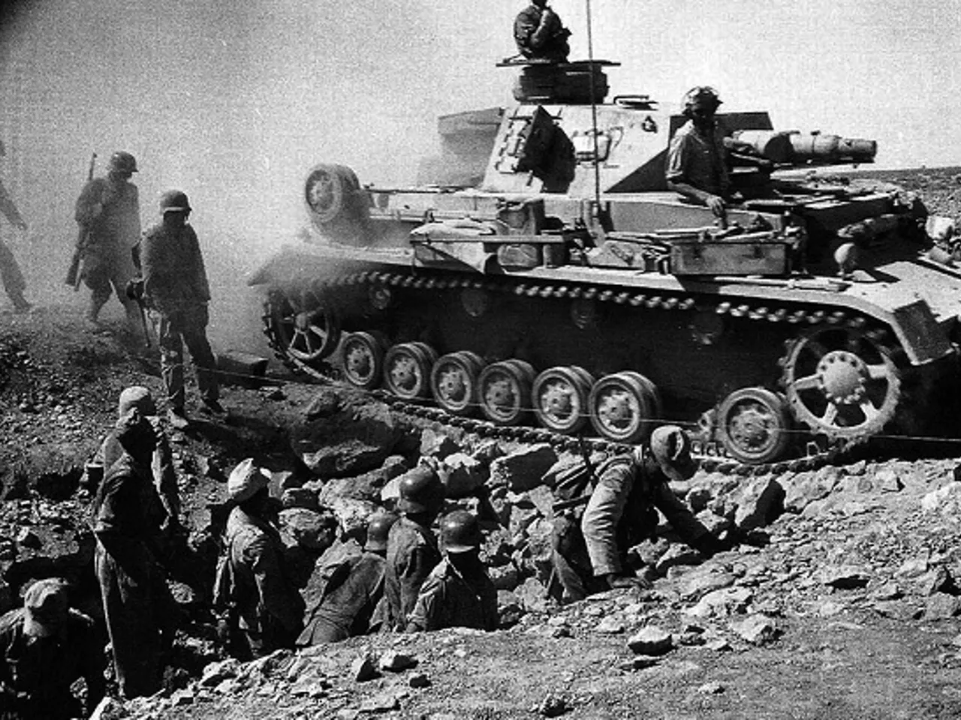
In addition, there were Anglo-French and Italian-French contradictions. The somewhat isolated position of France stimulated the interest of Italian imperialism in the French colonies in North Africa. England embarked on the path of encouraging Italian fascism in the fight against France. This undermined the already weak security system in Europe. Hungary and Bulgaria were also involved in the orbit of Italy's interests in order to disintegrate the Small Entente, and in 1926, an alliance was concluded with Romania and Albania. In addition, for some time there were contradictions between Italy and Germany over the Austrian territories.
Thus, again, as before the First World War, there was a balance of power that did not correspond to the distribution of colonies and markets among the imperialists. In addition, a new special antagonism has been added between the two economic systems — socialism and capitalism. It was possible to resolve the overdue contradictions for the imperialists only with the help of a new war, which German imperialism unleashed on September 1, 1939.

Conclusion
War has always and everywhere in history been a consequence of the action of objective laws of historical development. No war in history has been started solely by the will of one person or a group of individuals — and at the same time, it has always been waged for the specific economic and political interests of the ruling class.
The war under capitalism is a tool by which the capitalist class implements its goals: seizes markets, labor and capital applications, neutralizes opponents, and subjugates countries and peoples. At the same time, the broad strata of the working people have never gained anything from these wars. On the contrary: it is the common people who bear the brunt of the war, it is they who pay for it with their blood, labor and life.
Bourgeois publicists and writers have been trying for centuries to distort this primordial nature of wars. In order to expose this deception, it is necessary, when analyzing the causes and significance of each war, to find the objective economic interests of the parties involved, and to subject the wars to a comprehensive economic and political analysis.
In the second part of this material, we will analyze the myth of the alleged disadvantage of war for capitalists; show what profit it brings and talk about bourgeois theories of ending wars.
List of sources
- Lenin V. I. Report at the II All-Russian Congress of Communist Organizations of the Peoples of the East: Complete works. 5th ed. M.: Politizdat, 1970. p. 319.
- Stalin I. V. Final word on December 13: Essays. Volume 9. Moscow: OGIZ; State Publishing House of Political Literature, 1948. p. 383.
- Lenin V. I. On the Slogan for a United States of Europe.
- Savvin E. N. The relationship between Great Britain and China during the first opium War // 10th corps. 2018. No. 4. pp. 130-134.
- Korablin K. K., Lokteva O. A. The colonial policy of European states in China during the first (1840-1842) and second (1856-1860) "Opium wars" (historical and legal analysis) // Modern science: from theory to practice. pp. 111-124.
- Marx K. E. F. The history of the opium trade: Works. Vol. 12. M.: Politizdat, 1958. p. 564.
- Wei Tzu-chu. Imperialist investments in China (1902-1945). Moscow: Publishing House of the USSR Academy of Sciences, 1956. p.. 53.
- Baranovsky M. I. The American-British capitalists are the stranglers of the Taiping rebellion. // Questions of history. 1952. No. 1. pp. 106-125.
- Rostunov I. I. (ed.). The history of the Russian-Japanese War of 1904-1905. Moscow: Nauka, 1977. p. 383.
- Kalyuzhnaya N. M. The Uprising of the Ichetuan (1898-1901). Moscow: Nauka Publishing House, 1978. p. 365.
- Deineko A.A. General characteristics of the Yihetuan uprising in China as a socio-political phenomenon // Actual problems of humanities and natural sciences. 2016. 1-1. pp. 79-82.
- Kozlov A.M. China: The "Boxer" uprising of 1898-1902. // Bulletin of the Tambov University. Series: Humanities. 2011. No. 2. pp. 344-347.
- Potapchuk V. V., Potapchuk V. I. The military conflict of Russia with China in 1900 // The main trends in the state and social development of Russia: history and modernity. 2020. No. 1. pp. 11-17.
- Churilova I. M., Baranov D. A. The Uprising of the Ichetuan in the Far Eastern policy of Russia // Izvestiya Voronezh State Pedagogical University. 2022. No. 3. pp. 137-141.
- Ivanov A. Yu. The clash of interests of Russia and Japan on the Korean peninsula was a factor in the beginning of the Russian-Japanese war of 1904-1905. // Russia and the Asia-Pacific Region. 2014. 1 (83). pp. 159-171.
- Dosovitskaya V. V. Japan and Manchuria: the beginning of relations // History. 2013. 10. pp. 172-174.
- An Sen Ir. The Russian-Japanese war and the redistribution of the international system in East Asia // Bulletin of ZabGU. 2015. 3. No. 118. pp. 85-106.
- Gastov G. Japanese imperialism.: A political and economic essay. Moscow, 1930. p. 144.
- Galperin A. The Korean question in international relations on the eve of the annexation of Korea by Japan (1905-1910) // Questions of History. 1951. No. 2. pp. 12-30.
- Avarin V. Imperialism in Manchuria.: Volume 1. Stages of the imperialist struggle for Manchuria. 2nd ed. Communist Academy, Institute of World Economy and World Politics: Moscow; Leningrad : OGIZ. State Social-Economic. publishing house, 1934. p. 416
- Sklyarov D. The economic policy of Japanese imperialism in Manchuria. 2nd ed. Moscow, Leningrad: Partizdat, 1934. p. 117.
- Avarin V. "Independent" Manchuria. 2nd ed. Leningrad: Partizdat, 1934. p. 152.
- Zakharova G. F. Japan's policy in Manchuria. 1931—1945. Moscow: Nauka. The main editorial office of Oriental Literature, 1990. p. 266.
- Zhukov E. M. Japanese militarism: A Military Historical Study. Moscow: Nauka, 1972. p. 376.
- Savin A.S. Japanese militarism during the Second World War. Moscow: Nauka, 1979. p. 240.
- Sapozhnikov B. G. China in the fire of war (1931-1950). Moscow: Nauka. The main editorial office of Oriental literature, 1977. p. 351.
- Norden A. This is how wars are made: About the backstage side and the technique of aggression. Moscow: Progress Publishing House, 1972. p. 391.
- Cherkasov P. P. France and the US aggression in Indochina // Questions of History. 1976. № 9.
- Ivanov V. V. The influence of the Vietnam War on the socio-economic development of the United States in the 1960s-the first half of the 1970s. // Social and economic development of the Asia-Pacific region: experience, problems, prospects. 2014. No. 1. pp. 58-66.
- Migolatyev A. A. Imperialism: a bet on war. Moscow: Voenizdat, 1985. p. 242.
- Abalyan A. I. The Iran-Iraq armed conflict of 1980-1988 and its impact on the system of international relations in the Middle East // Bulletin of St. Petersburg University. International relations. 2015. No. 2. pp. 52-61.
- Hiro D. The longest war: The Iran-Iraq military conflict. New York: Routledge, 1991. xxiv, p. 323.
- Razoux P. The Iran-Iraq war. Cambridge Massachusetts, London England: The Belknap Press of Harvard University Press, 2015. xviii, p. 640.
- Primakov E. M. The modern history of the Arab countries of Asia: 1917-1985. Moscow: Nauka Publishing House, 1988. p. 644.
- Rudenko L. N. Problems of attracting foreign investments to Arab countries in the context of globalization: Together with the Institute of Economics of the Russian Academy of Sciences. Moscow, 2006. p. 197.
- Workman T. The social origins of the Iran-Iraq war. Lynne Rienner Publishers, 1994. p. 179.
- Belousova K. A. The Iran-Iraq War (1980-1988) and U.S. policy in Iraq // Bulletin of Ryazan State University named after SA Yesenin. 2005. 2 (12). pp. 44-55.
- Murray W., Woods K. M. The Iran-Iraq War: A military and strategic history. New York: Cambridge University Press, 2014. Xiv, p. 397.
- Abalyan A. I. The causes and prerequisites of the Iran-Iraq armed conflict of 1980-1988 // Bulletin of St. Petersburg University. Political science. International relations. 2014. No. 2. pp. 94-101.
- Nasirbeik A. I. Stages of development of the Iranian economy // Horizons of Economics. 2019. No. 6. pp. 61-66.
- Mammadova N. M. Iran: features of the formation of the political elite // Russia and the Muslim world. 2016. 10 (292). pp. 88-97.
- Bekkin R. Iran: the experience of Islamization of the economy // Russia and the Muslim world. 2007. No. 2. pp. 117-125.
- Venturini G. The Proxy 'Civil War' In Syria Is About Gas, Oil And Pipelines: Obtenido de https://www.countercurrents.org/venturini240913.pdf. 2013.
- Antipov K. V. China's Middle East policy in the context of the Syrian crisis // China in World and regional politics. History and modernity. 2012. 17. No. 17. pp. 204-226.
- Khlopov O. A. Hydrocarbon resources among the factors of the crisis and civil war in Syria // Bulletin of the Moscow State Regional University. 2022. No. 1. pp. 101-115.
- Gupta R. Understanding the War in Syria and the Roles of External Players: Way Out of the Quagmire? // The Round Table. 2016. 105. № 1. pp. 29–41.
- Salloum F. S. The struggle for Syria in context of the gas war // Journal of the Belarusian State University. International Relations. 2018. 2. pp. 25–31.
- Lin C. Syrian Buffer Zone — Turkey-Qatar Pipeline: ISPSW Strategy Series: Focus on Defense and International Security, Issue, 2015. p. 5.
- Maher D., Pieper M. Russian Intervention in Syria: Exploring the Nexus between Regime Consolidation and Energy Transnationalization // Political Studies. 2021. 69. № 4. pp. 944–964.
- Szénási E. Syria: another dirty pipeline war // Honvédségi Szemle–Hungarian Defence Review. 2017. 145. № 1. pp. 188–204.
- Gaal E. A. The place of Syria in the foreign policy of the People's Republic of China // XXI All-Russian Student Scientific and Practical Conference of Nizhnevartovsk State University. 2019. pp. 22-24.
- Agliullin I. Z. The energy aspect of the Civil War in Syria // National Security and Strategic Planning. 2013. No. 4. pp. 64-68.
- Tsyplin V. G. The Islamic gas pipeline and the outbreak of hostilities in Syria // /Problems of Russian civilization and methods of teaching history. 2021. No. 13. pp. 85-96.
- Komleva N. A. The Syrian crisis: oil and gas causes and consequences of geopolitical mobility // Discourse-Pi. 2013. 10. No. 3. pp. 60-65.
- Vladimirova P. V., Borodulina S. A. Macroeconomic interests of countries in Syria // Science among us. 2019. No. 5. pp. 294-297.
- Komleva N. A. The Syrian crisis as a manifestation of the struggle of global corporations // Actual problems of global research: Russia in a globalizing world. 2019. pp. 414-415.
- Kuznetsov A.V. Foreign investments of Russian companies: competition with Western European and East Asian TNCs // Bulletin of the Russian Academy of Sciences. 2016. 86. No. 3. pp. 203-214.
- Kuznetsov A.V. Russian direct investments as a factor of Eurasian integration // Economic issues. 2014. No. 8. pp. 58-69.
- Kuznetsova G. V. Foreign investment activity of Russian enterprises // National interests: priorities and security. 2014. No. 14. pp. 49-57.
- Stanis D. V. Ukraine in the interests of Western transnational corporations // Bulletin of the Peoples' Friendship University of Russia. Series: State and Municipal Administration. 2015. No. 2. pp. 55-65.
- Bakalinsky M. The coup in Ukraine through the prism of the economic interests of the West // Geo-economics. 2014. No. 34. pp. 111-128.
- The history of the First World War 1914-1918 / Comp. A.M. Ageev, D.V. Verzhkhovsky, V.I. Vinogradov, V.P. Glukhov, F.S. Krinitsyn, I.I. Rostunov, Yu.F. Sokolov, and A. Strokov. Moscow: Nauka, 1975. p. 673.
- Hayrapetyan M. E., Kabanov P. F. The First World Imperialist War of 1914-1918 Moscow: Publishing House "Enlightenment", 1964. p. 64.
- Zaionchkovsky A.M. The World War of 1914-1918: a general strategic essay. 2nd ed. Moscow: State Military Publishing House, 1931. p. 464.

Original article

