Capitalism and Corruption
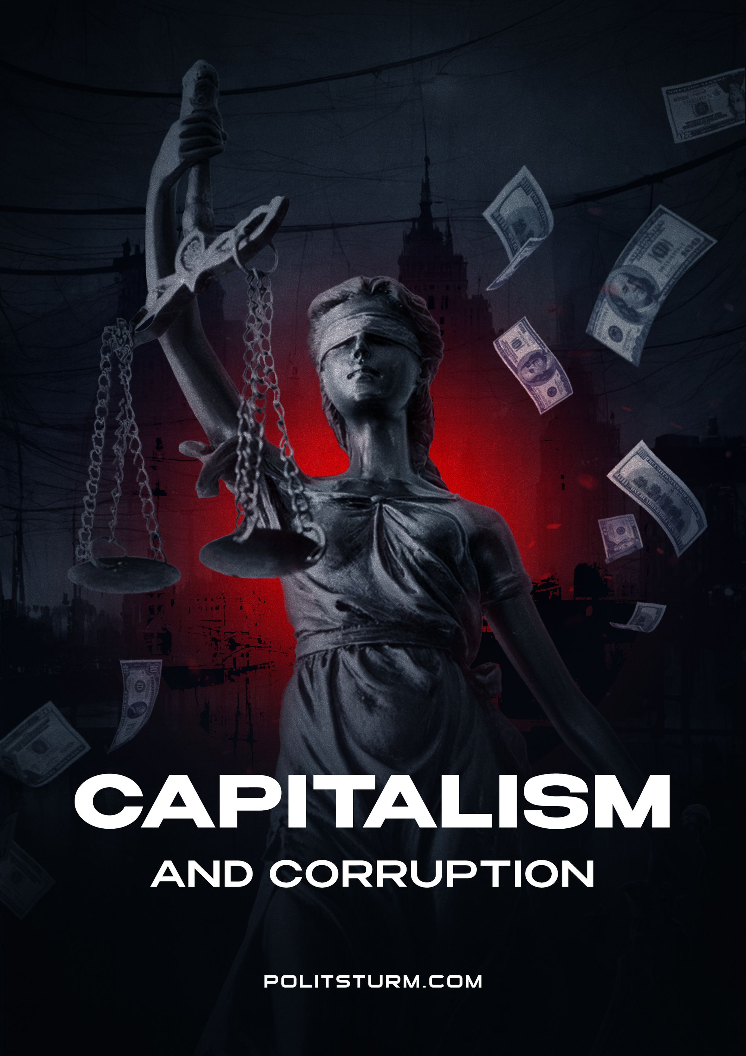

Original article
2022-12-25
13 min read

Corruption, no matter how much people talk about “right” and “wrong” capitalism, is an integral part of it. It would be a mistake to think that corruption is peculiar only to “undeveloped” or “developing” countries, and that such a phenomenon has been eradicated in the developed countries of the West.
No matter how much they fight corruption, no matter how many obstacles they create for it and no matter how cruelly they punish it, corruption cannot be defeated while preserving the capitalist system. After all, corruption is closely related to private property and the power that it gives to the ruling class.

I. What is corruption?
First of all, it is necessary to define the concept of “corruption”. The Great Soviet Encyclopedia gives the following explanation:
Corruption (from Latin corruptio - corruption, bribery) is a crime consisting in the direct use by an official of the rights granted to him by office for the purpose of personal enrichment. Corruption is also called bribery of officials, their venality.
Corruption is known to all types of exploitative states, but it is especially widespread in the capitalist state.
It is characteristic of the bourgeois state apparatus and parliament, where statesmen and politicians arrange personal affairs, using their official position. V. I. Lenin, describing imperialism as parasitic, decaying capitalism, pointed to its properties such as “venality, bribery on a gigantic scale...”.”
The fact that corruption in Russia is pervasive and deeply entrenched is undeniable.
However, there are widespread beliefs among Russian liberals that corruption is a problem only for backward states with the “wrong” capitalism. From this point of view, it is enough only to remove the “wrong” oligarchs, remove the current ruling elites from the trough and replace them with other, “right” oligarchs who will be against corruption, as everything will immediately return to normal and Russia will join a friendly family of “democratic states”.
This myth is almost as old as the Russian Federation itself, but on closer inspection it collapses like a house of cards. It turns out that corruption is no less characteristic of the countries of the “democratic league" than Putin's Russia.
According to 2014 polls, about 80% of Americans consider their authorities to be mired in corruption: the existence of institutionalized corruption – lobbying – regular corruption scandals, payment for the election campaign of a candidate for a particular elected position, which is compensated by various services after the election. All this is the norm of life in the USA, as it seems to be classical liberal propaganda: the strongholds of modern capitalism.
"There are no corruption—free zones in Europe; it has reached mind-boggling proportions and annually damages the European economy in the amount of 120 billion euros," former EU Commissioner for Internal Affairs Cecilia Malmstrom said in 2014.
The assessment of the situation from the European Anti-Fraud Office (OLAF) is even tougher. Experts say that the EU countries annually lose 323 billion euros from corruption, that is, a third of the budget of the eurozone countries until 2020.
Let's consider a couple of concrete examples.
France. The wife of the French presidential candidate from the Republican Party, Francois Fillon, was suspected of illegally receiving about 500 thousand euros. This was reported by the Agence France-Presse, referring to the data of the satirical publication Canard Enchaine. According to their information, Penelope Fillon for 10 years (from 1992 to 2002), while her husband was a member of parliament, received money from funds to which her husband had direct access.
Germany. In 2016, a corruption scandal broke out in Germany related to the activities of Siemens. According to the agency, Uriel Sharef, a member of the company's board of directors, was previously brought before a Munich court on fraud charges. According to the case file, the top manager ordered to pay high-ranking officials and entrepreneurs in Latin America bribes totaling $14.2 million. In addition, as the prosecutor's office decided, he was unable to liquidate the so-called "bribe fund" of $35 million.
Corruption is also rampant in the United States. For example, in April 2014, former Secretary of State John Kerry said that the State Department had no documents on contracts worth $ 6 billion. The auditors found the "hole". In the course of studying the history of contracts for the support of the State Department mission in Iraq, it turned out that the United States does not have documents for 33 out of 115 contacts for about $2 billion.
Error loading image
Of course, in words, American senators, Russian liberals and oligarchs, MEPs condemn corruption. Penalties for it are provided for in most criminal codes, however, as a rule, most of these crimes remain unpunished.
Corruption is not just linked to capitalism. It is a consequence of the existence of human exploitation by man in general. Wherever the labor of the worker is alienated, wherever there are power elites that lead a parasitic existence, there will always be corruption: from the Roman Republic of ancient times to the modern capitalist USA.
Corruption is one of the oldest phenomena in the history of human civilization. The first mentions of bribery and abuse of officials belong to the ancient city-states of Mesopotamia.
However, corruption is not so much connected with the government as with another public institution – private property. Officials abuse power in private interests, wanting to improve their financial situation through bribes and embezzlement of other people's money. The thirst for material gain, which is the main imperative that drives capitalist society, transfers the concepts of ownership to the state and power.
The position of power, budgetary funds, and the powers themselves are considered by the corrupt official as his property, from which he has the right to benefit. He can do this both directly using the opportunities offered by his position - and through ordinary bribes. They bribe state and political figures, exchange services and blackmail, turning politicians and employees into their quasi-property.
The owner of a corporation who bribes a TV channel or a blogger gets into his possession as well as the thoughts of the viewers of these channels. By bribing politicians, he acquires parties and parliament. In a word, political capital. By bribing statesmen, he subordinates part of the state to his interests.
All this makes it possible not only to use the state or part of it as their property, but also not to bear any responsibility for their actions at all. As, for example, the owners of mines in which people die, get away from punishment: all the media are silent about their guilt, judges turn a blind eye, and the state itself will also allocate money to the same owners.
Bourgeois society is such that a person endowed with power will naturally strive to ensure an increase in the quality of satisfaction of their needs using the available power. Simply put: as long as commodity-money relations, material inequality and class struggle persist, corruption will also exist. Until then, the government itself will be considered as a source of personal enrichment.
Consequently, the only way to overcome corruption once and for all is not to try to cultivate “honest” politicians, officials, prime ministers and presidents - in a bourgeois society, this word itself cannot be taken seriously. But only through the scrapping of the socio-economic basis, which allows, as stated, to dispose of people's property for selfish purposes. In other words: only with the liquidation of the capitalist system and the construction of a socialist society.

II. How Socialism Destroys Corruption
As we know, they could not completely eradicate corruption in the USSR and already during the period of “stagnation” (70-80) it became a serious problem. However, despite this, the Soviet system gave positive examples of how socialism makes it possible to effectively fight corruption.
The main goal of the Soviet state was to build communism, a classless society in which there is no exploitation of labour, in which the first need and meaning of life is the self-realization of a person.
On the way to this society, the Soviet government had to face a whole host of vices and prejudices that had not yet been eliminated in the public consciousness. One of these was the idea of the acceptability of corruption. It was inherited by the Soviet society from tsarist times.
The government of Soviet Russia, and later the USSR, actively took up the eradication of this problem. So, in 1918, the decree of the CPC “On Bribery” was issued, which provided for imprisonment for up to five years with confiscation of property for recipients and givers of bribes. In 1922, execution for bribery was introduced.
However, it was not enough just to punish those already involved in corruption cases. It was necessary to prevent and prevent the manifestation of this social disease.
Thus, one of the main methods of fighting corruption was the fight against the formation of the elite – a privileged stratum in the party and state apparatus.
It is worth giving a few examples. It is worth starting, for example, with the salaries of Soviet state and party figures.
So, none other than Vladimir Ilyich Lenin himself received a salary of 500 rubles for his work as chairman of the Council of People's Commissars - the government of the RSFSR/USSR. At the same time, the minimum wage for workers and employees of Moscow and the Moscow region was then at the level of 600 rubles, and the maximum salary of senior technical and administrative personnel was 3 thousand rubles.
Stalin in 1936, as general Secretary of the Central Committee of the CPSU (b), received 1200 rubles, while the average salary in the USSR in the second half of the 1930s was 300 rubles. In 1952, his salary was 10,000 rubles.
De facto, Joseph Stalin was also entitled to huge sums from the publication of his books, which were published in the USSR and abroad in millions of copies. Nevertheless, Stalin did not leave behind any real estate, bank accounts, or any other large monetary investments.
Stalin's personal property, which remained after his death, is well known and documented. The list of Stalin's things described by order of L. P. Beria on the evening of March 5, after the discovery of the generalissimo dead, impresses with its asceticism: several smoking pipes, 6 jackets, 10 trousers, a savings book with nine hundred rubles.
No jewelry (and in general things of any material value), amounts of cash were found at Stalin's Nearby dacha. As well as at other dachas that he visited during his 29-year leadership of the party and the country.
Other heads of the Soviet state also could not compare in earnings with modern ones.
So, Nikita Khrushchev received in different periods from 800 to 1200 rubles a month (from 256,000 to 320,000 at the exchange rate of 2019). Andropov also received 800 rubles.
For comparison: in October 2019, the monetary remuneration of the Prime Minister of Russia was set at 618.7 thousand rubles per month (with an average salary of 46.5 thousand rubles). Russian President Vladimir Putin raised his salary to 773,000 rubles per month on his birthday on October 7, 2019.
Until 1932, there was such a norm as the party maximum - the maximum monthly salary that existed for party members who are senior employees of institutions and enterprises. According to this norm, the salary of responsible employees could not exceed 150% of the average salary in the institutions and enterprises controlled by them. This limited the opportunities for chiefs to earn extra money on the side.
The Soviet state did not weaken the fight against corruption, including with the help of the judiciary. In 1948-1949, three corruption trials took place. The prosecutor's office revealed "numerous facts of bribery, abuse, merging with criminal elements and the imposition of unlawful sentences and decisions in the judicial authorities of Moscow, Kiev, Krasnodar and Ufa." 111 people were arrested in Moscow alone.
The fight against corruption in the early USSR was also carried out thanks to the state and party figures themselves, whose average portrait represented people from the people: former peasants and ordinary workers, teachers, engineers and doctors. The Soviet power was their power. The motives of the Soviet government are their motives.
This is an important psychological aspect. These people have never lost their connection with the people, preserving class consciousness and ethics. They accepted direct orders from those they represented, communicated on equal terms with their comrades, never broke away from people. Not living in palaces and not having luxury yachts, they worked for the benefit of the people, being part of it.
They did not perceive the people on whose behalf they ruled as a way of earning wealth and sincerely believed in the ideals of serving them. The domination of Marxism actively contributed to the cultivation and strengthening of such an attitude to management, the culture of public service.

Conclusion
Corruption is a consequence of the existence of private property. Capitalist society is built on greed and selfishness. An official sells his services to a capitalist who is ready to buy them for the sake of satisfying his interests. A person weighs all the costs and benefits of his criminal actions and rationally decides to commit a crime if the expected usefulness of such actions is higher than if he remained honest and spent his time and resources in a different way.
It has strictly destructive features, leads to an increase in social inequality and poverty, the inability of the authorities to solve social problems due to "kickbacks" to the detriment of the budgetary sphere. It reduces trust in the government and alienates it from society, as well as decomposes moral norms, etc.
Socialism makes it possible to destroy corruption itself, since it destroys private property.
Only a consistent and principled construction of a socialist society, where power directly belongs to the working people, where there are no elites and exploiters; where the destruction of commodity-money relations and the exploitation of man by man is carried out; where there is subordination of party and state figures to the interests of workers and control of citizens over their activities can defeat corruption.

Original article

