US Forces Canada to Drop Digital Tax
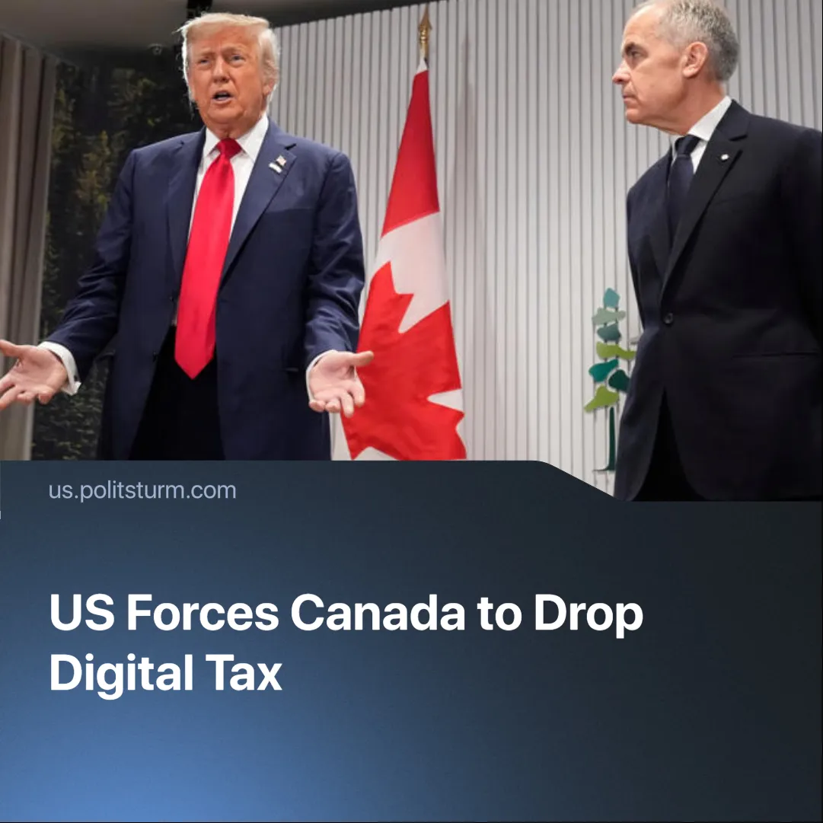

Original article
2025-07-05
1 min read

Canada has once again conceded to US pressure, cancelling its digital tax after Trump threatened to suspend trade talks.
Details. Donald Trump announced the suspension of all trade talks with Canada, calling the digital tax a "direct and blatant attack” on the United States.
► Canada had proposed a 3% Digital Services Tax (DST) on the income of American technology companies such as Google, Meta, and Amazon. This was expected to cost US tech firms $2–3 billion annually, including retroactive payments.
► Donald Trump called Canada's digital tax on US tech companies "egregious". He pointed out that the US economically has "such power over Canada" and could use it if necessary, but chooses not to. Trump also threatened that tariffs could be introduced within a week.
► The Canadian government cancelled the tax on June 29 in order to resume trade negotiations. The White House said Canada had “caved” to Trump’s demands.
► Both parties are aiming to finalise trade talks and reach an agreement by 21 July 2025.
Context. Canada was among the first targets of Trump’s tariffs, which included a 25% duty on Canadian goods excluding energy products.
► Trump has repeatedly floated the idea of annexing Canada. Although these statements were not official policy, they underscored his administration’s hawkish stance towards its northern neighbour.
► Canada has avoided the worst of Trump’s “Liberation Day” trade policy but has made several concessions, including ending surcharges on electricity exports as a condition for resuming trade talks. Nevertheless, Canada still faced tariffs on steel, aluminium, cars, and auto parts.

Original article

