California Prop 22 Erodes Worker Pay &amp; Benefits
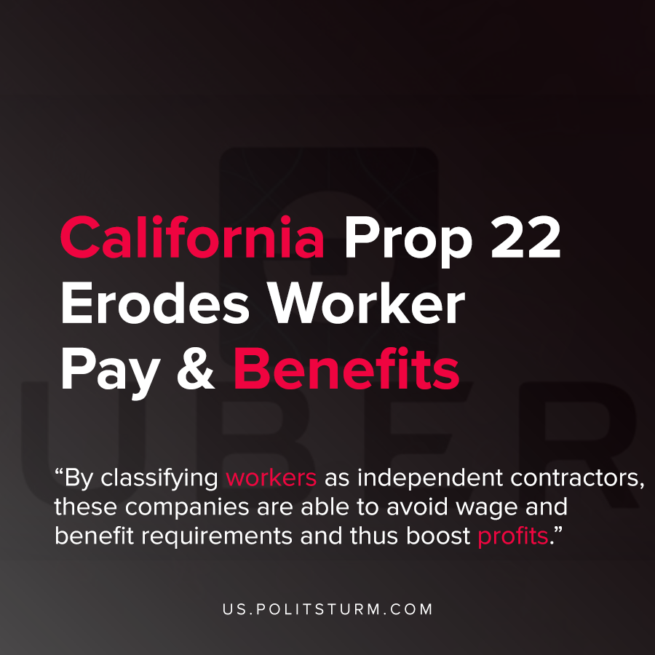

Original article
2020-11-10
1 min read

Proposition 22 passed in the state of California which allows companies such as Uber, Lyft, and Doordash to classify their workers as independent contractors. These companies funneled hundreds of millions of dollars in support of the campaign that would allow them to reduce their expenditures on benefits and wages.
The proposed text of Prop 22 claims to favor workers, even boasting that it provides “guaranteed minimum earnings” of 120% of the minimum wage. However, this only applies to “engaged time” and not the entire working time. Engaged time is narrowly defined as the moment when the worker accepts the rideshare or delivery request until its completion.
By classifying workers as independent contractors, these companies are able to avoid wages and benefit requirements and thus boost profits.
Also, the money raised in favor of the proposition was extremely unbalanced in favor of the large corporations. According to Ballotopedia, the proponents of the proposition outraised the opposition by a factor of 10:1.
While the proponents of bourgeois democracy present the system as neutral and just, the imbalance class dynamics are clearly visible in the case of Proposition 22. The proposition that erodes labor rights and benefits is fought for tooth and nail by the capitalists who use their money to shape public opinion and the law. The workers, without Marxist-Leninist theory, are on the defensive against the onslaught of the capitalist and their drive for greater profits.
Sources: 1 , 2 , 3 , 4

Original article

