California Fast Food Workers Protest Working Conditions
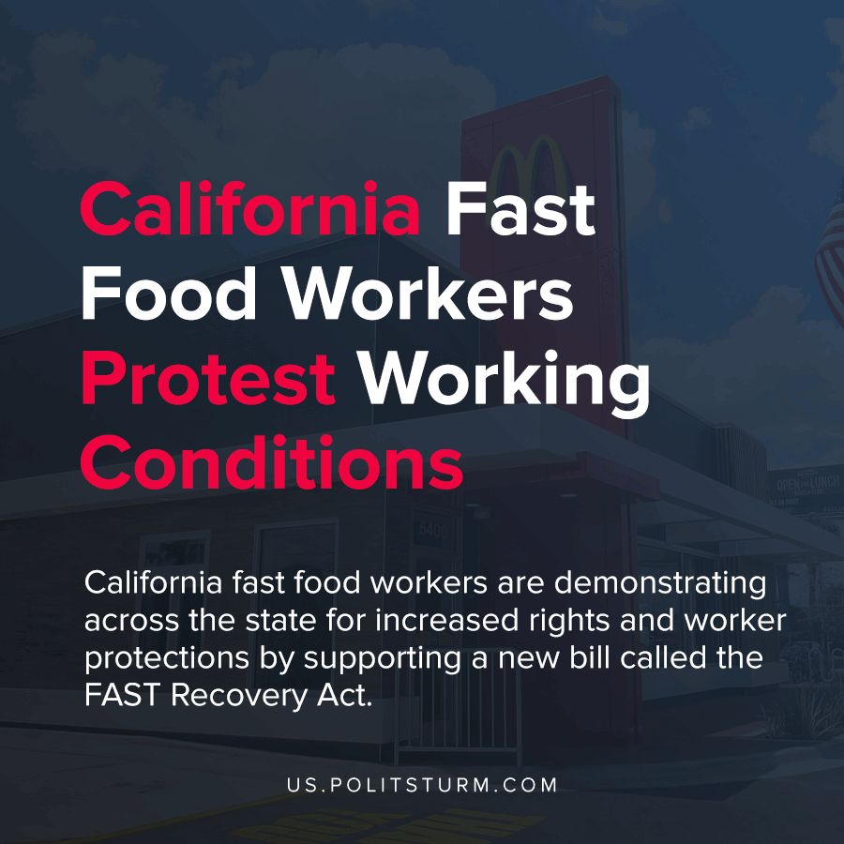

Original article
2021-04-15
1 min read

California fast food workers are protesting across the state for increased rights and worker protections by supporting a new bill called the FAST Recovery Act. Organizers and workers started demonstrating in support of the bill on Thursday in San Diego and will continue throughout the state as the hearing for the bill approaches.
The bill acknowledges that fast food workers receive low wages and few benefits while being subject to wage theft, health and safety risks, and discrimination.
The bill, if enacted, would establish a council who would set minimum standards on behalf of the workers. These standards would pertain to wages, working hours, and health and safety conditions including those relating to COVID-19.
Under the bill corporations such as McDonalds would also be required to ensure compliance for their affiliated franchises as well.

“California has been a leader in workers’ rights, and the FAST Recovery Act ensures that fast-food workers have a seat at the table and a role in improving safety in an industry rife with workplace abuses,” said Joseph Bryant, SEIU California Executive Board member and SEIU 1021 President.
The federal minimum wage in the United States is $7.25 per hour, a rate which has not been raised since July 24th, 2009.
While fast-food workers struggle to support themselves and their families on low wages, corporations such as McDonalds continue to return massive profits to shareholders.
While it is necessary for workers to struggle for any improvement in their working conditions and wages, the positions of capital and labor are in contradiction and attempts by organized labor to simply get a “seat at the table” have failed the workers in the long run. The stolen wages of the workers and poor working conditions serve to bolster the profits of the capitalists, who have every incentive to maintain this arrangement. It is necessary for the workers to organize with the intent of ending capitalist wage slavery and exploitation and to do so it is necessary to understand and apply Marxist-Leninist theory.
Source: 1 , 2 , 3 , 4 , 5

Original article

