Buffalo Electronics Company Closes and Lays Off All Employees
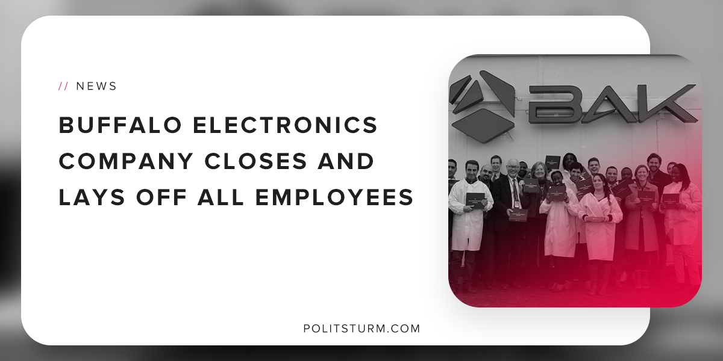

Original article
2018-11-15
1 min read

Buffalo electronics manufacturer Bak USA announced that it would be discontinuing all operations as of 11/1/2018. The company manufactured built-to-order computers and tablets that were manufactured in the United States.
The company was located on Michigan Avenue in Buffalo, New York and employed 77 workers. The company was a small business founded by the Bak family to produce electronics.
In a recent statement, the mayor of Buffalo stated, “Tariffs imposed by the Trump administration on products from China and the components which they get from China have essentially put Bak USA out of business,”. The chairman of Bak USA J.P Bak said that the company “did not reach the point of profitability necessary to sustain itself.”
The industrial decline across the United States historically has not been confined to the Trump administration. While the impact of tariffs may have had an impact on this individual company, manufacturing has been on a persistent 50-year decline.
Manufacturing employment in the Buffalo-Cheektowaga-Niagara Falls region has declined from 92,900 workers in September 1990 to 52,600 as of September 2018. The decline in manufacturing employment in this region accounts to -43%.
The industrial decline in the United States is not the result of a recent policy decision by the Trump administration, but rather a prolonged decline caused by the laws of capitalist development. Bourgeois economists refer to the decline of industrial production and the rise of finance capital as the state of a “mature economy”.
Realistically, industrial production has been leaving the imperialist countries for decades to exploit foreign workers and achieve higher profits producing in the peripheral countries.
The American worker can see that the protective tariffs imposed by the Trump administration have not brought industrial production back to the United States. At the same time, this downward trend in manufacturing employment has persisted through Democratic and Republic administrations alike. This trend is rooted in the foundations of the capitalist mode of production.
Sources: 1 2 3 4

Original article

