British Workers Told to Start Stockpiling Food
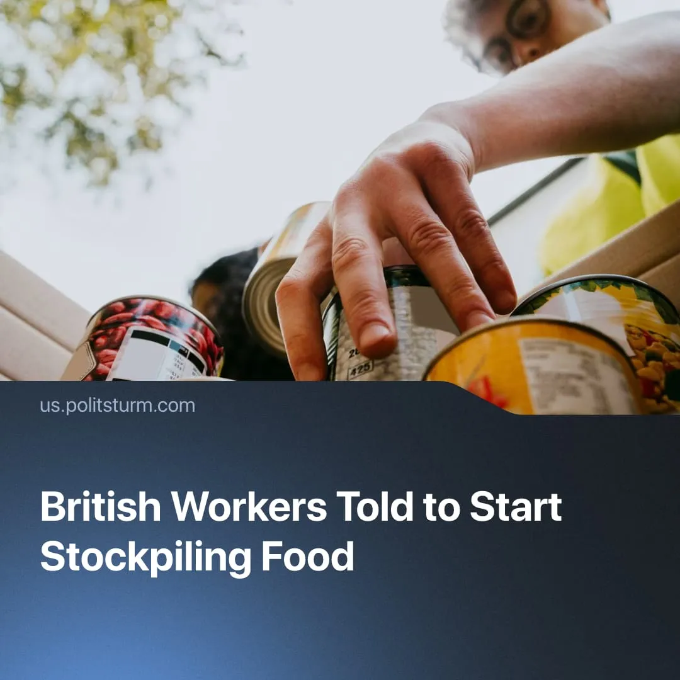

Original article
2026-09-16
1 min read

As Britain's food supply chains come under threat, the government's advice to workers is to stockpile food individually, whilst it accelerates military spending.
Details. UK Environment Secretary Dame Angela Eagle advised residents to stock up on food, following a National Audit Office report citing threats to Britain's supply chain, including disease outbreaks, cyberattacks, and the climate crisis. The intensifying El Niño phenomenon – a periodic global weather disruption caused by abnormal Pacific Ocean warming – is projected to further disrupt global food production, compounding months of drought-driven crop failures.
► The NAO noted that the government is overly reliant on the private sector to stabilise supply chains, and that UK households are less prepared for emergencies than their European counterparts though their readiness varies widely and falls well short of what the scale of these disruptions demands.
Context. The government has launched its first task force to strengthen climate security, bringing together leading security, military and academic experts. However, the task force will likely serve as a purely advisory body. Meanwhile, the government plans to re-approve oil drilling in the North Sea – two initially shelved projects due to climate damage – and in the Falklands, where oil was found in 2010.
► Despite the climate crisis turning into an emergency, militarization remains a key priority and is accelerating. The UK government plans to “reallocate the budget” from other departments to boost defense spending. A food transportation federation chief blamed "Russian cyber-hackers" for supply chain disruptions, consistent with the current trend of hysteria propaganda to justify militarisation.
► This year, the UK experienced consecutive heatwaves and nationwide drought, now followed by predicted torrential rain and flooding. Farmers claim this year’s harvest could be their last, with one-third reporting that farming has become unprofitable.

Original article

