British Workers in Poor Health Before Legal Retirement
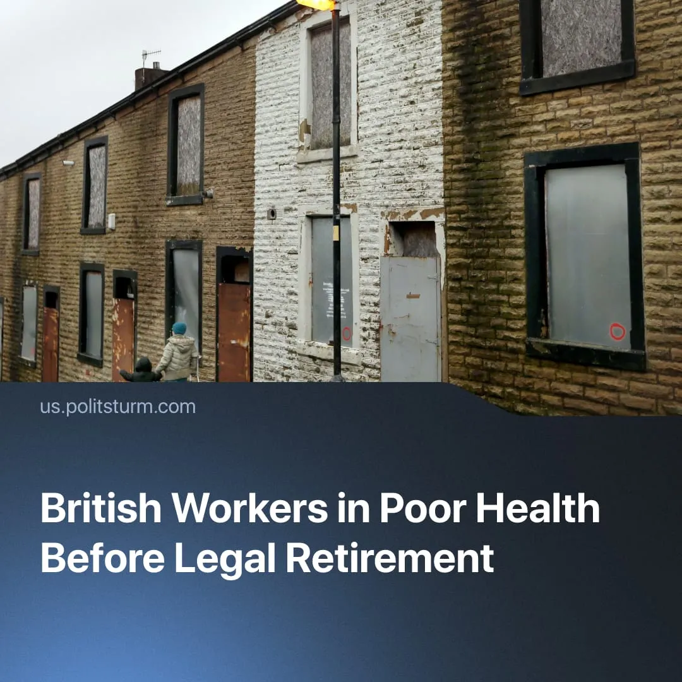

Original article
2026-05-06
1 min read

Poverty has caused a two-year fall in healthy life expectancy in the UK, with the wealthiest 10% living 20 more years in good health than the poorest.
Details. A recent study has found that poverty has caused a two-year decline in healthy life expectancy (HLE) in the UK over the past decade, with HLE falling below 61 for both men and women. This has resulted in a gap in which the wealthiest 10% live 20 more years in good health than the poorest.
► Workers are being worn down before they can legally retire. In 90% of areas, the average HLE falls below the state pension age; in more than 10% of places, it has fallen below 55 years.
Context. The UK remains in a cost-of-living crisis, with 7.1 million households going without essentials. Household energy bills and food prices have outpaced wage growth, forcing many in the working class into a “heat or eat” dilemma. Combined with long-term underinvestment in public health services, these factors have accelerated the deterioration of working-class health.
► By contrast, the Soviet Union, with a planned economy that eliminated the profit motive, guaranteed workers housing, employment, healthcare, and pensions as constitutional rights 90 years ago, with the aim of ensuring steady growth in living standards.

Original article

