British Scientists Claim ChatGPT is “Left-Wing Biased”
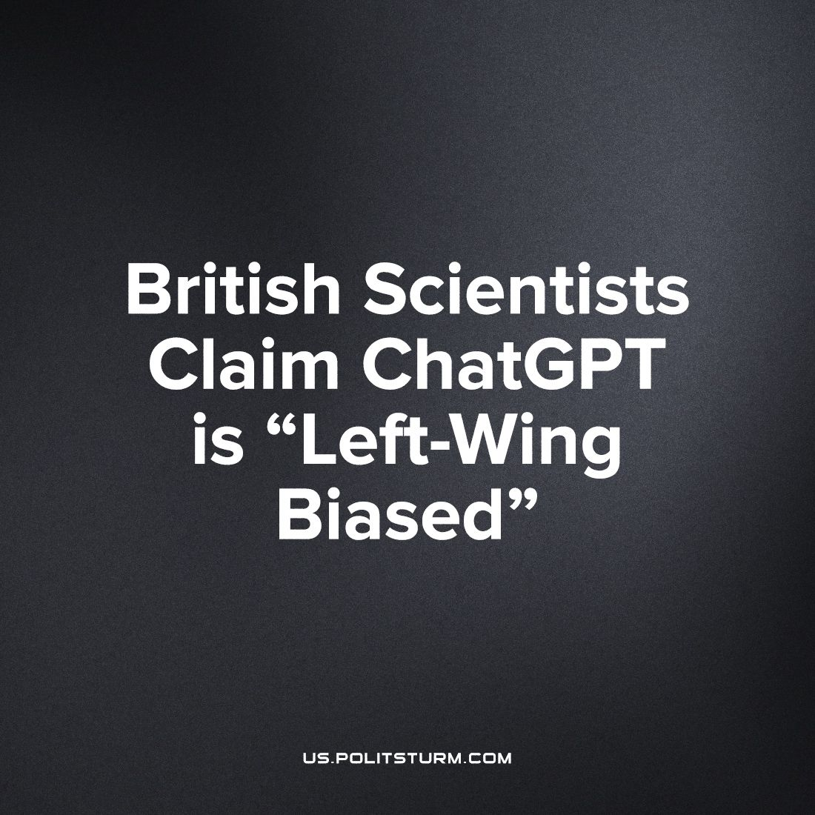

Original article
2023-10-17
1 min read

Scientists from the University of East Anglia conducted a study aimed at finding out whether generative AI models of the latest generation, including the sensational ChatGPT demonstrate political bias, or if they are impartial in their responses.
First, the AI was asked to pretend to be various persons inclined to certain political views, and for each character was asked 60 questions. Then the survey was conducted with the default algorithm, without being asked to display political beliefs. During the second survey, it turned out that the AI responses were closer to those expressed on behalf of the left.
To improve the accuracy of the results, each question was repeated 100 times. Further, the received answers were subjected to 1000-fold processing by an algorithm that sorted through a single data set to create a set of simulated samples.
Project manager Fabio Motoki stated that AI bias can influence users' political views and have potential consequences in political and electoral processes.
It is amazing to see how a bourgeois professor, trained to defend capitalism, worries about the "bias" of AI, because the data on which various AI systems are trained are selected from human society and human relations.
The reason for the left-wing responses is quite clear. The AI model is reflective of a society torn apart by class contradictions.
The gap between technological progress and social progress brings instability to both the economy and public sentiment. The ruling class seeks to put any new technology at its service and fence it off from society with legal and economic barriers, because in a market economy, science is subordinated to the interests of profit.
Source: Overclockers - "Scientists have found out that AI is More Communism than Capitalism" from August 18, 2023.

Original article

