On The Reaction of the British Establishment to the Palestine Conflict
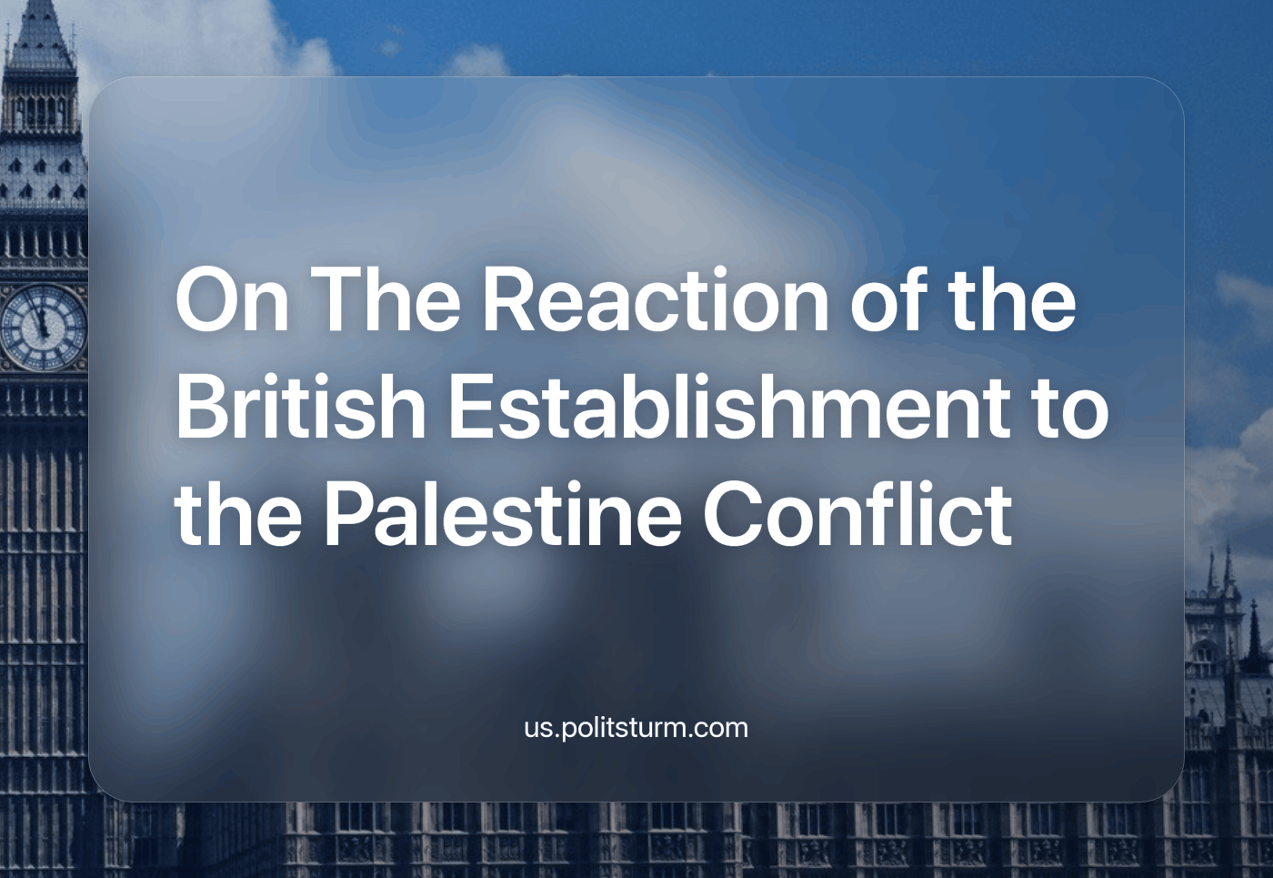

Original article
2023-11-17
21 min read

The ongoing Palestine conflict has been a focal point in global politics, drawing attention to the stance of various political figures and parties within the British establishment. In this article, we delve into the reactions of both the “Conservative” and “Labour” wings of the British ruling class, exploring their ties with pro-Israel lobby groups and dissecting their public statements and actions.

The Conservatives reaction
After the events of October 7th, the current Prime Minister Rishi Sunak of the ruling Conservative Party expressed support for the Israeli government [1] and its declared intention to launch a ground invasion of the Gaza Strip. His recent visit to Tel Aviv solidifies the UK's support of Israel. Sunak's explicit endorsement of Israel's efforts to "win" and standing by the country in its "darkest hour" underscores the alignment of British imperialist posturing [2].
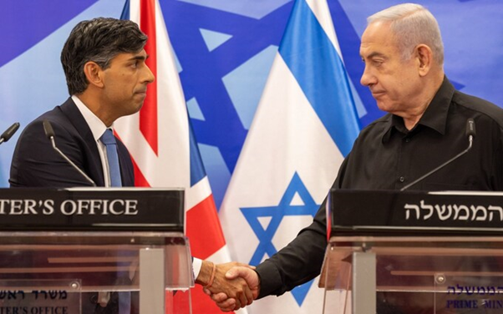
PM Sunak during his recent visit to Israel
In addition, he said: “We also recognise that the Palestinian people are victims of Hamas too. And that is why I welcome your [i.e., Netanyahu’s] decision yesterday that you took to ensure that routes into Gaza will be opened for humanitarian aid to enter” while remaining silent about the refugee camps in these “humanitarian” corridors that Israel is bombing [3][4]. As the so-called “Israeli Defence Force’s” vicious carpet-bombing campaign and ground invasion kill orders of magnitude more civilians and innocent children than Hamas’s terrorist raid, the Conservative government remains steadfast in their support of the Israeli government.
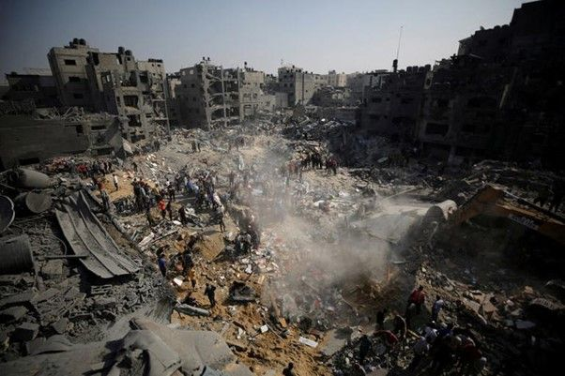
Refugee camp destroyed by Israeli bombing
The financial entanglements between the Conservative Party and pro-Israel lobby groups, particularly the Henry Jackson Society (HJS) and Conservative Friends of Israel (CFI), offer a glimpse into the real influences shaping Conservative policy towards Israel and the ongoing conflict in the region.
The HJS is a liberal “think tank” that received £83,452.32 over 2015-2017 from the UK Home Office ostensibly for a report on UK connections to Islamist terrorism, which was never produced. It has reported a total income of £1.4million, mostly in donations, but it has never disclosed its funders yet lawfully claims “charity” status. In turn, the HJS has donated over £12,000 to mainly Conservative MPs since 2013. It, legally as a “charity”, has also provided benefits totalling £10,798 to eight Conservative MPs since 2013. This includes £2,500 to Conservative MP Priti Patel (the previous Home Secretary) to pay for a trip to Washington DC to act as a delegate for their interests at a forum organised by the US Israel lobby AIPAC (American Israel Public Affairs Committee).
The Conservative MP and current Minister for Intergovernmental Relations, Michael Gove, was formerly on the board of directors of HJS and has previously declared that “anti-Zionism is anti-Semitism” [5]. In 2016, Gove received £2,764 from HJS to visit New York and receive an award at the anniversary of the Algemeiner Journal (a right-wing Zionist publication) [6].
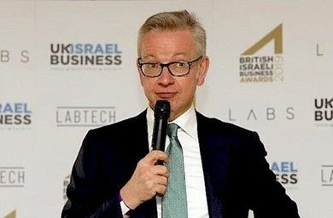
Minister Gove in Israel
The Conservative Friends of Israel (CFI) is a powerful Westminster lobby group of which 80% of all Conservative MPs are members. It has given funds to over a third of the Conservative government cabinet when Boris Johnson was PM [7]. Priti Patel is a former vice-chair of CFI who was sacked from the government in 2017 for off-radar meetings with Israeli politicians which were arranged by CFI’s honorary president, Lord Polak.
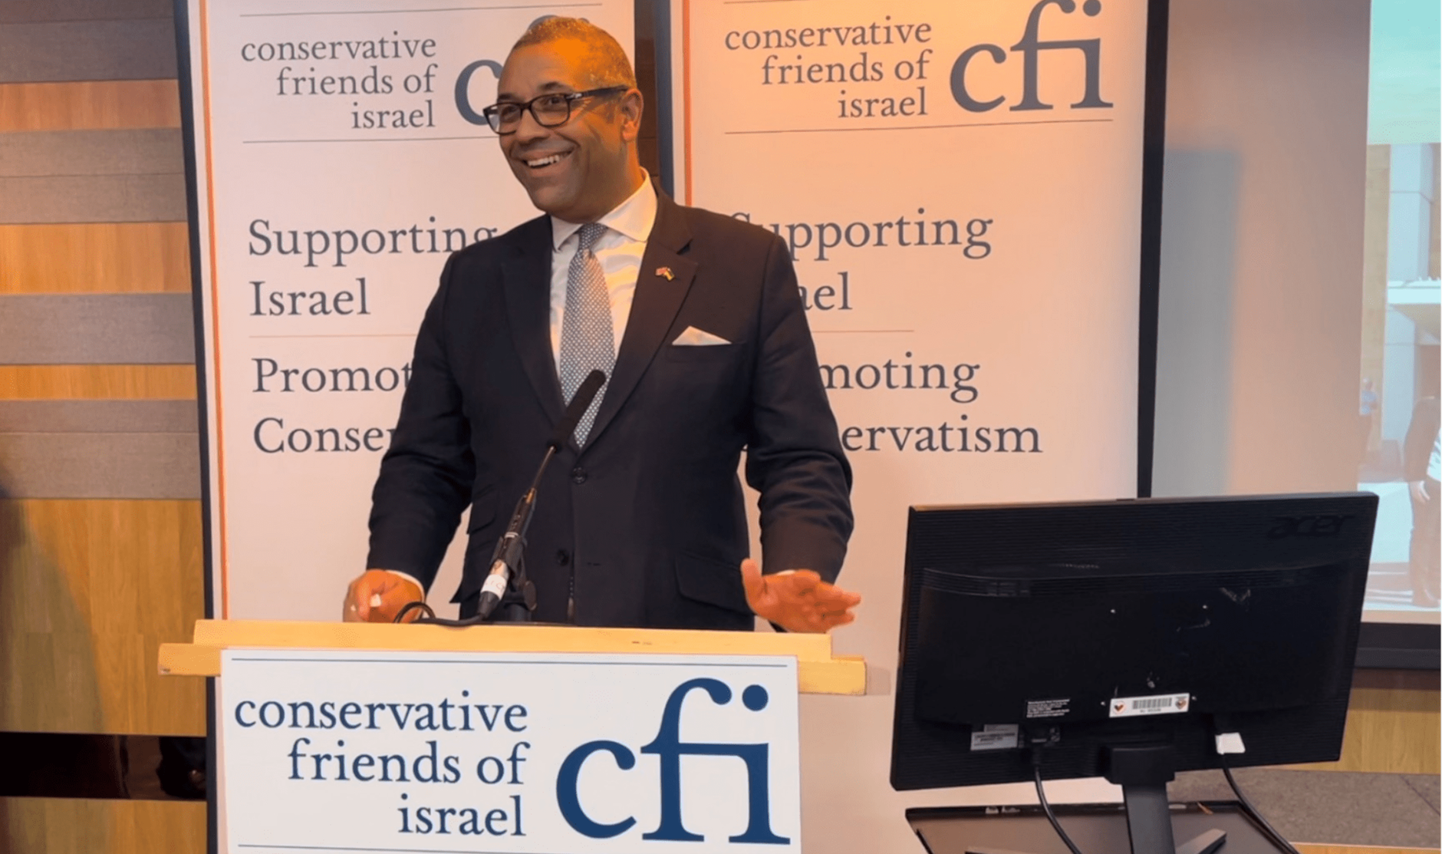
Foreign Secretary Cleverly speaking at a CFI event
The CFI has been revealed as the biggest donor of free overseas trips to MPs, with 155 free trips in the decade from 2012-22. For example, in 2015, just three months after their election as MPs, the CFI spent £4,000 sponsoring trips to Israel for James Cleverly and Suella Braverman. Both Cleverly and Braverman, early in their political careers at that time, expressed positive views about Israel following the trip, describing it as "amazing" and "highly informative".
Moreover, Cleverly, now as the Foreign Secretary, has been a vocal supporter of Israel’s collective punishment of Palestinians and war crimes, including blockading water, electricity and food from the Gaza Strip [8]. While Braverman attempted to criminalise the waving of Palestinian flags in the UK, as we have previously written about.
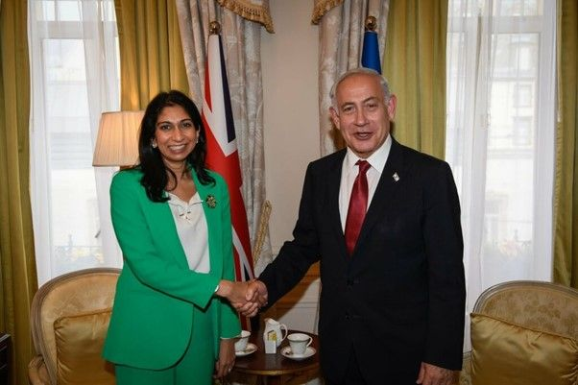
Braverman’s visit to Israel earlier this year as Home Secretary
Critically, the influence of these groups has shaped policy decisions, with instances of muted criticism of Israeli actions following complaints from the CFI. 25 years ago, historian and Conservative MP Robert Rhodes James described CFI as “the largest organisation in Western Europe dedicated to the cause of the people of Israel” [9].
British arms export licenses approved by the Conservative government to Israel covering various military components, including small arms, ammunition, night-vision technology, and intelligence, highlight the complicity of the UK in sustaining Israeli military dominance and occupation. The UK issued several of such licenses for arms sales to Israel totalling £400 million between 2016 and 2020, marking a significant increase compared to the £67 million worth of arms sales between 2011 and 2015 [10].
As we can see, the Conservative Party's financial ties with pro-Israel lobby groups, coupled with active support for Israel through arms trade, accentuate the imperialist influences shaping UK policies.

The Labour Party’s Reaction
Similarly, just like the Conservative Party, the Labour Party came out in favour of the Israeli government. This is unsurprising as the current leadership, under Sir Kier Starmer has spent the last few years conducting a smear campaign (in concert with the big media monopolies and the Conservative Party) against the previous leadership, under Jeremy Corbyn who is a critic of Israel. Just like Conservative MPs, they do this on the basis of conflating anti-Zionism with antisemitism.
Additionally, just the same as the Conservative Party, they are enmeshed in financial relations with Israeli lobbyists and special interest groups. Thirteen members (out of a total of 31) of Labour's current shadow cabinet, including prominent figures such as Keir Starmer, Angela Rayner, and David Lammy, have been revealed to have received substantial donations from the Labour Friends of Israel (LFI) and the pro-Israel lobbyist and multi-millionaire businessman Sir Trevor Chinn.
Chinn is a funder of LFI as well as a leader within groups like Britain Israel Communications and Research Centre (BICOM). This organisation is also funded by Poju Zabludowicz, a London billionaire whose father (whose fortune he has inherited) made millions manufacturing arms in Israel. Starmer has personally received a (undeclared at the time) donation of £50,000 from Chinn during his election campaign for leadership of the Labour Party. The total donations of Chinn to Starmer and his current shadow cabinet amount to £200,000.
LFI, established in 1957, aims to promote the interests of the State of Israel within the Labour Party, and notably, it does not disclose its funding sources. It has very close ties with the Israeli embassy which likely is a significant source of its financial backing. Since 2002, LFI has played a significant role in funding "fact-finding" trips to Israel for Labour MPs, contributing over £150,000 to such initiatives. Members of Keir Starmer's shadow cabinet have received more than £17,000 for participating in these trips. Starmer himself has described LFI as “an invaluable source of energy and ideas for me and my team”. Correspondingly, he has refused to criticise the extreme racial and national chauvinism in Israel, its treatment of Palestinians and denial of their right to national self-determination [11].
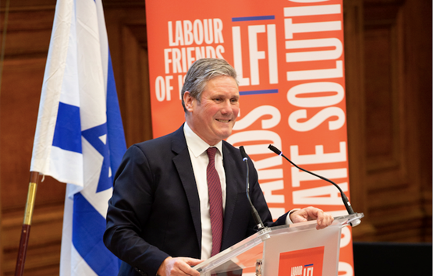
Starmer speaking at a LFI event
In a video that gained attention, Kier Starmer, who has a background as a "human rights" lawyer, speaking on LBC, asserted that Israel "has the right" to withhold water and electricity from Gaza [12]. This led to much of the British public bringing back his nickname “Sir Kid Starver”, which he duly earned earlier this year by refusing to say that the Labour Party would end the two-kid benefit cap (which contributes to the poverty of hundreds of thousands of children in the UK) should they be elected [13].
In addition, more recent statements by Keir Starmer against a potential ceasefire in Gaza have added fuel to the controversy. His rationale is that Hamas has not yet been destroyed and could still launch another attack similar to October 7th [14]. This is clearly nonsense, considering the fact that Israeli intelligence ignored reported signs of the attack well before it happened [15], likely in order to use the raid as a pretext for what they are doing now.
However, even if this was not the case, the “IDF” is inflicting orders of magnitude more civilian casualties on Gaza than Hamas did to Israel. Since October 7th, Hamas killed around 30 Israeli children [16], while Israel has killed at least 3,000 Palestinian children so far and this figure is continuing to rise at a staggering rate. Why does Starmer not also think Hamas also should have the right to indiscriminately carpet bomb Israel until the “IDF’s” capabilities to attack Palestine are destroyed? Or is it that the life of one Israeli child is worth more than the life of 100 Palestinian children? In addition, 41 children have been killed in the West Bank (where there is no Hamas) since October 7th [17]. Why is Starmer not advocating for the Palestinian Authority’s right to “defend itself” by similarly committing acts of terror against Tel Aviv?
Starmer and the Labour Party leadership have uncritical support for Israel, and they refuse to condemn even the most egregious and overt Israeli war crimes. Like for example the withholding of food, water, and electricity, [18] the intentional and frequent targeting of civilians and civilian infrastructure (like the refugee camps mentioned earlier), the use of white phosphorous munitions [19], all coupled with genocidal rhetoric from the Israeli government [20]. They would have no trouble condemning Russia for all these things in Ukraine. This hypocritical dichotomy demonstrates just how deep and embedded Israeli interests are within the Labour Party.

The British Public’s Reaction
In contrast to the two main parties, the British public is overwhelmingly supportive of an immediate ceasefire according to a YouGov Poll [21], with 76% of respondents in favour of a ceasefire and 8% of respondents against a ceasefire. Unlike capitalist politicians, normal working people are not beholden to the interests of groups of businessmen and the lobbying efforts of foreign states. So, when faced with the harrowing scenes of destruction and devastation coming from the Gaza strip, there is no reason, other than bourgeois delusions, for them to not be instinctively upset.
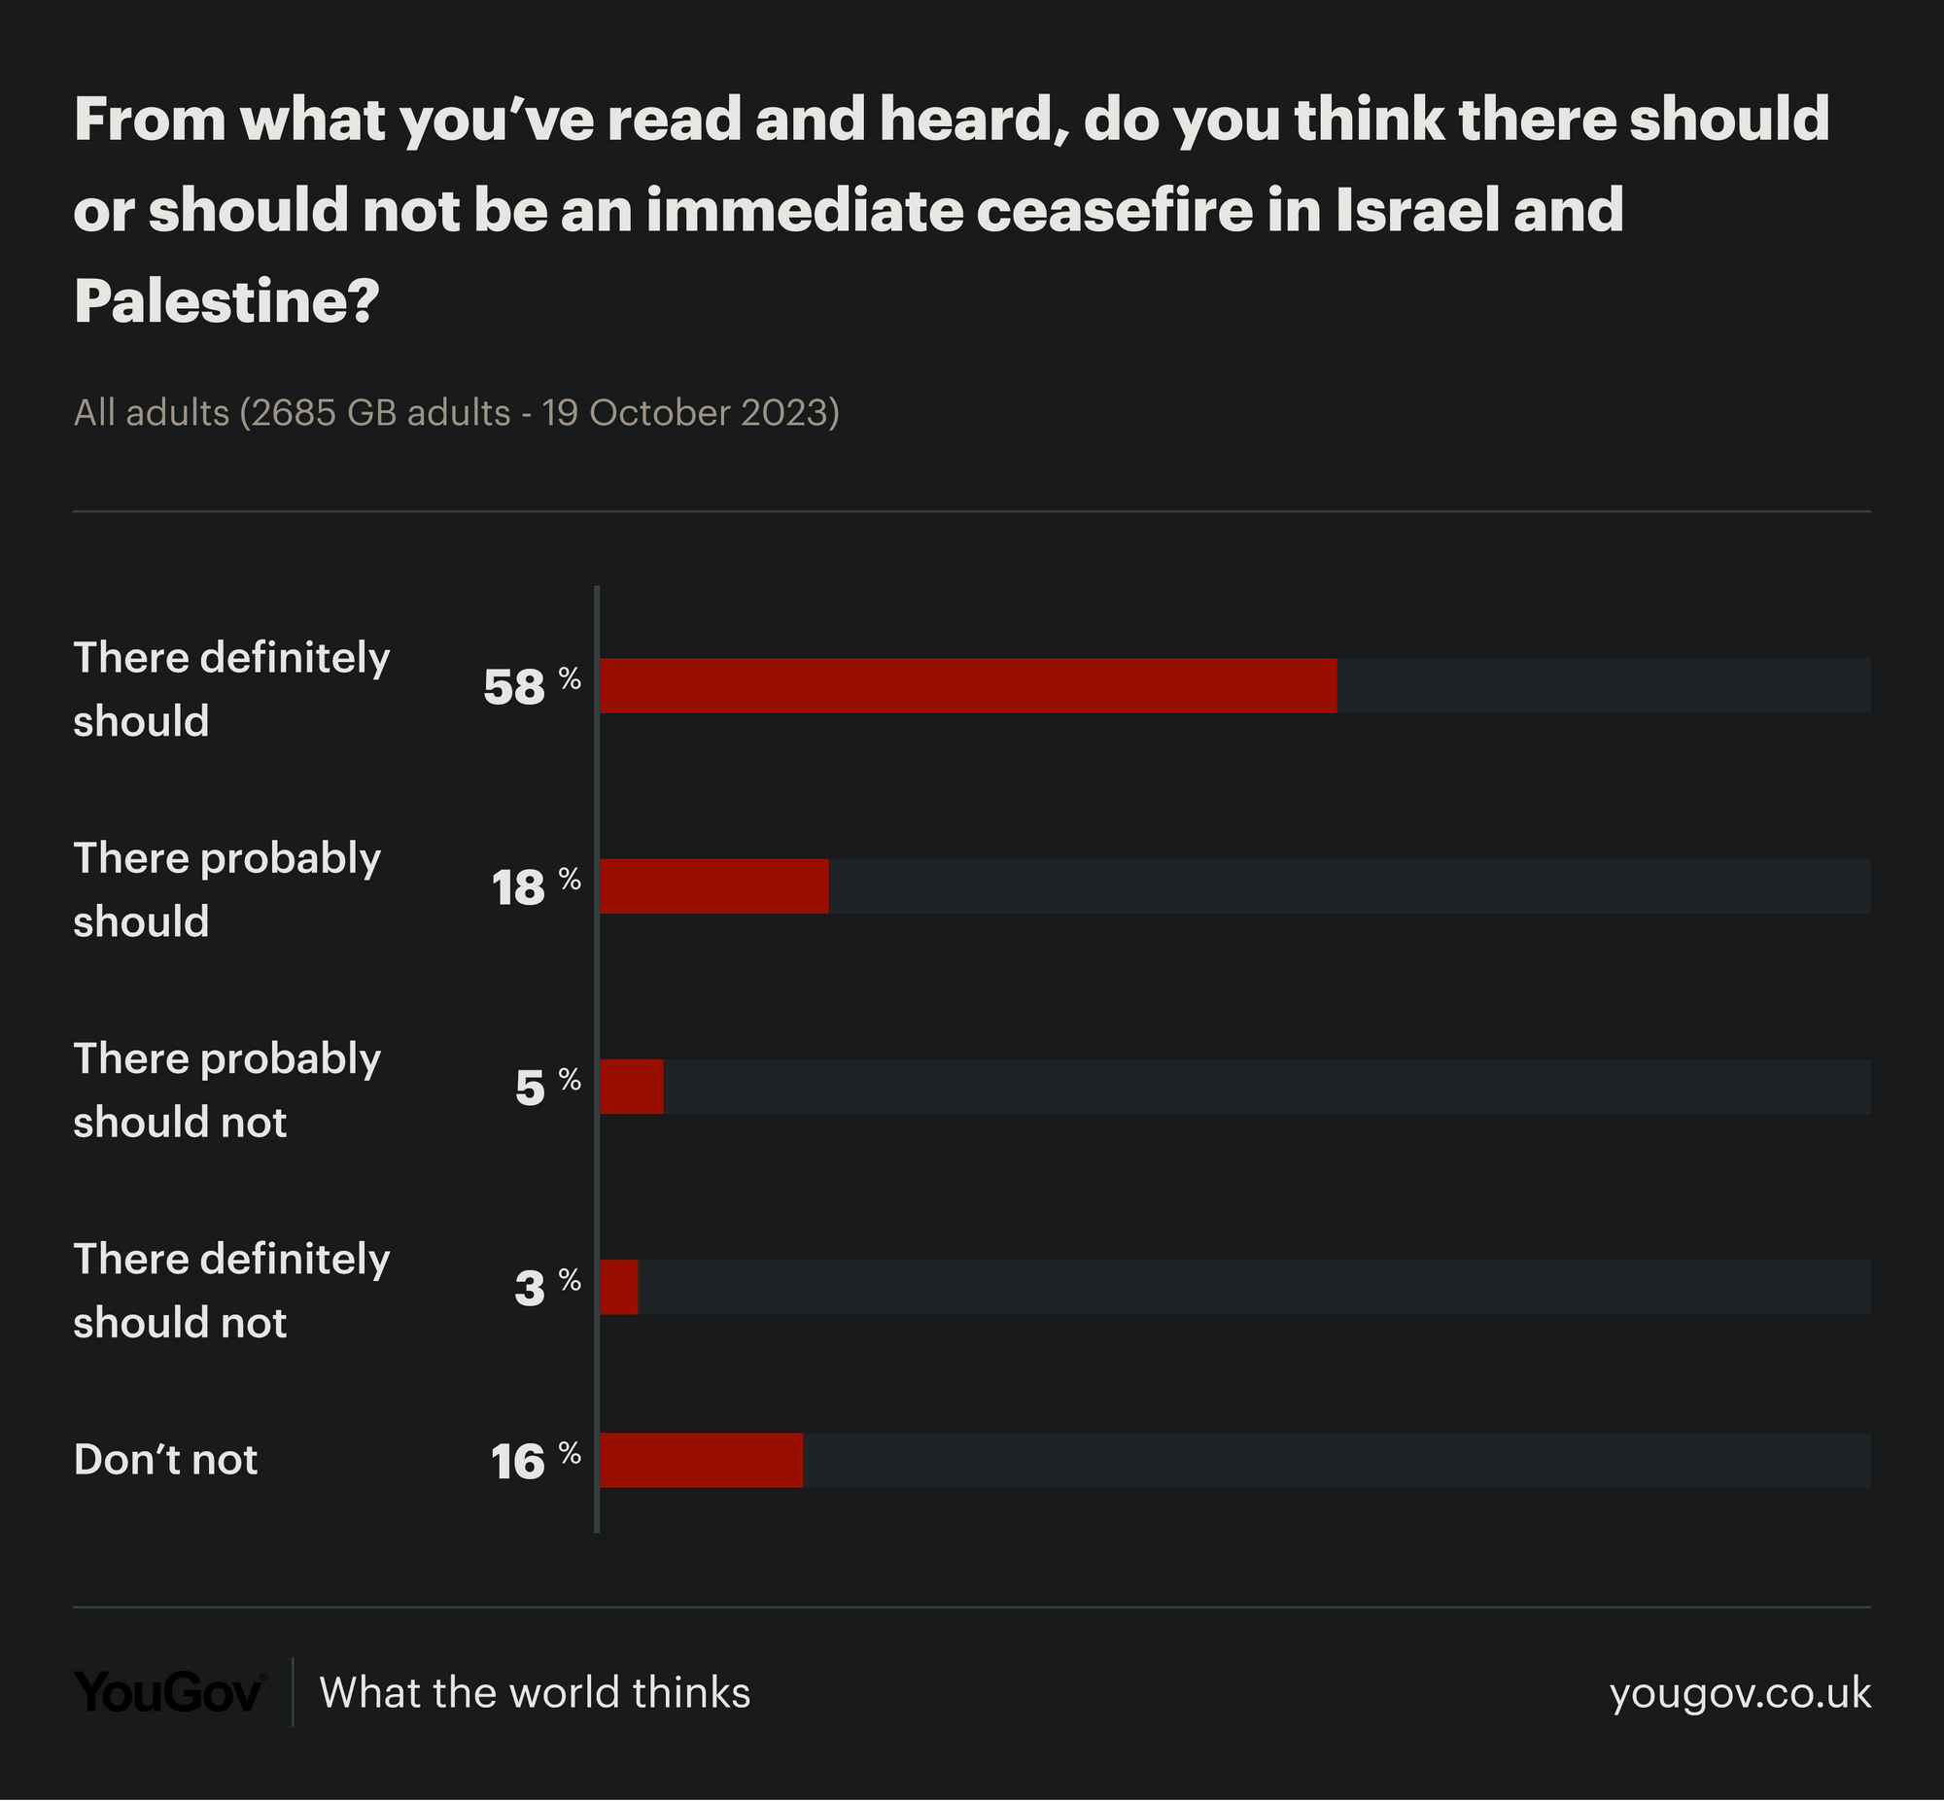
YouGov Poll Results
In addition, there have been widespread and large-scale protests and demonstrations calling for a ceasefire as the principal demand in cities all across the country. For example, on November 11th (Armistice Day) the protests in London were estimated to be 800,000 strong [22].
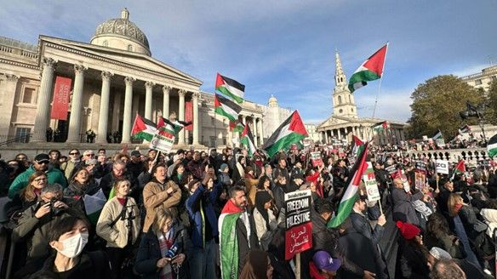
Pro-Palestine demonstration in Trafalgar Square in London.

Why Do They React This Way?
So overall, the policies of both the “Conservative” and “Labour” factions of the British ruling class are united in full-throated support for Israel. Meanwhile, the majority of people are generally in favour of a ceasefire and desire peace. This situation has arisen not just because of groups like the CFI and LFI and the rampant corruption between them and the government and various shadowy businessmen and lobbyists – these are simply the features, but the cause is the real economic interests that drive and underpin all of them.
We live in the era of imperialism, or monopoly capitalism, where a handful of corporations have grown incredibly massive and dominate the state and public life. And it is the interest of these monopolies that guide the actions of the state. They are compelled by the laws of capitalism to grow or perish and to divide and re-divide the world amongst themselves. They will do this through whichever means works best for them, be it national enslavement by debt and capital exports, market competition, economic blockade and sanctions or through war. And Israel generally acts in accordance with the interest of the Western bloc of countries, as part of this bloc itself.
What this means concretely is that clearing out the Gaza Strip will bring huge economic benefits and profit to Israel as well as its foreign backers cheering it on. There is a large natural gas field estimated to hold 1 trillion cubic feet of hydrocarbons within Gaza’s territorial waters that Israel has been unable to properly develop due to the ongoing dispute with the Palestinians in Gaza [23]. After Gaza is cleared, not only is there no obstacle to the development of this field, but also there is no need to share any of the wealth with the former residents. In addition, as usual with these wars, each relevant country’s military-industrial complex seeks to gain and profit from the production and sale of weapons as well as the speculation on their stock prices.
Similarly, in terms of benefits for Israel's foreign “partners”, there is the recent India-Middle East-Europe (IMEC) trade agreement, that Israel is an integral part of [24]. This new trade route will link India and Europe, bypassing China’s Belt and Road initiative. This, combined with the new gas fields that could help fulfil Europe’s energy needs without reliance on Russia, is a very attractive prospect for Western Powers, including Britain. Similarly, it also explains the Arab nations’ (many of which previously refused any and all diplomatic ties to Israel) current lukewarm responses to the conflict in Palestine, as they too will reap benefits from the IMEC.
Therefore, eliminating the instability in Israel caused by the brutal treatment of Palestinians and the threat of Islamist terrorism, by displacing the Palestinians from the Gaza Strip, would secure this route. Iran and Turkey’s comparatively more hostile reaction towards Israel can be explained by the fact that they will lose out on trade as China’s New Silk Road passes through them. China’s fairly muted reaction can be explained by the fact that they own and operate the Israeli port of Haifa [25] and they are also the majority shareholder in the Greek port of Piraeus [26], both of which are essential to this new route and consequently, the PRC stands to gain either way.
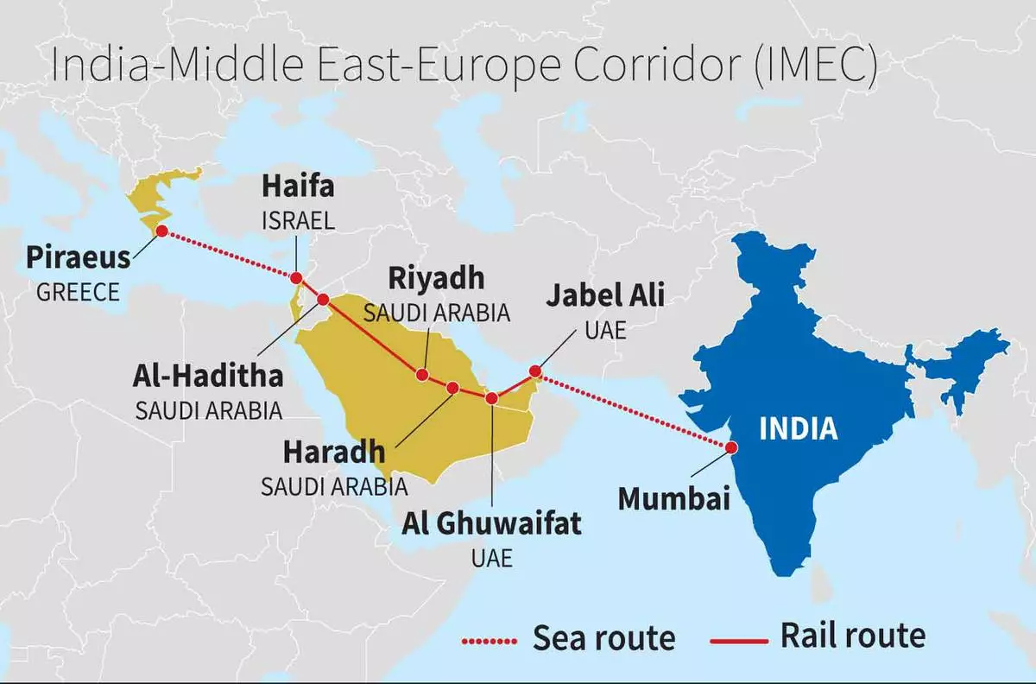
The planned IMEC trade route
The Israeli government as well as its Zionist accomplices in the British Conservative and Labour Parties will have you believe that criticism of Israel or anti-Zionism is antisemitic and supportive of terrorism. We have previously written about Israel using these accusations in response to widespread criticism around the world as an attempt to silence it. In fact, it is the opposite.
Zionism is antisemitism. Israel has declared itself “the nation-state of the Jewish people” in its constitution [27] and so it is currently committing, and has historically committed all these harrowing abuses against the Palestinians, therefore, in the name of the Jewish people. This is an insult to every single non-Zionist Jew worldwide – is it not an act of antisemitism of an enormous scale? As Marx said “what a misfortune it is for one nation to have subjugated another”, and as Lenin said, “Can a nation be free if it oppresses other nations? It cannot”.

The Way Out
Proletarian internationalism is the only way out; a joint struggle of Israeli and Palestinian workers, led by their respective communist parties. However, it is not possible to gain real internationalism by declaration, it must be built and earned.
First of all, is the task of forming genuinely communist parties in these countries, so that communists will be able to effect events in an organised and coherent way. The right of Palestinians to self-determination up to and including their right to form a separate state must be a crucial demand of the Israeli communist party, and national and ethnic chauvinism cannot be tolerated to the slightest degree in order for them to earn the trust of the Palestinian workers, to wage a joint struggle against their real oppressors – the capitalists.
Now that every country is capitalist and has a home market, the national bourgeoisie has no more historically progressive tasks and can only seek to bring about monstrous reaction. Hamas is an obvious manifestation of this, however, even the secular Palestinian resistance like Fatah has thrown away their attempts at true social revolution since the fall of the USSR. They are led by capitalists who enrich themselves at the expense of their suffering people, collaborate with the Israeli government on issues of “national security” and are beholden to and dependent on other foreign interests. The only true path to national liberation now is socialism.
Similarly, in Great Britain and other Western countries, spontaneous protests with social-pacifist demands are not enough. The demonstrations in Britain in 2003 against the Iraq War, are considered to be the largest in British history. Around 1-2 million people protested in London [28], however, the war still went ahead. This is because war is an inevitability under capitalism – especially in its imperialist phase.
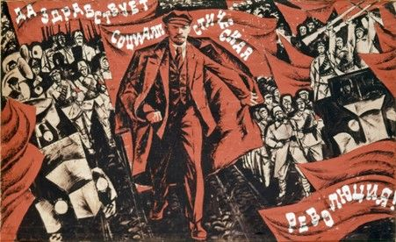
“Should this be taken to mean that socialists can remain indifferent to the peace demand that is coming from ever greater masses of the people? By no means. The slogans of the workers’ class-conscious vanguard are one thing, while the spontaneous demands of the masses are something quite different. The yearning for peace is one of the most important symptoms revealing the beginnings of disappointment in the bourgeois lie about a war of “liberation”, the “defence of the fatherland”, and similar falsehoods that the class of capitalists beguiles the mob with. This symptom should attract the closest attention from socialists. All efforts must be bent towards utilising the masses’ desire for peace. But how is it to be utilised? To recognise the peace slogan and repeat it would mean encouraging “pompous airs of impotent [and frequently what is worse: hypocritical] phrase-mongers”; it would mean deceiving the people with illusion that the existing governments, the present-day master classes, are capable-without being “taught” a lesson (or rather without being eliminated) by a series of revolutions-of granting a peace in any way satisfactory to democracy and the working class. Nothing is more harmful than such deception. Nothing throws more dust in the eyes of the workers, nothing imbues them with a more deceptive idea about the absence of deep contradictions between capitalism and socialism, nothing embellishes capitalist slavery more than this deception does. No, we must make use of the desire for peace so as to explain to the masses that the benefits they expect from peace cannot be obtained without a series of revolutions.
An end to wars, peace among the nations, the cessation of pillaging and violence-such is our ideal, but only bourgeois sophists can seduce the masses with this ideal, if the latter is divorced from a direct and immediate call for revolutionary action. The ground for such propaganda is prepared; to practice that propaganda, one need only break with the opportunists, those allies of the bourgeoisie, who are hampering revolutionary work both directly (even to the extent of passing information to the authorities) and indirectly.
The slogan of self-determination of nations should also be advanced in connection with the imperialist era of capitalism. We do not stand for the status quo, or for the philistine Utopia of standing aside in great wars. We stand for a revolutionary struggle against imperialism, i.e., capitalism. Imperialism consists in a striving of nations that oppress a number of other nations to extend and increase that oppression and to repartition the colonies. That is why the question of self-determination of nations today hinges on the conduct of socialists of the oppressor nations. A socialist of any of the oppressor nations (Britain. France, Germany, Japan, Russia, the United States of America, etc.) who does not recognise and does not struggle for the right of oppressed nations to self-determination (i.e., the right to secession) is in reality a chauvinist, not a socialist.” – Lenin, The Question of Peace
The task of communists is to outline a real path to a permanent peace – a world without antagonistic class divisions. As well as organising the working class of each nation into a force capable of first fighting against the immediate interests of the capitalists; able to enact powerful political strikes to disrupt their machinations and arms shipments. And as the workers grow in strength, they must fight for a system against the long-term interests of the capitalists, a system that no longer requires war – a communist system. Capital, swollen to grotesque dimensions, now veils the entire globe, standing steadfast in its united front against the international working class. The business tycoons and financial magnates who sow discord between nations frequently share ownership stakes in the very same multinational corporations that they operate together. To counter the worldwide alliance of capitalists, a chorus of international workers must rise in solidarity. We are involved in this work and call upon all class-conscious workers and communists to join us.
Sources:
[1] https://www.bbc.co.uk/news/uk-politics-67151404
[2] https://www.telegraph.co.uk/world-news/2023/10/19/rishi-sunak-britain-israel-to-win-war-netanyahu-hamas-gaza/
[3] https://www.aljazeera.com/gallery/2023/11/6/palestinians-run-for-their-lives-as-israeli-strike-hits-al-maghazi-camp
[4] https://www.aljazeera.com/news/2023/11/1/israels-deadly-attack-on-the-jabalia-refugee-camp-what-we-know-so-far
[5] https://www.jewishnews.co.uk/michael-gove-at-tory-conference-anti-zionism-is-anti-semitism/
[6] https://www.declassifieduk.org/revealed-uk-home-office-paid-80000-to-a-lobby-group-which-has-funded-conservative-mps/
[7] https://www.declassifieduk.org/revealed-third-of-british-cabinet-including-boris-johnson-has-been-funded-by-israel-or-pro-israel-lobby-groups/
[8] https://www.declassifieduk.org/pro-israel-lobby-group-paid-for-uk-foreign-and-home-secretaries-first-trips-as-mps/
[9] https://www.telegraph.co.uk/news/worldnews/middleeast/israel/9740044/The-cowardice-at-the-heart-of-our-relationship-with-Israel.html
[10] https://www.theguardian.com/commentisfree/2021/jun/13/british-backing-israel-unbearable-status-quo-palestinians
[11] https://www.declassifieduk.org/two-fifths-of-keir-starmers-cabinet-have-been-funded-by-pro-israel-lobbyists/
[12] https://www.youtube.com/watch?v=5HQYfsUAf3s
[13] https://skwawkbox.org/2023/07/17/sir-kid-starver-trends-in-uk-the-new-milk-snatcher-moment/
[14] https://skwawkbox.org/2023/10/31/starmer-stopping-killing-in-gaza-might-lead-to-more-violence-but-keeping-bombing-brings-peace/
[15] https://www.timesofisrael.com/surveillance-soldiers-warned-of-hamas-activity-on-gaza-border-for-months-before-oct-7/
[16] https://theconversation.com/in-the-israel-hamas-war-children-are-the-ultimate-pawns-and-ultimate-victims-216411
[17] https://www.savethechildren.org.uk/news/media-centre/press-releases/at-least-41-children-killed-in-west-bank-as-violence-spikes
[18] https://www.aljazeera.com/news/2023/11/7/one-month-of-no-water-food-and-healthcare-for-gaza
[19] https://english.elpais.com/international/2023-11-01/amnesty-international-accuses-israel-of-using-white-phosphorus-against-civilians-on-the-lebanon-border.html
[20] https://english.alarabiya.net/News/middle-east/2023/10/26/Former-Israeli-ambassador-to-UN-calls-Palestinians-horrible-inhuman-animals
[21] https://yougov.co.uk/topics/travel/survey-results/daily/2023/10/19/e363e/1
[22] https://www.theguardian.com/world/live/2023/nov/11/pro-palestine-march-london-israel-hamas-war-gaza-armistice-day?filterKeyEvents=false&page=with:block-654fb15e8f08f02e9fecafd0#block-654fb15e8f08f02e9fecafd0
[23] https://www.reuters.com/business/energy/israel-gives-nod-gaza-marine-gas-development-wants-security-assurances-2023-06-18/
[24] https://www.financialexpress.com/business/defence-world-leaders-launch-india-middle-east-europe-economic-corridor-seen-as-counter-to-chinas-bri-3238862/
[25] https://www.reuters.com/world/middle-east/israel-opens-chinese-operated-port-haifa-boost-regional-trade-links-2021-09-02/
[26] https://www.dw.com/en/greece-in-the-port-of-piraeus-china-is-the-boss/a-63581221
[27] https://he.wikisource.org/wiki/%D7%97%D7%95%D7%A7-%D7%99%D7%A1%D7%95%D7%93:_%D7%99%D7%A9%D7%A8%D7%90%D7%9C_%E2%80%93_%D7%9E%D7%93%D7%99%D7%A0%D7%AA_%D7%94%D7%9C%D7%90%D7%95%D7%9D_%D7%A9%D7%9C_%D7%94%D7%A2%D7%9D_%D7%94%D7%99%D7%94%D7%95%D7%93%D7%99
[28] http://news.bbc.co.uk/1/hi/uk_politics/2762027.stm

Original article

