British Capitalist Buys Stairwell in London to Help Start-Ups
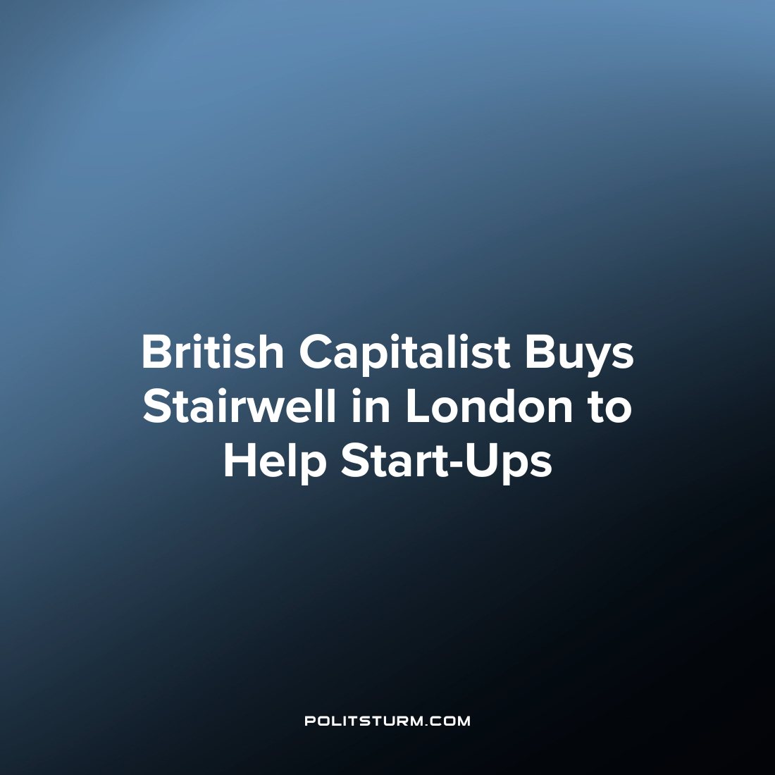

Original article
2023-08-09
2 min read

London capitalist, Simon Squibb, has purchased a disused stairwell for £25,000 in Twickenham, London to help new small businesses survive and thrive. He plans to turn it into a pop-up shop, office or “live-work space” for entrepreneurs that have started new businesses to use for one month at a time rent-free if he can get planning permission for the construction works required. If not, he plans to use it as a “networking space” for entrepreneurs and for somewhere for them to seek his investment, or at the very least an office for the company he owns and runs, which is a social media website for entrepreneurs. He already owns a £2 million mansion which is also used as a space for entrepreneurs to meet and receive advice.

The stairwell in Twickenham
Despite the rapidly decreasing position of the petty bourgeois as a class, they are important for capitalist ideology and as such are promoted, propped up with plentiful loans and given generous tax breaks (especially so in countries high on the imperialist pyramid). They represent the aspirations of social mobility under the current system – the capitalist mythology that anyone can become rich if they work hard or smart enough, most well known in the US as the “American Dream”. In place of rapidly declining “welfare state” policies designed to give a popular basis to capitalism, the capitalists of Britain promote entrepreneurial schemes to perform the same function.
Of course, despite this, 20% of new British businesses fail in their first year, and over 70% are bankrupt within their first decade, with their property and equipment liquidated and placed into the hands of the big banks. The number of small businesses in the UK shrank by 6.6% (from 5.9 million to 5.5 million) over the last 3 years, while the biggest capitalists who own the largest monopolies get richer and richer. Marxism-Leninism teaches us that the proletarianization of the Petit-bourgeoisie as a class is part of the laws of motion of capitalist development, where capital inevitably centralises in fewer and fewer hands. In addition, even if success was guaranteed, not everyone can become entrepreneurs and “be your own boss” or “chase your dream” as the system requires a class of people that own nothing but their own labouring power to be exploited by the people who own the means of production.
And so, unlike “welfare” policies which actually improved the lives of workers in the imperialist countries (paid for via super-profits extracted from dependent countries), these schemes are just that – schemes. Designed to get people to enthusiastically participate in capitalism by investing their savings on a gamble that is very likely to fail. And this particular scheme where aspiring Petit-bourgeoisie are encouraged to live and work on a literal stairwell in their forlorn rat race for wealth is indicative of the sorry state of British capitalism.
Sources: 1 2

Original article

