British Army Deployed for Strike-Breaking
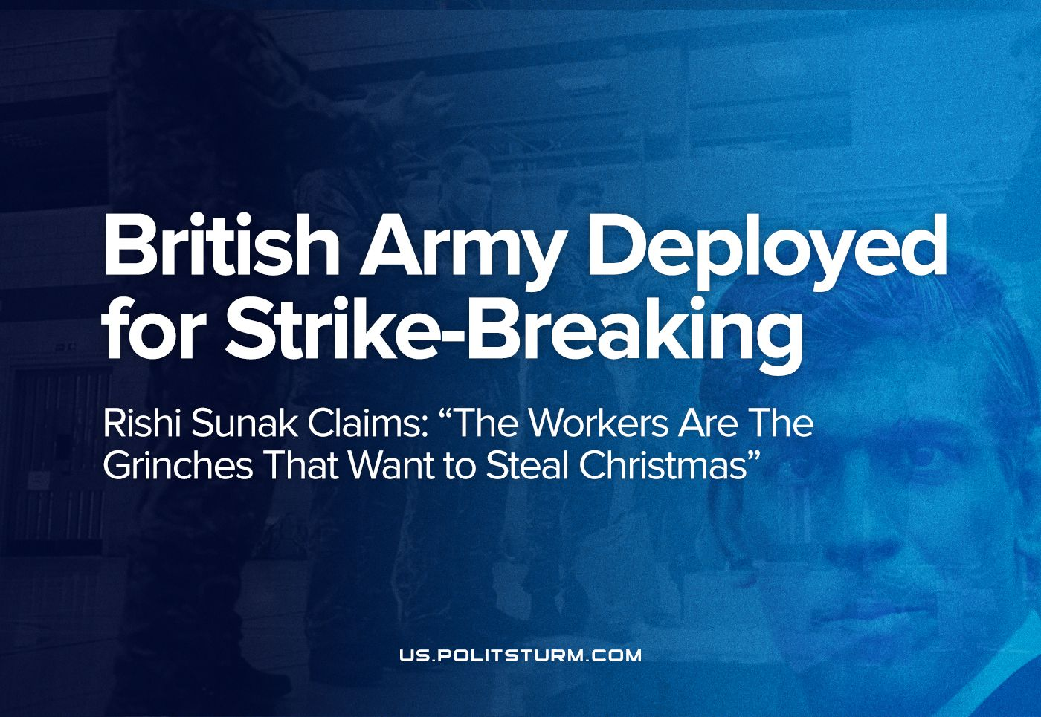

Original article
2022-12-21
5 min read

A terrific wave of strike ballot activity has swept over British industries from the health service, railways, road maintenance, the Royal Mail, baggage handlers, driving instructors to the border force and likely more in the next year. The Cabinet Office, in a series of emergency meetings, has ordered British Army personnel to begin training to replace ambulance workers who are striking from Dec 21st-28th, despite union guarantees of the required emergency coverage, as well as custom agents during the Border Force strike (12.23.2022-01.31.2023), and even in fire-fighting for another possible strike at the start of next year.
The government revealed on Sunday that at least 1,200 troops are being deployed for these purposes – double the previously-announced number.
Today, an ambulance strike began in England and Wales for which 170 military personnel have been training in London to scab. However, this training reportedly lasted only two days. This crash-course leaves them incapable of replacing experienced first responders for treating the worst of London’s accidents. Sunak’s gamble to use soldiers to undermine the negotiating position of the hundreds of thousands of union workers will lead to deaths.
Error loading image
It is the Sunak government which keeps ambulance drivers off the streets. Many recite the propaganda that deployment is intended to reduce the inevitable impact of the strikes.
But what demands could call for such extreme emergency action?
All striking workers are trying to win themselves a pay increase on-par with or above the rate of inflation, and in most cases are also fighting to secure public funding for, and ensure the integrity of, the otherwise crumbling public service for which they work.
These workers were lauded as “essential” and “heroic” during the pandemic and now they are defamed in the media as “selfish” and “uncaring” for mobilizing against the wholesale collapse in British living standards. But in actuality, it is only the workers who care about the industry that they work for, not the capitalists who are solely concerned with the extraction of ever yet greater profits.
For example, one of the railway workers’ demands is that the government scrap their plan to replace preventative railway maintenance with “risk-based” maintenance which is a big risk to passenger safety. Similarly, the health service workers hope to reverse the deterioration of the NHS by demanding greater funding.
The government’s refusal to accept an at or above inflation pay rise, and the usage of the army as strike-breakers are stances indicative of their dedication to the class which they serve: the capitalists. A dedication to keep the workers’ share of the wealth that they create as low as possible, keeping profit as high as possible even in public industries. In response, most unions have promised additional strike action should the government fail to respond adequately.
Continuing its infamous history, the opposition “Labour” Party once again is betraying the class they claim to fight for: the proletariat. Its leader, Keir Starmer, is parroting the government lie that an above-inflation pay increase is unaffordable. He dearly hopes to advertise himself as even more loyal to the British ruling class than the Tories!
In Scotland, the SNP is discussing deployment of their own military scabs in the event of a potentially huge strike by the 330,000-member Fire Brigade Union currently being balloted. Such a measure is not unprecedented in this current climate. In September, 114 were deployed by the SNP for two months to bolster the deficient Scottish Ambulance Services.
Error loading image
The position of the ambulance services is a case study in the ongoing crisis of the capitalist states’ ability to fulfill its promise of basic services. It has long been understood that the groundwork is being laid for the eventual total privatisation of the NHS. Austerity measures implemented a decade ago have brought the healthcare system to its knees, fostering dissatisfaction and consent for open privatisation: such a tactic was used by the Thatcherites before. Ambulance services are increasingly unreliable: a lack of hospital beds and ambulance crews has led to 24-hour waits for emergency medical transportation to arrive, and then left to wait in the hospital car park before being admitted.
This inevitably will open up the option of private companies being used to ‘fill the gaps’ caused by the bourgeois government as a ‘temporary measure’. Slowly but surely, the role of private capital will expand, and the use of soldiers today drives a wedge into the position of NHS staff, laying out the battle plan from which their jobs can outsourced to those with few qualifications, and the future attacks in the class war can be launched.
The use of the armed forces to break the strikes may well expand in the coming months as industrial disputes continue to grow. As such, British imperialism will increasingly resort to the use of soldiers to break strikes but this is a double-edged sword as their forces have shrank and are already unable to fulfill the global ambitions its masters once had a century ago. Put simply, the more strikes there are here, the more soldiers there are here and aren't deployed abroad. No doubt this will become a political issue: the Labour Party already reveals its role as an imperialist stooge by its fanatic support for the armed forces and accusations that the Conservatives are not doing enough to ensure that the armed forces can accomplish their mission to protect the power of the monopolists.
Soldiers have been ordered to fill-in for civilian matters 85 times this year, and gain no great benefit from their scab duties (not even the usual higher scab-pay). A lower salary than most of the striking workers, as well as having taken a pay rise below inflation (therefore, a pay-cut, in real terms). The use of the army as strike-breakers is not unprecedented in the case of strikes by emergency service workers, however it is more unusual for them to be used to replace a striking Border Force. From examples like policing under Operation Tenderer, and the 1990 Ambulance strike, this card has played many times over the past 40 years.
Starting November 21st, other military personnel have been given at least five days of training to fill Border Force positions at various ports and airports in Britain. On Dec. 9th, the Ministry of Defense confirmed major airports like Heathrow, Gatwick and Cardiff have confirmed the presence of British troops training to check passports, process refugees, and migrants crossing the Channel; security and customs to replace the strike timed over the busy holiday season.
In addition to calling on the army to act as strike-breakers, the government has proposed a whole host of new anti-union laws, making Britain’s trade union laws, which are already amongst the worst in Western Europe, even more draconian. These new proposed laws include a ban on emergency service strikes, a minimum service limit, raising the threshold for a successful strike ballot, and increasing the minimum notice time given to employers. The capitalists are determined to crush any attempt at working-class organising as they know that it is a direct threat to the rule of capital.
This government acts in desperation to outlast the striking workers and must attack their broader public support. Should the workers’ prevail this winter against the mounting forces, their victory will only be temporary. They must realize that they do not need the capitalists to run things, when in fact these parasites bring the public to crisis and ruin. All efforts by the state to preserve itself from the decisive strikes of the workers must be revealed for what it is, and so unleash the power of the masses to counter the 'emergency' powers of self-preservation.
Sources: 1, 2, 3, 4

Original article

