Britain Faces Highest Tax Increase in Over Seven Decades
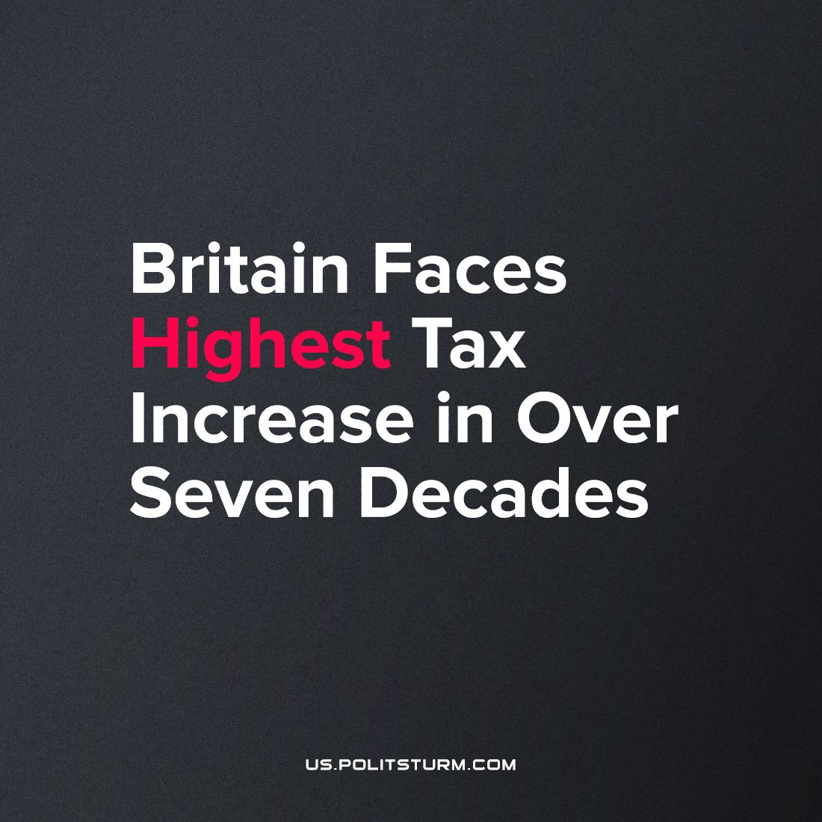

Original article
2023-10-01
2 min read

In the United Kingdom, tax levels are being raised to their highest level in over 70 years, on track to composing 37% of the state’s income – a £100 billion increase by 2024 according to the IFS think tank. This move includes a 1.25 percentage point increase in National Insurance contributions, projected to generate an extra £36 billion over a span of three years.
Ostensibly, this surge is framed as a response to the strains placed on the healthcare system and welfare state due to the recession and fallout from the pandemic. However, in reality, this financial augmentation is primarily an attempt to compensate for Britain’s diminishing super-profits within the global imperialist hierarchy.
The implications of this tax hike highlight the systemic contradictions embedded within capitalism. The burden of this tax increase is disproportionally shouldered by working people (who are already struggling to make ends meet under the current cost-of-living crisis), accentuating in greater detail, the socioeconomic divide between the working class and the capitalists. Food bank usage and starvation, homelessness and deprivation are all on the rise in the UK.
This situation underscores a fundamental characteristic of the capitalist state – it primarily serves the interests of the ruling capitalist class. It prioritises profit accumulation over the welfare of the masses, as it is either owned controlled and run directly by capitalists themselves, or indirectly through representatives who are inevitably bought off by the capitalists. The change in the composition of taxation as a percentage of total government income is projected to be nearly 5%, which is higher than even under Clement Atlee’s ‘Labour’ (i.e. social-democratic) government during the period of the rise of Britain’s welfare state, where the proportion was raised by nearly 4%. Back then these policies were possible due to the wealth extracted from Britain’s abundant colonies, and the relative strength of British imperialism on the world stage.
They were desirable for the capitalists to implement to placate a working-class that had been trained to use arms en-masse and just assisted in the defeat of fascism of abroad and would not tolerate it at home. Now, however, the capitalists raise tax to make up for the ever-increasing shortfall of imperialist super-profits, and squabble amongst each other to loot what remains of Britain’s welfare state.
Capitalism facilitates the production of far more goods and services than in any previous epoch of human history. However, the surplus of these to what is necessary for the very basic reproduction (and often even less) of each worker is appropriated by the capitalist. This dynamic underscores a critical contradiction: the surplus, which is a product of social labour, takes the form of surplus-value and is privately owned and controlled under capitalism.
This tax hike perpetuates this contradiction by allowing the capitalist state to fleece the workers, further decreasing their share of social wealth. The imperative solution lies in a transition from a system that abolishes the private appropriation of the social surplus to one where the surplus is used for the common good of society; the satisfaction of the ever rising material and cultural requirements of all human beings united by the abolition of class distinctions. Its a fundamental transformation that can only be realised through the establishment of communist society.
Sources:
https://www.bbc.co.uk/news/uk-politics-66945729
https://ifs.org.uk/articles/will-be-biggest-tax-raising-parliament-record

Original article

