Britain and Saudi Arabia Deepen Imperial Alliance
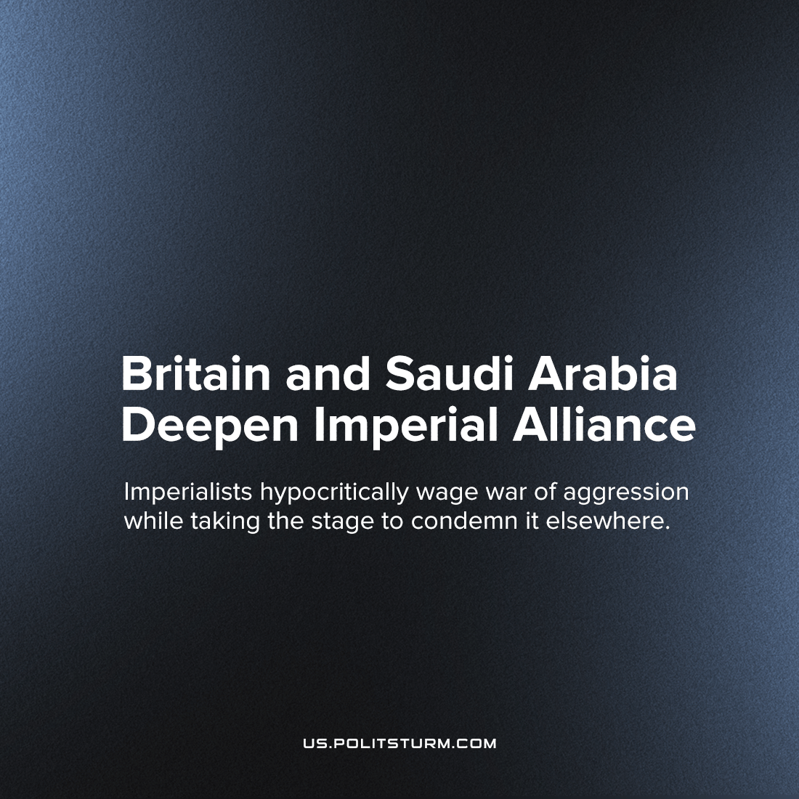

Original article
2023-03-04
2 min read

British “Defence” Secretary Ben Wallace visited Saudi Arabia last week and signed a statement of intent with the Saudi government, headed by its reigning hereditary Crown Prince and Prime Minister Mohammed Bin Salman, in favour of deepening military and economic collaboration and diplomatic ties.
This is the latest development in a long economic and military collaboration between the two countries, in which Britain (in conjunction other Western capital) has supplied the Gulf monarchies with arms in order to enforce their rule over the region and facilitate the export of oil back to Western countries at a price acceptable to them. This relationship plays out with an abundance of corruption; with bribery in order to win contracts and “skimming off the top” on both sides, as is normal under capitalism.
The statement of intent will likely lead to Saudi’s inclusion to the joint-European Future Combat Air System (FCAS) programme. Just as nature changes due to the development of internal contradictions, so do social relations and relations of capitalist dependency on the world stage. While Saudi’s inclusion to the FCAS programme is not yet confirmed, it is demonstrative of the decline of British capital, as it demonstrates how the formerly dependant country of Saudi Arabia is in the process of acquiring its own military-industrial complex (instead of being dependant on Western arms exports) and joining the ranks of the major imperialist countries, while the strength and international position of British capital declines. The reactionary monarchy of Saudi Arabia strengthens its place in the central circle of the most advanced imperialists, who establish programmes such as FCAS to expand their bombing war on Yemen.
While the capitalists that rule Britain decry Russian escalation of the conflict in Ukraine on “moral” grounds, they are creating military forces to support the horrific war of its autocratic allies against Yemen. Their “humanitarianism” ends where profits begin. War, the continuation of political conflict by violent means, is an inevitability under the imperialist stage of capitalism that we live in. Only when classes have been abolished internationally and productive relations have been completely demystified; when all human beings have social equality and equal opportunity to work the socially owned means of production and are rewarded according to their need, will class conflict and class exploitation and all the violence and war that it spawns be permanently relegated to the dustbin of history.
Source: 1

Original article

