Brazil Says it Will Amplify Commercial Relations with China


Original article
2024-08-13
3 min read

The Vice-President of Brazil, Geraldo Alckmin, has declared that Brazil-China relations have reached a new record, with trade relations increasing by 7.4% in the first semester of 2024 compared to the previous year. This statement was made during an event celebrating 50 years of diplomatic relations between the two countries.
China is currently Brazil's largest trading partner. In 2023, Brazil exported US$ 89.4 billion to China and imported US$ 60.7 billion [1].
Exports are mainly extractive products such as iron ore and its concentrates (20% of the total) and crude petroleum oils or bituminous minerals (18%). In the agricultural sector, Brazilian soybean exports accounted for 36%. Fresh, chilled or frozen beef accounted for 8.9% of exports. (We have previously touched on China’s relation to Brazilian agriculture in a previous article).
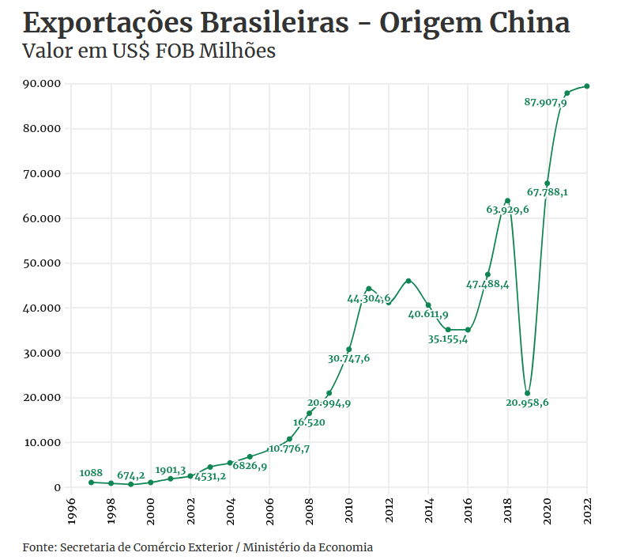
Imports include thermionic valves and tubes (11% in 2022), followed by organic-inorganic compounds (8.2%) and telecommunications equipment (6.8%). Some examples of other products imported by Brazil are medicine and pharmaceutical products (except veterinary), various electrical machines and appliances, and office parts and accessories [2].
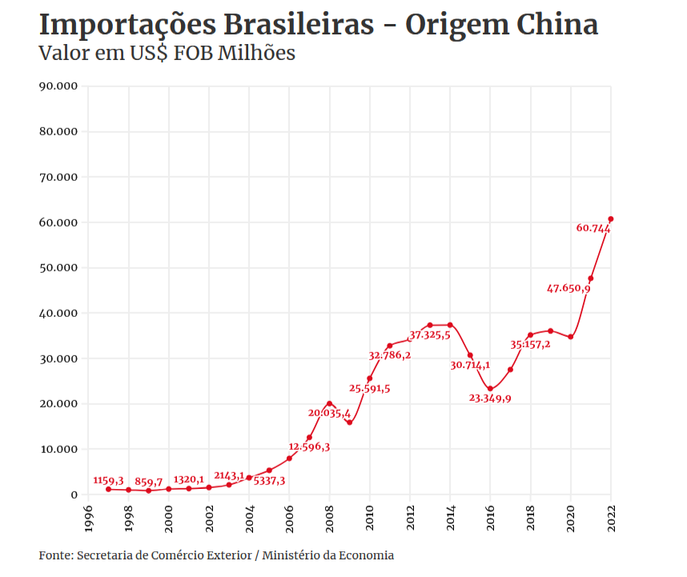
A difference in product types can be observed in the import-export relationship. While Brazil remains largely deindustrialised and exports mainly primary products, China sells industrial products. This creates a situation where Brazil becomes dependent on China for expensive equipment, as it is unable to produce it itself.
However, Alckmin said that increased economic ties would help industrialise the country.
"We want to neo-industrialise Brazil. There is no economic development without industry, there is no social development without industry. So we want neo-industrialisation, which is important, and a densification of production chains"
But he also said that:
"The tax reform...", referring to a tax reform passed last year, "will boost the industry and bring more investment and exports because it removes cumulative effects, so it completely relieves investment and exports".
It is clear from this statement that the government's focus is on continuing to export to China. But even if Brazil were to use Chinese investment to industrialise, it would be tying these new industries to Chinese imperialism (we have written extensively about this).
The imperialist powers try to spread their influence and redivide the world among themselves. Firstly through "peaceful" means, but when these fail, the imperialist powers resort to war. This is clear in the crisis in Ukraine, where Western and Russian imperialism have clashed and are now trying to decide who will control the region.
China is trying to gain influence in Brazil. BRICS+ is an example of this. Baron O'Neill of Gatley, a member of the House of Lords in the UK and the originator of the BRIC acronym, has been quoted as saying that China "dominates the Brics because it is twice the size of all the others put together" in the same way that the US dominates the G7 [3].
Of course, the UK is aligned with Western imperialism and it would suit them to discredit the BRICS+. However, this observation is correct. China has the largest GDP of the BRICS+ countries, at US$16.86 trillion in 2021, while the others are all below three trillion. China has also consistently had the largest amount of exports among the BRICS+ countries [4].
The imperialist powers will continue to try to redivide the world among themselves. While the workers of the world are struggling every day and being exploited more and more, the big corporations are trying to make the highest possible profit. The capitalist states compete with each other to increase these profits.
The only way to secure the interests of the working class, to end exploitation and to stop the imperialist powers from exploiting the people of the world is to build socialism.
Under socialism, the state is run by the working class for the interests of the working class. A planned socialist economy is capable of rapid industrialisation, as seen in the USSR, which went from a semi-feudal country to a world superpower in less than 30 years. This industry was designed to meet the needs of its people, not to make profits or subjugate other less industrialised countries.
The working class needs a truly communist party, guided by Marxism-Leninism, to lead it in the colossal task of achieving socialism. Join Politsturm and help towards building this party.
Sources: 1/2/3/4

Original article

