Brazilians Campaign for a Shortening of the Working Week
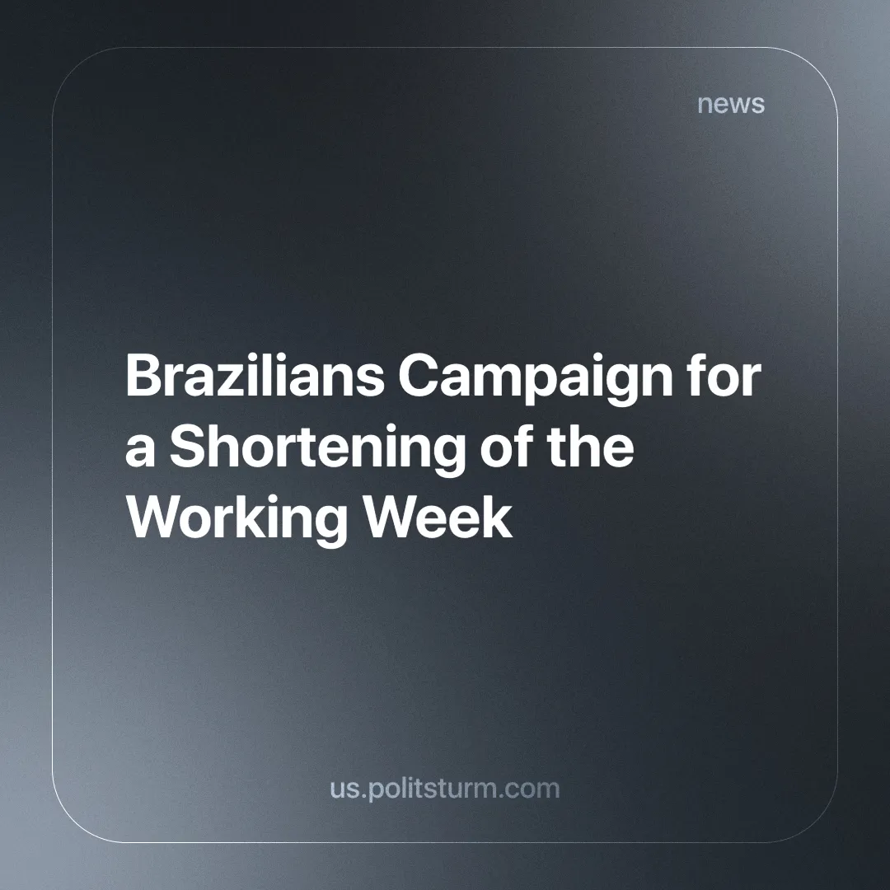

Original article
2024-11-27
4 min read

In recent months, the Life Beyond Work (VAT) movement has received increased attention in Brazilian media. What began as a TikTok video complaining about abusive working conditions and lack of leisure time has grown into a movement that has gathered 2.5 million signatures on a petition. A proposal inspired by this movement was presented to Congress by Erika Hilton, a federal deputy from the social democratic party PSOL (Party for Socialism and Liberty). [1]
Currently, Brazilian labour laws state that a worker cannot work more than 44 hours per week or 8 hours per day, with an additional 2 hours per day allowed if negotiated between the worker and the employer.
This usually translates into a working week of 5x2 - five days of work and two days of rest. However, in services and commerce, it is common to see a 6x1 working week. This is achieved by having a working day of 7 hours and 20 minutes, or working 8 hours some days and having some shorter days to compensate.
TikToker Rick Azevedo made a video that has been widely circulated on social media, denouncing this exploitative system. He points out that if he, who has no children and lives alone, does not have enough free time to take care of himself, he wonders how those who do have children are supposed to manage their lives. He went on to call for a "revolution in the country against the 6x1 working week". [2]
Erika Hilton (PSOL) has taken the idea to Congress and is campaigning for a 36-hour week, which does not specify how many days off a worker can have, but simply reduces the number of hours worked per week. The proposal for a constitutional amendment (PEC) has gathered enough signatures to begin the very long process through Congress, where it will face fierce opposition.
The capitalists and their mouthpieces claim that reducing the workweek will bankrupt small businesses and that many will have to cut wages, raise product prices and lay off workers to stay afloat and remain profitable.
Many previous movements for pro-worker reforms have faced similar criticism. Shorter working days were said to destroy productivity; ending child labour would destroy industries that needed cheap labour; wage increases were always said to bankrupt businesses. The capitalists will resort to any excuse to keep as much of the social wealth in their hands as possible.
Karl Marx shows us that these claims are often untrue, using the example of wage increases in Britain between 1849 and 1859.
“Well, what was the result? A rise in the money wages of the factory operatives, despite the curtailing of the working day, a great increase in the number of factory hands employed, a continuous fall in the prices of their products, a marvellous development in the productive powers of their labour, an unheard-of progressive expansion of the markets for their commodities.” [3]
The struggle to reduce the working week, like the struggles above mentioned, is an economic struggle to benefit the workers. With the 6x1 work week being particularly gruelling, replacing it would be a significant victory for the Brazilian proletariat.
But its success depends on getting it through a Congress full of pro-capitalist politicians. Workers' organisation is crucial in this struggle; workers must keep up the pressure on the government and not accept watered-down proposals designed to stifle the movement without significant concessions.
There have been some successes in this regard. Workers organised demonstrations across the country demanding the end of the 6x1 week [4] and the São Paulo dairy and food workers' union (STILASP) has announced that workers at Pepsico Brazil will go on strike until the 6x1 week is abolished [5].
However, it is hard to say how successful the movement will be. At the moment, the Brazilian left is divided between various left-liberal, reformist and nominally communist parties. This will lead to a lack of cohesion between workers and will limit how far the demands can go.
Successful or not, the VAT movement will be a valuable lesson for the working class in organisation and struggle. How the various left-wing parties in the country will use this movement remains to be seen. However, there is currently no truly communist party in Brazil that could use it to develop class consciousness and advance the proletarian cause.
Like the working class in every country, the Brazilian working class is being exploited and exhausted. The 6x1 workweek is indeed an especially tiring work schedule, and the VAT movement is an admirable grassroots effort to fight it. But because it is purely an economic struggle for better conditions within the capitalist system, it is very limited in what it can achieve.
The capitalist class will often make temporary concessions to the working class in order to appease it and keep it from fighting for socialism.
Economic concessions cannot free the capitalist system from its inherent flaws and limitations, caused by the private ownership of the means of production, which leads to a system based on cutthroat competition where profit is placed above the needs of society.
These concessions can always be taken away once the working class is weakened. They can be taken away slowly over time or more quickly in times of strife, such as wars or crises.
Economic struggles, while important, must not be separated from political struggles. The working class, under the leadership of a communist party, must maintain a constant fight, not for a more "tolerable capitalism", but for the complete replacement of the capitalist system.
Under socialism, the means of production are publicly owned and therefore planned to meet the needs of society as a whole. Exploitative 6x1 working weeks in the current system are designed to squeeze maximum profit out of workers. Socialism eliminates the pursuit of profit, replacing it with a focus on improving the quality of life for society as a whole. Increasing productivity and higher levels of economic automation will reduce working hours, making labour less exhausting and dangerous while freeing up time for each individual’s personal development.
This will never come about while Congress is composed of capitalists (or people bought off by capitalists). Only working-class power can guarantee that all workers' rights that are won will be maintained until the workers can abolish all other classes including themselves.
But a communist party is needed to guide the working class, to educate it about its role in capitalism and to explain the limits of individual economic struggles. The communist party must be able to link all proletarian struggles to the ultimate goal of achieving socialism.
If you want to help in the task of working towards creating the vanguard parties we need, consider joining Politsturm.
Sources:
[1] BBC News Brasil — Fim da escala 6x1: o que diz a proposta que reduz jornada de trabalho para 36 horas semanais — 12/11/2024
[2] TikTok — Até quando essa escravidão?? — 13/09/2023
[3] Marx, Karl. Value, Price and Profit. New York: International Co., Inc, 1969. Volume II, pp 9
[4] Brasil de Fato — Em São Paulo, trabalhadores vão às ruas contra escala 6x1: 'O povo está revoltado' — 15/11/2024
[5] STILASP Instagram — PEPSICO DO BRASIL | ESTAMOS EM GREVE PELO FIM DAS JORNADAS 6x1 e 6x2! — 25/11/2024

Original article

