BP Profits Double as Workers' Essentials Prices Climb
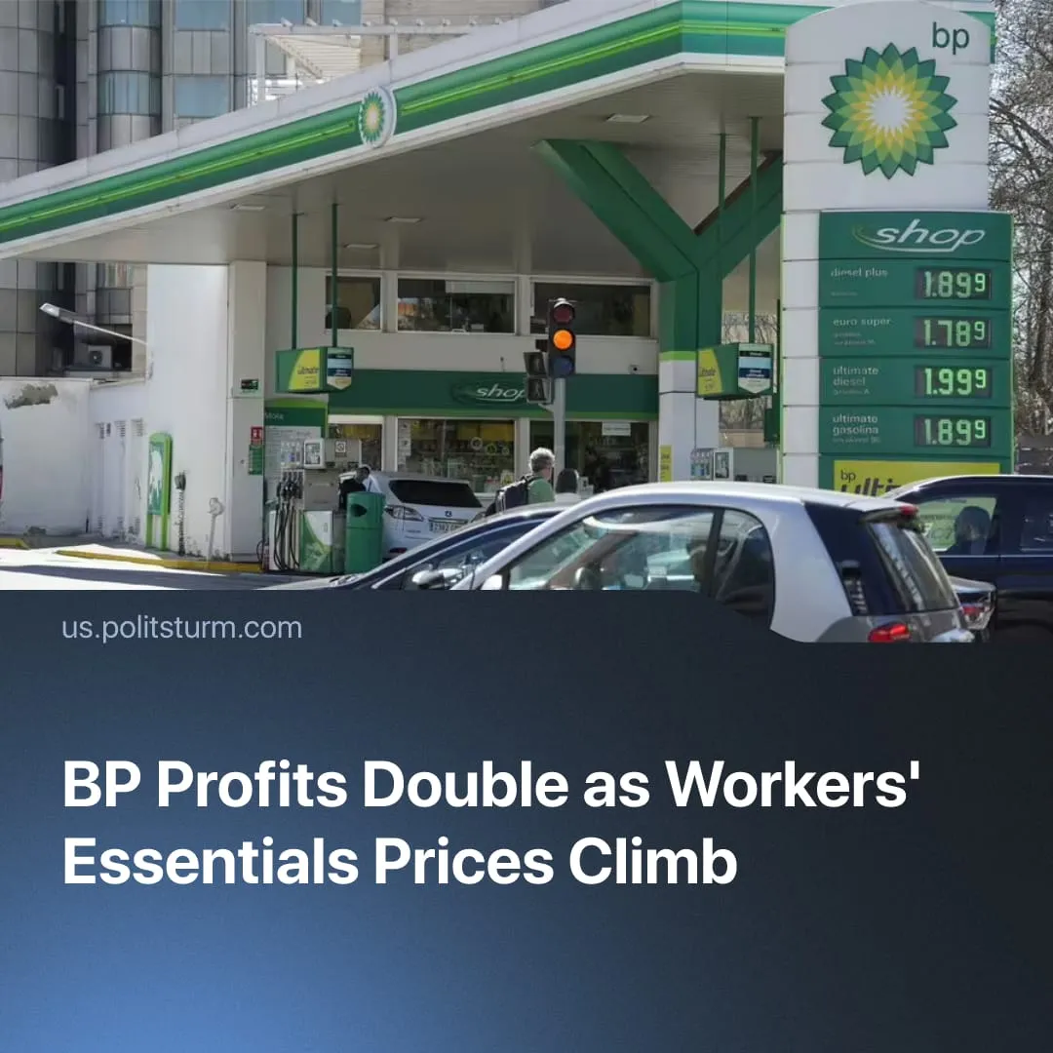

Original article
2026-05-13
2 min read

British Petroleum doubles its corporate profits as prices for workers' essentials begin to climb globally.
Details. British Petroleum (BP) has reported more than doubling its profits in its first results since the outbreak of the Iran war, surging to $3.2 billion from $1.4 billion year-on-year, with analysts projecting even greater returns as the full effects of sustained high oil prices continue to accumulate.
► This massive revenue surge has triggered a sharp rise in the company's share prices, far above fair value estimates, ensuring that this wartime windfall is distributed directly to corporate shareholders and the broader capitalist class. With dividends included, a £20,000 investment in BP last year is now worth £35,608.
► British Petroleum faces no actual supply crisis, as its European and North American operations – both oil extraction and refining – bypass the Strait of Hormuz entirely, unlike global competitors. With zero material scarcity, the monopoly simply aligns its prices with inflated global rates to extract maximum profit. Driven by the law of capital, BP secures record margins at the direct expense of the public standard of living.
► Anticipating fierce public backlash, the UK’s Energy Secretary Ed Miliband said, "profiting from a crisis is morally and economically wrong” and suggested “taxing these windfall profits to help fund support with the cost of living." Despite this, BP's effective tax rate has been lowered to 43% this year, down from 69% in 2025.
Context. The ongoing military blockade of the Strait of Hormuz is driving severe global price increases, with roughly 1 in 3 of the world's oil tankers previously dependent on the route. Since 90% of this traffic flowed East toward Asia, Western monopolies like BP, Shell, Chevron and ExxonMobil remain far less exposed than Asian competitors – yet still exploit the crisis to pocket $60 billion in extra profits from global price surges.
► Nevertheless, disruption is reverberating globally through trade, with transportation costs spiking due to fuel shortages – pump prices are up over 50% in the USA – triggering cascading inflation on working class essentials, from groceries to energy bills.
► Using severe global emergencies to drive corporate accumulation is not a new occurrence. While the recent pandemic devastated the working class, the richest one percent captured nearly two-thirds of all new wealth as monopolies doubled their profits. The current Gulf blockade operates on this same method, opportunistically using supply shocks to aggressively accelerate the exploitation of workers.

Original article

