Both US and Iran Deploy Theocratic Propaganda to Justify Conflict
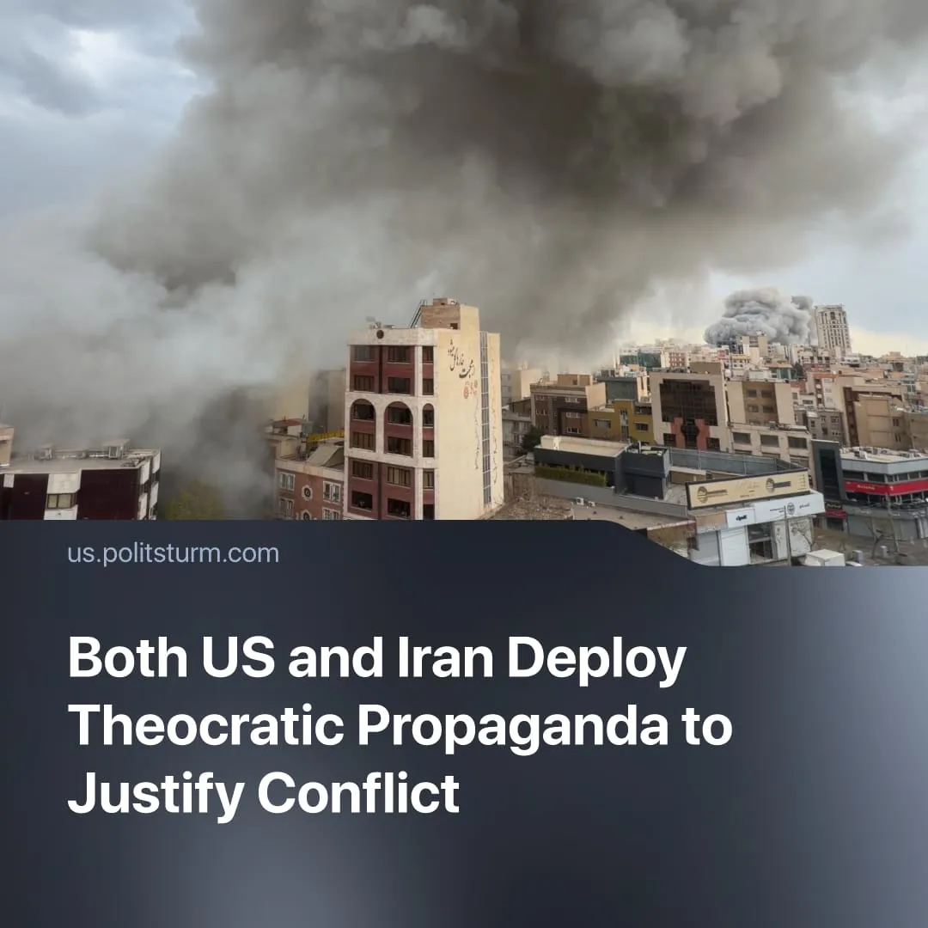

Original article
2026-04-27
2 min read

Both the US and Iran have declared "victory.” They depicted the conflict in religious terms, with Iran portraying it as a “holy war” and the US calling it “God’s plan.”
Details. In the USA, the Trump administration used Islamophobia and crusade rhetoric as part of their war propaganda. President Trump himself claimed "God" was siding with the US offensive, and Secretary of War Hegseth called for military action to be aligned with God's will. Trump personally prayed together with Christian leaders while the conflict in Iran was escalating. A number of American soldiers complained that commanders said the war was "God's plan” and linked it to “Armageddon”.
► Ceasefire between Iran and the US has been presented by Trump’s administration as a triumph, whilst labelling critics as "losers". He explicitly mentions he is "taking the oil" and “making a fortune”. At the same time, Trump declared that, “our great Military is Loading Up and Resting, looking forward, actually, to its next Conquest.” finishing with a triumphant MAGA slogan “AMERICA IS BACK!”
► Following the attack on the school on 28 February, the Iranian regime used "jihad" propaganda by labelling the victims Islamic "martyrs”. The assassination of Ali Khamenei was portrayed by Iranian state media as “martyrdom” to mobilise the masses to “defend” the Iranian people.
► Like the US, Iran claimed to have won the war and presented it as a victory "against colonialism", using nationalist rhetoric and even bringing back old pre-Islamic kings in propaganda posters. The regime called the war “imposed” by the US and described the war as a “collective axis of resistance” using moralistic language depicting the US and Israel as the “Great Satan.”
Context. Despite both the Iranian and US elites claiming their actions serve “the people”, the reality reveals the opposite. In Iran, for example, 26 million people already live in absolute poverty, and 4 million cannot afford food, while the regime’s elite – whose number continues to increase – enjoy a life of luxury abroad. Similarly, in the US, the top 1% of the population owns around 32% of the country's total wealth, while the bottom 50% own just around 4%, with this wealth gap currently growing.
► Both Iran and the US have faced growing protests due to worsening conditions and military escalation. In response, authorities in both countries resorted to arrests and violence, justifying repression through ideological rhetoric – religious in Iran and nationalist in the US.
For a deeper analysis of the US-Iran conflict, see the Marxist position on this subject: The Middle East: Architecture of War.

Original article

