Boston Starbucks Workers Declare Strike Victory
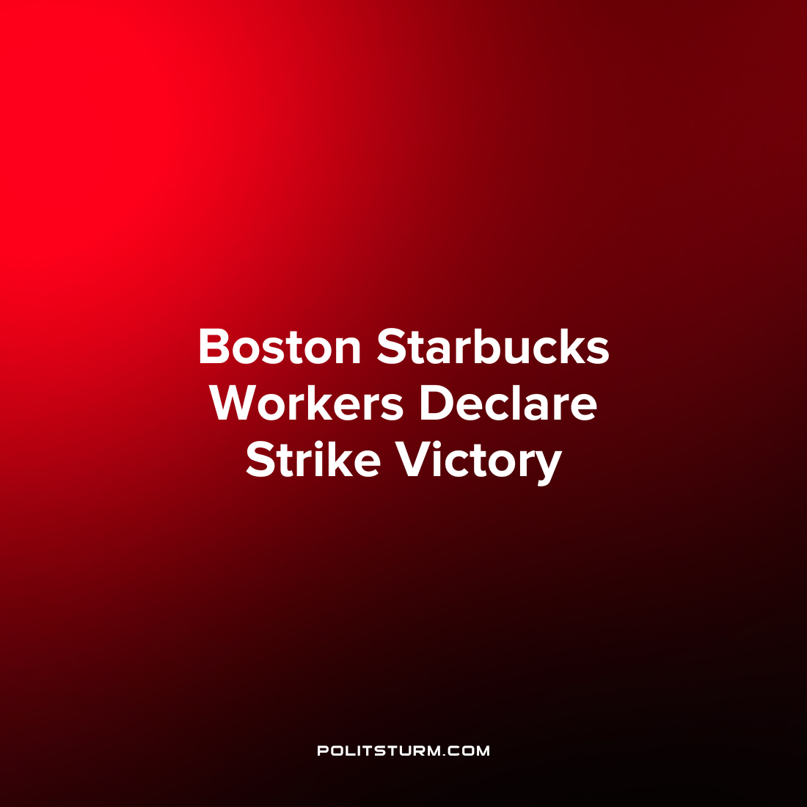

Original article
2022-09-23
1 min read

Starbucks Workers at the 874 Commonwealth Avenue location in Boston, Massachusetts declared victory after going on strike for 64 days. The workers went on strike in part due to “threats of discipline or termination” made by a manager over a newly imposed availability policy. The striking workers also expressed dissatisfaction with understaffing at the Starbucks locations.
After remaining on the picket line for 64 days, Starbucks Workers United stated that the company has conceded that the availability policy cannot take effect at unionized stores and they are replacing the aforementioned manager.
While the concessions made to the union represent a small victory, there is still much more work that needs to be done with respect to worker organization in the United States. It is necessary for workers to be educated in Marxist-Leninist theory and to view the capitalists not as “partners”, but within the context of the class struggle.
Source: 1

Original article

