Boris Johnson Resigns: What's Next?
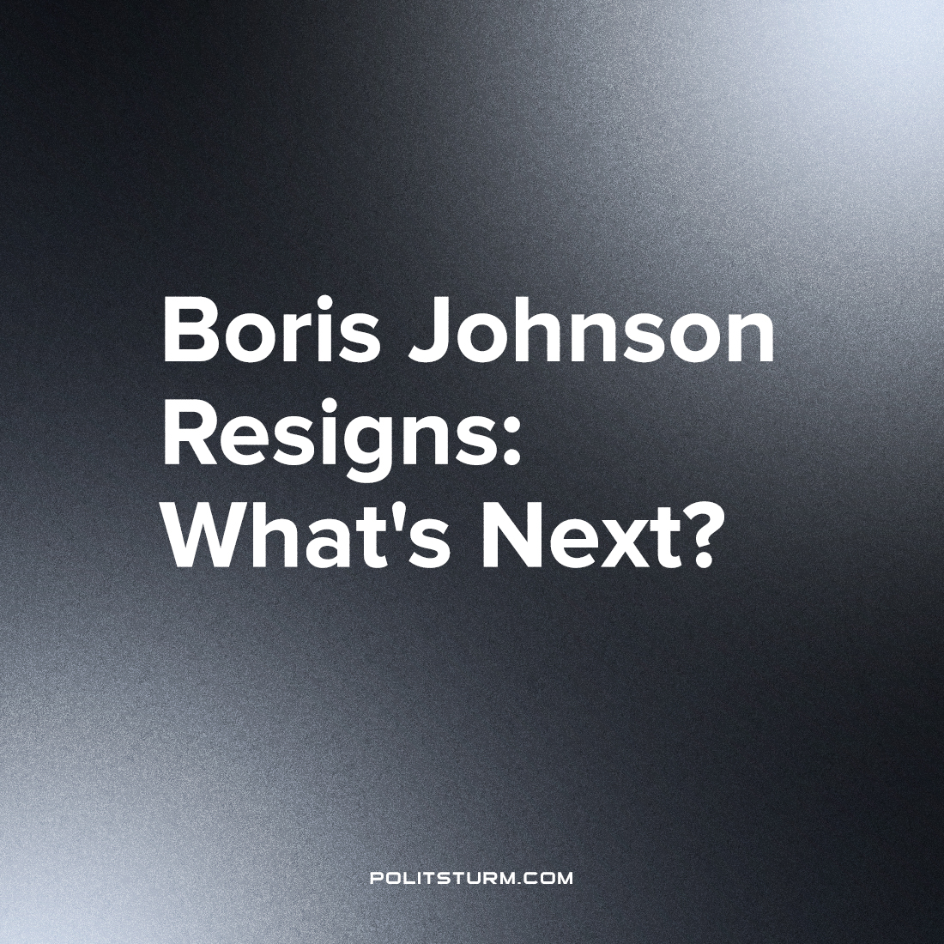

Original article
2022-07-09
2 min read

The U.K. Prime Minister (PM) Boris Johnson has resigned. British PMs are not elected directly by the public but instead are chosen from within their own party. The political parties also put forward candidates for parliamentary elections, and should a party win a majority of the seats they can form a government.
As a result, notwithstanding a parliamentary election they only way a Prime Minister can be ousted is from within their own party. After barely surviving a “no confidence” vote a month ago, it is clear that now even the majority of his own party is against him as evidenced by the series of resignations within his government and so his position has become untenable. He intends to remain as PM until October, where the ruling Conservative party will elect a new leader.
Why has his own party turned against him? It is because he had appointed a known sex predator to a position of power and responsibility within the Conservative party, who used this position to molest two young men last week in a private club for Conservative party members. This is what finally mobilised the majority of the Conservative party against the Boris Johnson regime.
It was not the fact that while millions more were forced into poverty due to the woefully inadequate furlough scheme, Boris Johnson used over £100,000 in money received as a political bribe to decorate his home with golden wallpaper. Nor the knowledge that millions were locked down at home and unable to attend the funerals of their deceased relatives (killed by a woefully inadequate pandemic response) while Boris Johnson and other government ministers were throwing parties. Neither was it the fact that while the cost of living skyrockets and millions default on their payments and are forced into debt slavery, the UK government spends billions of pounds in fanning the flames of the events in Ukraine.
This is because they (individually and as representatives of the bourgeoisie as a class) are collectively responsible for all these things and more. These are the sources of popular discontent with the British government; however, they will not be solved by a change in Conservative party leadership, nor the so-called “Labour” party. Both wings that the bourgeoisie puts forth in the façade that is liberal democracy have completely disgraced themselves. The so-called “labour” party has removed its mask completely and turned itself into being an openly anti-labour party, with its leadership coming out against the recent rail strikes and proclaiming themselves a “party of business”.
It is capitalism that has caused the problems that the country is facing, and only socialism can fix them. With the extreme unpopularity of both main parties, there is no one to stand up for the interests of the working class that could benefit from this opportunity. Virtually the entirety of the British establishment was mobilised to crush the movement of the lukewarm social-democrat Jeremy Corbyn, and one of the most important lessons to learn from this experience is that real change must be fought for outside the “labour” party. The task of forming a truly communist party on the basis of Marxist-Leninist theory, to lead the working masses, is all the more urgent.
Sources:
https://www.wionews.com/photos/the-rise-and-fall-of-uk-pm-scandals-that-rocked-boris-johnsons-premiership-495263#parish-khan-more-sexual-misconduct-allegations-495254
https://www.gov.uk/government/news/pm-announces-further-1-billion-in-military-support-to-ukraine
https://www.theguardian.com/business/2022/jul/06/cost-of-living-2m-households-missed-bill-every-month-this-year
https://www.bbc.co.uk/news/62048687
https://skwawkbox.org/2022/06/20/video-starmer-betrays-striking-workers/

Original article

