Bank of England Predicts UK's Longest Recession
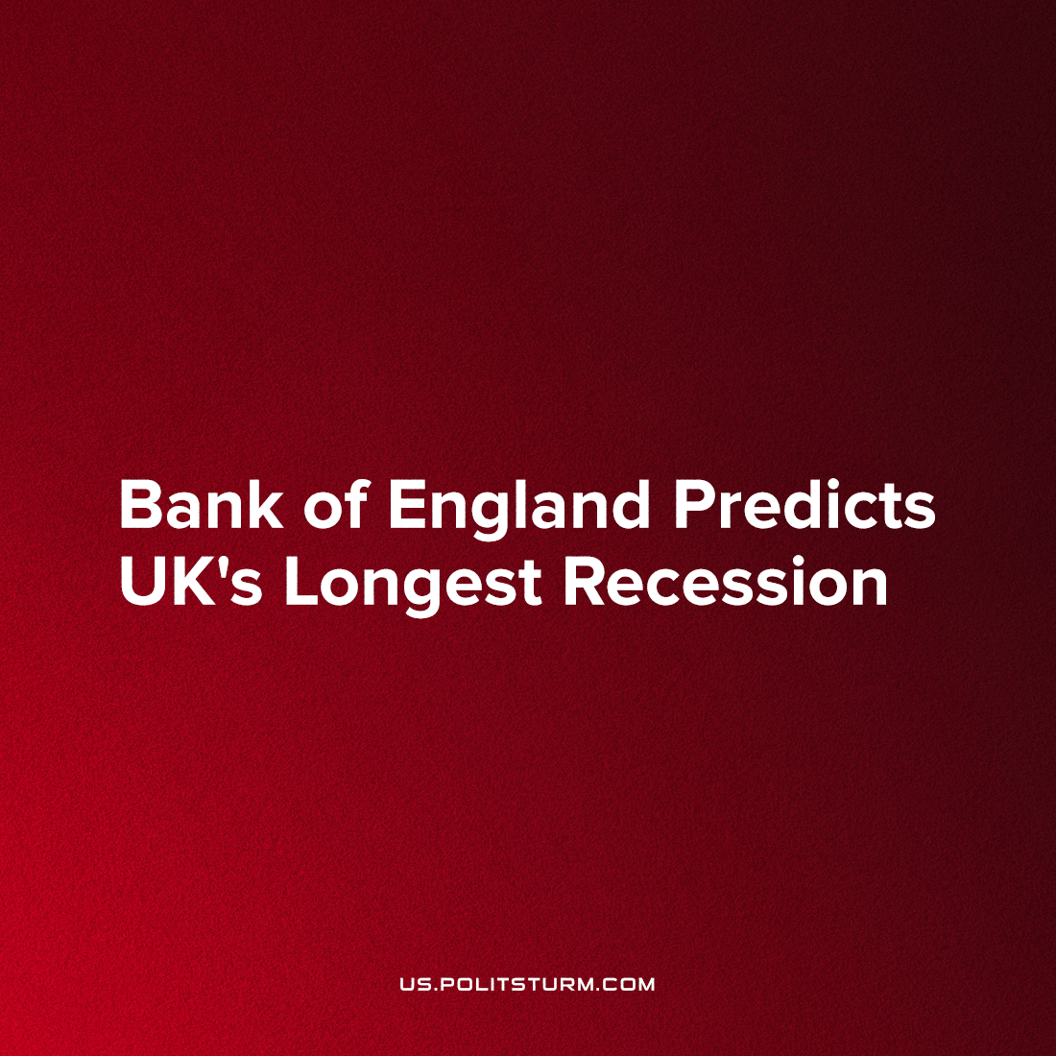

Original article
2022-11-17
2 min read

The Bank of England anticipates that the UK will enter the longest recession in British history (at least since records began in the 1920s). As a result, it has increased interest rates from 2.25% to 3%, the biggest jump in more than 30 years [1]
The increased interest rates will punish those already in debt – the majority of the population, who on average had a personal debt of £33,410 in March of this year [2] which is more than 100% of average annual income, a figure that has likely only increased since. In addition, the Bank expects unemployment to rise to 6.5%, making the prospects for working people in Britain look very bleak. This measure will also encourage finance-capitalists to hoard their money instead of investing it. Why would they risk losing their money investing in businesses producing commodities that have been rendered unaffordable for the majority of the population due to the recession, for a resultant return that has no guarantee to be positive, let alone higher than 3%? Instead, now they are guaranteed a 3% rate of income simply by storing their money in a bank. In the meantime, industrial-capitalists will continue to churn out commodities that have become and will continue to become increasingly unaffordable to the majority of the population, leading to a crisis of overproduction. In such a crisis, the industrial-capitalists will be further subordinated to finance capital and many of the petit-bourgeoisie and some middle capitalists will be entirely unable to stay afloat and therefore forced to sell their property and businesses to the monopolists for very little, as they themselves are forced to sell their own labour thereby joining the ranks of the workers. As Marx says:
“The rate of interest reaches its peak during crises, when money is borrowed at any cost to meet payments. Since a rise in interest implies a fall in the price of securities, this simultaneously offers a fine opportunity to people with available money-capital, to acquire at ridiculously low prices such interest-bearing securities as must, in the course of things, at least regain their average price as soon as the rate of interest falls again.” [3]
Crises of overproduction are a regular and repeating occurrence – demonstrative of the anarchy of production inherent to capitalism. Poverty and unemployment are “necessary” evils from the standpoint of the capitalists. Workers in Britain can go on strike to win a temporary reprieve from their ongoing immiseration, but in order to solve these problems for good we need a new system – a socialist system.
Sources: 1, 2, 3

Original article

